Speaking Lesson Plan
TITLE | A Song About Rain
INSTRUCTOR |  |  |  | Ss’ LEVEL | AGE GROUP | No of Ss | LENGTH
Eun-Ji Kim |  |  |  | Beginner | 6-7 years | 9 students | 50 min

MATERIALS

Dolls, flash cards, audio system, audio file, sticker, review worksheet.
AIMS 1. |  | To be better able to speak simple declarative sentences by singing an English song.
2. |  | To study vocabulary ‘go’ vs ‘come’ by watching flash cards.
3. |  | To practice a grammatical pattern ‘want + to + base verb’ by changing verb in the song.

LANGUAGE SKILLS
Listening |  |  | English song, vocabulary pronouncing
Speaking |  |  | Repeating vocabulary, singing English song
Reading |  |  | Vocabulary on flash cards, review worksheet
Writing |  |  | Vocabulary spelling on review worksheet.
LANGUAGE SYSTEMS
Phonology |  |  | Pronunciation about ‘r’ (e.g. rain)
Lexis |  |  | Distinguishing between ‘go’ and ‘come’
Grammar |  |  | Verb pattern ‘want + to + base verb’
Discourse |  |  | Story about rain episode
Functions |  |  | Wishing & hoping to stop raining.

ASSUMPTIONS

Students already know:
if they imitate teacher’s action hard, they’ll get one sticker as reward and if they volunteer, they’ll get it one more.

ANTICIPATED GRAMMATICAL ERRORS AND SOLUTIONS
Some students have difficulty in pronouncing /r/ sound and pronouncing it like /l/.
- Pronounce /r/ carefully and make students watch mouth movement. Check students pronunciation one by one.

REFERENCES

https://www.youtube.com/watch?v=1Mk6RRf4kKs
http://www.melon.com/album/detail.htm?albumId=2270004

NOTES
- Plan B:
If electronic materials aren’t working, teacher sing a song for her/himself.
- Cut-off plan:
If time is short, cut post-activity short (teach 1~2 words instead of 4 words).
- SOS activity:
Do a review worksheet that is homework originally.

PRETASK TITLE |  |  | A Doll Play About Rain
AIMS |  |  |  | MATERIALS
To predict the topic of lesson by watching a doll play |  |  |  | Dolls
TIME | SET UP | STUDENTS |  |  | TEACHER
8 min | Whole class | Students will watch a doll play about a story of rain |  |  | Perform a doll play

NOTES

Arrange seating in a circle. This arrangement keeps going until lesson is finished.

TASK PREPARATION TITLE |  |  | Studying Essential Vocabulary
AIMS |  |  |  | MATERIALS
To study vocabulary about a song (rain, come, go, play) by watching flash cards. |  |  |  | Flash cards (rain, come, go, play)
TIME | SET UP | STUDENTS |  |  | TEACHER
2 min | Whole class | Students will be given instruction about main activity and be asked instruction checking questions.  Q1. What do we sing a song about?  Q2. Can we dance with singing a song? |  |  | Give instruction.  Ask ICQs.
10min | Whole class | Before doing main activity, students will learn vocabulary (e.g. rain, come, go, play) with flash cards. (This is pre-teaching). |  |  | Show flash cards with action.

NOTES

Use Total Physical Response method(TPR). First, show flash cards with pronouncing it. Next, do again with doing action. If you want to know TPR more, refer to you-tube.

TASK REALISATION TITLE |  |  | Singing & Dancing
AIMS |  |  |  | MATERIALS
To be better able to speak simple declarative sentences by singing a English song. |  |  |  | Audio system, audio file, stickers.
TIME | SET UP | STUDENTS |  |  | TEACHER
3 min | Whole class | Students will be read the lyrics of a song, ‘Rain, rain go away’ once |  |  | Read it loudly and slowly with action once.
5 min | Whole class | Students will be shown teacher’s singing the song with dance once. (Teacher model) |  |  | Sing the song with dance once.
7 min | Whole class | Students will sing the song with dance by imitating teacher twice and more. |  |  | Play audio.  Sing the song with dance.
5 min | Individual | Two or three volunteer students will sing it with dance in front of students.  Students will get one sticker and volunteers will get one more. |  |  | Play audio.  Give stickers

NOTES

-Teacher needs to encourage students who have shy personality to participate.
-If students have difficulty in singing along the song, turn off audio and sing it slowly.
-If anybody doesn’t volunteer, encourage them as reward.
-Give one sticker to everyone and one more to volunteers as reward.

POST TASK TITLE |  |  | Learning more.
AIMS |  |  |  | MATERIALS
To study vocabulary about weather (sunny, windy, snowy) by watching flash card. |  |  |  | Flash cards about weather, review worksheet
TIME | SET UP | STUDENTS |  |  | TEACHER
8 min | Whole class | Students will learn three kinds of weather vocabulary (e.g. sunny, windy, snowy) more with flash cards. |  |  | Show flash cards.  Pronounce it with action.  Test them.
2 min | Individual | Students will be handed out a review worksheet as homework. |  |  | Hand out review worksheet to students.

NOTES

Test all vocabularies by showing flash cards.

Song lyrics

Rain, rain, go away.
Come again another day
Daddy wants to play
Rain, rain, go away.

Rain, rain, go away.
Come again another day
Mommy wants to play
Rain, rain, go away.

Flash card

rainy | sunny
 | 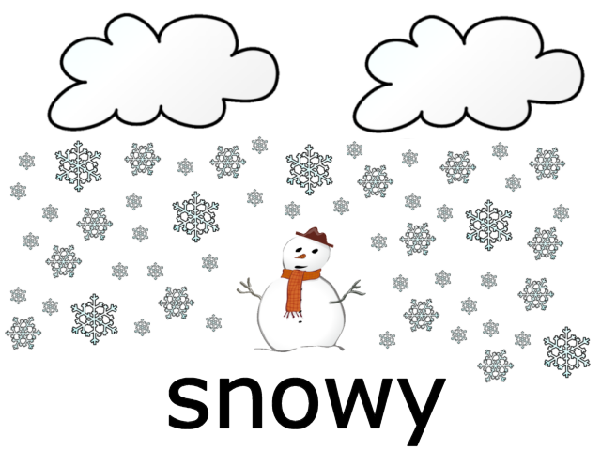
windy
play
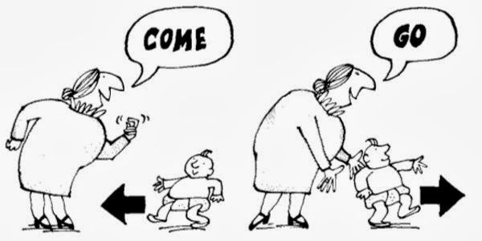

Review worksheet

Listen and put the picture into the correct order. (Mother says the word)

● | ●● | ●●● | ●●●●

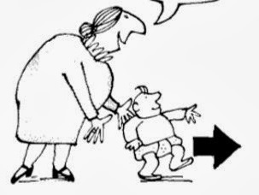 | 