TBLT Grammar Lesson Plan
Topic: Writing a storybook
Instructor | Level | Age | Number of students | Length
Jin Hyung Kim | Beginner | 12 | 7 | 50min

Materials: A computer with a speaker, projector, paper, marker, worksheet, storybook page, cards, SOS/planB

Aims:
1. Learn present continuous tense and form by lecture.
2. Get used to using present continuous form by drilling.
3. Learn how to apply present continuous tense to real project by writing and presenting narration and dialogue for the storybook.

Language skills:
Speaking: Drilling and presenting a storybook.
Listening: Listening sentences of present continuous form from the movie clip.
Reading: Reading worksheet.
Writing: Worksheet practicing and script writing.

Language systems:
Grammar: Learn present continuous tense and form.
Lexis: Learn new words on the storybook.
Phonology: Learn '-ing' sound.
Function: learning about different use of the word 'pointer'.
Discourse: Understanding how story develops within sequenced illustrations.

Assumptions:
Students know basic words to describe the storybook for children.
Students know 'to be verb'.
Students are familiar with drilling of substitution table.
Students know the rules for comparative and past tense, so they are familiar with the rules how vowel+consonant becomes double consonants, vowel+y becomes i and etc.

Anticipated Errors and Solutions:
Students have some problems when they add -ing to verbs
- > Remind them of rules.
Students have some questions about different usages of -ing form.
-> Teach them at the next class.

References:
https://www.youtube.com/watch?v=Ay2D8chFBKw
http://www.edufind.com/english-grammar/present-continuous-tense/
http://www.englishpage.com/verbpage/presentcontinuous.html
https://en.islcollective.com/resources/printables/worksheets_doc_docx/present_continuous_tense_questions/present-continuous-actions/58807
https://www.youtube.com/watch?v=xuWUBAs2C6g

Notes: If students get bored during lecturing grammar rule, do drilling and ask students to make sentences.

Pre-task: present continuous tense
Aims: Learn the form and concept of present continuous tense |  |  | Materials: Video clip, grammar rule presentation paper, worksheet, substitution table
Time | Set Up | Student |  | Teacher
2min  2min  5min  3min  2min  3min | Whole class  Whole class  Whole Class  Whole Class  Whole Class  Whole Class | Find -ing sound from the video clip and getting hint for the meaning of it.  Answer to guiding questions  Listening  Repeating  Practicing  Q&A to next students. |  | Ask them to find repetitive sound in the sentences from the clip. Show video clip.  Ask guiding questions.  Lecturing present continuous tense (time line, grammar rule)  Drilling (substitution table) - CCQ  Handing out worksheet  ICQ - Q&A game "what are you doing?"
Notes: If they have hard time to get '-ing' sounds, show video one more time. After the video, ask if this situation started from the past and still going on and will be finished in the near future.

Task Preparation:
Aims: Practicing making sentences for the task |  |  | Materials: Storybook illustration sequence page, pictures of Pointer
Time | Set Up | Student |  | Teacher
2min  1min | Whole class  Whole class | Looking at the illustration and answering to teacher's questions.  Getting instruction |  | Eliciting some key words from the task page.  Instruction for the task- ICQ
Notes: Show the picture of Pointer if they don't understand it. Let them make 2 sentences for each illustration and one of them should use present continuous tense.

Task Realization: Writing a story for the storybook
Aims: Learning to use present continuous tense in the storybook |  |  | Materials: Storybook illustration sequence page
Time | Set Up | Student |  | Teacher
14min  14min | Pair  Pair | Making dialogue and narration for the storybook.  Presenting students' script. |  | Monitoring  Monitoring
Notes: Discreet monitoring but when students get stuck, then actively involve. Use cards for the case of no volunteering.

Post Task
Aims: Getting feedbacks and comprehension check |  |  | Materials:
Time | Set Up | Student |  | Teacher
2min | Whole class | Giving feedbacks and answering questions |  | Ask how the activity was and check the concept of present continuous tense.
Notes: Give URL for the full movie of "The Pointer" for them to check that later at home. Use the movie as a SOS/PlanB if time left.

Grammar rule page (big paper or just on the board)
PRESENT CONTINUOUS TENSE
Subject | + to be verb | + verb + ing
She | is | talking.
I | am | reading  studying  running  jumping  laughing  swimming | now  at present  at the moment
He  She  Kevin | is
You  They | are

USE 1 Now
- You are learning English now.
- You are not swimming now.

USE 2 Longer Actions in Progress Now
- I am studying to become a doctor.
- I am not studying to become a dentist.

USE 3 Near Future
- I am meeting some friends after work.
- I am not going to the party tonight.

USE 4 Repetition and Irritation with "Always"
• She is always coming to class late.
• He is constantly talking. I wish he would shut up.

Worksheet
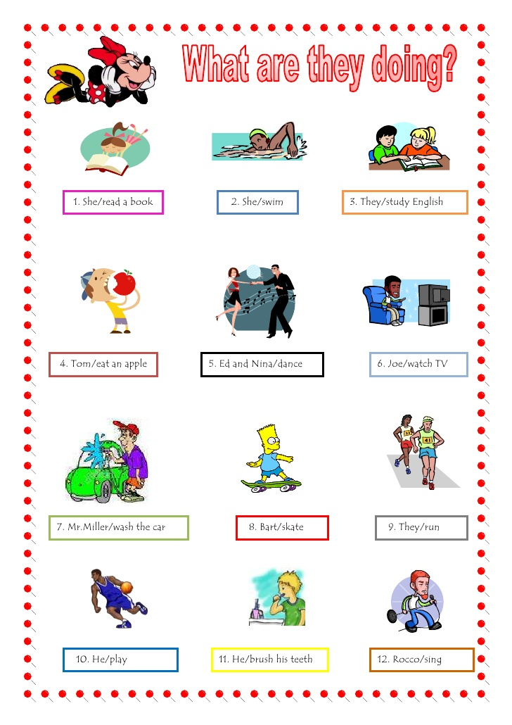

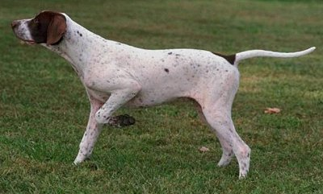

Story writing (Mickey Mouse and Pluto)
1. Write at least two sentences for each illustration.
2. One of sentences for each illustration should be present continuous tense.
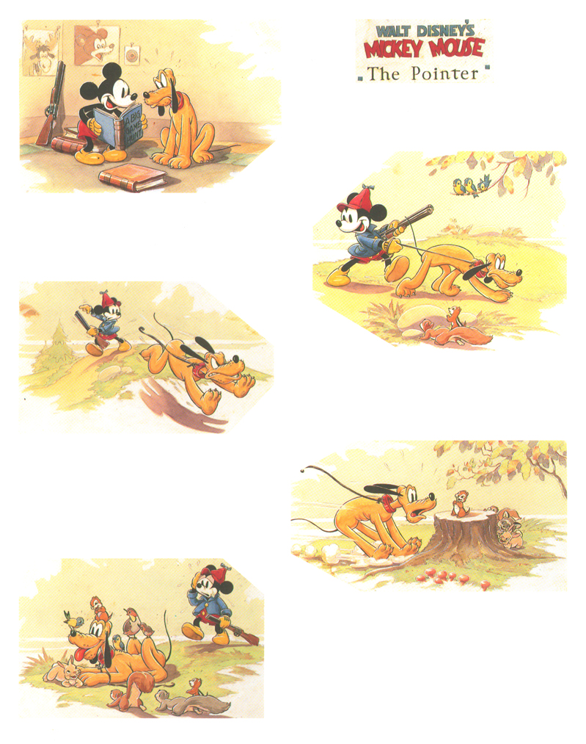

SOS activity
Watching movie 'The Pointer'
https://www.youtube.com/watch?v=xuWUBAs2C6g

