TBLT Lesson Plan
Topic:: Future tense will vs going to (In the holiday I will/ I am going to)
Instructor | Level | Age | Number of students | Length
Sofia | Elementary/  High beginners | 16 (Middle school second grade) | 7 | 50 minutes

Materials:
Whiteboard, markers; pen and paper; student worksheet#1 and #2, plan B/ SOS
Aims:
- To learn how to use future tense (going to/ will.) through teachers explanation using possible situations.
- To learn the difference of using’ going to’ and ‘will’ by applying both into sentences.
- To practice and get used to using future tenses in everyday situation when students talk about their holiday (future) plans during task realization so that students are comfortable with the use.
Language skills:
Listening: Listening to teacher’s pronunciation, explanation and other student’s plans.
Speaking: Having verbal discussions and presentations.
Writing: Writing down holiday plans on the calendar and also student worksheets.
Reading: Reading worksheets, whiteboard and also reading others calendars with the holiday plans written on it.
Language systems:
Grammar: Use of future tense (will vs going to)
Phonology: Students focus on clear pronunciation of new grammar.
Function: Using proper language for situations that will be happening in the future using future tense.
Discourse: Students do a role play presentation in pairs; and a group of three.
Assumptions:
Students are familiar with teacher’s teaching style and comfortable with teacher attending a class for a semester.
Students know about fortune telling.
Anticipated Errors and Solutions:
Student may not have any plans for the holiday
- Students can make a plan for the holiday in the class
- Students can imagine what they would want to do( can be anything and not real ex. win the lotto and be a millionaire)
Some students might finish their task before other students do
- Plan B/ SOS
References:
http://calendarworkshop.com/month/august-2015
http://img.wikinut.com/img/3zxcqexxvy448h1l/jpeg/0/Fortune-Teller.jpeg
Notes:
Students must be monitored through task preparations
Make sure that students are on task and listening to speakers at the right situation.
Students first listen to teacher’s pronunciation then repeat during substitution drills.
Pre-task: Warner
Aims: To understand the different uses of will and going to and also understanding how to use them |  |  | Materials: Whiteboard, markers, student worksheets, pen
Time | Set Up | Student |  | Teacher
2 mins | Whole class | Students answer guiding questions and reach the answer ‘future’ to reach the topic for the class. |  | Greetings  Elicit ‘future’ from students through guiding questions and picture of fortune teller.  Write ‘Future tense’ on the board.
9 mins | Whole class | Students listens to the teacher, keep an eye on the whiteboard to understand the concept.  Students repeat after teacher for substitution drills.  Student will understand the concept of future tense and answer CCQ |  | Explain what will and going to are and the uses.  Substitution drills.  CCQ
2 mins |  | Students listen to instructions. |  | Give instructions  ICQ
3 mins | In groups of 2.2.3 | In groups of 2.2.3, students will fill in the blanks in the worksheet and discuss about the answer in their groups. |  | Group students into groups of 2.2.3 (to groups of two, one group of three.)  Hand out student worksheet1  Set up task and monitor
Notes: Make sure students have full understanding with the concept of future tense and make the students use it.

Task Preparation: Filling up the calendar with future plans.
Aims: To practice and show understanding future tense by writing plans on the calendar. |  |  | Materials: student worksheet, pen, crayon/colour pencils, markers
Time | Set Up | Student |  | Teacher
2 mins | Whole class | Students listen to instructions. |  | Give instructions  ICQ
15 mins | In groups of 2.2.3 | Students make their own plans on the calendar having discussion to share information in their groups. |  | Group students into groups of 2.2.3 (to groups of two, one group of three.)  Set up task and monitor
Notes: Monitoring students is essential to check if students are struggling or if they’re finished earlier than others.

Task Realization: Presentation
Aims: To confirm and present full understanding of using future tense (will/ going to) and practice speaking. |  |  | Materials: Student worksheet
Time | Set Up | Student |  | Teacher
10 mins | In groups of 2.2.3 | In groups of 2.2.3 each group of students will come up to the front of the class to present plans of other students in the same group. |  | Monitor
Notes: Ensure students are talking about the right information on the others calendar to see they have had discussed about it.

Post Task: Feedback
Aims: To confirm understanding student’s presentation done by using future tense. |  |  | Materials: Whiteboard, markers
Time | Set Up | Student |  | Teacher
5 mins | Whole class | Students have a big group discussion about each other’s plans |  | Monitor  Guide students buy making one person speaking at a time
2 mins | Whole class | Students give feedback about the usefulness of the class. |  | Elicit feedback
Notes: Monitoring is important through-out discussions and students giving feedback to each other to make sure that they don’t get off track or not participating and also being respectful to their classmates.

Substitution drill table.

I | am | Going to | watch the television.
She | is |  | go to the park.
He | are |  | wear a hat.
They | will |  | play basketball
We |  |  | promise.

Student worksheet#1

Fill in the blank with the right form will/going to

- I ______________ wear a blue shirt tomorrow.
- She is ______________ have pasta for her dinner.
- Roger ______________ wear a salmon shirt for the last class.
- They are ______________ throw a party tonight.
- My mother ______________ bake some cakes for my friends.
- When I grow up, I am ______________ be a lawyer.
- We ______________ win this game!!
- I ______________ promise that I will love you forever, will you marry me?(wink)
- He is ______________ go to Disney land next week.
- I ______________ eat chocolate right after this class.

Student worksheet#2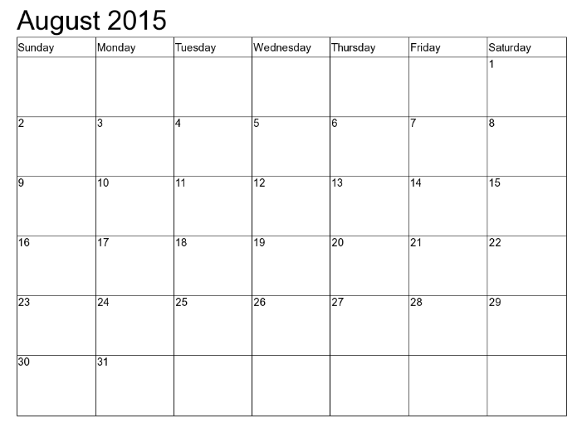
Plan B/ SOS
<Discussion questions.>

Q: What will you have for your breakfast tomorrow?

Q: What will you be in the future?

Q: With the question above, what are going to do to help that future?

Q: ( Make your own question to yourself.)

