READING LESSON PLAN
TITLE | History of Halloween
INSTRUCTOR |  |  |  | Ss’ LEVEL | AGE GROUP | No of Ss | LENGTH
Sun Hwang |  |  |  | Intermediate | 20 | 9 | 50

MATERIALS

History of Halloween(Copies of the text), white board and markers
AIMS 1. |  | To exercise their intensive reading skills by analyzing the text.
2. |  | To practice improving reading comprehension by Q&A activity after reading the text.
3. |  | At the end of lesson, student will be better able to know about Halloween by understanding the text.

LANGUAGE SKILLS
Listening |  |  | Students will listen the video about Halloween to understand better about what they are talking about.
Speaking |  |  | Students will talk about Halloween after reading the text.
Reading |  |  | Students will read the text about Halloween.
Writing |  |  | Students will fill in the answer sheet after reading the text.
LANGUAGE SYSTEMS
Phonology |  |  | [l] vs. [r] Halloween, Ireland, lantern, religious, spirit, problem
Lexis |  |  | Trick or treat, Jack 'o lanterns, costume, turnip
Grammar |  |  | Using past tense when telling the story in the past.
Discourse |  |  | History of Halloween.
Functions |  |  | Explaining. Giving information

ASSUMPTIONS

Students may enjoy Halloween, but they may not know the history.

ANTICIPATED GRAMMATICAL ERRORS AND SOLUTIONS
Many Korean students forget using the past tense while they talk about the event of the past.
After reading this text, teacher will emphasize on what the event were written in the past tense.

REFERENCES
https://www.youtube.com/watch?v=vbK_iyC0FXM
https://www.youtube.com/watch?v=eYqznC_50AQ

NOTES

Enter your Plan B, your Cut-off plan and your SOS activity here
1. Plan B : If the computer and the projector not working properly,
Teacher will not show the video. Use only the copied text.
2. Cut-off plan : If too slow and lack of time, ask questions to some of students, not all of them.
3. SOS plan
- Word search : to find Halloween words in the worksheet. (see the attached worksheet)
- Word chain : A category of words is Halloween.

PRETASK TITLE |  |  | Special occasions in the second half year
AIMS |  |  |  | MATERIALS
To talk about special occasions which would happen or be expected in later this year while having a small chat. |  |  |  | none
TIME | SET UP | STUDENTS |  |  | TEACHER
5 min | Whole class | Student will talk about some special occasions they are expecting later this year. |  |  | To talk about special day.

NOTES

none

TASK PREPARATION TITLE |  |  | What is Halloween?
AIMS |  |  |  | MATERIALS
To have more interests on Halloween by talking about their Halloween experiences.  To talk about Halloween by sharing Ss' knowledge about it. |  |  |  | none
TIME | SET UP | STUDENTS |  |  | TEACHER
10 min | Whole class | Student will talk about their Halloween experiences.  Student will talk about their knowledge about Halloween. |  |  | To bring up the subject of Halloween as one of events in the second half year.

NOTES

There may be students who haven't had Halloween events ever before. Please care for the those students and let them talk about their knowledge about Halloween instead of Halloween experience.

TASK REALISATION TITLE |  |  | The history of Halloween
AIMS |  |  |  | MATERIALS
To be better able to know about the history of Halloween by reading the text about Halloween.  To check and talk about Halloween by solving the Q&A worksheet. |  |  |  | The copies of text and Q&A worksheet, YouTube video,
TIME | SET UP | STUDENTS |  |  | TEACHER
25 min | Small group | Students will read the text about the history of Halloween and watch the video.  Students will solve the Q&A worksheet after read the text carefully and check their understanding about Halloween. |  |  | Give Ss the copies of text and Q&A worksheet.  Check often if anyone have trouble to do the activity.

NOTES

Please check the vocabularies with Ss such as Trick or treat, Jack 'o lanterns, costume and turnip as reading the text.

POST TASK TITLE |  |  | What do you want to be on this Halloween?
AIMS |  |  |  | MATERIALS
To be able to check their understanding about the history of Halloween while talking about Halloween costume and ideas of Halloween. |  |  |  | none
TIME | SET UP | STUDENTS |  |  | TEACHER
10 min | Whole class | Students will talk about their Halloween costumes which want to be wore on this Halloween.  Students will talk about some good ideas to enjoy Halloween. |  |  | To check their understanding by CCQ

NOTES

To talk with Ss that we'd better know the histories of some other culture such as Valentine's day, April Fool's Day and so on as long as we enjoy them.

History of Halloween

Like many other holidays, Halloween has evolved and changed throughout history. Over 2,000 years ago people called the Celts lived in what is now Ireland, the UK, and parts of Northern France. November 1 was their New Year's Day. They believed that the night before the New Year (October 31) was a time when the living and the dead came together.
More than a thousand years ago the Christian church named November 1, All Saints Day (also called All Hallows.) This was a special holy day to honor the saints and other people who died for their religion. The night before All Hallows was called Hallows Eve. Later the name was changed to Halloween.
Like the Celts, the Europeans of that time also believed that the spirits of the dead would visit the earth on Halloween. They worried that evil spirits would cause problems or hurt them. So on that night people wore costumes that looked like ghosts or other evil creatures. They thought if they dressed like that, the spirits would think they were also dead and not harm them.
The tradition of Halloween was carried to America by the immigrating Europeans. Some of the traditions changed a little, though. For example, on Halloween in Europe some people would carry lanterns made from turnips. In America, pumpkins were more common. So people began putting candles inside them and using them as lanterns. That is why you see Jack 'o lanterns today.
These days Halloween is not usually considered a religious holiday. It is primarily a fun day for children. Children dress up in costumes like people did a thousand years ago. But instead of worrying about evil spirits, they go from house to house. They knock on doors and say "trick or treat." The owner of each house gives candy or something special to each trick or treater.

True or False? Choose your answers !!

1. The Celts thought the spirits of dead people returned to the earth on October 31st.
True
False
2. The Celts created All Hallows.
True
False
3. All Hallows is on October 31st.
True
False
4. The word Halloween comes from the word Hallows eve.
True
False
5. A thousand years ago Europeans wore costumes to get candy.
True
False
6. Americans still carve turnips to use as lanterns.
True
False
7. Today Halloween is especially for children.
True
False
8. Children get candy by saying "trick or treat."
True
False

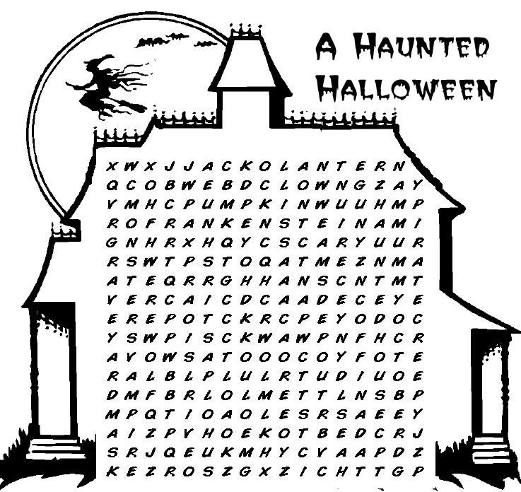
 | bat  black cat  broom  candy clown  cobweb | coffin  costume  creepy  Dracula  Frankenstein  ghost  graveyard | Halloween  happy  haunted house  jack-o'-lantern  mask  monster  mummy | October  party  pillowcase  pirate  pumpkin  scary | skeleton  spooky  trick-or-treat  vampire  werewolf  witch
