Reading Lesson Plan
TITLE | Tea Culture in the UK
INSTRUCTOR |  |  |  | Ss’ LEVEL | AGE GROUP | No of Ss | LENGTH
Eun-Ji, Kim |  |  |  | Intermediate | Adult | 9 students | 50 min

MATERIALS

White board, board marker, 9 copies of article, 9 copies of reading comprehension worksheet, 9 sheets of paper, 9 copies of vocabulary list
AIMS 1. |  | To practice reading compound-complex sentences by reading a text about tea culture in the UK.
2. |  | To study comparative pattern (more than twice as ~ as ..) by making comparative sentences by themselves.
3. |  | To practice cooperative skills as they study and explore a subject together.

LANGUAGE SKILLS
Listening |  |  | Explanation about comparative pattern / group presentation
Speaking |  |  | Answer to guide questions, ICQs and CCQs / discussion on the article / presentation
Reading |  |  | Article about tea culture in the UK / vocabulary list
Writing |  |  | Comparative sentences / reading comprehension worksheet / summarizing and paraphrasing the article
LANGUAGE SYSTEMS
Phonology |  |  | Use intonation naturally : main part of speech(e.g. noun, verb, adverb, etc) is pronounced strongly while sub part of speech(e.g. article, etc) pronounced weakly.
Lexis |  |  | Changing part of speech : Smuggle(v) & smuggling(n) / uninitiate(a) & the uninitiated(n)
Grammar |  |  | Comparative pattern : as ~ as .. and more than multiple as ~ as ..
Discourse |  |  | Article about tea culture in the UK.
Functions |  |  | Explaining about the history of tea and types of it.

ASSUMPTIONS

Students already know:
basic words so they can read the article smoothly. Even if they don’t know unfamiliar words, they can guess the meaning pretty well.

ANTICIPATED GRAMMATICAL ERRORS AND SOLUTIONS
They will be confused about a double negative pattern in the text. (e.g. not uncommon)
→ Explain that it is positive meaning while you do the task-preparation part or circulate groups.
They will be confused about distinguishing between as~as and more than∙multiple as~as.(comparative pattern)
→Clarify the differences with examples in the task-preparation part.

REFERENCES
http://www.learnenglish.de/culture/teaculture.html
http://english-magazine.org/english-reading/english-for-culture/328-tea-high-tea-and-afternoon-tea-novembers-culture-article
https://www.youtube.com/watch?v=6C8n0-Zbixk
http://www.oxforddictionaries.com/

NOTES

Plan B:
If Ss have difficulty understanding comparative pattern, explain it again in next lesson.
Cut-off plan:
Cut discussion time short or do a part of comprehension worksheet.
SOS activity:
Read vocabulary list together. If Ss are confused some words, clarify them more detail.

PRETASK TITLE |  |  | Leading to Topic of Tea
AIMS |  |  |  | MATERIALS
To predict the topic of lesson by answering guide questions |  |  |  | -
TIME | SET UP | STUDENTS |  |  | TEACHER
3 min | Whole class | Students will answer guide questions to predict the topic of lesson, tea culture in UK.  Q1. What do you want to do during summer vacation?  Q2. Where do you want to travel in Europe?  Q3. What kind of beverage do UK country people love to drink a lot? |  |  | Ask guide questions

NOTES

Make students share their ideas a lot.

TASK PREPARATION TITLE |  |  | Studying Important Grammar
AIMS |  |  |  | MATERIALS
To study comparative pattern (as ~ as .. and more than multiple as ~ as ..) by listening explanation. |  |  |  | White board, board marker.
TIME | SET UP | STUDENTS |  |  | TEACHER
5 min | Whole class | Before doing main activity, students will learn comparative pattern (as~as.. / more than twice as ~ as ..) by listening to explanation with examples.  Students will practice comparative pattern by making comparative sentences by themselves. (This is CCQ.)  e.g. → Usain Bolt runs as fast as I can.  → Usain Bolt runs more than twice as fast as I can. |  |  | Explain comparative pattern.
3 min | Whole class | Students will be given instruction about main activity and be asked instruction checking questions.  Q1. After reading it carefully, what do you have to do?  Q2. What part will you read? (as pointing each groups)  Q3. What number of questions on the comprehension worksheet will you answer? (as pointing each groups)  Q4. What minute presentation will you prepare? |  |  | Give instruction.  Ask ICQs.

NOTES

- When you think that there are too many ICQs, pick out some questions.
- For CCQ, give a situation which is related to comparative and then ask a question, ‘how will you express this situation by using comparative pattern?’.

TASK REALISATION TITLE |  |  | Jigsaw Activity for Reading
AIMS |  |  |  | MATERIALS
To practice reading compound-complex sentences by reading a text about tea culture in UK. |  |  |  | 9 copies of reading text, 9 copies of reading comprehension worksheet.
TIME | SET UP | STUDENTS |  |  | TEACHER
3 min | Threes | Students will make three into a group and each group will receive different topic of a reading text to read. |  |  | Make 3 groups.  Hand out article & worksheet.  Inform each group about different parts of the text to read.
10 min | Threes | Students will read the materials and then share their ideas with members to understand it thoroughly. |  |  | Circulate to help Ss’ discussion.
9 min | Threes | Students will answer comprehension questions, check the answers each other and correct errors. |  |  | Check exercises.

NOTES

This activity is a kind of jigsaw. If you don’t know how to manage it, refer to https://www.youtube.com/watch?v=6C8n0-Zbixk

POST TASK TITLE |  |  | Sharing with All
AIMS |  |  |  | MATERIALS
To practice cooperative skills as they explore a subject together. |  |  |  | 9 sheets of paper, 9 copies of vocabulary list.
TIME | SET UP | STUDENTS |  |  | TEACHER
5 min | Threes | Students will prepare oral presentation about what they read to share it with all.  (Summarize and paraphrase it) |  |  | Hand out a sheet of paper to each group.  Assist Ss to prepare presentation.
10 min | Threes | Students will give presentation, answer question and get feedback. |  |  | Comment on information to include, delete, etc.
2 min | Individual | Students will receive a vocabulary list and read it 3 times for review as homework. |  |  | Hand out a vocabulary list.

NOTES

Make Ss just read vocabulary list instead of memorizing.

The History of Tea in the UK
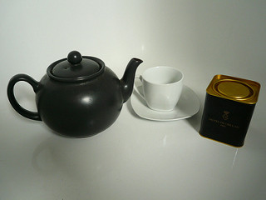
Tea only made its way to England in large quantities in the first years of the 17th century. Dutch and Portuguese traders were shipping tea from China and a few other Asian countries to Europe regularly by 1610.
Tea was being sold more widely in England by 1657, in London’s existing coffee houses, but it was called Tcha, China Drink, Tay or Tee, and was generally sold as a remedy to cure all ills; from fatigue and lack of virility to overall poor health and diseases of all kinds, and it was expensive. Tea was sold in the mid-1600s for as much as £10 per pound (£22 per kilogram), which is around £2,000 in today’s money. Needless to say, the average Brit didn’t have a £4,000 a year habit at the time. Commoners and servants would be lucky to earn £50 per year back then, so tea was exclusively for the very well off and they would lock it away in tea caddies.
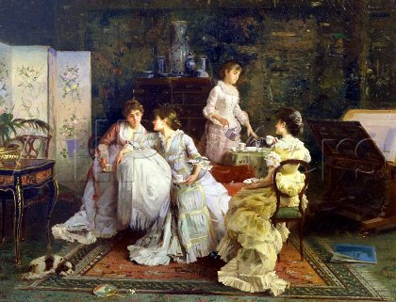
Nonetheless, it was available on almost every street in London by 1659. When Queen Catherine of Braganza, wife of King Charles II, introduced the custom of taking tea to the royal court in 1662 it became more than just addictive, it became fashionable. By the mid-18th century, Canton was exporting nearly 7 million tons of tea to Europe each year; nearly half of it on British owned ships.
Of course, the Crown didn’t take long to see the growing popularity of this new luxury good as a source of income. By the 18th century tea imports were being taxed at as much as 119%. The heavy taxation of course lead to smuggling on a massive scale, but also the sale of lower quality, sometimes dangerously adulterated tea. Used tea leaves were often dried and mixed in with new leaves, and plants like liquorice, sloe and willow were used to ‘bulk up’ the much more expensive tea leaves. This smuggling was largely eliminated after 1784, when the tax on tea was brought down to 12.5%, but adulteration remained a large problem until it was made illegal in 1875.

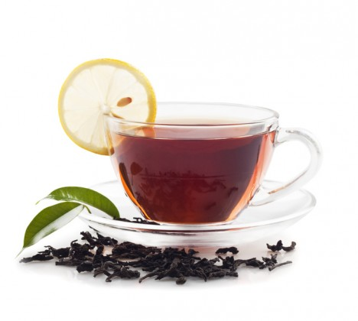
Types of Tea
There are many varieties of tea, from English Breakfast tea, to Earl Grey and the tarry Lapsang Souchong, they all come from the plant Camellia Sinensis, and are simply processed in different ways.
Black tea mixtures are still the most common type drunk in the UK, and it can be a shock for visitors. Black tea, be it from Twinings, Liptons, Tetley or PG Tips, makes a darker brew, because the leaves have been allowed to oxidise before drying. This is why it is why we usually serve it with milk, although it is not uncommon to drink it black or with lemon.
You may still find tea made with loose leaf tea leaves, served up in a pot, and poured into the best china cups with saucers for visitors, but behind closed doors it is likely to be served in a mug, and made with a tea bag.
Green tea, made by not allowing the leaves to oxidise as much, thereby producing a more delicate flavour, is also very popular, as it's gained a reputation for being healthy.
Less popular white tea is also available, made from very young leaves and dried with no processing at all.

Tea Today

Tea still a large part of daily life in the UK today, but it seems to be on the decline. The amount of tea purchased in the UK fell by more than 10% in the five years leading up to 2002, and has been dropping ever since. Tea sales fell by 6% in 2014 alone, and most restaurants report selling more than twice as many cups of coffee as they do tea.
More than £1 billion was spent on coffee in high street stores in 2013, more than twice what was spent on tea bags.
Still, what goes around, comes around, it's bound to become fashionable again, and I don’t see tea going away any time soon. Fancy a cuppa?

Afternoon tea
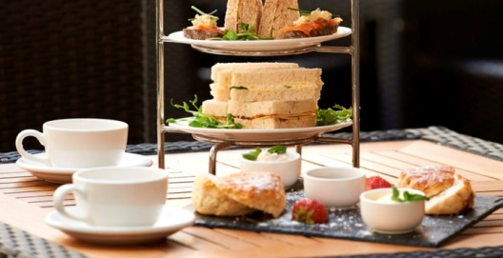
Afternoon tea (or Low tea) is a light meal typically eaten at 4:00 pm. It originated in Britain, though various places in the former British Empire also have such a meal. However, most Britons no longer eat such a meal.
Traditionally, loose tea would be served in a teapot with milk and sugar. This would be accompanied by various sandwiches (customarily cucumber, egg and cress, tuna, ham, and smoked salmon), scones (with butter, clotted cream and jam) and usually cakes and pastries. Traditionally the tea and food would be served on a lounge (or low) table.
While afternoon tea used to be an everyday event, nowadays it is more likely to be a treat in a hotel, café, or tea shop, although many Britons still have a cup of tea and slice of cake or chocolate at teatime. Accordingly, many hotels now market and promote afternoon teas.

High tea
To the uninitiated "high tea" may be a confusing term.
High tea is an early evening meal, typically eaten between 5:00 and 6:00 pm. It would be eaten as a substitute for both afternoon tea and the evening meal. The term comes from the meal being eaten at the ‘high’ (main) table, instead of the smaller lounge (low) table. It is now largely replaced by the later meal tea.
It would usually consist of cold meats, eggs and/or fish, cakes and sandwiches. In a family, it tended to be less formal and is an informal snack (featuring sandwiches, cookies, pastry, fruit and the like) or else it is the main evening meal.
On farms, in rural areas or other working class environments, high tea would be the traditional, substantial meal eaten by workers immediately after nightfall, and would combine afternoon tea with the main evening meal.
In recent years, High tea somehow became a word for exquisite afternoon tea. Such usage is incorrect. High Tea is not, in traditional terms, afternoon tea.

Reading Comprehension Task.
Answer the following questions.

[The History of Tea in the UK]
1. Why was tea sold in England in the mid 1600s?
→
2. Could most of people buy tea in the mid 1600s?
→
3. When did tea become fashionable?
→
4. What did happen because of heavy taxation?
→
5. How was smuggling decreased?
→

[Types of Tea]
6. Why is back tea dark?
→
7. Does black tea make more delicate flavor than green tea?
→
8. Did the amount of tea purchased fall in 2001?
→
9. Which one did UK people drink more in the restaurant in 2014, tea or coffee?
→
10. Is the Popularity of tea on the increase in the UK today?
→

[Afternoon tea & High tea]
11. When is Afternoon tea eaten?
→
12. Could you eat cold meats in Afternoon tea?
→
13. Could you have High tea at 12 pm for lunch?
→
14. Where would be High tea served?
→
15. Does High tea mean delicate afternoon tea in traditional terms?
→

Reading Vocabulary List
1. addictive (adjective) /əˈdɪktɪv/
→ Habit-forming, causing dependency.
→ e.g. The addicting properties of sugar or fast food could easily be tested in humans.
2. caddy (noun) /ˈkadi/
→ A small storage container.
→ A tool caddy.
3. smuggle (verb) /ˈsmʌɡ(ə)l/
→ Move (goods) illegally into or out of a country.
→ Cocaine smuggling has increased alarmingly.
4. adulterate (verb) /əˈdʌltəreɪt/
→ Render (something) poorer in quality by adding another substance.
→ The brewer is said to adulterate his beer.
5. bulk up (verb) /bʌlk/
→ Treat (a product) so that its quantity appears greater than it is.
→ Traders were bulking up their flour with chalk.
6. brew (noun) /bruː/
→ A cup or mug of tea or coffee.
→ He took a sip of the hot reviving brew.
7. lead up to (phrasal verb) /liːd/
→ Immediately precede.
→ The weeks leading up to the elections.
8. be bound to (adjective) /baʊnd/
→ Certain to be or to do or have something.
→ There is bound to be a change of plan.
9. uninitiated (adjective) /ʌnɪˈnɪʃɪeɪtɪd/
→ Without special knowledge or experience.
→ The discussion wasn’t easy to follow for the uninitiated.
10. exquisite (adjective) /ɪkˈskwɪzɪt/
→ Extremely beautiful and delicate.
→ Exquisite, jewel-like portraits.

