Reading Lesson Plan
TITLE | Zoo animals
INSTRUCTOR |  |  |  | Ss’ LEVEL | AGE GROUP | No of Ss | LENGTH
Sanghee Kim |  |  |  | Lower intermediate | 10 | 12 | 50

MATERIALS

4 worksheets about animals & Zoo Map, Pen or Pencil
AIMS1. |  | Ss will be able to express their experiences of the zoo.
2. |  | Ss will be able to study “animal’s characteristics” by reading sentences from the worksheet.
3. |  | Ss will be able to figure out direction of “animal’s zoo map” by reading directions from the “zoo map “picture.

LANGUAGE SKILLS
Listening |  |  | Listen to classmates and conversation when Ss talking about “experience of zoo”.
Speaking |  |  | Speech the sentences by reading the questions from the worksheets
Reading |  |  | Read sentences questions from the worksheet.
Writing |  |  | Write down the answers from worksheets questions.
LANGUAGE SYSTEMS
Lexis |  |  | Build up animal’s vocabulary. (e.g. panda, giraffe,monkey)
Phonology |  |  | Compare “lion kangaroo”.
Grammar |  |  | Speak using past tense. (e.g. I went to zoo…. )
Discourse |  |  | Tell an experience to classmates.
Functions |  |  | Answer for map’s direction.

ASSUMPTIONS

Ss had enough experience at Zoo Park.
SS already practice about the pass tense.

ANTICIPATED GRAMMATICAL ERRORS AND SOLUTIONS
If time is running out, shorten the Ss speech time.

REFERENCES

www.english‐4kids.com

NOTES

Plan B: If lots of Ss absent do sing a song “Let’s go to the Zoo”.

Cut-off: If Ss take long time to worksheets teacher can help
Sos: Puzzle maker word search
PRETASK TITLE |  |  | Memory of Zoo Park
AIMS |  |  |  | MATERIALS

Improve speaking skill through speech their opinions.

Improve listening skill through listen classmate’s experiences.
TIME | SET UP | STUDENTS |  |  | TEACHER
5mins | Whole Class | Ss will be able to express their experiences of the zoo. |  |  | Greeting & Asking

NOTES

Make Ss comfortable during class .Give to have a chance speech each student at least one time.

Students suppose to listening carefully other friends.

TASK PREPARATION TITLE |  |  | Animal’s name
AIMS |  |  |  | MATERIALS
Improve reading skill through read worksheet questions. |  |  |  | Animal words worksheet, Pen or Pencil
TIME | SET UP | STUDENTS |  |  | TEACHER
8mins | Indivisible | Ss will be able to find the letter of animal’s name from the worksheet. |  |  | Monitoring
2mins | Whole Class | Speech each words.(animals name) |  |  | Giving answer

NOTES
Get each Ss to write their name on the top

TASK REALISATION TITLE |  |  | Who am I? & Zoo map
AIMS |  |  |  | MATERIALS
Improve reading skill find the words through worksheet letters. |  |  |  | Worksheet “Words search &Reading Map” Pen or Pencil
TIME | SET UP | STUDENTS |  |  | TEACHER
15mins | Indivisible  Whole Class | Ss will study animal’s characteristics by answering from worksheet’s questions.  Speech each questions and answer by reading worksheet’s answers. |  |  | Handout worksheet  Giving answer
7mins | Indivisible | Ss will find zoo animals by following map’s direction though worksheet. |  |  | Handout worksheet  Observe
3mins | Whole Class | Ss will speech the map’s questions and find animal’s street name. |  |  | Giving answer

NOTES

If Ss difficult do worksheets teacher can help.

POST TASK TITLE |  |  | My favorite animal
AIMS  Improve writing skill by doing worksheet. |  |  |  | MATERIALS  A4 paper sheet, Pen or Pencil
TIME | SET UP | STUDENTS |  |  | TEACHER
10mins | Whole class | Ss will draw favorite animals and write down animal’s name and food.  (e.g My favorite animal is .  This animal likes eat .) |  |  | Explain instruction

NOTES
If Ss take long time to worksheets give for homework.

<Worksheet 1 Word Search > Name: ………………
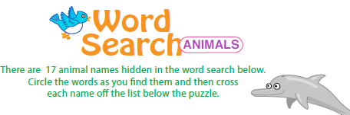

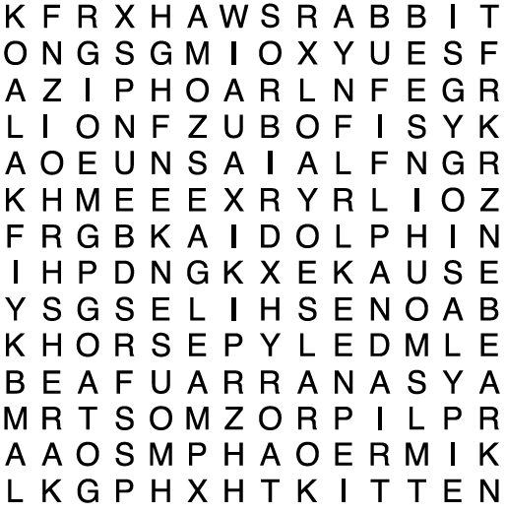

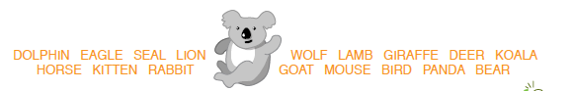

<Worksheet 2 Who am i?> Name: ………………

Who am I?

1) I am the king of the animals. _ _ _ _
2) My skin is grey; I´ve got a long trunk and big ears. _ _ _ _ _ _ _ _
3) I live in the sea. My teeth are very big. _ _ _ _
4) I live in the jungle, I love bananas. _ _ _ _ _ _ _ _ _ _
5) I am a dangerous wild cat with black stripes. _ _ _ _ _
6) My neck is very long; my body is yellow with brown spots.
_ _ _ _ _ _ _
7) I live in the desert, I´ve got one hump. _ _ _ _ _ _ _ _ _
8) I live in Australia. I carry my baby in a pouch. _ _ _ _ _ _ _ _
9) My skin is grey, I live in Africa, and there is a horn on my nose.
_ _ _ _ _ _ _ _ _
10) My fur is white; I live in the Arctic, I´m a _ _ _ _ _ bear
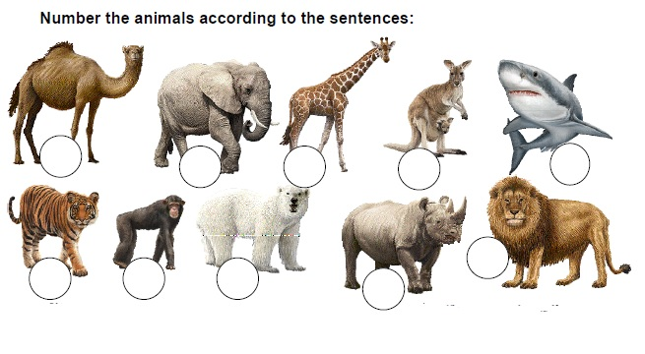

<Worksheet 3 Zoo Map >
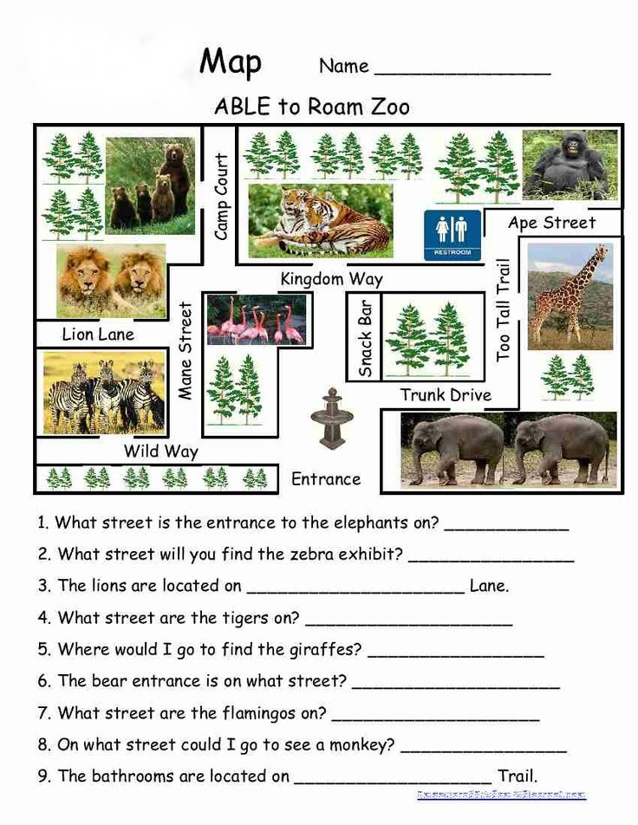

My favourite animal is…… Name: ………………

Draw animal

My favorite animal is .

This animal likes eat .

<Worksheet 1 Word Search>
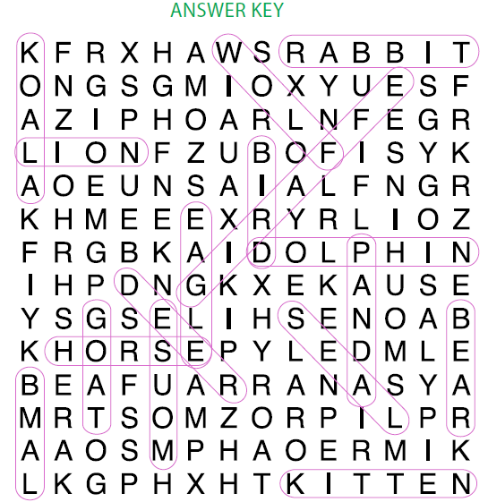

<Worksheet 2 Who am I?>
Answer:
1) lion 2) elephant 3) shark 4) chimpanzee 5) tiger 6) giraffe 7) dromedary 8) kangaroo
9) rhinoceros 10) polar bear
Correct numbers of the animals:7 – 2 – 6 – 8 – 3 /5 – 4 – 10 – 9 – 1

<Worksheet 3 Zoo Map>
Answer
- Trunk Drive 2)Wild Way 3)Lion Lane 4)Kingdom Way 5)Too Tall Trail 6)Camp Court
7) Kingdom Way 8)Ape Street 9) Too Tall

