Grammar Lesson Plan
TITLE | Quantifiers “ Some & Any ”
INSTRUCTOR |  |  |  | Ss’ LEVEL | AGE GROUP | No of Ss | LENGTH
Sanghee Kim |  |  |  | Intermediate | 6 | 12 | 50

MATERIALS

2 Worksheet about some & any, Pen or Pencil, Video
AIMS1. |  | Ss will be able to listen to conversation by watching story from the video.
2. |  | Ss will be able to read conversation’s dialog by reading worksheet.
3. |  | Ss will be able to practice “some & any” by doing worksheet.

LANGUAGE SKILLS
Listening |  |  | Listen to conversation when Ss watch the short story.
Speaking |  |  | Speech the sentences by reading conversation’s dialog from the worksheets
Reading |  |  | Read conversation’s dialog by reading worksheet
Writing |  |  | Write down the answers from worksheets questions.
LANGUAGE SYSTEMS
Lexis |  |  | Build up story’s vocabulary. (e.g. unhappy, clown)
Phonology |  |  | Compare “salt [sɔ:lt] and milk [mɪlk]”.
Grammar |  |  | Figure out meaning of some & any.
Discourse |  |  | Read conversation’s dialog by reading worksheet
Functions |  |  | Figure out meaning of some & any.

ASSUMPTIONS
Ss already know vocabularies from the dialog.
Part of Ss already learned some/any.

ANTICIPATED GRAMMATICAL ERRORS AND SOLUTIONS
If time is running out, shorten the Ss speech time.

REFERENCES

https://www.youtube.com/watch?v=q5I2aqkHfIk

NOTES

Plan B: If lots of Ss absent do watch more video about “some & any”

Cut-off: If Ss take long time to worksheets teacher can help
Sos: Puzzle maker word search
PRETASK TITLE |  |  | In the kitchen
AIMS |  |  |  | MATERIALS
Improve listening skill through watch video. |  |  |  | Video scene
TIME | SET UP | STUDENTS |  |  | TEACHER
3mins | Whole Class | Ss will listen to short conversation by watching from video scene. |  |  | Greeting & Ready video scene

NOTES

Make Ss comfortable during class.

Students suppose to listening carefully conversation.

TASK PREPARATION TITLE |  |  | Aha!
AIMS |  |  |  | MATERIALS
Improve reading skill through read dialog. |  |  |  | Worksheet (dialog)
TIME | SET UP | STUDENTS |  |  | TEACHER
10mins | Whole Class | Ss will read dialog by reading sentences from the worksheet. |  |  | Handout worksheet

NOTES
Get each Ss to write their name on the top

TASK REALISATION TITLE |  |  | Do we have any ~~~?
AIMS |  |  |  | MATERIALS
Improve grammar find the correct answer doing worksheet. |  |  |  | Worksheet about “some &any” , Pen or Pencil
TIME | SET UP | STUDENTS |  |  | TEACHER
10mins | Whole Class | Ss will talk about dialog and discuss different between “some and any”. |  |  | Observe
5mins | Whole Class | Ss will speech their opinions about between “some and any”. |  |  | Explain about quantifiers
10mins | Indivisible | Ss will find correct answer by doing worksheet. |  |  | Handout worksheet
5mins | Whole Class | Ss will speech answer “some and any” from the worksheet. |  |  | Giving answer

NOTES

If Ss difficult do worksheets teacher can help.

POST TASK TITLE |  |  | Make a stentence
AIMS  Improve writing skill by doing worksheet. |  |  |  | MATERIALS  Worksheet, Pen or Pencil
TIME | SET UP | STUDENTS |  |  | TEACHER
7mins | Whole class | Ss will make a sentence by using “some & any” |  |  | Explain instruction

NOTES
If Ss take long time to worksheets give for homework.

<Worksheet 1 In the kitchen >

Husband: Honey, we don’t have any sugar.

Wife: We have some sugar darling.
It’s in the cupboard.

Husband: Ah ok. Do we have any eggs?
I’d like to make some omelette.

Wife: There some eggs in fridge I think.

Husband: Is there any milk in the fridge?

Wife: No, there isn’t any milk at all.
We need buy some milk.

Husband: Ok, what about flower?
Do we have any flower?

Wife: Yes, we do.
We have some flower in the cupboard.
But we don’t have any salt and any oil too.

Husband: Ok I’ll go shopping and buy some oil, some salt and some milk. I won’t buy any eggs, any flowers and any sugar.

Wife: Thank you darling you always so helpful
That’s why I love you.

<Worksheet 2 which one? >
Name: ………………
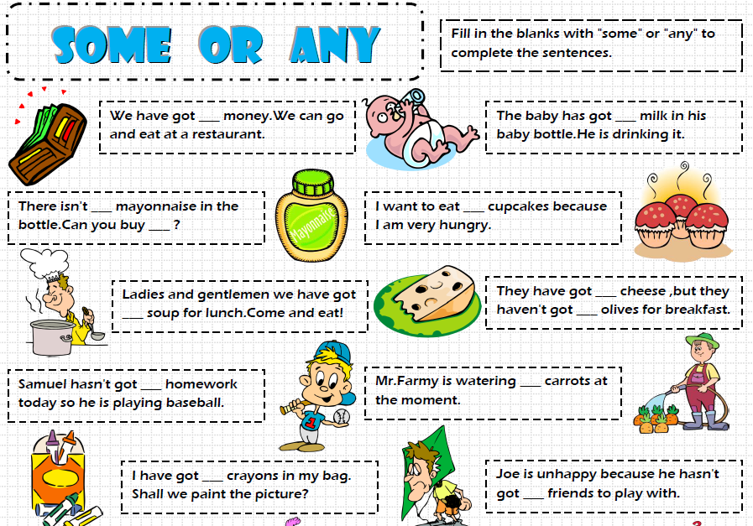
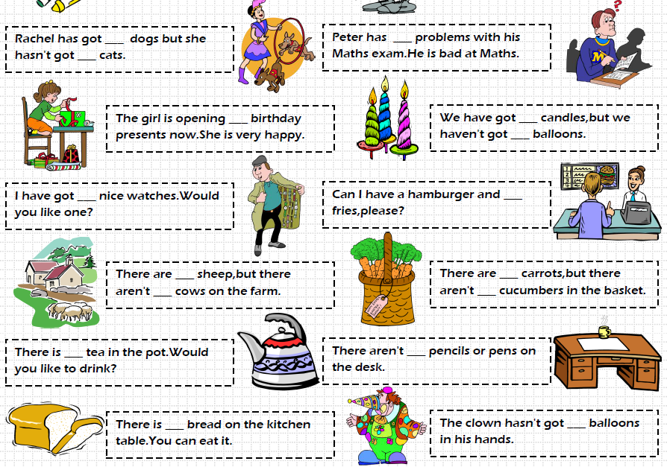

<Worksheet 3 Make a story >

Make a sentence using “some& any”

.

.

<Worksheet 2 which one? >
Answer:
