TITLE | Hungry Birds
INSTRUCTOR |  |  |  | Ss’ LEVEL | AGE GROUP | No of Ss | LENGTH
Eun Hye Lee (Grace) |  |  |  | Lower/Pre Intermediate | 10~11 | 8 | 50 Minutes

MATERIALS
- White board/board markers
- Audio/CD

Flash cards

Vocabulary worksheet (hand out) 8 copies
- Strip-story (2 sets - for 2 groups / should be cut)
- Make sentences worksheet (hand out) 8 copies
AIMS1. |  | Students will be learning new vocabularies through the listening.
2. |  | Students will practice the listening with ordering the story and complete the worksheets.
3. |  | Students will be able to understand the story in a right order and imagine the story.

LANGUAGE SKILLS
Listening |  |  | Students will listen to teacher’s explanations of new vocabularies, listen to the story, and listen to the other students talk.
Speaking |  |  | Students will answer the teacher’s questions and talk with team members.
Reading |  |  | Students will read the listening script.
Writing |  |  | Students will practice to make sentences (complete the worksheets).
LANGUAGE SYSTEMS
Phonology |  |  | Monitoring the students speak, say the word “mouth” /θ/, “mouths” /z/ sounds carefully
Lexis |  |  | Vocabularies with singular and plural forms (worm-worms, mouth-mouths)
Grammar |  |  | Simple past tense – verb form (sat, went, gave)
Discourse |  |  | A short story about the mommy bird and baby birds
Functions |  |  | A short story (Storytelling)

ASSUMPTIONS

- The students already know teacher’s teaching style.

- The students already know verb form (simple past tense)

ANTICIPATED GRAMMATICAL ERRORS AND SOLUTIONS
- Some students might difficult to say /z/ sounds mouths, birds, and worms
- Monitoring the students and correct them when and make students practice the words
- Some students might make errors to say the verb in the past tense verb
- Give a clue using the CCQ

REFERENCES

- Hungry birds story: http://www.rong-chang.com/children/kid/kid_008.htm
- Pictures: www.clipartpanda.com / www.naturesfootprint.com

NOTES

Plan B: If the audio doesn't work, techer can read the story.

Cut-off plan: If there isn't enough time to complete the second worksheet, the worksheet can be home work.

SOS activity : Students can draw the pictures about the story

PRETASK TITLE |  |  | - Warmers / new vocabularies
AIMS |  |  |  | MATERIALS
Students will be able to understand the vocabularies.  Students will complete the worksheet |  |  |  | A white board / board markers  Flash cards  Vocabulary worksheet
TIME | SET UP | STUDENTS |  |  | TEACHER
4 min | Whole class | Students will listen the teacher’s explanations of new vocabularies and answer the questions |  |  | Give students concept checking questions (CCQ) / show the flash cards
4 min | Individual | Students will complete the worksheet |  |  | Monitoring students do worksheet
4 min | Groups | Students will discuss and correct the worksheet as groups |  |  | Monitoring each groups work and give a clue if needed

NOTES

Students already learned the verbs forms of the simple past tense. However, go over the verb form of simple past tense.

TASK PREPARATION TITLE |  |  | - Guiding questions / Eliciting
AIMS |  |  |  | MATERIALS
Students will think and guess the story with the guiding questions. |  |  |  | - A white board / board makers
TIME | SET UP | STUDENTS |  |  | TEACHER
4 min | Whole class | Students will answer the questions  Q1. What does the bird eat?  Q2. Where does the bird live?  Q3. Can the baby bird fly? |  |  | Ask students the guiding questions before they listen to the story.

NOTES

If need more questions, can add more questions.

TASK REALISATION TITLE |  |  | - listen to the story and do strip-story
AIMS |  |  |  | MATERIALS
- Students will listen to the story and answer the comprehension questions  - Students will do strip-story |  |  |  | Computer / Audio  A white board / board makers  2 sets of Strip-story
TIME | SET UP | STUDENTS |  |  | TEACHER
10 min | Individual/  Group | Students will listen to the story and discuss about the answers that teacher asks  (Literal)  Q1. Where were the baby birds?  Q2. What did the mommy birds bring?  (Interpretive)  Q3. Did the baby birds want to eat more worms?  (Applied)  Q1. If you were a mommy bird what would you like to bring to the baby birds? |  |  | - Make students listen to the story carefully  - Ask students comprehension questions  - Monitoring students when they talk in a group  - Give clues if they need
10 min | Group | - Students will listen to the story again  - Students will make the story in a right order  - After complete the ordering sentence strips each team member read the strips. |  |  | Hand out the strip-story technique  Monitoring each group

NOTES

There are 8 students in the class, so usually divided students into two groups.

POST TASK TITLE |  |  | Making new sentences / Worksheet
AIMS |  |  |  | MATERIALS
Students will practice making new sentences and write the sentences in a right order |  |  |  | A white board / board markers  Worksheet
TIME | SET UP | STUDENTS |  |  | TEACHER
5 min | Individual | Students will make sentences / complete the worksheet |  |  | Monitoring students / give clues if students need
5 min | Group | Students will discuss and correct the worksheet as groups |  |  | Monitoring students / give clues if students need
4 min | Whole class | Students will review about the lesson |  |  | Review shortly

NOTES

If the time limited, students can complete the worksheet at home.

Story script
Title: Hungry Birds

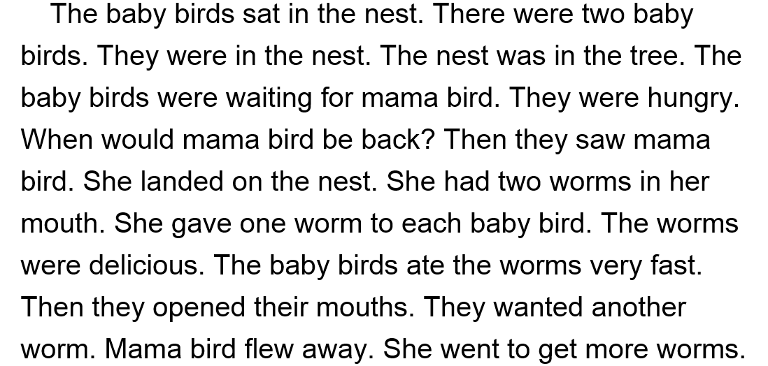

Flash cards
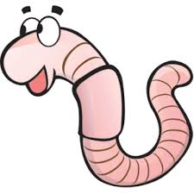www.naturesfootprint.com

worm

nest
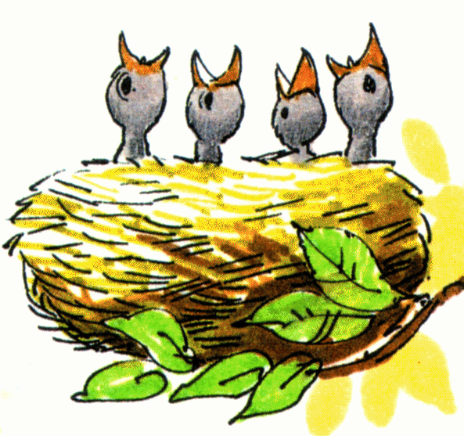www.clipartpanda.com

went

go

sat

sit

was

is / am

flew

fly

had

has / have

ate

eat

saw

see

were

are

Vocabulary worksheet #1

* Match the word with the right picture

worm | nest

* Write the simple past tense verb

went | sat | was | flew
had | ate | saw | were

- go - 2. have / has -

- eat - 4. sit -

- are - 6. am / is -

- fly - 8. see -

Strip-story

The baby birds sat in the nest. There were two baby birds. They were in the nest.
The nest was in the tree. The baby birds were waiting for mama bird. They were hungry.
When would mama bird be back? Then they saw mama bird. She landed on the nest.
She had two worms in her mouth. She gave one worm to each baby bird. The worms were delicious.
The baby birds ate the worms very fast. Then they opened their mouths. They wanted another worm.
Mama bird flew away. She went to get more worms.

Making sentences Worksheet #2

* Write short sentences using the given words

hungry | waiting for | gave | ate | very fast

2.

3.

* Complete the sentences correctly

- waiting, the baby birds, mama bird, for

- wanted, worm, another, they

- flew, bird, mama, away

