TITLE | Parts of the Body
INSTRUCTOR |  |  |  | Ss’ LEVEL | AGE GROUP | No of Ss | LENGTH
Ryan |  |  |  | Beginner / Lower intermediate | 10 | 8 | 45min

MATERIALS

White board, Board marker, Flash cards, PC, Speaker, Audio File(song), Worksheet
AIMS 1. |  | Students will improve listening skills through listening the words.
2. |  | Students will practice listening carefully with action.
3. |  | Students will understand with fill out the worksheet.

LANGUAGE SKILLS
Listening |  |  | Students will be listening to Audio file and teacher’s talk.
Speaking |  |  | Students will sing a song “Head, Shoulders, Knees & Toes”
Reading |  |  | Students will read the lyrics “Head, Shoulders, Knees & Toes”
Writing |  |  | Students will be filling out the worksheet with teacher’s talk.
LANGUAGE SYSTEMS
Phonology |  |  | Students will focus on sound of words
Lexis |  |  | Students will focus on spelling of words
Grammar |  |  | Students will understand grammar (singular/plural) with sing a song.
Discourse |  |  | Students will understand the story with sing a song and following teacher.
Functions |  |  | Students will know and understand their parts of body.

ASSUMPTIONS

Students already know the words and meaning “left and right”.

ANTICIPATED GRAMMATICAL ERRORS AND SOLUTIONS
Students will confuse to spell of ‘shoulder, eye, knee and so on.

REFERENCES

http://www.eslkidstuff.com/esl-kids-lesson-plans.html

NOTES

PCs doesn’t work, teacher sing a song. / Flash cards doesn’t ready, teacher show his/her body parts to students.

PRETASK TITLE |  |  | Check Voca
AIMS |  |  |  | MATERIALS
Students will notice new words of body parts with flash cards. |  |  |  | Flash cards (mouth, ear, hair, nose, eye, hand, leg, head, shoulder, knee, arm, chest, foot)
TIME | SET UP | STUDENTS |  |  | TEACHER
7 min | Whole class | Watch flash cards with teacher’s voice and then, they guess the spell of words. |  |  | Show flashcards and speak slowly the words.

NOTES

Repeat the words several times. If all students already knew the word, just check lightly.

TASK PREPARATION TITLE |  |  | “Head, Shoulders, Knees & Toes” 1
AIMS |  |  |  | MATERIALS
Students will understand words by listening carefully. |  |  |  | Audio file(song), Lyric of “Head, Shoulders, Knees & Toes”
TIME | SET UP | STUDENTS |  |  | TEACHER
6 min | Whole class | Listening and sing the song “Head, Shoulders, Knees & Toes” with following teacher’s action.  Repeat three or more times to familiar with activity. |  |  | Turn the audio file and show the motion(touch body following the song)

NOTES

Repeat the words several times. Do the motion first slow and gradually fast.

TASK REALISATION TITLE |  |  | “Head, Shoulders, Knees & Toes” 2 / Opposite expression
AIMS |  |  |  | MATERIALS

Students will apply what they listen the words and motions.
TIME | SET UP | STUDENTS |  |  | TEACHER
12 min | 2 groups | Apply the words that students learned or known to the song.  Each member of groups leads other students in their group once.  All member follow one student’s motion with sing a song.  Sing a song slowly to follow other students can. |  |  | Show how to play to apply words  Make two groups  Coach the students
13 min | whole class | Do opposite motion with teacher’s talk and motion.  Someone who incorrect the motion or follow same motion, he/she moves to front side and give talk and motion. |  |  | Give a motions words to students.  Give instructions to do themselves.

NOTES

Enter any useful information or comments which might help another teacher to teach this class from this lesson plan

POST TASK TITLE |  |  | Fill out Worksheet.
AIMS |  |  |  | MATERIALS
Students will understand body parts with filling out worksheet. |  |  |  | Work sheet
TIME | SET UP | STUDENTS |  |  | TEACHER
7 min | Whole class | Students fill out the work sheet following teacher’s talk. |  |  | Hand out the work sheet  Talk the words to students.  Check the students fill out work sheet correctly.

NOTES

If the time is limited to do it, give it homework.

Flash cards
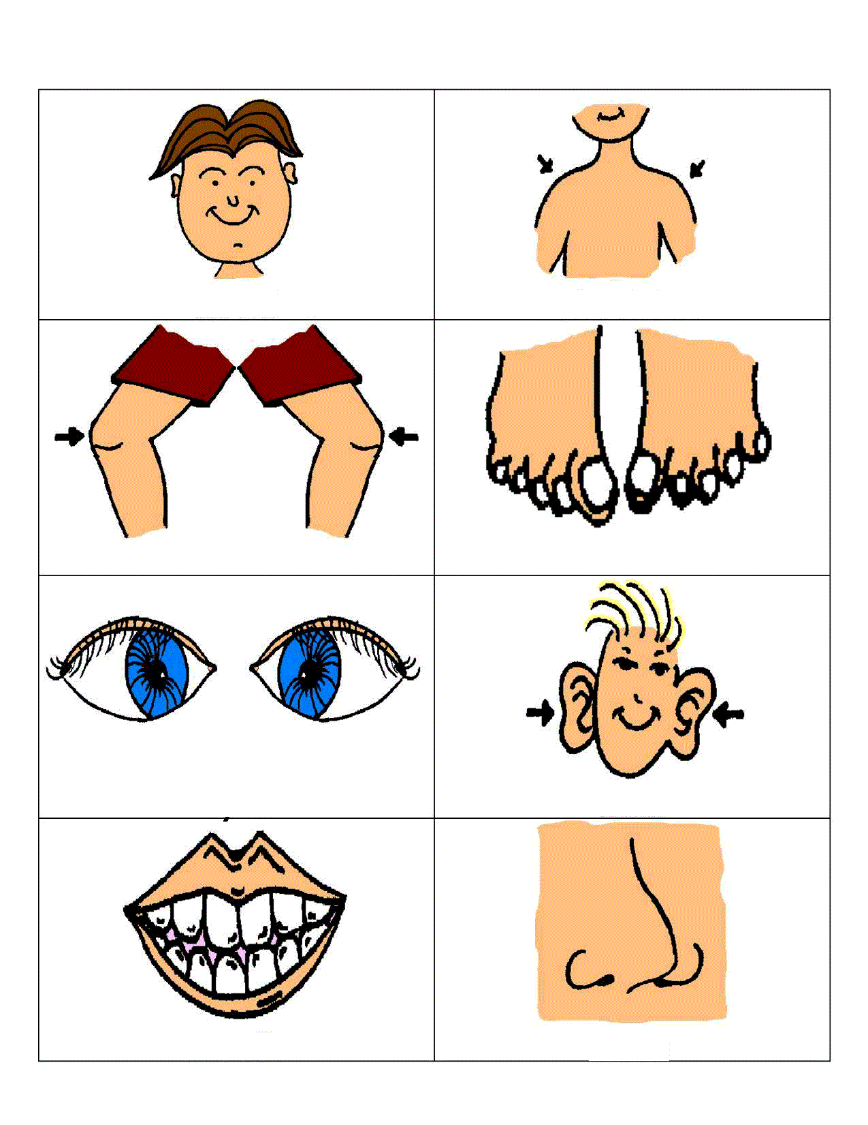

Work sheet
