Listening Lesson Plan
FAST FOOD

Length: 50 minutes
Students: 9
Level: Beginner
Instructor:
Amy (Song Ji Min)

Materials:
- Video clip
- Listening script handout, answer sheet
- vocabulary worksheet #1, fill in the blanks worksheet #2, Questions worksheet #3
- Board and markers
- Computer, Project beam, Pictures about fast food

Aims:
- SWBAT learn and practice their listening and vocabulary skills by working on their worksheets and watching a video clip.
- SWBAT practice their writing skill through a fill in the blank activity.
- SWBAT practice their speaking skill when they discuss their own opinions about the topic.
- SWBAT practice listening skills by watching video

Language Skills:
- Reading: vocabulary and worksheet
- Writing: fill in the blank worksheets and questions worksheets
- Listening: listening to teacher’s instructions, discussing with classmates
- Speaking: Sharing their opinions in pairs or groups

Language Systems:
- Phonology: Listen to teacher and classmates speaking
- Function: Fill in the blank, sharing opinions with classmates
- Lexis: Key vocabulary
- Grammar: Correct their answers & worksheets
- Discourse: Expressing opinions

Assumptions:
Students already know:
- How the class is set up and run
- The teacher’s style of teaching and the pace of the course
- Most students have eaten FAST FOOD

Anticipated Errors and Solutions:
- Students might need more time to work on the fill in the blank worksheet
-> If it takes longer than 5 minutes, give the students the listening script
- Some students might not be able to understand the dialogue of the video
-> Listen two times and if students still can't understand read the script together
-What if the video is not working
-> Prepare a video file on your smart phone to play

References:
http://www.englishblog.com/2015/06/animated-english-fast-food.html
http://www.esldiscussions.com/j/junk_food.html

Lead-In

Materials: Board, Markers, Pictures
Time  3 min  5 min | Set Up  whole class  whole class | Procedure:  <Greeting>  “Hello everyone. How are you today?  What did you have for lunch?  I had hamburger and French fries.  <Eliciting and Prediction>  T Show Ss pictures and T posts the pictures on the whiteboard to elicit the topic  T elicits from the Ss by asking questions about FAST FOOD.  First, Please take a look at the pictures  What do you see in this picture?  Do you like fast food?  If so, Why?  How often do you eat hamburgers?  (Each Ss should have chance to answer the questions)  Ok. Today we are going to learn about FAST FOOD.  T writes the topic on the whiteboard.

Pre-Activity
Materials: Vocabulary worksheet # 1
Time  7 min  5min | Set Up  whole class  Groups |  | Procedure:  T distributes the fill in the blank worksheets.  Ss fill in the blanks on the worksheet using words from  the box.  <Instruction>  We are going to fill in the blanks. I will give 7 minutes.  After you finish, you will check the answers you’re your partner.  <Demonstration>  Look at the paper. If you have any vocabulary questions, ask the teacher. For example, “ take out “ means talking quietly.  <ICQ>  How much time do you have? (7 min)  Do you work in pairs or alone? (alone)  Let’s start!!  Time’s up!!  <Monitoring>  Ss check and share the answers with their partner.  T corrects it if the answer is wrong.  Let’s check and share the answers with your partner.  <CCQ>  Do you understand the meaning of the word? (yes)  What did you write in the blanks?  (FAST FOOD key vocabulary)  Good job!!
Main Activity
Materials: Video clip, computer, projector beam, worksheet #2 (fill in the blank of listening)
Time  2min  5min  2min  2min  5min  5min |  | Set Up  Whole  Class  Whole  Class  Whole  Class  Whole  Class  Whole  Class  Individually | Procedure:  <Instruction>  I will show a simple video once by using a beam projector.  We are going to see a short video for 5 minutes.  First, You will watch the video and listen to the dialogue.  Listen carefully and try to memorize situation.  <ICQ>  How much time do you have? (5min)  How many times do you watch the video?(once)  Are you ready?  Let’s watch the video!!  ( Ss watch and listen to the dialogue )  Time’s up!!  <Elicit>  T asks three Wh-questions.  Ss try to guess what is the dialogue situation.  Where are they? (In a fast food restaurant)  What did customer order?  ( A double cheeseburger with fries and a large Coke or  hamburger set)  What are they talking about?  (what to eat and the cost )  (Ss answer the elicited questions.)  <Monitoring>  I will show you again speech bubble version of the video.  Check the elicited questions and answers while watching to video.  T explains the answers.  They are in a fast food restaurant.  And customer ordered a double burger with fries a large Coke.  <Listening comprehension>  Activity 1 – Listen & Repeat  <Instruction>  Now, we will watch the video again.  Please listen carefully and repeat the dialogue this time.  Ss repeat the dialogue and practice speaking skills.  Activity 2 – Listen & Understand  <Instruction>  I will give you a listening worksheet.  We will listen to a dialogue.  I will give you 5 minutes. Please fill in the blanks on the worksheet while listening to the dialogue.  Please listen carefully.  Ss listen to the whole dialogue and fill in the blanks of the worksheet.  <ICQ>  How much time do you have? (5min)  Are you working in pairs? (No)  Time’s up!!  <Monitoring>  T monitors Ss directly while the students are checking the answers.  After doing the worksheet. (worksheet # 2)  T hands out the answer sheet.  Ss will check the answer while looking at the answer sheet.  I will hand out the answer sheets. Please check your worksheet.
Post Activity
Materials: Worksheet #3
Time  5min  2min  2min |  | Set Up  4 groups  Whole  Class  Whole  class | Write for questions and Discuss  T hands out the worksheet to the students.  Ss make 4 groups.  Ss discuss about JUNK FOOD with their partner.  <Instruction>  Now, Time to discuss .  I will give you question worksheet.  There are 2 parts in the worksheet- Student A and Student B.  Choose A or B and write answers by yourself.  After finishing the questions, please discuss the questions with your partner.  Let’s make 4 groups.  Look at the worksheet.  You think and write own opinions about the questions on your worksheet paper. I will give you10 minutes.  <ICQ>  Do you have to choose one part? (yes)  How much time do you have? (10min)  <Monitoring>  T monitors directly. If they ask something T answers their questions.  Time’s up!!!  How was the discussion? Is that fun?  (Ss will say answer)  Give homework  T gives homework about today’s lesson.  T hands out homework sheet.  I will give you homework.  Please prepare your homework and we will have a presentation about your homework.  We will give each other feedback.  Closing & Feedback  Class is over! What did you learn today?  We learned about FAST FOOD.  Did you enjoy our topic today?  Thanks for listening. Have a lovely day!!  Bye!!

Dialogue video file
http://www.englishblog.com/2015/06/animated-english-fast-food.html
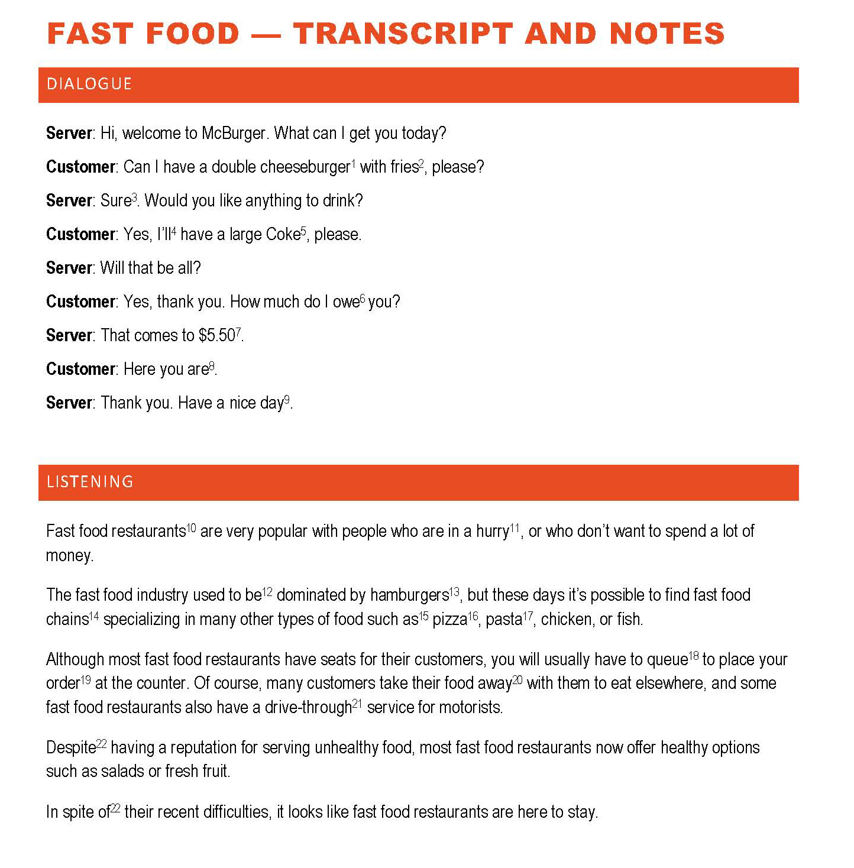
Vocabulary Worksheet # 1

Choose the matching words from the box and fill in the blanks

Cheeseburger , Double cheeseburger, Burger, French fries,
chips, Sure, I’ll have, Coke, Owe, $5.50, Here you are,
Have a nice day, Fast food restaurants, In a hurry, Used to, Hamburger, Chain, Such as, Pizza, Pasta, Queue, order, takeaway, takeout, Drive-thru, Despite, in spite of

1. A cheeseburger is a hamburger topped with a slice of cheese. A double cheeseburger has two patties of meat. Burger is short for hamburger, which, despite the name, is not made with ham but beef.
2. Fries are French fries (=long thin pieces of potato cooked in hot oil).
In Britain, they are often called chips.
3. Sure is used for saying yes or for agreeing to something: ‘Can I borrow the car?’
‘Sure, no problem.’
4. I’ll have (a contraction of ‘I will have’) is an expression used when ordering food or drink: I’ll have the fish.
5. Coca-Cola is often referred to as Coke: I’d like a Diet Coke, please.
6. If you owe someone money, you have to give them a particular amount of money because you have bought something from them or have borrowed money from them: John still owes me £10 for that meal.
7. $5.50 can be said in different ways: five dollars and fifty cents, five dollars fifty, or just five fifty.
8. Here you are is an expression used when giving something to someone.
9. Have a nice day is an expression often used by American service employees at the end of a transaction. The phrase is not generally used in Europe, as some find it artificial or even offensive.
10. Fast food restaurants are typically part of a restaurant chain or franchise operation.
11. If you are in a hurry, you need to go somewhere or do something quickly. Note that ‘hurry’ is a noun here—you cannot say ‘We are very hurry’. However, ‘hurry’ can be a verb: We have to hurry, or we’ll miss the bus.
12. Used to [ˈjuːst tuː] is used to talk about something that happened regularly in the past, but does not happen now: I used to play golf at the weekend, but I don’t have time for it now.
13. The term hamburger originally comes from Hamburg, Germany's second largest city.
14. A chain is a group of businesses such as shops, hotels, or restaurants that all belong to the same person or company: Ibis is a French hotel chain.
15. Such as is a phrase used to introduce examples of the thing just mentioned: He likes watching team sports such as football and cricket.
16. Pizza is one of those words (like ‘cake’ and ‘beer’) which can be countable or uncountable depending on the meaning: I ate too much pizza (U) last night. I ate six pizzas (C) last week.
17. Pasta is always uncountable: Ravioli and spaghetti are types of pasta. Pasta is my favourite dish.
18. Queue can be a verb or noun: The queue was too long. The English love to queue. Americans use ‘line’ and ‘wait in line’: We had to wait in line to pay.
19. Order can be a verb or noun: Are you ready to order (v.)? May I take your order (n.)?
20. A takeaway is a meal that you buy in a restaurant or shop and take home to eat. The American word is takeout. The word ‘takeaway’ can also be used to refer to the restaurant itself: There’s a good Chinese takeaway near where I live.
21. In American English the spelling is drive-thru.
22. Despite and In spite of mean the same thing and can be followed by a noun or gerund — never by an infinitive or a verb clause: Despite their recent difficulties … In spite of having problems … but not Despite they have…

Fill in the blanks Worksheet # 2
(Listen & Understand)

are very popular with people who are , or who don’t want to spend a lot of money.
The fast food industry be dominated by , but these days it’s possible to find fast food specializing in many other types of food , , chicken, or fish.
Although most fast food restaurants have seats for their customers, you will usually have to to place your at the counter. Of course, many customers take their food with them to eat elsewhere, and some fast food restaurants also have a r service for motorists.
having a reputation for serving unhealthy food, most fast food restaurants now offer healthy options such as salads or fresh fruit.
their recent difficulties, it looks like fast food restaurants are here to stay

Worksheet # 3

(Write the answers and Discuss with partner)

STUDENT AQUESTIONS (Do not show to Student B)

1) | How often do you eat junk food
2) | What is it about junk food that is so bad for us?
4) | Is the junk food from your country tastier than the junk food from other countries?
5) | How can you change your lifestyle to eat less junk food?

STUDENT BQUESTIONS (Do not show to Student A)

1) | Do lots of people eat junk food in your country?
2) | What do you think of people who eat mostly junk food?
3) | Does junk food or good quality healthy food make you happier?
4) | If you had to choose between a strict vegetarian diet forever or a junk food diet forever, which would you choose?
5) | Why does junk food cost so much?

Homework

- MAGAZINE ARTICLE :
Write a magazine article about fast food. Read what you wrote to your classmates in the next lesson. Give each other feedback on your article.

- FAST FOOD POSTER :
Make a poster about fast food. Show it to your classmates in the next lesson. Give each other feedback on your poster.

