Speaking Lesson Plan
TITLE | Put on your shoes!
INSTRUCTOR |  |  |  | Ss’ LEVEL | AGE GROUP | No of Ss | LENGTH
Eun Hye Lee (Grace) |  |  |  | Elementary | 8 | 6 | 50 Minutes

MATERIALS
- White board/board markers
- Audio/CD/Computer

Flash cards

“Put on your shoes” Vocabulary – Worksheet #1 (hand out) 7 copies (+1 Extra)
- “Put on your shoes” Vocabulary Review – Worksheet #2 (hand out) 7 copies (+1 Extra)
AIMS1. |  | Students will study new vocabularies.
2. |  | Students will practice speaking sentences from the song.
3. |  | Students will practice “put on your + noun (clothing: shoes, jacket, scarf, hat)” through the song

LANGUAGE SKILLS
Listening |  |  | Students will listen to teacher’s explanations of new vocabularies and listen to the song.
Speaking |  |  | Students will answer the teacher’s questions and sing a song.
Reading |  |  | Students will read the worksheets.
Writing |  |  | Students will write the vocabularies (complete the worksheets).
LANGUAGE SYSTEMS
Phonology |  |  | Monitoring the students speak, say the word “shoes” /z/ and “Let’s” sounds carefully
Lexis |  |  | Vocabularies with pair (shoe-shoes)
Grammar |  |  | Put on your + noun (clothing: shoes, jacket, scarf, hat)
Discourse |  |  | A song about the parents and a boy
Functions |  |  | Give instructions (commands) to put on the shoes (clothing) before go out

ASSUMPTIONS

- The students already know each other.

- The students already know when teacher is dancing (acting), should follow the teacher.
- The students already know how to read and “go outside” means.

ANTICIPATED GRAMMATICAL ERRORS AND SOLUTIONS
- Some students might make errors to say put on and hurry up
- Monitoring the students and correct them when and make students practice the words
- Some students might difficult say the word “shoes”
- Monitoring the students and make students say the word correctly.

REFERENCES

- Song: http://www.songlyrics.com/super-simple-learning/put-on-your-shoes-lyrics/

http://supersimplelearning.com/songs/original-series/one/put-on-your-shoes/

- Flash card: http://www.kizclub.com/Flashcard/Clothing/clothing(C).pdf
http://supersimplelearning.com/resource-center/wp-content/plugins/s2member- files/put-on-your-shoes-flashcards.pdf
- Pictures: www.clipartpanda.com, http://3.bp.blogspot.com/
- Worksheets: http://blog.naver.com/hera0505/220269406053

NOTES

Plan B: If the audio doesn't work, techer can sing a song (song lyrics attached). Also, if the teacher has the smart phone, techer can find the song(Put on your jacket) on the YouTube website.

Cut-off plan: If there isn't enough time to practice the sentence “Put on ~” with new clothing vocabularies in pairs can skip the part. (Post-task)

SOS activity :

Students can play the actions game.

One student stand in front of the other students, show the actions (put on your jacket), the other students say the sentence.
- Role play
- Make students into 4 roles Dad, Mom, sister, and a boy (each role can do 2 or 3 students together)-All students can do it together at the same time.
- They can act and sing a song together.

PRETASK TITLE |  |  | - Warmers / “Put on your shoes” Vocabulary – Worksheet #1
AIMS |  |  |  | MATERIALS
Students will be able to understand the vocabularies.  Students will complete the “Put on your shoes” Vocabulary – Worksheet #1 |  |  |  | A white board / board markers  Flash cards  “Put on your shoes” Vocabulary – Worksheet #1
TIME | SET UP | STUDENTS |  |  | TEACHER
4 min | Whole class | Students will listen the teacher’s explanations of new vocabularies and answer the questions  Q1. How is the weather in Winter?  Q2. What do you need to put on (wear) when you go outside? |  |  | Give students concept checking questions (CCQ) / show the flash cards
3 min | Whole class | Students will learn new clothes words(shoes, jacket, scarf, hat) and phrases (put on, hurry up) |  |  | Show the students flash cards  If the students have a difficulty to speak the words make them practice
4 min | Individual/  Whole class | Students will complete the “Put on your shoes” Vocabulary – Worksheet #1 |  |  | Monitoring students complete their worksheet

NOTES

When they learn new vocabularies, show the flash card.

TASK PREPARATION TITLE |  |  | - Guiding questions / Eliciting
AIMS |  |  |  | MATERIALS
Students will think and guess the song with the guiding questions. |  |  |  | - A white board / board makers
TIME | SET UP | STUDENTS |  |  | TEACHER
4 min | Whole class | Students will listen to the teacher’s instructions about the lesson.  Students will answer the questions.  Q1. What is the song about?  Q2. Do we dance when we sing a song? |  |  | Explain about the song  Ask questions(ICQ)to check they understood well

NOTES

If need more questions, can add more questions.

TASK REALISATION TITLE |  |  | - Listen to the song or watch video clip and sing a song and dancing
AIMS |  |  |  | MATERIALS
- Students will listen to the song or watch the video clip  - Students will sing a song and dancing |  |  |  | Computer / Audio / Video clip  A white board / board makers
TIME | SET UP | STUDENTS |  |  | TEACHER
5 min | Whole class | Students will listen or watch the video clip and answer the questions  Q1. Who do you see?  Q2. What do you need to put on before you go out? |  |  | - Make students listen to the song carefully  - Ask students questions about the song (ask them in a present form questions)
10 min | Whole class | Students will follow the teacher. They will sing and dance. |  |  | -sing a song and dance with students
10 min | Whole class | Students will sing a song and dance with music. |  |  | -Turn on the music and sing a song with students

NOTES

Make the students come out and make circle

If some students are shy to dance, teacher needs to encourage the students.

POST TASK TITLE |  |  | Studying extra clothing vocabularies and assigned the “Put on your shoes” Vocabulary Review – Worksheet #2 as homework
AIMS |  |  |  | MATERIALS
Students will study new clothing words and practice to say the sentence “Put on~” |  |  |  | A white board / board markers  Extra vocabulary flash card  “Put on your shoes” Vocabulary Review – Worksheet #2 (Homework)
TIME | SET UP | STUDENTS |  |  | TEACHER
4 min | Whole class | Students will study extra clothing vocabularies |  |  | Show the Flash card of clothing vocabularies
4 min | Pairs/  Whole class | Students will practice the sentence “Put on ~” with new clothing vocabularies in pairs |  |  | Monitoring students / give clues if students need
2 min | Individual | Students will have “Put on your shoes” Vocabulary Review – Worksheet #2 as homework and answer the teacher’s questions.  Q1. What do you need to do you need to do on the each pictures?  Q2. What do you need to write in the box? |  |  | Give the homework (worksheet#2) and give instructions about the homework (ICQ)

NOTES

-If the time limited, students do not need to practice the sentences with new vocabularies in pairs.
-If the time left, teacher can show the flash card to each student and make them say the vocabulary.

“Put on your Shoes” song lyrics
♫ Put on your shoes, your shoes, your shoes. [Gesture putting on your shoes.]
Put on your shoes, your shoes, your shoes.
Put on your shoes.
Let's go outside. [Point outside the window.]
Hurry up. Hurry up. Hurry hurry up! [Make a "come on...let's go" gesture and then everybody runs around the room in a circle.]
Put on your jacket, your jacket, your jacket. [Gesture pulling a jacket over your shoulders as if it were cold.]
Put on your jacket, your jacket, your jacket.
Put on your jacket.
Let's go outside.
Hurry up. Hurry up. Hurry hurry up!
Put on your scarf, your scarf, your scarf. [Gesture putting on your scarf.]
Put on your scarf, your scarf, your scarf.
Put on your scarf.
Let's go outside.
Hurry up. Hurry up. Hurry hurry up!
Put on your hat, your hat, your hat. [Gesture putting on your hat.]
Put on your hat, your hat, your hat.
Put on your hat.
Let's go outside.
Hurry up. Hurry up. Hurry hurry up!
Put on your shoes. [Gesture putting on your shoes.]
Your jacket. [Gesture putting on your jacket.]
Your scarf. [Gesture putting on your scarf.]
And your hat. [Gesture putting on your hat.]
Hurry up. Hurry up. Hurry hurry up! ♫

“Put on your shoes” Flash cards

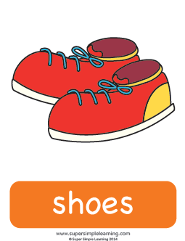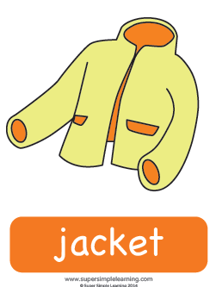

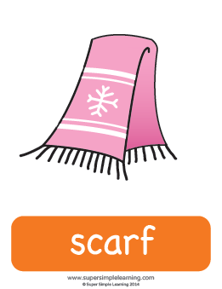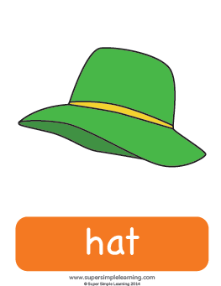

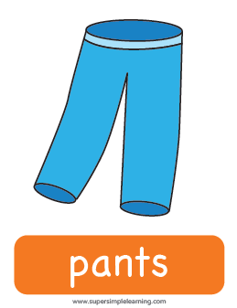

hurry up

put on

Extra clothing Flash card
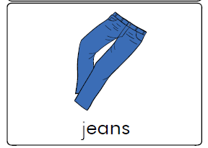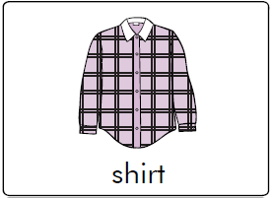

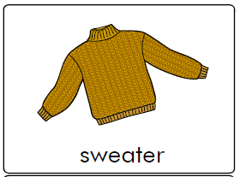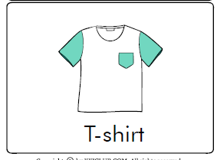

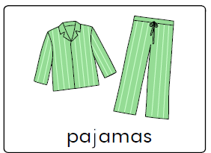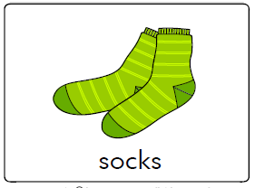

“Put on your shoes” Vocabulary – Worksheet #1

- Match the picture with the right word.

“Put on your shoes” Vocabulary Review – Worksheet #2

- Draw and write the word.

hat, scarf, jacket, shoes

