Speaking Lesson Plan
TITLE | The shape
INSTRUCTOR |  |  |  | Ss’ LEVEL | AGE GROUP | No of Ss | LENGTH
Hye in kim (Helen) |  |  |  | Beginners | 8 | 6 | 50 min

MATERIALS

Cd, Cd player, Stick board, the shapes puzzle, shapes name cards, “This is” “I like” cards and pictures of shapes on dice, colored pencils, white shapes worksheets(6copies) and colored shapes worksheet
And writing shapes name worksheet(6copies)

AIMS 1. |  | Ss will be able to practice the differences of shapes and speaking a sentence with the shapes by rolling a dice activity
2. |  | Ss will study the shapes’ name by singing the shapes song
3. |  | Ss will be able to speak the shapes by find right pieces of shapes

LANGUAGE SKILLS
Listening |  |  | Hello song, shape song, T’s instruction.
Speaking |  |  | Rolling a dice and make a sentence and find right pieces of shapes, shape song
Reading |  |  | This is shapes name cards
Writing |  |  | Coloring the shapes
LANGUAGE SYSTEMS
Phonology |  |  | Correct pronunciation of the shapes
Lexis |  |  | Circle, triangle, square, heart
Grammar |  |  | Simple present tense
Discourse |  |  | Shapes song, rolling a dice of the shapes, coloring the shapes
Functions |  |  | Singing, speaking, and seeking the shapes

ASSUMPTIONS

Ss know the colors and name of classroom objects

ANTICIPATED GRAMMATICAL ERRORS AND SOLUTIONS

When Cd player is not working, T should sing the song by herself

REFERENCES

Enter key references here for sources of the ideas and materials you used to plan this lesson

NOTES

Let Ss discuss what objects they can find for each shapes.

PRETASK TITLE |  |  | Hello and introduce the shapes with the song
AIMS |  |  |  | MATERIALS
Ss will practice to speak the shapes’ name by song |  |  |  | Cd, Cd player
TIME | SET UP | STUDENTS |  |  | TEACHER
3min | wholeclass | Students listen and sing the hello song and the shapes song |  |  | Play the music and sing with students
3min | wholeclass | Answer the class objects name and the shape |  |  | Ask students what shapes in the classroom

NOTES

Hello song

“ Hello, Hello, How are you? Hello Hello, Peekaboo
Ann and Sera Hello peekaboo
Hello, Hello, How are you? Hello Hello peekaboo.”

The shapes song
“동그라미 circle, 세모는 triangle, 네모는 square, 사랑해요 heart”

TASK PREPARATION TITLE |  |  | The puzzle of shapes
AIMS |  |  |  | MATERIALS
Ss will study the shapes by find right pieces and able to practice the name by read and speak the name of the shapes |  |  |  | Stick board, the shapes puzzle, shapes name cards
TIME | SET UP | STUDENTS |  |  | TEACHER
2 min | Whole class | Students listen what T’ speaks and speak the name of the shapes when T point it and ask it |  |  | T tells Ss the name of shapes when she pointing it for 3 times and asks Ss the shapes name
7 min | individual | Ss try to find right pieces of the shapes |  |  | Call each Ss at front and help them to find right pieces

NOTES

If Ss struggle to find the right pieces, give a hint

TASK REALISATION TITLE |  |  | Roll dice
AIMS |  |  |  | MATERIALS
Ss will be able to practice simple present tense with the shape |  |  |  | “This is” “I like” cards and pictures of shapes on dice  Stick board
TIME | SET UP | STUDENTS |  |  | TEACHER
1min | Whole class | Ss listen to T’s instruction |  |  | T explain how to do this activity (notes)
17 min | individual | Ss picks cards from a back and roll a dice. Whatever cards and shape came out, Ss makes a sentence. Answer the Ss |  |  | T hold the bag and stick the card that Ss pick and after Ss roll a dice stick the shpae on the board. help Ss make a sentence with the card and shape. Ask classmates do they know other way to say it. ask where the shape can be found

NOTES

Ss picks cards from a back and roll a dice. Whatever cards and shape came out, Ss makes a sentence. Ex) “I like” card and heart shape “I like heart” and ask Ss where heart can be found. Ex) point the chest, say “ mother and father” “love”…etc

POST TASK TITLE |  |  | Color the shape with correct colors
AIMS |  |  |  | MATERIALS
CCQ for the shpaes by coloring the shpes with T’s instruction and write the name of shapes |  |  |  | Color pencils and color shapes worksheet paper
TIME | SET UP | STUDENTS |  |  | TEACHER
8min min | individual | Listen T’s instruction and color the right shapes with right color |  |  | Tell them use what color for each shapes and after Ss finish show them correct ones
7 min | individual | Write the simple sentence and name of the shapes |  |  | Tell them to write the sentence on worksheet
2 min | wholeclass | Listen and sing the goodbye song |  |  | Sing the goodbye song

NOTES

Ss might struggle for color the right shapes, so monitor them and help them

Paste worksheets, handouts and lesson materials here
Color the Shapes!
NAME: DATE:
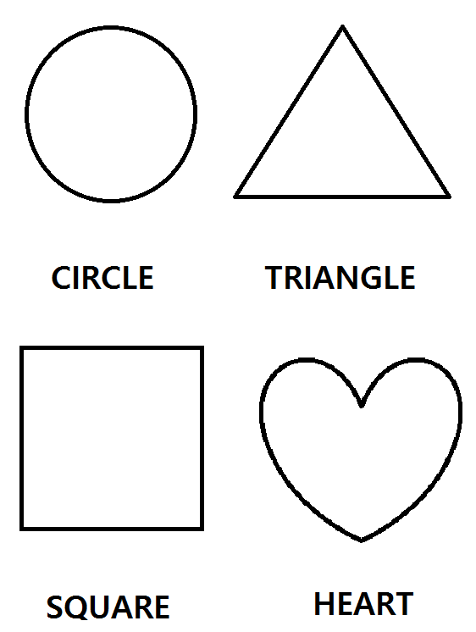

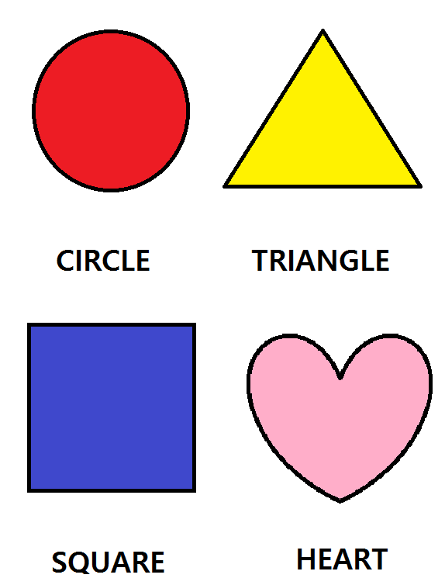

Write the Shapes’ name
NAME: DATE:

CIRCLE

TRIANGLE

SQUARE

HEART

The sentence cards
I LIKE…
THIS IS…
I LIKE…
THIS IS…
I LIKE…
THIS IS…
I LIKE…
THIS IS…
The shapes cards
CIRCLE
TRIANGLE
SQUARE
HEART

