TITLE | What's This?
INSTRUCTOR |  |  |  | Ss’ LEVEL | AGE GROUP | No of Ss | LENGTH
Su Ah Han (Anna) |  |  |  | Elementary | 10 | 6 | 50min

MATERIALS

● Computer ● alphabet letters ● stickers ● picture cards
● CD-ROM
AIMS1. |  | Students will say the expressions "What's this (that)?/It's a (an)~."
2. |  | Students will say the expressions and sing the song “What's This?"

LANGUAGE SKILLS
Listening |  |  | Listen say the expressions "What's this (that)?/It's a (an)~."
Speaking |  |  | Say the expression and sing the song “What's This?"
Reading |  |  | Recognize and read the letters from L(l) and G(g)
Writing |  |  | Write the letters from L and G
LANGUAGE SYSTEMS
Phonology |  |  | Listen and identify 'l' sound.
Lexis |  |  | a, book, cup, eraser, it, lemon, listen, look, pen, pencil, ruler, that, this, what
Grammar |  |  | Practice Verb, "What‘s this/that?" and "It's a(an) ____."
Discourse |  |  | Greetings
Functions |  |  | Asking an Object's Name: What's this/that?  • Answering an Object's Name: It's a _____.  • Attracting Attention: Look!

ASSUMPTIONS

All the students are 3rd grade and a beginner level.
- Students are already knew phonics.

ANTICIPATED GRAMMATICAL ERRORS AND SOLUTIONS

If some students have some difficulties to say the word and sentences clearly, Let other students, who understand, teach them.
If some students say the word without using no intonation, flat tone, teacher should guide and teach exact intonation and let them practice a lot.

REFERENCES

Song & Chant Video: http://textbook.tsherpa.co.kr/2014/textbook/class.aspx?bookcd2=A6-C1-EE-EE-03-01&class7=02
Pictures: http://textbook.tsherpa.co.kr/2014/textbook/class.aspx?bookcd2=A6-C1-EE-EE-03-01&class7=02

NOTES

Enter your Plan B, your Cut-off plan and your SOS activity here
Plan B: If the visual aids like projector, computer, video doesn’t work, then using paper sheet or drawing on the white board.
Cut-off plan: If role-playing time is short, teacher should cut the time of student’s speaking.
SOS activity: consider lesson plan and process activity

PRETASK TITLE |  |  | Greetings, Motivation, Objectives, Chant
AIMS |  |  |  | MATERIALS
Students will know the picture and guess what it means. |  |  |  | computer  CD-ROM  picture cards
TIME | SET UP | STUDENTS |  |  | TEACHER
1 min | Greetings | Say hello each other |  |  | - Hi, everyone.
min | Introduction | What to Study |  |  | Today, we will sing a song and play a fun game using the expressions
1min | Look  &  Think | - What are Kelly and Minho doing?  -What's happening in the second picture? |  |  | CD-ROM

NOTES

TASK PREPARATION TITLE |  |  | Act & Play, Song, Repeat, Speak & Play
AIMS |  |  |  | MATERIALS
Students will practice the expressions dialogue and say “What is this?” |  |  |  | computer  CD-ROM
TIME | SET UP | STUDENTS |  |  | TEACHER
4min | Listen  &  Check | Watch the clip and listen to the dialog carefully.  - What happened to the book?  - What does the dove have?  - Now let's listen to the dialog again and answer.  Q: What did the magician say pointing to the book?  ▪Look! What's this? |  |  | CD-ROM
5min | Expressions | [Scene 2]  - What did Minho answer to the question "What's this?"  [Scene 3]  - What did the magician say pointing to the pencil?  - What does that mean?
1min | Listen  &  Repeat | Let's listen to the dialog one more time and repeat it one line at a time.
1min | Watch  &  Think | - I'll show you the video clip without any sound.  Let's guess what's happening.
3min | Make  a  Dialog | Make a dialog with your partner. Say it aloud.  - Share your dialog with your classmates. Who wants to go first?  - Now, listen to the example dialog and compare it.
1min | Listen  &  Repeat | Watch the clip again and repeat the dialog.

NOTES

TASK REALISATION TITLE |  |  | ACT & PLAY
AIMS |  |  |  | MATERIALS
Students will say the expression “it’s ~” |  |  |  | computer, CD-ROM
TIME | SET UP | STUDENTS |  |  | TEACHER
5min | Listen  to the Song | - Watch the clip and listen to the song.  - What things did you hear?  - (Activity) Find the things in the song. Point to them.
5min | Let's  Sing | Let's listen and sing one part at a time.  - Now, let's sing the whole song together.  - This time, we'll sing and dance to the melody.  - Watch the clip and follow the actions as you sing. |  |  | CD-ROM
2min | Speak & Play | a. Listen to me and put the cards in order.  b. Touch each card and say, for example, "It's a book." |  |  | picture cards

NOTES

POST TASK TITLE |  |  | Check up, Mission
AIMS |  |  |  | MATERIALS
Students will know L and G words. |  |  |  | computer,  CD-ROM
TIME | SET UP | STUDENTS |  |  | TEACHER
1min | Review | - (showing a pencil) Look! What's this?  - (pointing to an eraser on the desk) Please ask me.
2min | Good-bye | - Next class, we'll read and write the letters from G(g) to L(l). We'll also play a game.  - See you next class.  - Bye, everyone.
1min | Homework | Do the activities in the digital textbook.

NOTES

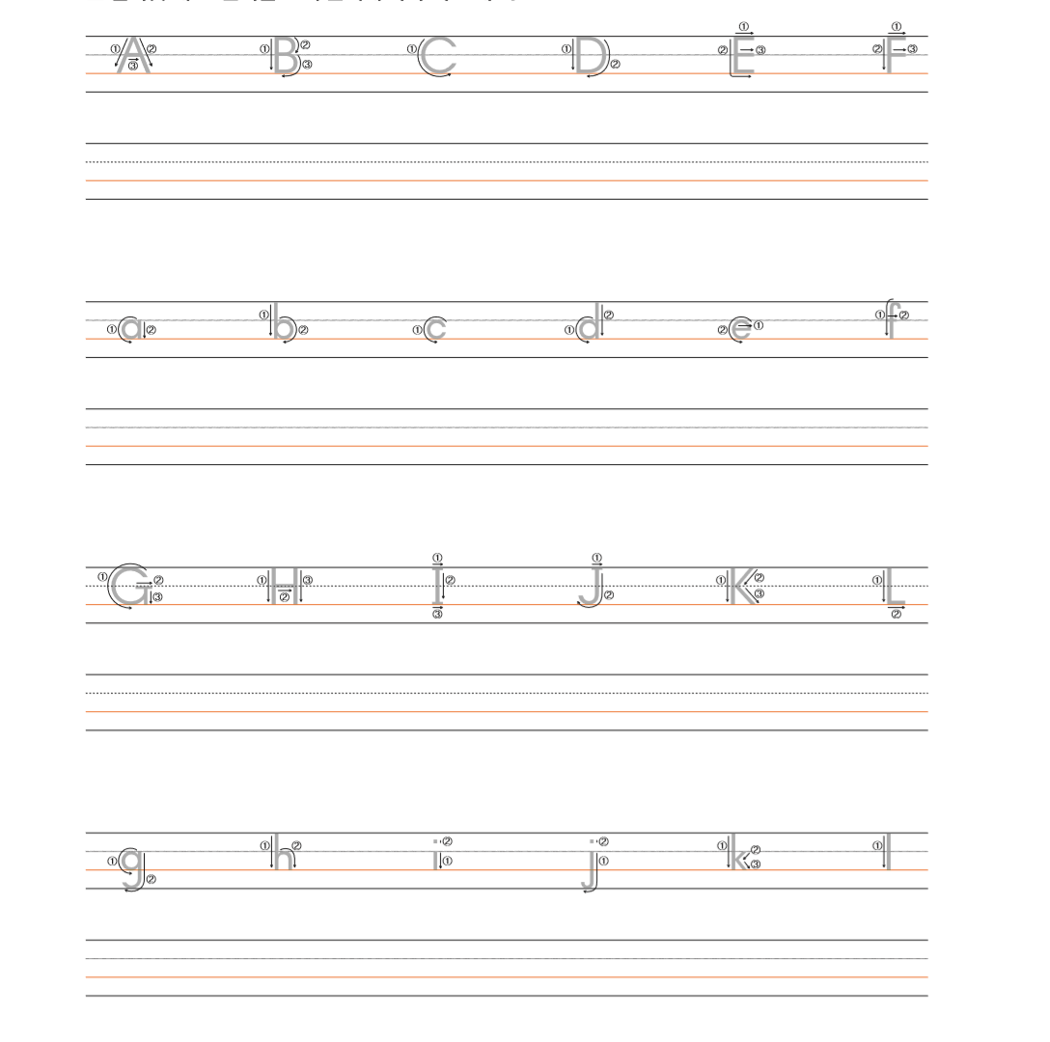

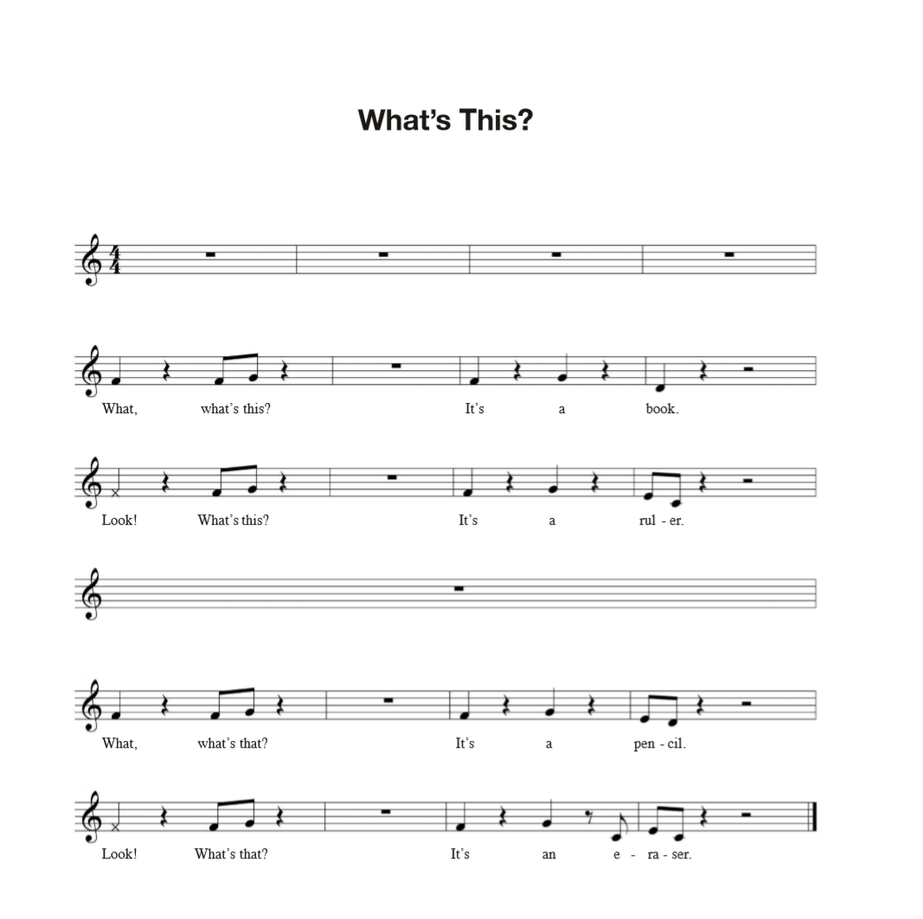

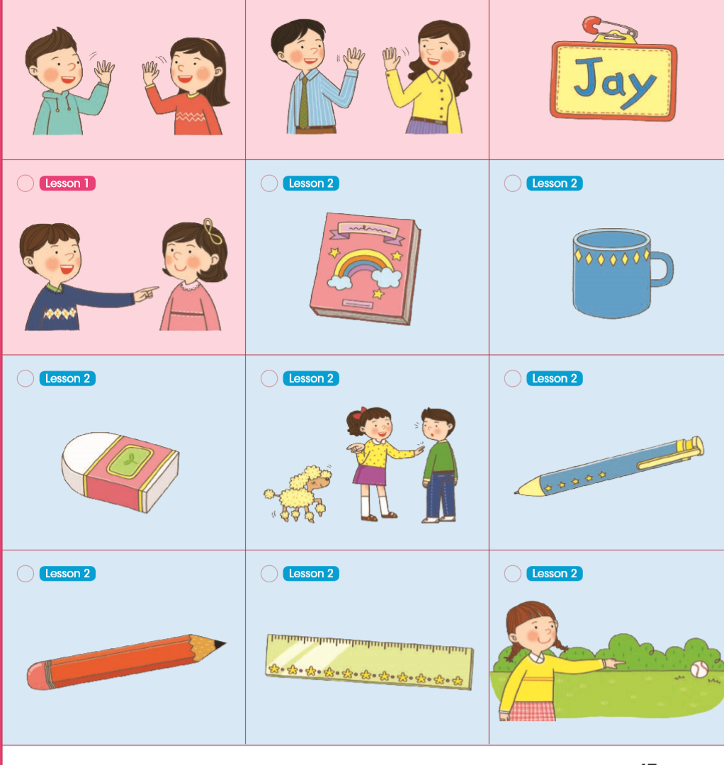

a | 하나의
book | 책
cup | 컵, 잔
eraser | 지우개
it | 그것
lemon | 레몬
listen | 듣다
look | 보다
open | 열다
pen | 펜
pencil | 연필
ruler | 자
that | 저, 그
this | 이; 이것
what | 무엇, 어떤, 몇, 무슨

