Speaking Lesson Plan (TBIT)

How to order coffee?

Instructor:  Ashley  (Ye Rim Lee) | Level:  Intermediate | Students:  19 | Length:  25 minutes

Materials:
- White board, board marker
- Pictures (coffee, eliciting the topic and word)
- Counterfeit money
- worksheets

Aims:
- Students will be able to order coffee in café.
- Students will be able to identify what kind of coffee.
- Students will be able to distinguish currency between British and America.
- Students will be able to identify the difference in culture between Korea and English-culture countries.

Language Skills:
- Reading: reading the worksheet.
- Listening: listening teacher’s instruction, teacher’s demonstration and partner’s idea.
- Speaking: discussing pair or group, showing the real-play, answering teacher’s question, and repeating words.
- Writing: writing the answer in the worksheet.
Language Systems:
- Lexis: Vocabulary in the worksheet.
- Function: discussing, giving and receiving opinions, ordering coffee
- Discourse: observing and answering what it is
- Grammar: Auxiliary verb (e.g Could , May and Would + [subject])

Assumptions:
Students already know:
- the teacher's teaching style.
- the basic vocabulary of ordering words

Anticipated Errors and Solutions:
If students don’t how to ask for things in cafe
-> Teacher will give drill the questions (e.g Can I have... please, How you got any...?)
If time is short
-> cut the time of sharing the student’s stories.

References:
Topic and Worksheets : Teaching English website
http://www.wikihow.com/Order-Coffee
http://www.teachingenglish.org.uk/article/shopping-%E2%80%93-a-caf%C3%A9

Pre-task
Materials: white board, board marker
Time  1min | Set up  Whole class | Procedure:  <Greeting>  Good morning guys. How are you today?  <Eliciting and Introduction of Task>  Do you like coffee? (yes) Me either.  Today, we are going to talk about taking various café,  And then, we are going to learn how to order coffee.
Task-Preparation
Materials: white board, board marker, pictures(vibration bell), worksheet
Time  1min  2min  3min  1min  4min | Set up  Whole Class  pairs  Whole Class  Whole Class  pairs | Procedure:  1. Difference of culture in café.  <Instructions>  There are many different things between Korea and English- culture countries. The reason is today we going to learn about how to order coffee. So, let’s think about difference of café culture. You have to talk together in pair. I am going to give 1minute.  (distribute a hand out)  <Demonstration>  (A comparative table on the white board) for example, in Korea, after customer order, they receive “vibration bell”. (Show the picture) On the other hand, in English –culture countries, customers have to speak their names, and it is written on their drink. (during teacher speaks, T writes example)  <ICQ’s>  - So, what are you going to do? (think and discuss different between Korea and English culture country)  Ok. Go!  (Teacher monitors discreetly. Answer students if they ask questions. Be flexible with time. Give time warning: 10 second left.)  10 second left.  I think all of you have finished writing. Tell me. (While students talk answer, teacher needs to write it down on the white board and give good feedback.)  Good job.  2. Discussing own experience.  <Instructions>  Have you ever ordered coffee in aboard? What is the most memorable thing for you that happened? Let’s talk about your experience. Good memory and bad memory. I am going to give you 1minute. Think about it.  Ok. Let me have it, Lily  Anything else?  3. Decide what kind of milk you want  <Instructions>  Turn to the next page.(worksheet2) When you order coffee, you have to decide what kind of milk you want. This activity is based on the information gap. So, you have to make a pair group. Please fill in the black using the following references. There is a next page. I am going to give 4minutes.  < Demonstration >  Let’s work together first question. If you want no milk at all, you want . Turn to the next reference page. Which one do you think it is? Right. Espresso. Because there is no milk.  <ICQ’s>  - What are you going to do? (fill in the blank)  - How much time do you have? (4min)  Ok. Start!  (T monitoring. Give time warning:1min)
Task Realization
Materials: white board, board marker, picture(coffee, money)
Time  2min  10min | Set up  Whole Class  Whole Class | Procedure:  1. How to order coffee? (general understanding)  <Instruction>  Turn to the next page.(worksheet3) This conversation is on order of coffee. (divide two teams)A team is a clerk, B team is a customer. Let’s try to read the conversation together loudly.  (students read loudly)  2. Real-play (main activity)  < Instruction >  Now, this time we are going to do real-play. First, you have to make 2groups. (Divide two teams) here are two café. “Monmouth (British) café” “Intelligentsia (American) café” Team A and B will use the different currency. (Show picture of currency) two become clerk, others become customer. You can order coffee using the kind of coffee we learned. I will give 10minutes.  < Demonstration >  I am going to show you, first. (teacher does demonstration)  <CCQ’s>  - If I customer can I have mocha without chocolate? Is that right? No)  - Can I pay Euro in the American cafe? ( No)  - How much time do you have? (10min)  GO!!  (Teacher monitors discreetly and does note-taking. Answer students if they ask questions)  Great.
Post Task
Materials: white board, board marker
Time  1min | Set up  Whole class | Procedure:  Feedback & Conclude lesson  You did well.  What did you learn today?  Did you enjoy today's activity? I hope you had good time  (Listen Ss feedback of activity)  You did many activities. What is the memorable activity? Do you have any question?  (Dismiss the class if there’s no question.)  Great gob, guys!  See you tomorrow. Have a nice day.

worksheet #1

<Difference of cafe culture>

Korea | English-culture countries

<Your experience>

-worksheet #2- Information gap <A>
<Decide what kind of milk you want>

- Fill in the blank. (Refer to next page )

  - If you want no milk at all, you want an Espresso .
  - If you want just a dab of foam, you want .
  - One part foam and one part milk is a 'Cappuccino' .
  - Mostly foam is a 'dry Cappuccino' and all foam is .
  - A lot of milk and a little foam is a latte .
  - A lot of milk and no foam is .
  - A mocha is a latte with chocolate syrup.
  - Brewed coffee with steamed milk is .
  - An Espresso with whipped cream is a Con Panna .

Espresso, Macchiato, Cappuccino, extra -dry cappuccino
latte, flat latte(white), mocha, café au lait, Con Panna

-worksheet #2- Information gap <B>
<Decide what kind of milk you want>

- Fill in the blank. (Refer to next page )

  - If you want no milk at all, you want .
  - If you want just a dab of foam, you want a Macchiato .
  - One part foam and one part milk is .
  - Mostly foam is a 'dry Cappuccino' and all foam is an "extra-dry cappuccino".
  - A lot of milk and a little foam is .
  - A lot of milk and no foam is a flat latte(flat white) .
  - is a latte with chocolate syrup.
  - Brewed coffee with steamed milk is a café au lait .
  - An Espresso with whipped cream is .

Espresso, Macchiato, Cappuccino, extra -dry cappuccino
latte, flat latte(white), mocha, café au lait, Con Panna

-worksheet #2-

The following are reference materials.
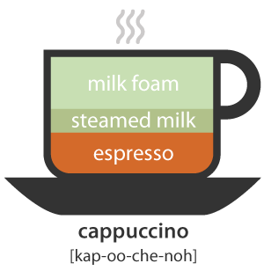 | 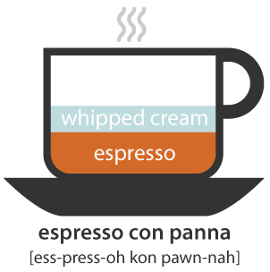 | 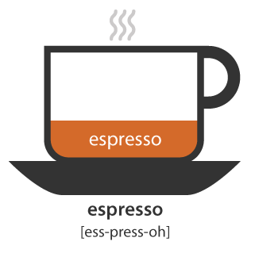
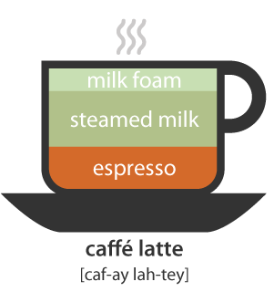 | 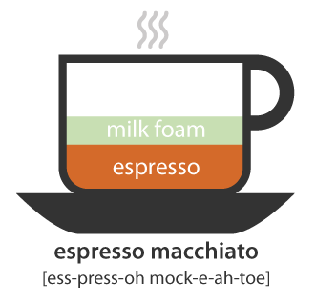 | 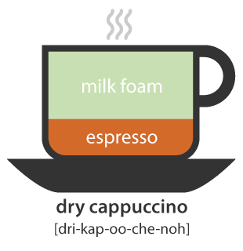
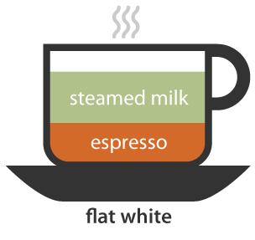 | 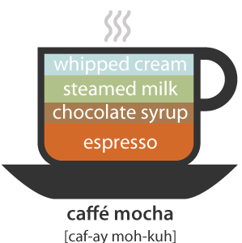 | 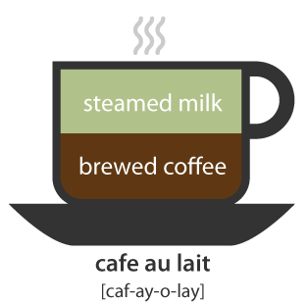

worksheet #3
Can I help you? ¹⁾

롷롷로롷롷롷롷롷롷롷롷롷롷롷롷롷롷롷ㄹ
Can I have²⁾ a small³⁾ non-fat⁴⁾ Mocha, please?

What’s your name?

Ashley. A.S.H.L.E.Y.

OK. That’s $2.75 please.

Here you are.

Thank you. This is your changed. Have a great day

Have a nice day too.

¹⁾ What I do for you? / May I help you? Could I help you?
³⁾ Size
Small
Medium
Large

⁴⁾ Specify the type of milk and coffee
Low fat
Decaf
Whole or Non-fat

²⁾ Can I get / May I have / I will have/
I want / I’d like

<Material_ pictures>

Vibration bell

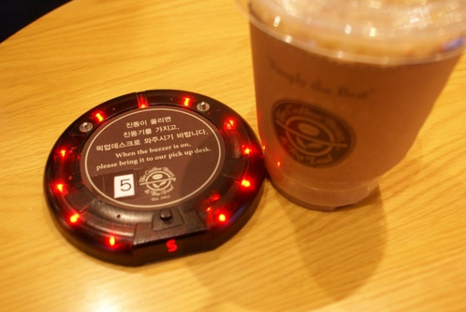

Espresso

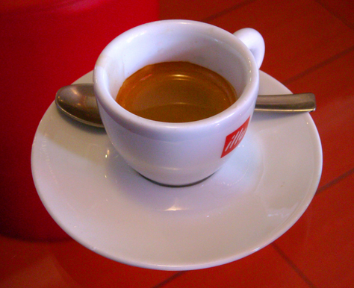
Macchiato (mock-e-ah-to)

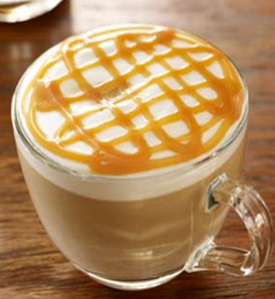

Cappuccino

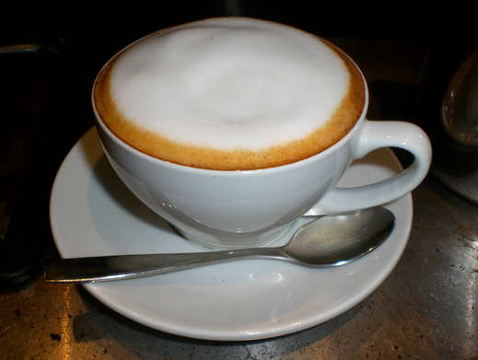
Extra-dry cappuccino

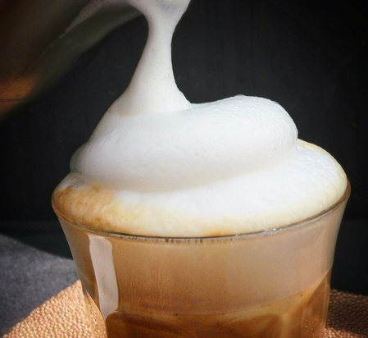

Latte

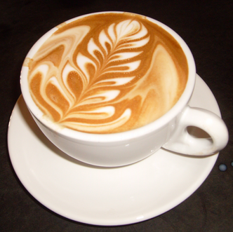
Flat latte.

Mocha

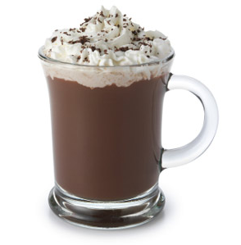

Café au lait.

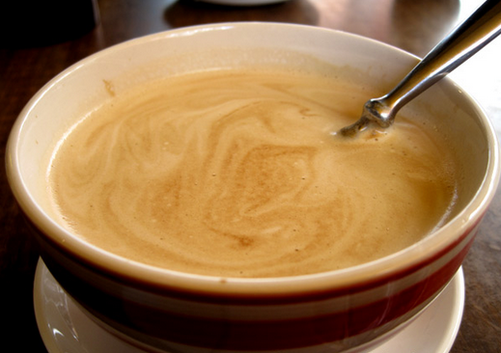

a Con Panna

