Grammar Lesson Plan

We lost macaroni, macaroni, and macaroni!

Length: 25 minutes
Students: 9
Level: Upper Intermediate
Instructor:
Grace Lee

Materials:
PPT slides
A board
Materials - Worksheet #1, 2 ( 9 copies), Two paragraphs (to contain missing commas.)
Realia ( Macaroni )

Aims:
SWBAT use commas properly by T’s explanation and worksheets.
SWBAT clarify about using commas when they write their own essays through the main activity.
SWBAT tell some other punctuation uses from comma use through the whole class.

Language Skills:
Reading: Ss read through the contents of the two worksheets and understand them.
Writing: Ss write answers on the worksheet.
Listening: Ss listens to what teacher says and what other Ss discuss using commas by group work.
Speaking: Ss have discussion on comma use through group work.

Language Systems:
Grammar: Focusing on comma use and comma rules.
Lexis : Understanding of the meanings of some words and idioms by worksheets.

Assumptions:
Ss already know about quite a few of grammar points such as conjunctions and restrictive clause/nonrestrictive clause.
Ss are at an upper intermediate.
Ss can talk to one another in English.

Anticipated Errors and Solutions:
Using commas is quite challenging for Ss, especially like distinguishing comma use in front of ‘which’ clause and ‘that’ clause.
- Error correction with explanation and reformulation.
Ss would not have understanding about worksheets
- Peers’ correction by group work

References:
Teach-nologyInc. (1999-2010). “teAchnology”. (Teach-nology, Inc) missing commas in paragraph: http://www.teach-nology.com/worksheets/language_arts/punctuation/pun7.html
University of Victoria English language center. (1998-2008). “Study Zone”. Using commas: http://web2.uvcs.uvic.ca/elc/studyzone/330/grammar/comma.htm.
Pictures – http://google.com/

Lead-In
Materials: PPT slides
Time  1minute | Set Up  . | Procedure:  Before class, T finishes setting up a computer and check if PPT slides work well. Then, T puts the topic and some other materials on the board.  <Greetings>  T starts with a smile and waits until Ss stop chatting and get attention to T.  T: Good morning! How are you?  (Some students would have no response and the others would react to T positively.)  (After checking Ss are quite good, T gets down to the lesson.)  <Eliciting>  T shows a PPT slide to Ss.  T: What comes to your mind as you see the picture?  (Some Ss would be laughing and the others would  respond)  T: You guys will eat grandma? That doesn’t make sense!  Actually we need a comma in this sentence. (T shows the  next slide to Ss.) So, sometimes, comma saves lives, right?

Pre-Activity
Materials: PPT slides
Time  10 minutes |  | Set Up  S-S | Procedure:  <9 Comma rules>  T : Let’s listen to an interesting story.  (An audio clip)  T: As you listened, Mr. macaroni has gone away from Sentence world! So, what will happen? Well, let’s move on to the next slide to see what’s going on! Above all, we should be informed of some comma rules!  (The next slide is about ‘the listing use’)  (T asks one student to answer which sentence is correct.)  T: In other words, comma is optional for listing use in a sentence, but it MUST have “and”.  (The next slide is about ‘the conjoining use’)  ( After T shows one example, T also tries asking one student to read out another example and, at the same time say where commas should be placed)  T: As you see the yellow box, there are coordinating conjunctions such as for, and, nor, but, or, yet, and so. FANBOYS!)  These conjunctions join two or more items such as words, main clauses, or sentences.  ( Like this way, T explains about the rest of the comma rules and in the middle of explanation, T pauses and asks some questions to Ss individually.)  (…)  <CCQ>  Do we put a comma after FANBOYS?  Does apposition mean dates, numbers, and addresses?
Main Activity
Materials: worksheets # 1,2 ( 9copies), Realia (Macaroni), Two paragraphs (to contain missing commas.)
Time  5minutes  7minutes |  |  | Procedure:  (T introduces the main activity. T shows an instruction with  the PPT slide)  <Instruction>  T: This time, you’ll do practice for using commas! (Ss pass  the worksheets around.) First of all, write the commas in the  correct place. Then, write a proper comma rule in each  sentence. It’s group work. Three, three, three. You have  2minutes.  <Demonstration>  T: Let’s look at the number one on the worksheet. The wind  was so strong that it blew away my big red umbrella.  Which part is the right place to put a comma? (Ss would  respond or not.)  Actually, we need a comma between “big” and “red”.  And then, what is this comma rule? (Ss would respond or  not.)It’s coordinate adjectives! Alright, let’s give it a try.  <ICQ>  Do you work alone? (No.)  Do you have 3minutes? (No.)  T: Ok, done! You’ll check the answer sheet (T shows the sheet with PPT slide.) and correct your answers with your group members for 1 minute.  (Peer correction)  (After then, T moves on to the next activity.)  <Instruction>  (T prepares for realia and two paragraphs.)  (T shows the instruction with PPT slide.)  T: This time, we’ll have a fun game, which is called as “We  lost Macaroni, Macaroni, and Macaroni!”  - First of all, make 2 teams. (Four & five)  - Each team has a different color of macaroni : Red & Yellow  - Each team reads the given paragraph and puts macaroni on proper positions in sentences. (2 minutes)  - Two teams switch their seats taking their own macaroni and check if another group did it right. (2minutes)  (note! If one team finds some errors on another group’s task, replace its macaroni to its own one.)  <Demonstration>  (T shows the PPT slide applied with a variety of animations. It’s helpful for Ss to get the picture at a time.)  <ICQ>  Is it necessary for each team to find errors?(No.)  Do we use macaroni to put a question mark? (No.)
Post Activity
Materials:
(T gives feedback/error correction.)

T : Did you guys enjoy my class?
(Ss would respond.)

T: I want you guys to review about using commas with worksheets. Tomorrow, we will have a reading class! Bye!

What is comma?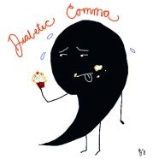
Commas are used to adjust the rhythm of a sentence, or to provide greater clarity to a sentence.

9 Comma Rules

- The listing use
He brought coffee, sandwiches and cheese. (O)
He brought coffee, sandwiches, and cheese. (O)
- Comma is optional for listing use in a sentence, but it MUST have “and”.
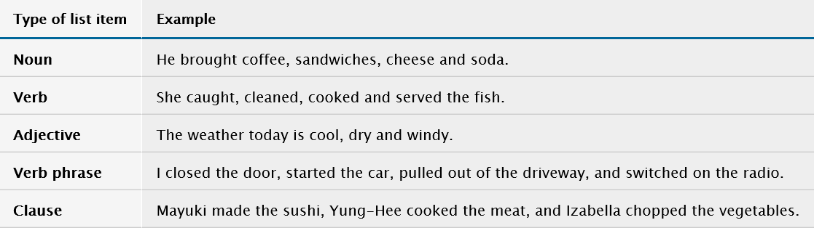

- The conjoining use
Coordinating conjunctions
- A comma is usually placed before a conjunction.
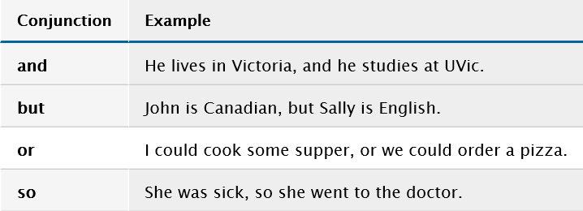

- Combining two clauses -> a comma is used to join two clauses.
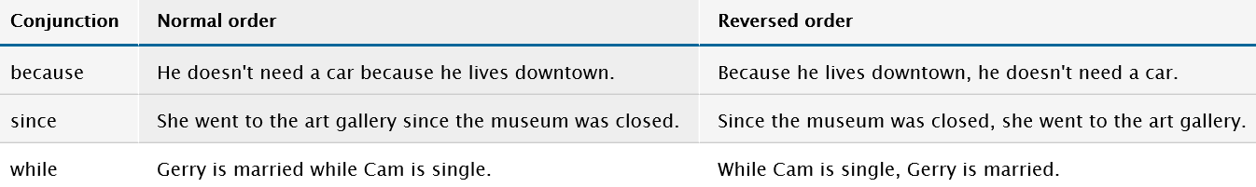

- Introductory words or phrases
Well, I’ll see you later.
Yes, I will try.
In fact, he watched TV for thirteen straight hours.

- Using quotations either at the beginning or the end
Joe said, “Are you coming to the movie later?”
“Come to the movies,” said Joe.

- Apposition ( the relation between a word and a noun phrase that follows)
My teacher, Mr. Clark, is a great singer!

- Parenthetical or nonrestrictive elements
The chair, which is my father’s favorite, was found downstairs.
The chair that is my father’s favorite was found downstairs. (No comma)
(Note! nonrestrictive elements are introduced by which,, but restrictive elements are introduced by that. )

- Typographical information (dates, numbers, and addresses)
Today’s date is January 31, 2006.
I live in Halifax, Nova Scotia.

- Coordinate adjectives
Note! Use commas to separate coordinate adjectives.
(Coordinate adjectives are two or more adjectives that are describing the same noun.)
The position will require dedicated, insightful, accurate work.

Missing Commas! 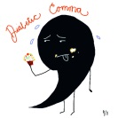

Directions: Every sentence is missing commas. Write the commas in the correct place. Then, write a proper comma rule in each sentence. (A list of comma rules is below.)

1. The wind was so strong that it blew away my big red umbrella.
2. At my birthday we had clowns balloons and birthday cake.
3. When I go to my grandpa’s house I help him cut the lawn pile wood and weed the garden.
4. My dad’s makes his spaghetti sauce with tomatoes beef and mushrooms.
5. My brother drove all the way home to pick me up but found I had already left.
6. David Adams a New Brunswick writer won the Governor General’s Award.
7. She lived in Seoul Korea.
8. “You will leave me” said Christine.
9. The book which is my mother’s favorite is on the table.
A List of Comma Rules
The listing use
The conjoining use
Reversing the order of clause
Introductory words or phrases
Quotations
Apposition
Parenthetical or nonrestrictive elements
Dates, numbers, and addresses
Coordinate adjectives

Missing Commas! (Answer sheet)

Directions: Every sentence is missing commas. Write the commas in the correct place. Then, write a proper comma rule in each sentence. (A list of comma rules is below.)

1. The wind was so strong that it blew away my big, red umbrella. Coordinate adjectives
2. At my birthday, we had clowns balloons and birthday cake. Introductory words
3. When I go to my grandpa’s house, I help him cut the lawn pile wood and weed the garden.
Combining two clauses
4. My dad’s makes his spaghetti sauce with tomatoes, beef(,) and mushrooms. The listing use
5. My brother drove all the way home to pick me up, but found I had already left.
The conjoining use
6. David Adams, a New Brunswick writer, won the Governor General’s Award. Apposition
7. She lived in Seoul, Korea. Dates, numbers, and addresses (Typographical)
8. “You will leave me,” said Christine. Quotations
9. The book, which is my mother’s favorite, is on the table.
Parenthetical or nonrestrictive elements
A List of Comma Rules
The listing use The conjoining use
Combining two clauses Introductory words or phrases
Quotations Apposition
Parenthetical or nonrestrictive elements
Dates, numbers, and addresses
Coordinate adjectives

We lost Macaroni, Macaroni and Macaroni!

If you want to know the most amazing ice cream in the state of Texas I can tell you. Amy's ice cream that is owned by my cousin has creamy delicious ice cream in the South. She offers stinky fruit but she also offers normal flavors like chocolate vanilla and strawberry. If you are ever in Houston you need to be sure and stop in for a taste. She is located at 298 Wesson Avenue Houston Texas.

If you want to know the most amazing ice cream in the state of Texas, I can tell you. Amy's ice cream that is owned by my cousin has creamy, delicious ice cream in the South. She offers stinky fruit, but she also offers normal flavors like chocolate, vanilla(,) and strawberry. If you are ever in Houston, you need to be sure and stop in for a taste. She is located at 298 Wesson Avenue, Houston, Texas.

