Grammar Lesson Plan
TITLE | Superlatives (the most, ~est)
INSTRUCTOR |  |  |  | Ss’ LEVEL | AGE GROUP | No of Ss | LENGTH
Eun Hye Lee (Grace) |  |  |  | Lower/Pre Intermediate | 14~15 | 6 | 50 Minutes

MATERIALS
- White board/board markers
- Audio/CD/Computer/Projector
- Superlative Picture #1, Superlative Picture #1 (for the Pretask)
- Complete the sentences (the ~est, most~) – Worksheet #1 (hand out) 7 copies (+1 Extra)
- Describe the picture (the most, ~est) - worksheet #2 (hand out) 7 copies (+1 Extra)
- Review (the ~est, most~) – Worksheet #3 (Homework) (hand out) 7 copies (+1 Extra)
AIMS1. |  | Students will study structures of the superlatives sentences by describing the pictures. .
2. |  | Students will practice writing the superlatives sentences by completing the worksheet.
3. |  | Students will study superlatives form naturally by watching a video clips of superlatives.

LANGUAGE SKILLS
Listening |  |  | Students will listen to teacher’s explanations of superlatives sentences, instructions, other students talk, and a video clip.
Speaking |  |  | Students will answer the teacher’s questions, talk with other students in groups and repeat the sentences after the teacher.
Reading |  |  | Students will read the sentences and completing worksheets.
Writing |  |  | Students will fill in the blanks by completing the worksheets.
LANGUAGE SYSTEMS
Grammar |  |  | Form of superlatives sentences (the most, ~est)
Lexis |  |  | Vocabularies of superlative form (bad-worst, good-best, (a) little – the least)- irregular form words
Phonology |  |  | Monitoring the students speak, say the word “brave-bravest /v/+est”, “strong-strongest /g/+est” sounds
Discourse |  |  | The students are going to share their writing (worksheet) of superlative sentences with group.
Functions |  |  | Figure it out the form of superlatives sentences.

ASSUMPTIONS

- The students already know each other.

- The students already know when the teacher read the passage or read their work, should repeat it.
- The students already know the form of comparison (more, ~er than) sentences from the previous lesson.
- The students already know the rule that more than 2 syllabus word, put more instead ~er (eg. cold - colder / useful – more useful).

ANTICIPATED GRAMMATICAL ERRORS AND SOLUTIONS
- Some students might make errors to say the before the most, -est
- Monitoring the students and correct them when and make students say the sentence correctly
- Some students might difficult say the word “”
- Monitoring the students and make students say the word correctly.

REFERENCES
- Video clip 1: https://www.youtube.com/watch?v=872gqAJjc1g
- Video clip 2: https://www.youtube.com/watch?v=KpzrmoW_gwc
- Worksheet: http://examples.yourdictionary.com/examples-of-comparitive-and-superlative-adjectives-for-kids.html
Grammar in Action 2 (YESBooks) - p.40~43
- Picture: http://www.suggestkeyword.com/c3VwZXJsYXRpdmFz/ https://www.youtube.com/watch?v=Zo7bh7FQD-4

NOTES

Plan B: If the video clip is not working, techer can write some example sentences on the board and make students practice the sentences.

Cut-off plan: If there isn't enough time, skip the watch the video clip #2 (Task Preparation).

SOS activity :

Sentence writing

Students can write sentences using the superlative sentences.
- Students can read their sentences out loud.
- Bingo game
- Give a piece of paper to students (if don’t’ have the paper, students can take out their notebook).
- Make students draw box (9 or 16), write the vocabularies of superlative form.
- Each student says the word, and who ever make the 3 lines first win.

PRETASK TITLE |  |  | - Warmers / Review/ Guiding questions
AIMS |  |  |  | MATERIALS
Students will get some ideas about the superlative sentences by pictures#1, #2 |  |  |  | A white board / board markers  Video clip / Computer / Projector  Superlative pictures #1, Superlative pictures #2
TIME | SET UP | STUDENTS |  |  | TEACHER
5 min | Whole class | Students will review the comparison sentences by answering the questions. (picture#1)  Q1. Whose book is this?  Q2. How is the length of the Jane’s book?(thin or thick)  Q3. Look at the Tom’s book, which book is the thicker?  Q4. Look at the Kelly’s book, how many books are now?  Q5. How is the Kelly’s book, which book is very thick?  Q6. Whose book is the thicker? |  |  | Show the picture#1 (PPT), ask questions about the picture. (comparison)
3 min | Whole class | Students will look at the pictures(#2 small-smaller-smallest, fat-fatter-fattest, short-shorter-shortest) |  |  | Show the Pictures#2 and ask students questions (ICQ)

NOTES
Show the Superlative pictures #1 and #2 (attached the picture in this file)
If need to ask more question, can add more questions.

TASK PREPARATION TITLE |  |  | - Eliciting / Superlative chart #1/ Practice #1/ Video clip #1/ Worksheet #1
AIMS |  |  |  | MATERIALS
Students will study vocabularies in the superlative form  Students will practice the vocabularies in superlative form by completing the worksheet |  |  |  | - A white board / board makers  - Superlative chart #1  - superlative Practice #1  - Video clip #1  - Complete the sentences (the most, ~est) Worksheet#1
TIME | SET UP | STUDENTS |  |  | TEACHER
5 min | Whole class | Students will look at the “Superlative chart #1” of the vocabularies of superlatives form and sentences.  Students will repeat the vocabularies of superlatives form  Students will do “Practice #1” together after repeating the superlatives form sentences. |  |  | Show “superlative chart #1”  Give instructions that they need to do.  Ask questions (ICQ) to check they understood well.
4 min | Whole class | Students will watch the video clip #1 and answer the questions.  Q1. Big – bigger - ~ ? (answer: biggest)  Q2. Colorful – more colorful - ~? (answer: most colorful)  Q3. Bad – worse- ~? (answer: worst) |  |  | Show the video clip #1 and ask questions.
5 min | Individual  / pairs | Students will complete the worksheet #1  Students will share the work in pairs. |  |  | Monitoring the students complete the worksheet correctly. If some students don’t understand, give them clue by asking questions)

NOTES
Show the video clip #1 (see the reference-click the link).

If some students have difficulty to complete the vocabulary worksheet, help them.

When they read the vocabulary worksheet loud, if they make error to say vocabularies help them to say correctly.

TASK REALISATION TITLE |  |  | - Reading the passage / video clip#2/ picture worksheet#2
AIMS |  |  |  | MATERIALS
- Students will watch the video clip about the lesson (superlative sentences)  - Students will make sentences by describing the picture. |  |  |  | A white board / board makers  video clip#2  picture worksheet#2
TIME | SET UP | STUDENTS |  |  | TEACHER
5 min | Individual | Students will watch the video clip #2 and answer the questions.  Q1. Which snail is the fastest and prettiest?  Q2. Which snail is the slowest? |  |  | Make sure students watch the video clip.  Ask questions so check they understood well.
10 min | Group/  Whole class | Students will make sentences of the picture  (Worksheet #2)  Student will work in groups. |  |  | Monitoring students are discussing and making sentences correctly.  If some students have a difficulty making the write sentences, help them.
5 min | Whole class | Students will write their own sentences on the board and share the sentences. |  |  | Monitoring all the students make sentences correctly. Help the students if they need.

NOTES
Show the video clip #2 (see the reference-click the link).

If some students are quiet encourage them to involve in the group.

POST TASK TITLE |  |  | Review and assign the homework
AIMS |  |  |  | MATERIALS
Students will discuss about the questions |  |  |  | A white board / board markers  – Worksheet #3 (Homework)
TIME | SET UP | STUDENTS |  |  | TEACHER
5 min | Whole class | Students will discuss and answer about the questions related with students in the class (classmates).  Q1. Who is the tallest student in the class?  Q2. Who has the longest hair in the class?  Q3. Who has the shortest hair in the class?  Q4. Who is the youngest in the class? |  |  | Talk about the students in the class using the superlative form.  Monitoring students discuss the idea.
3 min | Whole class | Students will listen to the teacher’s instruction, answer the ICQ.  Q1. What is the first question?  Q2. What do you need to do next? |  |  | Give the homework (worksheet#3) and give instructions about the homework (ICQ)

NOTES

-
-If the time left, teacher can ask more questions related to the students in the class and make students make questions related with the students in the class.

Complete the sentences (the ~est, most~) – Worksheet #1
- Look at the example and complete the sentences using the given words (change the form- the ~est, most)

- young / person Henry is in his family.

- small / continent Australia is in the world.

- easy / question This is on the math test.

- good / music I think rock is of all.

- popular /sport Soccer is in Brazil.

- Look at the pictures and complete the sentences. (change the form- the ~est, most)
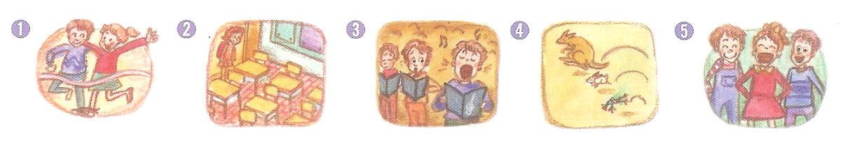

- Kyle and Jessie are running in the three-legged race.

- Maria usually arrives to the class in the morning.

- The man on the right is singing in the choir.

- The kangaroo jumps of the animals.

- Sarah smiles of the children.

fast far happily early loudly

Describe the picture (the most, ~est) - worksheet #2
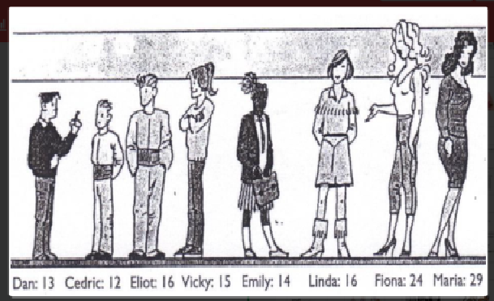

Review (the ~est, most~) – Worksheet #3 (Homework)

- Complete the dialogue (change the form- the ~est, most)

Clerk: May I help you?
Linda: I’m looking for a backpack.
Clerk: We have three brand new backpacks.
Linda: Wow, they look really nice!
Which one is [comfortable]?
Clerk: The yellow one has [good] straps.
Linda: How much is it?
Clerk: It’s 80 dollars. It’s [expensive] in our shop.
But I’m sure it’s [nice] one.
Linda: I don’t have enough money. What is [cheap] one?
Clerk: The blue one is. But it is [small] backpack of the three.
Linda: How about the red one? Its design is gorgeous.
Clerk: Yes, it has [pretty] design.
But it’s [heavy] of all three.
Linda: How much is it?
Clerk: It’s 40 dollars.
Linda: Well, I will just take the blue one.

- Write about your family using the given words.

e.g. My grandfather is the fattest in my family.

old young cute beautiful funny nice tall
short fat thin smart handsome busy lazy

Superlative Picture #1 -Pretask

Superlative Picture #2- Pretask

Superlative Chart #1 – Task Preparation
smart | She is the smartest girl in our class.
hot | Yesterday was the hottest day of the year.
Cheap | The hotel is the cheapest in town.
old | That church is the oldest building in the town.
good | That was the best movie ever.
boring | It was the most boring film I’ve ever seen.
interesting | This is the most interesting book I have ever read.
shortest | I am the shortest person in my family.
handsome | Sam is the most handsome boy in the whole school.
hot | Katie wore the prettiest dress she owned.
bad | It was the worst day of my life.
high | Everest is the highest mountain in the world.
long | The Nile is the longest river in the world.
expensive | It’s the most expensive toy.
fast | The fastest animal in the world is a cheetah.
tall | My sister is the tallest in our family.

Superlative Practice #1 - Task Preparation

