Topic: Travel Abroad
Instructor: | Level: | Age: | Number of Students: | Length:
Jiae Lee | Intermediate | Adults | 14 people | 50 minutes
Materials:
- Pictures of travel (as a tool for eliciting the topic)
- An audio file and IPad (4 minutes 13 seconds)
- 14 copies of listening worksheets (comprehension questions, True/False questions and scrambled sentences)
- 14 copies of discussion questions
- White board, board markers, board eraser, and tape

Aims:
- Students will be able to explain the new vocabulary by understanding how they are used in sentences
- Students will be able to identify and discuss the main idea of the audio file by completing comprehension questions and True/False questions together with a partner.
- Students will be able to make grammatically correct sentences by unscrambling scrambled words.
- Students will be able to express their own opinions by answering discussion questions.

Language Skills:
- Listening: Listening to the audio file about travel
- Speaking: Discussing about answers and opinions with a partner.
- Writing: Writing answers and opinions in a worksheet.

Language Systems:
- Phonology: Pronunciation of new vocabulary (exotic, initiative, and resourcefulness)
- Lexis: New vocabulary (exotic, initiative, and resourcefulness)
- Grammar: Unscramble scrambled words
- Discourse: Make sentences that are related to the topic while discussing

Assumptions:
- Students are at an intermediate level.
- Students already know most of words in the article
- Students already know how to express their opinions in English.

Anticipated Errors and Solutions:

- Students might not be able to pronounce the word “exotic” properly.
- Ask students to repeat the word three times after showing them how to pronounce it.
- Students might consider the word “initiative” as an adjective just like “productive.”
- Tell students that the word is a noun and give them some example sentences by using the word.

References:
- Cotter, C. (n.d.). Travel Abroad. Retrieved November 16, 2015, from http://www.headsupenglish.com/index.php/lower-intermediate-students/lower-intermediate-skill-builders/lower-intermediate-listening/564-travel-abroad

f
Presentation
Aims:  - SWBAT understand what they are supposed to do in the lesson.  - SWBAT explain the new vocabulary by understanding how they are used in sentences. |  |  | Materials: White board, board markers, board eraser, worksheets, pictures of travel, and tape
Time | Set Up | Student | Teacher
1 minute  2 minutes  4 minutes  4 minutes  1 minute | Whole Class  Whole  Class  Whole  Class  Whole  Class  Whole Class |  | Greeting:  Hello, everyone! How are you today? (There are usually some positive answers like “Good,” “Fine,” etc.)  OK! Let’s move on to today’s topic.  Eliciting:  Here are three pictures and I will put these on the board. What do you see in these pictures? (Luggage, passport, plane, camera, etc.) What can people do with these things? (Travel)  Great! Have you ever travelled abroad? (Yes/No)  Instruction:  OK, Today’s topic is travel as you probably expect. We are going to listen to an audio file, which is about travel, and work on some questions and have some time to discuss about travel. These activities are going to be done in pairs, so work with a person sitting next to you.  Did everybody get one? (after passing the worksheets out)  Activity 1 (write the steps on the board):  Now, the first thing you need to do is listening to the audio file. Second, answer the comprehension questions and the True/False questions, and rearrange the mixed words to make appropriate sentences together with your partner. I encourage you to talk to each other to answer the questions. I will play the file once and you have 8 minutes to complete.  ICQ:  How many times are you going to listen to the file?  How much time are you going to have to complete the answers?  New Vocabulary (write them on the board):  Before listening to the file, let me clarify some vocabulary that might be new to some of you.  (exotic, initiative, and resourcefulness)  - Explain the words in sentences and do Error correction for exotic & initiative as planned.  Starting Cue:  OK, Let’s listen carefully for the activity 1!  Activity 2:  Now, I am going to give you all worksheets with two discussion questions and you are going to have 10 minutes to talk about the questions on the worksheet with your partner.  ICQ:  How much time will you have for discussing?
Notes:
Practice
Aims:  - SWBAT identify and discuss the main idea of the audio file by completing comprehension questions and True/False questions together with a partner.  - SWBAT make grammatically correct sentences by unscrambling scrambled words.  - SWBAT express their own opinions by answering discussion questions. |  |  | Materials: The audio file, IPad, worksheets
Time | Set Up | Student | Teacher
5 minutes  8 minutes  8 minutes | Whole Class  In pairs  In pairs | Listen to the audio file.  Activity 1:  Discuss and answer the comprehension questions, True/False questions and rearrange the mixed words with a partner.  Activity 2:  Talk about the discussion questions on the worksheet with a partner. | Play the audio file.  Go around the class and give help if needed.  Go around the class and give help if needed.
Notes:
Production
Aims:  - SWBAT answer the questions correctly by working in pairs  - SWBAT have a chance to hear other students’ opinions except their own partner’s |  |  | Materials: Worksheets
Time | Set Up | Student | Teacher
6 minutes  6 minutes | Whole  Class  Whole  Class | As a class, students will check their answers. Each group will answer at least once.  As a class, students will hear other students’ opinion about the discussion questions.  The 2 groups who have only one chance to answer for the activity 1 need to talk about the discussion questions. | Activity 1:  Give each group a chance to answer. (There are 7 groups and 12 questions, so 5 groups will have two chances to answer while 2 groups will have one chance to answer.)  Activity 2:  Give a chance to the 2 groups who answer only once for the activity 1 to answer the discussion questions.
Notes:
Post Production:
Aims:  - SWBAT review what they are taught in the lesson by being asked about CCQs and doing homework. |  |  | Materials: white board, board markers, board eraser
Time | Set Up | Student | Teacher
2 minutes  2 minutes  1 minutes | Whole Class  Whole  Class  Whole  Class |  | Give CCQs in order to check students’ understanding of the new vocabulary.  CCQ:  Which place can you describe as exotic?  Do initiative and resourcefulness help people solve problems?  Give homework (write it on the board):  - Make 2 sentences for each new word  - Summarize the audio file, which is going to be sent to students via email, after listening it twice at home.  Closing Cue:  OK! You all did a great job for today and don’t forget to do your homework and bring it to the next class. Thank you and have a nice day!
Notes:

Pictures of Travel

Listening Script

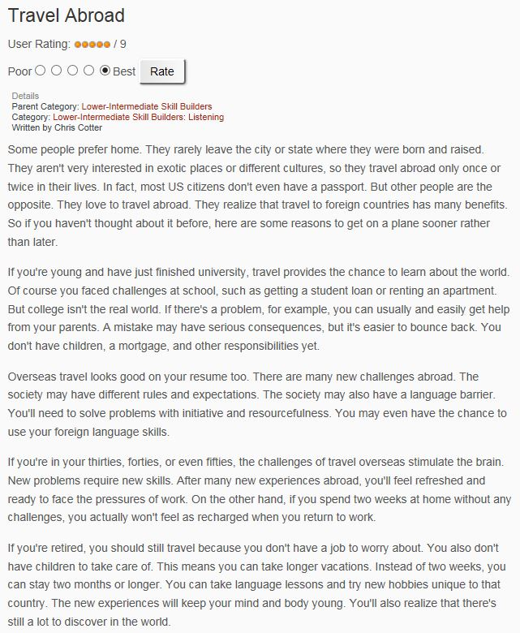

Listening Worksheet
- Comprehension Questions
- Why do some people rarely travel?

- What chance can young people get from traveling?

- Why is the experience of traveling abroad good for one’s resume?

- Why do people who work need to travel?

- What benefit can people who are retired get from traveling?

- True/False Questions
- People who are not interested in exotic places and different cultures tend to travel. ( )
- People can have a chance to use their foreign language skills by traveling. ( )
- Staying at home for two weeks can make people feel recharged when they go back to work. ( )
- People who are retired can travel for two months or longer because they do not have children to take care of. ( )

- Scrambled Sentences
- university travel if young you just are and have finished chance provides the world to learn about the

- you after refreshed will abroad many feel new ready work experiences the and pressures to face of

- resourcefulness you problems need will initiative to and solve with

Discussion Questions

- Is there any other benefits of traveling?

- Do you prefer to make a plan for your travel or not?

