Topic: Asking for Clothing Alteration
Instructor: | Level: | Age: | Number of Students: | Length:
Jiae Lee  Yoon Ju Cho (Irene) | Upper-Intermediate | Adults | 12 Students | 25 minutes
Materials:
- Clothes (Realia)
- Clothes Flashcards (Vocabulary and role-play)
- Board, Markers and Tape
Aims:
- SWBAT identify what problems clothes have and explain the problems by learning expressions for altering clothes.
- SWBAT ask for clothing alteration by role-playing.
Language Skills:
- Speaking : Answering teachers’ questions and role-playing
- Listening : Listening to teachers’ instructions and role-playing
- Writing : Writing a dialogue in class and an essay as homework
Language Systems:
- Discourse: Making a conversation that are related to the topic.
- Lexis : New vocabulary and expressions about clothes
- Function : Asking for clothing alteration
- Phonology : Pronunciation of “alteration” and other new vocabulary
Assumptions:
- Students are at an upper-intermediate level.
- Students already know how the class is set up and run.
- Students already know how to express their opinions in English.
- Students are familiar with role-playing.
Anticipated Errors and Solutions
- Students may not be able to pronounce “alteration” properly.
- Ask students to repeat the word three times after showing them how to pronounce it.
- Students may not be able to spell “alteration” correctly.
- Write the correct word on the board.
- Students may not be able to distinguish the differences between “alteration” and “alternation.”
- Give students two sample sentences to show their differences.
References:
Shopping - Clothes. (n.d). In ToLearnEnglish.com. Retrieved from
http://ko.talkenglish.com/lessondetails.aspx?ALID=708

Pre-Task
Aims:  - SWBAT predict and guess what topic would be dealt with in class.  - SWBAT explain what problems clothes have by describing flashcards.  - SWBAT distinguish the differences between “alteration” and “alternation” by reading two sample sentences. |  |  | Materials:  - Realia (Clothes)  - Vocabulary Flashcards  - Board and markers  - Tape
Time | Set Up | Student |  | Teacher
2 minutes  3 minutes  2 minutes | Whole class  Whole class  Whole class |  |  | Greeting:  Hello, everyone! How are you today? (There are usually some positive answers like “Good,” “Fine,” etc.) Great! I will lead the first half of class and Irene will lead the class after me. OK! Let’s move on to today’s topic.  Eliciting:  Take a look at Irene for a second. (Irene is wearing a jacket, which can be described as too big, too large, too long and too loose for her, next to me.) Ok, how can you describe her jacket? (There can be various answers like “too big,” “too large,” “too long” and “too loose.”)  Vocabulary and target sentences:  Yes, everybody seems to get some ideas. Her jacket can be described as too big or too large for her like this clothes on this flashcard, but it can be also considered as too long or too loose for her like this one (while pointing each clothes flashcard on the board). So, when you have these problems with your clothes, what you need to do is to alter your clothes to fit you better. In other words, today we are going to learn how to ask for clothing alteration. Here are two sentences that we are going to study for today. When you want to ask whether a store provides alteration or not, you can simply say “Do you provide alteration here?” And, when the store does provide alteration and you want to know the price of getting alteration, what you can say is “How much will it cost to get alteration done on these pants?”  Error correction:  Ok, there is one thing that you should be careful when you use the word “alteration.” Since the word is quiet similar to a word “alternation” in terms of the sound, the spelling and the meaning, you need to know their differences. First, in terms of their sounds, you need to include the /r/ sound for alteration, but exclude the /r/ sound while including /n/ sound for alternation. Can you guys repeat “alteration” three times after me? Ok, great! Now, in terms of their spellings, for alteration, there is no n, but there is n for alternation as you can see here. Next, the meaning of alteration is the act of process of making something different so that you can use the word in the sentence like “Do you provide alteration here?” when you want to change your clothes to fit you better. However, the word “alternation” means the act of following and being followed by turns, so you can use the word in a sentence like “The alternation of day and night is because of the Earth’s rotation on its axis.”
Task Preparation
Aims:  - SWBAT understand what task they would do and how to do it in class by listening to instructions. |  |  | Materials:  - Board and markers  - Flashcards for Role-playing
Time | Set Up | Student |  | Teacher
2 minutes | Whole class | As a class, students will listen to the instructions and answer ICQs. |  | Introducing the task:  Now, we are going to do role-playing. Everyone needs to make a pair with a person sitting next to you.  Giving instructions:  I will give a clothes flashcard to each pair. When you receive a flashcard, decide who is going to be a clerk and a customer. Then, each pair should write a short dialogue together in terms of getting clothing alteration by using the flashcard you received and the two sentences we learned at the beginning of the class today. And, act it out with your partner. You will have 12 minutes for this. After finishing role-playing, we will share some of your dialogues with the class.  ICQs:  How much time do you have?  What will you do and with who?  Ok, let’s pair up and get started!  Hand out the clothing flashcards to each pair.
Task Realization
Aims:  - SWBAT ask for clothing alteration by role-playing. |  |  | Materials:  - Flashcards for role-playing
Time | Set Up | Student |  | Teacher
12 minutes | In pairs | Writing a dialogue and role-playing in pairs. |  | Monitoring:  Listen to how students talk to each other and take a note if students’ errors are founded. And, give help if needed.
Post Task
Aims:  - SWBAT review what they learn in class by sharing their task with peer students.  - SWBAT write an essay with their own experiences of altering clothes by doing their homework. |  |  | Materials:  - Board and markers
Time | Set Up | Student |  | Teacher
2 minutes  2 minutes | Whole class  Whole class | Gathered as a whole class and present their work with the class. |  | Give opportunities for sharing:  Ok, everyone. It is time to act it out! Is there any volunteer who wants to share how you did?  (If no one volunteers, teachers might use the name plates to pick one of the groups.) Good, can you guys share your work with the class? You guys can do it on your seat.  After students’ presentations (there can be several presentations if time remains), give them a positive feedback.  Check aims:  Today, we learned how to ask for clothing alteration.  CCQs:  Is alteration a type of music?  Does alteration mean re-sizing clothes to fit?  What do you need to do when your clothes are too big or too long for you?  How can you ask for clothing alteration?  Get feedback.  Was it easy or difficult?  What was the most interesting new thing you learned today?  Closing by giving homework:  Ok, all of you guys did a good job!  Before ending the class, let me give you homework. Your homework is writing an essay with your own experience of altering clothes. Your essay should be one page, double-spaced, and typed. Ok! We will see next time. Have a nice day!

Clothes flashcards on the board
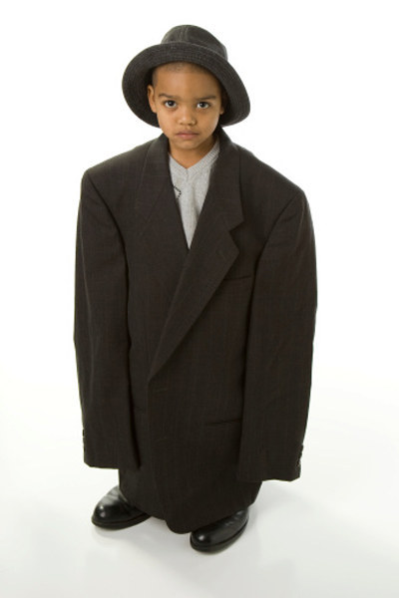

Clothes flashcards for role-playing
