Listening Speaking Reading Grammar Writing
Topic: New Year’s Resolution

Instructor:  Ji | Students Competency Level  Pre-intermediate | Number of Students:  10 | Lesson Length:  52min
Materials: (List the Names of all materials used in the lesson. Materials must be shown at the end of this document)
- White Board, Makers
- Pre-activity Cards
Card 1
Card 2
Card 3
Card 4
- Timeline
- Example Card
- Board Card
- Dice
Aims: (What students will be able to achieve by participating in the activities of the lesson. (Ss gain or get by doing…)
- Improve Ss listening skill by listening to T’s story, Ss stories, playing game and presentations.
- Improve Ss speaking skill by answering T and Ss, sharing stories, playing game
- Be able to use simple future tense ‘will’ and ’ be going to’ in the proper situation by understanding timeline and practicing with some example

Language Skills: (Lists what activities language skills students will be using by participating in the activities of the lesson.)
- Reading: (Where did reading occur in the lesson?)
Example Card, Timeline, Playing game
- Listening: (Where did listening occur in the lesson?)
T talk, Ss talk, playing game
- Speaking: (Where did speaking occur in the lesson?)
Sharing new year’s resolution
- Writing: (Where did writing occur in the lesson?)
Ss new year’s resolution

Language Systems: (Lists what language systems students will be using by participating in the activities of the lesson.)
- Phonology: (sound)
T talk, Ss presentation, Ss discussion by sharing their plans, playing game
- Function: (situation)
Sharing new year’s resolution
- Grammar: (language structure)
Simple future tense ‘Will vs Be going to’
- Discourse: (communication)
T-S-T, Ss presentations , sharing plans, playing game

Assumptions: (What students must already be able to do and what concepts must already be mastered before the lesson in order to achieve the aims of the lesson.)
- All Ss know future tense but don’t know the difference of ‘will’ and ‘be going to’
- All Ss can think about next year’s plan
- All Ss know how to do a board game
Anticipated Errors and Solutions: (What things might go wrong in the lesson and what the solution will be. An SOS activity should also be included)
- If Ss have difficulty to plan for next year: Help Ss by asking what was the the goal for last year you haven’t done for now.
- If Ss make a mistake to use future tense : Rephrase and respond.
- If Ss are slow: give more time to think.
References:

Lead-In or Pre-Task Part (Warm-Up Part to activate and create interest in the lesson.)
Materials: (List the Names of all materials used in the Lead-In or Pre-Task Part of the lesson. Materials must be shown at the end of this document)
None
Time: | Classroom Set Up: | Student Activity and Goals: | Teacher Procedure & Instructions:
2min  6min | W  W | Greet T  Listen to T.  Talk to T and other Ss | Greet Ss.  Start with my plan after the class.  Elicit Ss what is their plan after the class.  T rephrases if needed.

Pre-Activity or Task Familiarization Part (Presentation Part Presenting the language structure to be covered in the lesson. Prepares students for the communication activity.)
Materials: (List the Names of all materials used in the Pre-Activity or Task Familiarization Part of the lesson. Materials must be shown at the end of this document)
-Timeline for Future tense
-Example Card
- Pre-activity Cards
Card 1
Card 2
Card 3
Card 4
Time: | Classroom Set Up: | Student Activity and Goals: | Teacher Procedure & Instructions:
5min  4min | W  W | Ss listen and understand how to use ‘will’ and ‘be going to’  Ss look at the cards.  Take turn to make sentences. | Put timeline on the board.  Explain the difference of ‘will’ and ‘be going to’. Show Ss example card to get familiar to it.  Show Ss pre-activity card(#1-4)  Let Ss make sentence by using proper future tense.

Main Activity or Task Realization Part (Practice to Production Part Teacher lead practice of the language presented and move to communication based more student centered activity)
Materials: (List the Names of all materials used in the Main Activity or Task Realization Part of the lesson. Materials must be shown at the end of this document)
- Papers, Pens
Time: | Classroom Set Up: | Student Activity and Goals: | Teacher Procedure & Instructions:
3min  5min  5min  7min | W  Pairs  W | Ss listen to T.  Think about new year’s resolution. Write it down.  Work in pairs.  Do presentation with a partner’s new year’s resolution.  Listen and respond to T. | T introduces ‘New Year’s Resolution’  Ask Ss think about their new goal for 2016. Make it 5 things by using future tense( ‘will’ or ‘be going to’)  Let Ss work in pairs. And share their plan each other.  T starts presentation followed by students.  Give positive feedback.

Post Activity or Post Task Part (Wrap-Up Part Close the Lesson on a high note to and consolidate language learned in a communication based activity new situation.)
Materials: (List the Names of all materials used in the Post Activity or Post Task Part of the lesson. Materials must be shown at the end of this document)
-Board Card
-Dice
Time: | Classroom Set Up: | Student Activity and Goals: | Teacher Procedure Instructions:
2min  10min  3min | W  W  W | Listen to T’s instruction and prepare for the game.  Ss play game with T.  Listen to T.  Say goodbye. | Introduce Board game for future tense. Put the game board on the white board.  Ask Ss to come to the front to play the game. T starts first.  Congratulate the winner and thank Ss for participating. Give a good comment.  Close the class.

Timeline

Will(’ll)
Decision
Now

….I’ll ........

PAST NOW FUTURE

Be going to

Decision
before

…….I’m going to……..……

PAST NOW FUTURE

Example card

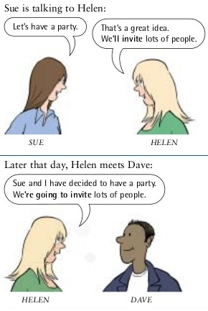

Pre Activity Card

Card #1

A: Hello. Can I speak to Amy, please?
B: Just a minute. him. ( I / get )

Card #2
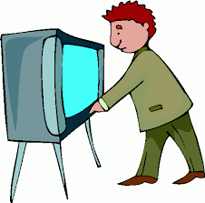.
A: Why are you turning on the TV?
B: the news. ( I / watch)

Card #3
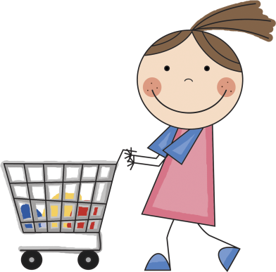

A: Where are you going? Are you going shopping?
B: Yes. some things for dinner. ( I / buy)

Card #4
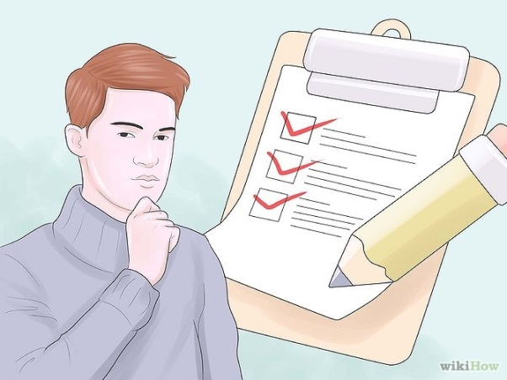
There was a job advertised in the website. At first you were interested, but then you decided not to apply.
A: Have you decided what to do about that job you were interested in?
B: Yes, for it. ( I / not / apply )

Board Game

