Topic: It’s a Month Until Christmas
Instructor: | Level: | Age: | Number of Students: | Length:
Jihye Kang,  Jinyong Kim | Low Intermediate | adults | 12 | 25 minutes
Materials:
- Picture
- Sticky preposition plates
- 12 copies of the practice worksheet
- 12 copies of the discussion worksheet
- White board and board markers
Aims:
- SWBAT predict the usage of prepositions of location by answering questions during the present phase
- SWBAT learn and also use prepositions of location while practicing during the practice phase
- SWBAT describe the decorations in the room using prepositions of location by sharing their ideas with group members
- SWBAT learn and define some new decorations used on Christmas day by arranging them beautifully with group members
- SWBAT suggest their own ideas to decorate the party room nicely during discussion
- SWBAT compare their results with others by watching other teams’ presentations
- SWBAT share ideas in a group and present each other’s opinions.
Language Skills:
- Reading: reading worksheets to answer questions
- Listening: listening to teacher’s explanation and instructions, and classmates’ ideas
- Speaking: drilling, practice activities, and sharing ideas
- Writing: answering worksheets and doing homework
Language Systems:
- Lexis: new vocabulary words in the discussion worksheets
- Grammar: use of prepositions of location
- Discourse: sharing and discussing ideas for decorating Christmas party room
- Function: describing the room and giving ideas
Assumptions:
- Students might already have learned the usage of prepositions before
- Students might already have been familiar with some location prepositions
- Some students might have party experiences
- Some students might be good at decorating a party room
- Students might know the teacher style of teaching and the pace of the course
- Students might know how the class is set up and run ( there will be 4 students groups at each table)
Anticipated Errors and Solutions:
- Students might have difficulty in understanding the meaning
- Teacher provides more examples
- Students might have a hard time drilling
- Teacher gives the students more chances to practice
- If students need more time to finish their activity
- Be flexible with the time as giving students more time to finish their activity and cut off the time of post activity
- If students finish their tasks earlier than anticipated
- Give students more time on final activity
References:
- CGBen. (2015, November 25). It's a month until Christmas - how ready are you for the big day? Retrieved November 27, 2015, from
http://www.cornishguardian.co.uk/s-month-Christmas-ready-big-day/story-28241456-detail/story.html#ixzz3st5OeWe7
- Position Prepositions. (n.d.). In Englishpage.com. Retrieved November 25, 2015, from http://www.englishpage.com/prepositions/position_prepositions_1.htm
Notes:

Presentation:
Aims:  - SWBAT predict the usage of prepositions of location by answering questions during the present phase |  |  | Materials:  - Picture  - Sticky preposition plates  - White board and board markers
Time | Set Up | Student |  | Teacher
4 min  4 min | Whole Class  Whole Class | Students answer the question  Students answer the question  Students answer the question  Students answer the question  Students listen to teacher’s explanations  Students answer the question  Students answer the question  Students answer the question  Students answer the question  Students answer the question  Students answer the question  Students answer the question  S1 and S2 attach the right preposition on the board  Students repeat after what teacher says  Students answer the questions |  | Lead-In  Hello, everyone.  How are you today?  It’s very cold outside. Right?  Time flies. And It’s a month until Christmas.  Exciting! As you know, We will have a big event on 19th this month. What is it?  Yes, Christmas party!  We are going to decorate the party room today. In order that we will learn about some location prepositions to decorate the party room.  (Pointing the board).  Do you know what is preposition?  Right,  Ok, We are going to learn about 9 location prepositions.  Are you familiar with what these are?  Explanation  In – into a place  Above – in a higher position than something(=over)  “In” means into a place and “Above” means a higher position than something  For example,  “the ring is in the box”  And you can also say,  “The ring above the box”  Where is the ring?  Good job.  On – “touching” a surface  “On” means touching a surface.  Like this [picture]  Where is the ring?  Right!  Below – in a lower position than something  “Below means in a lower position than something. So, where is the apple?  Ok,  Behind – at the back of a thing  Behind means at the back of a thing.  Where am I standing?  [standing behind John]  Good job,  Against – touching or in contact with  Beside – next to or close to  Against means “touching or in contact” with and beside means next to or close.  So, look at this picture,  Where is the ring?  Right!  Among – with a particular group(more than two)  Around – surrounding something  Among means with a particular group more than two and around means surrounding something.  Look at this picture,  The ring among the box. Is it correct?  You’re right! Because there is only one box.  Look at this picture,  ->the ring is among the boxes.  And you can also say,  The boxes are around the ring.  Alright!  Error Correction  You can confuse the prepositions.  Beside and besides.  Do you know besides meaning?  Yes, right. Besides means apart from or excepting. So It means totally different to beside!  Drills  Look at the Picture,  And Please attach the right preposition on the board.  S1 and S2, Would you?  There is wreath above the fireplace.  There is a fireplace below the wreath.  There is a Christmas tree behind the table.  There is a dog beside the club sofa.  ----------------------------------------  There are 2 vases among candles on the table.  There are many X-mas decorations in the house.  There are curtains against the wall.  There are candles on the fireplace.  The candles on the table are around the vases.  Good job!  CCQs  (Pointing the picture)  - Where is the wreath?  - Where are the long candles?  - What is the around the vases?
Notes:
Practice:
Aims:  - SWBAT learn and also use prepositions of locations while practicing during the practice phase |  |  | Materials:  - 12 copies of the practice worksheet  - White board and board markers
Time | Set Up | Student |  | Teacher
3 min  3 min | Whole Class  Pairs  Whole Class | Students listen to what teacher says  Students answer the questions in pairs  Students listen to what teacher says  From Grace, students make their own sentences using the prepositions on the board |  | 1. Controlled Practice  instructions  Let’s exercise in pairs. I will give you two versions of worksheets for each pair. (studentA and studentB version). So, make a pair with a partner next to you, and take turns answering the questions. Student A has the answers for student B and vice versa, okay? Student A should go first.  I will give you 3 minutes.  (Pass out the worksheet and run task)  (Monitor discreetly. Answer students if they ask questions)  (Give time warning: 30 seconds left)  Do you need more time to do this?  (If yes – give 30 seconds extra time  If no – move on to the next activity)  2. Less-Controlled Practice  Instructions  Now, we will do a chain-drill activity. I will start by making a sentence with one of the prepositions on the board and I will pick one of you guys. And the next person who is picked will make a sentence using another preposition on the board and point out someone else. We will go around until every preposition has gone from the board.  Demonstration  I will go first using the preposition “in”. We are in the classroom. I made a sentence.  And I am going to get rid of this preposition form the board. And I will pick Grace as the next person. Grace, please make a sentence using one of the prepositions on the board.
Notes:
Production:
Aims:  - SWBAT describe the decorations in the room using prepositions of location by sharing their ideas with group members  - SWBAT learn and define some new decorations used on Christmas day by arranging them beautifully with group members  - SWBAT suggest their own ideas to decorate the party room nicely during discussion  - SWBAT practice speaking and listening ability by sharing ideas in a group and presenting each other’s opinion. |  |  | Materials:  - 12 copies of the discussion worksheet #1,2  - White board and board markers
Time | Set Up | Student |  | Teacher
1 min  5 min  3 min | Whole class  Groups  Whole Class | Students listen to what teacher says  Students answer the questions  Students share their ideas  One group presents their ideas |  | Instructions  Like teacher Katie mentioned before, there will be a TESOL Christmas party on 19th of December. So, from now on, we are going to decorate our own party room in groups. I will give you two pieces of paper for each group. There are some decorations, furniture and equipment that you can use in decorating a party room on worksheet #2. What you need to do is share your ideas with your group members to make the best party room we have ever had using the worksheet #1. You don’t need to draw all the details, just decide the locations for each item. Make sure to use the location prepositions that we have learned when you talk.  Demonstration  For example, I can say ”why don’t we put a Christmas tree next to the front door and put some present boxes in front of the tree.”  And you can also use any number of items as you wish. For example, you can have just one desk or 10 desks if you want. You have 5minutes.  CCQs  What will you do?  Who do you work with?  Let’s get started.  (Monitor discreetly. Answer students if they ask questions)  (Give time warning: 30 seconds left)  Presentation  Now let’s share your final results with the whole class.  Which team wants to share the ideas? Okay then, I will pick one. Group #1, please come up here and describe your group’s party room.  (Let them describe their own party room. Go through all groups)
Notes:
Post Production:
Aims:  - SWBAT compare their results with others by watching other teams’ presentations |  |  | Materials:  - White board and board markers
Time | Set Up | Student |  | Teacher
1 min | Whole Class | Students answer the question  Students listen to what teacher says |  | Closing  What did you learn today?  (If there is time, check the error correction using the board again – beside/besides)  I hope we can have a wonderful Christmas party together.  Homework  Describe your own room using the all the prepositions of location that we learned today.  We will talk about prepositions of time next lesson. Bye, bye.
Notes:

Practice Worksheet
<Student A>
- Santa is sitting (among/between/on) a chair.
- The girl is standing next to Santa.
- (Behind/Between/Besides) the girl, there is a Christmas tree.
- There are more presents under the tree.
- Santa’s big bag is lying (below/on/above) the floor.
- The girl is standing between the two boys.
- The woman is holding a cup (below/in/above) her hands.
- On the table are a laptop, a paper, a calculator, an appointment, two pens and a muffin.
- Our teacher stands (under/above/in front of) the class.
- We have posters on the walls.
- The wall is (behind/in front of/above) her desk.
- Joe and Alan sit beside each other.
- There’s a wastepaper basket (on/next/under) her desk.
- Above the teacher’s desk is a clock.
- Tom sits (between/in front of/near to) Lucy and James.

Practice Worksheet
<Student B>
- Santa is sitting on a chair.
- The girl is standing (besides/next/next to) Santa.
- Behind the girl, there is a Christmas tree.
- There are more presents (on/under/above) the tree.
- Santa’s big bag is lying on the floor.
- The girl is standing (between/besides/on) the two boys.
- The woman is holding a cup in her hands.
- (On/next/over) the table are a laptop, a paper, a calculator, an appointment, two pens and a muffin.
- Our teacher stands in front of the class.
- We have posters (above/on/on top of) the walls.
- The wall is behind her desk.
- Joe and Alan sit (between/beside/next) each other.
- There’s a wastepaper basket under her desk.
- (On top/Opposite/Above) the teacher’s desk is a clock.
- Tom sits between Lucy and James.

Discussion Worksheet #1:
Decorating a Christmas Party Room

White board

Front door
Windows

Back door

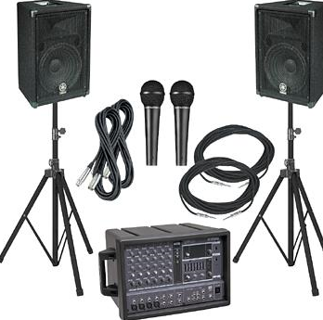
Discussion Worksheet #2
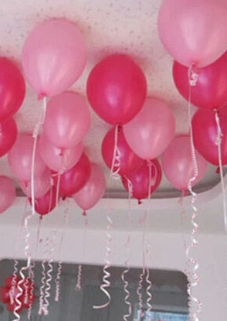
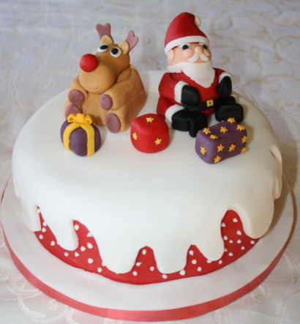
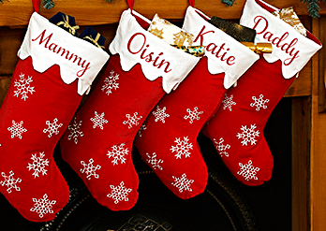
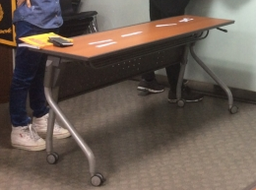
Wreath

