Listening Speaking Reading Grammar Writing
Topic:China & Cars: A Love Story
Instructor:  Michael | Students Competency Level  Upper-intermediate | Number of Students:  4 | Lesson Length:  51 minutes
Materials:(List the Names of all materials used in the lesson. Materials must be shown at the end of this document)
- Whiteboard and Marker
- Pictures
- The Chaos in Beijing traffic jam
- Beijing Air Pollution At Dangerously High Levels
- A Luxury Car in front of the Great Hall of the People in Beijing.
-Workers Polishing up a Rolls-Royce outside a Petrol Station in Beijing.
- Flash Cards
-Words And Their Definitions
-Idioms and their definitions

- Authentic Article
- China & Cars: A Love Story
- Worksheets
- Reading Comprehension
- COLLOCATIONS
- QUESTION TAGS
- IDIOMS
- HOMEWORK
- Answers Sheets
Aims:(What students will be able to achieve by participating in the activities of the lesson. (Ss gain or get by doing…)
- Ss get the main idea by skimming the reading text and answering a guiding question.
- Ssguess the meaning of new words and find their uses by completing a definition-matching worksheet.
- Ss improve speaking and listening ability by sharing ideas in groups.
- Ss improve scanning skill by answering comprehension questions.
Language Skills:(Lists what activities language skills students will be using by participating in the activities of the lesson.)
- Reading: (Where did reading occur in the lesson?)
Reading the text and worksheets
- Listening:(Where did listening occur in the lesson?)
Listening to the teacher and classmates speaking
- Speaking: (Where did speaking occur in the lesson?)
Group discussions
- Writing: (Where did writing occur in the lesson?)
Taking a note of their classmates’ opinions during the group discussion.
Language Systems: (Lists what language systems students will be using by participating in the activities of the lesson.)
- Phonology: (sound)
Discussion, teacher talk
- Function:(situation)
Showing surprise or annoyance.
- Lexis: (meaning)
Matching new words and idioms to their definitions
- Grammar:(language structure)
Question Tags
- Discourse: (communication)
Discussion, responding teacher
Assumptions:(What students must already be able to do and what concepts must already be mastered before the lesson in order to achieve the aims of the lesson.)
Students already know:
- how the class is set up and run
- the teacher’s style of teaching and the pace of the course
- how tophrase their idea into full sentences in English
- how to work together with their classmates
- how to skim and scan

Anticipated Errors and Solutions:(What things might go wrong in the lesson and what the solution will be. An SOS activity should also be included)
If Ss may not have many ideas -> Solution : T gives them little examples
If activity lasts too long -> Solution : T cuts the unnecessary parts
If activity finishes too soon-> Solution : T makes suggestions and shares ideas
If Ss may not understand -> Solution: T shows demonstration.
If certain Ss are shy -> Solution: T encourages them, gives positive feedback , and changes roles for them.
References:http://www.guardian.co.uk/world/2012/dec/14/china-worlds-biggest-new-car-market

Lead-In or Pre-Task Part (Warm-Up Part to activate and create interest in the lesson.)
Materials: (List the Names of all materials used in the Lead-Inor Pre-Task Partof the lesson. Materials must be shown at the end of this document)
- Whiteboard and Marker
- Pictures
- The Chaos in Beijing Traffic Jam
- Beijing Air Pollution At Dangerously High Levels
Time: | Classroom Set Up: | Student Activity and Goals: | Teacher Procedure &Instructions:
1min  3min  5min | Whole  Whole  Whole | Ss greet the teacher  Ss listen to the teacher and respond  Ss discuss their opinion | Greeting  Show pictures and ask Ss to guess where the place is and what you see  Tell Ss China has a growing problem with cars in the main cities causing congestion and pollution. On average 2000 cars are added to the streets of Beijing a day.  Tell the students that they are on the Transport Committee in Beijing, they are going to be having a meeting where they need to brainstorm as many proposals as possible to deal with traffic congestion problem, and then decide on a solution.

Pre-Activity or Task Familiarization Part (Presentation PartPresenting the language structure to be covered in the lesson. Prepares students for the communication activity.)
Materials: (List the Names of all materials used in the Pre-Activity or Task Familiarization Part of the lesson. Materials must be shown at the end of this document)
- Whiteboard and Marker
- Flash Cards
-Words And Their Definitions

Time: | Classroom Set Up: | Student Activity and Goals: | Teacher Procedure &Instructions:
1min  5min | Group  Group | Ss move into group  Ss match words and their definition | Get Ss to come out and divide Ss into group  Place Words flash cards on the desk and  get the students to come out and match words to their definition

Main Activity or Task Realization Part(Practice to Production PartTeacher lead practice of the language presented and move to communication based more student centered activity)
Materials: (List the Names of all materials used in the Main Activity or Task Realization Partof the lesson. Materials must be shown at the end of this document)
- Whiteboard and Markers
- Pictures
- A Luxury Car in front of the Great Hall of the People in Beijing.
-Workers Polishing up a Rolls-Royce outside a Petrol Station in Beijing.
- Authentic Article
- China & Cars: A Love Story
- Worksheets
- Reading Comprehension
- COLLOCATIONS
- IDIOMS
- QUESTION TAGS

Time: | Classroom Set Up: | Student Activity and Goals: | Teacher Procedure &Instructions:
3min  7min  5min  3min  5min  5min | Whole  Group  Group  Group  Group  Group | Ss listen to and respond to the teacher  Ss read the text silently  Ss answer the questions  Ss match the collocations and respond to teacher  Ss match the idioms with the definitions  Ss add question tags and say each other | Show Picture 3,4 and ask some questions  (Do you know how much a car costs in China?  Do you know what the average annual income is in Beijing?  Why do you think the Chinese still want to spend their hard earned salaries on a vehicle? )  Divide Ss to group  Get Ss to read through the text  Get Ss to answer the questions on reading comprehension worksheet  Ask Ss where they could find the answers  Get Ss to match the collocations without looking back at the text, and then suggest your own collocations and ask their suggestion and tell right answer.  Put idiom flash cards on the desk and get Ss to come out and match the idiom with the definition, and then fill the missing idiom in the sentences below  Get Ss to add question tags to either both or one of the following sentences, and then practice saying them with the correct intonation:

Post Activity or Post Task Part (Wrap-Up PartClose the Lesson on a high note to and consolidate language learned in a communication based activity new situation.)
Materials: (List the Names of all materials used in the Post Activity or Post Task Part of the lesson. Materials must be shown at the end of this document)
- Whiteboard and Marker
- Worksheet
- Flash cards
- - IDIOMS
- Answers Sheets

Time: | Classroom Set Up: | Student Activity and Goals: | Teacher Procedure Instructions:
5 min  3min | Group  Whole | Ss practice IDIOMS  Ss listen to the teacher | Write the idioms onto flashcards and place them face down on the table. The students need to take turns drawing an idiom, so that the others can guess it, and then ask each other questions with that idiom.  HOMEWORK  Get Ss to go through the text and underline all the phrasal verbs. Then they need to find a synonym or a definition for that phrasal verb in the context that it is used in the text:

Picture 1
The Chaos in Beijing Traffic Jam

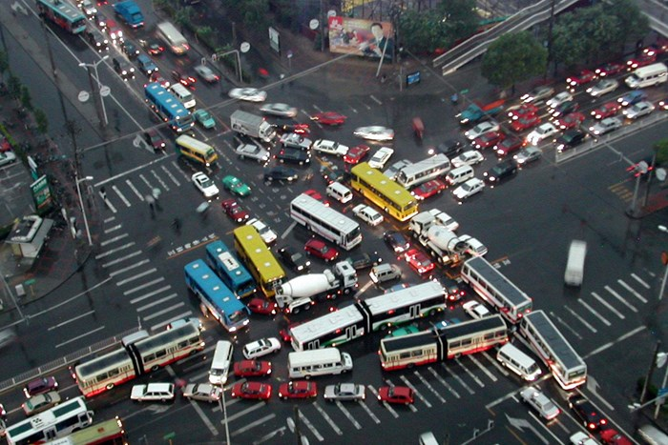
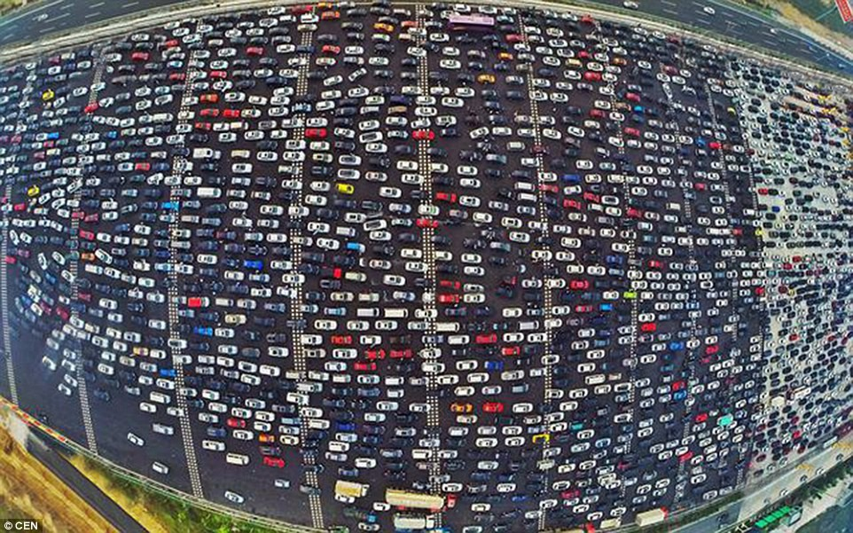

Picture 2
Beijing Air Pollution At Dangerously High Levels
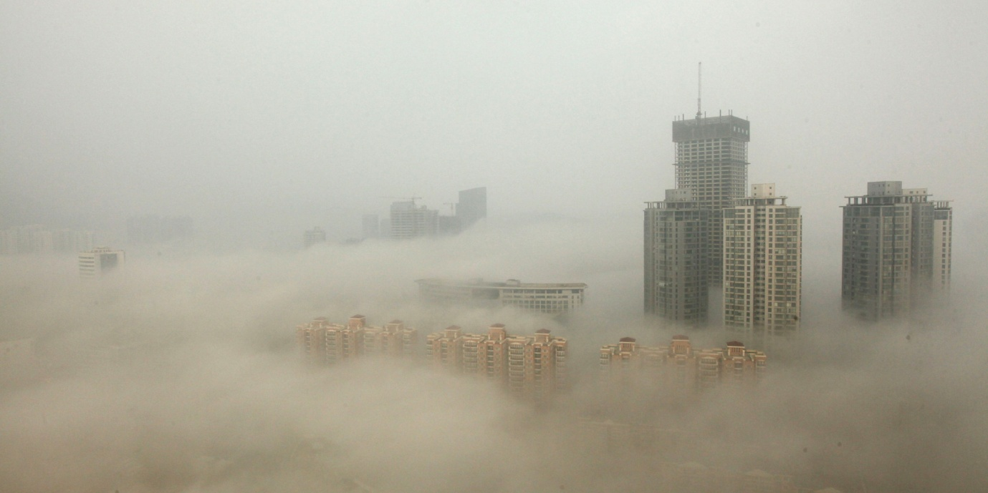

Picture 3
ALuxury in front of the Great Hall of the People in Beijing

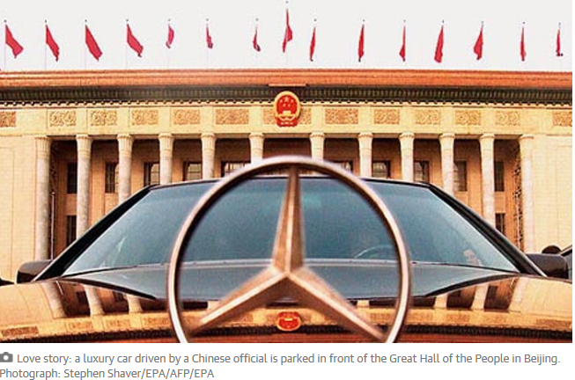

Picture 4
Workers Polishing up a Rolls-Royce outside a Petrol Station in Beijing
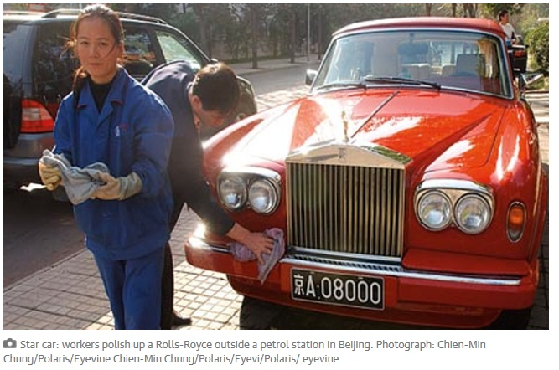

Flash Cards
Words AndTheir Definitions

to acquire | to buy or obtain for oneself
loiter | to stand or wait around without an apparent purpose
glimpse | to see something briefly or partially
soar | to climb swiftly
striking | attracting attention, impressive
get out of hand | to not be in control anymore
eligible | qualified to be chosen (especially for marriage)
impecunious | to have little or no money, penniless

1. at a crossroads | a. to do something with as much speed and energy as you can
2. climb on the bandwagon | b. to do something enthusiastically and as completely as possible, especially if this involves spending a lot of money
3. to go full throttle | c. you are at a point where an important decision  or choice has to be made
4. to go to town | d. to do something just when it happens, not in advance
5. to cross that road/bridge when I come to it | e. to do something because it is popular  and everyone else is doing it
Idioms and their Definitions

- Authentic Article
CHINA AND CARS: A LOVE STORY
It is half a century since Zhang Jing's father impressed the neighbours with a mark of his family's rising fortunes.He was the first in the village to acquire a bicycle. Though America was deep in the golden age of the automobile, those days lay so farahead for China that small boys would loiter on street corners in Beijing, waiting until a car drove by and theexotic tang of petrol fumes filled their nostrils. Even by the early 1980s, glimpses of imported Soviet Ladas orstately Chinese Red Flag saloons were rare outside the capital"

China's love affair with cars began late, but it has more than made up for the delay. In 2000 there were 4m cars for the 1.3bn population and experts predicted that the number would be six times higher by the end of the decade. Instead, it soared 20-fold. But at 220,000 to 400,000 yuan – £22,000 to £40,000 – the cars are a hefty investment in a city (Beijing) where last year the average (annual) income was about 33,000 yuan.

Some believe that the US has reached "peak car . In the US, there are around 600 cars per 1,000people, against a global average of 135, according to the Economist Intelligence Unit. In China? Just 44. Meanwhile, officials have used infrastructure construction to shore up GDP figures and promote development across the country. If Beijing's six ring roads are striking, the national network's expansion is more so.

In 2000,there were 16,000km (11,000 miles) of expressway, according to state media " .It really likes the fact that 95%of cars on the road are built here, thanks to very high tariffs on imported cars. It means investment in factories,jobs, tax revenues. On the other hand, [it is] suddenly confronted with the potential risks to national security inthat it is more than ever reliant on imported oil. How do you feed this monster. They are saying: we have to manage this, because it's big and it could get out of hand."
China is roughly the same size as the US, but its population is four times bigger, and the downsides of car growthare already obvious. In 2011 alone, 62,387 people were killed on the roads, according to the police. Although those figures show the toll declining from a peak in 2002, other researchers question the data and thedownwards trend. In 2007, they point out, police recorded 81,649 deaths on the roads, whereas death registrations suggested that crashes killed 221,135.
The problems are becoming so bad that Beijing has banned motorists from driving one day a week and limited new car registrations through a lottery system. In 2010, some 790,000 cars were added to the capital's roads –more than 2,000 a day. In October they said they would consider ordering odd and even-numbered licence plates to drive at alternate times in specific areas. Shanghai has also taken action and Guangzhou hopes that similar measures will halve the number of new vehicles. Chongqing, a south-westernmetropolis, has discussed introducing a congestion charge

Zhang Penghao is in search of his first car, without a great deal of enthusiasm. Despite his friendly smile, his eyes are gloomy behind his heavy glasses." His only reason for buying a vehicle is to improve his eligibility. "If a girl can see you didn't drive to pick her up, she won't bother coming out. It is no coincidence that the soundbite that has come to sum up modern Chinese materialism centres on a car. When a dating show contestant rebuffed an impecunious suitor with the words, "I would rather cry in the back of a BMW than laugh on the back of a bicycle", they instantly became part of popular lore. Chinese motorists know they must impress, whether they are seeking partners for romance or business. Roll up in an Audi and you ensure a basic degree of respect. Arrive in a domestic Chery QQ hatchback and you are doomed before you get through a client's door. "People don't really think about whether they need a car, but feel they have to have one to show their status

Worksheets

Reading Comprehension
Read through the text and answer the following questions:
- How does car ownership in China compare with the rest of the world?

- Would the Chinese government like to see the motor industry in China grow or not?

- Is police data about road fatalities in China accurate?

- What proposals have been implemented and which ideas have been put forward in Beijing to reduce trafficcongestion?

5. What are the main reasons for people in China wanting a car?

COLLOCATIONS
Match the collocations without looking back at the text, and then suggest your own collocations:

Ringroads imported Soviet Ladas suitor
on street corners a bicycle 20-fold

Your own suggestions:
to acquire _________________ ____________________

to loiter _________________ ____________________

to glimpse _________________ ____________________

to soar _________________ ____________________

striking _________________ ____________________

impecunious ________________ ____________________

IDIOMS
Match the idiom with the definition, and then fill the missing idiom in the sentences below:

1. at a crossroads | a. to do something with as much speed and energy as you can
2. climb on the bandwagon | b. to do something enthusiastically and as completely as possible,especially if this involves spending a lot of money
3. to go full throttle | c. you are at a point where an important decision  or choice has to bemade
4. to go to town | d. to do something just when it happens, not in advance
5. to cross that road/bridge when I come to it | e. to do something because it is popular  and everyone else is doing it

1. She’s not really interested in protesting against the government. She is just __________________________because all her friends are doing it.
2. They really _______________________ for their wedding. It must have cost a fortune!
3. I’m not going to worry about that now, it might never happen!
I’ll __________________________________.
4. We’re really __________________________________ at the moment. We could stay here or move toanother country.
5. If you want your business to succeed, you need _____________________________.

QUESTION TAGS
We often use question tags to show surprise and disbelief:
NOTE: If we want to express surprise or annoyance, we can use a positive question tag with a positive sentence.
You didn’t really go there, did you? It’s an awful place, isn’t it?
It’s snowing, is it? We’d better dress warmly, hadn’t we!

Add question tags to either both or one of the following sentences, and then practice saying them with thecorrect intonation:
1. He was loitering outside the cinema. He wouldn’t be there now.
2. He acquired a new Porsche. He couldn’t have got the money legally.
3. You caught a glimpse of her wedding dress. It’s beautiful.
4. The prices have soared. That’s outrageous.
5. That’s a striking hat. It must have cost a fortune.
6. He’s impecunious. He doesn’t look it.
7. You aren’t eligible for the prize. You’re too old.
8. His behavior is getting out of hand. Well, do something about it!

- Answers sheets

Reading Comprehension
Get the students to read through the text and answer the following questions:
1. How does car ownership in China compare with the rest of the world? It is very low (44 cars per 1000 people),well below the rest of the world (135 cars per 1000 people)

2. Would the Chinese government like to see the motor industry in China grow or not? They would like it togrow because it provides jobs and tax revenue, although they are concerned about being dependent onimported oil.

3. Is police data about road fatalities in China accurate? No, there were more registered deaths in car crashesthan on the police records.

4. What proposals have been implemented and which ideas have been put forward in Beijing to reduce trafficcongestion? Implemented - motorists are banned from driving one day a week. Proposals – licence plates willbe odd or even number, and restrict drivers to times and locations

5. What are the main reasons for people in China wanting a car? Status, to be acceptable for marriage, to getbusiness contracts

COLLOCATIONS
Get the students to match the collocations without looking back at the text:
to acquire a bicycle, to loiter on street corners, to glimpse imported Soviet Ladas, to soar 20-fold, striking ringroads, impecunious suitor

QUESTION TAGS
Answers:
NOTE: If we want to express surprise, doubt or annoyance, we can use a positive question tag with a positive
sentence.
1. He was loitering outside the cinema, was he? He wouldn’t be there now, would he?
2. He acquired a new Porsche, did he? He couldn’t have got the money legally, could he?
3. You caught a glimpse of her wedding dress, did you? It’s beautiful, isn’t it!
4. The prices have soared, have they? That’s outrageous, isn’t it?
5. That’s a striking hat, isn’t it! It must have cost a fortune, mustn’t it!
6. He’s impecunious, is he? He doesn’t look it, does he?
7. You aren’t eligible for the prize, are you? You’re too old, aren’t you?
8. His behavior is getting out of hand, is it? Well, do something about it!

IDIOMS
Answers:
1c, 2e, 3a, 4b, 5d
1. She’s not really interested in protesting against the government, She is just climbing on the bandwagonbecause all her friends are doing it.
2. They really went to town for their wedding. It must have cost a fortune!
3. I’m not going to worry about that now, it might never happen! I’ll cross that road/bridge when I come to it.
4. We’re really at a crossroads at the moment. We could stay here or move to another country.
5. If you want your business to succeed, you need to go full throttle.

HOMEWORK
Get the students to go through the text and underline all the phrasal verbs. Then they need to find a synonym ora definition for that phrasal verb in the context that it is used in the text:

Answers:

made up for to do something more quickly or more often because something prevented you from making progress before

shore up to support, to prop up

reliant on Dependent

point out to notice and comment

drop off to deliver

pick up to collect

sum up a brief statement that presents the main points in a concise form

roll up to arrive by car

