Listening Speaking Reading Grammar Writing
Topic:Truth Seekers
(Language Target : PAST PERFECT)
Instructor:  Michael | Students Competency Level  Pre-intermediate | Number of Students:  4 | Lesson Length:  58minutes
Materials: (List the Names of all materials used in the lesson. Materials must be shown at the end of this document)

- Picture1
- Picture2
- Picture3
- Picture4
- Picture5
- Drilling Wall Chart
- PAST PERFECT
- Timeline
- SENTENCES
Subject + had + (adverb) + past participle
- QUESTIONS
Had (not) + subject + (adverb) + past participle
- Truth Seekers Worksheet
- CLUE CARDS: John’sday
- CLUE CARDS: Alice’s day
- PC
- Beam projector
Aims:(What students will be able to achieve by participating in the activities of the lesson. (Ss gain or get by doing…)
-Improve Ss grammar skills about Past Perfect tense by T practicing Past Perfect exercises and activities for Ss .
-Improve Ss listening skills by listening T’s story, Ss’ story, playing games and presentations.
-Improve Ss speaking skills by answering T , Ss presentations, sharing stories, drilling and playing games.

Language Skills:(Lists what activities language skills students will be using by participating in the activities of the lesson.)
- Reading: (Where did reading occur in the lesson?)
drilling wall chart, writing sentences
- Listening:(Where did listening occur in the lesson?)
teacher talk, Ss talk , game
- Speaking: (Where did speaking occur in the lesson?)
sharing Ss stories about activities happened.
- Writing: (Where did writing occur in the lesson?)
taking a note of their classmates’ opinions during the group discussion.
writing sentences using the Past Perfect
Language Systems: (Lists what language systems students will be using by participating in the activities of the lesson.)
- Phonology: (sound)
drilling , Discussion, T and Ss talk
- Lexis: (meaning)
Past Perfect use writing activities and historical events
- Grammar:(language structure)
Past Perfect
- Discourse: (communication)
discussion, responding teacher, sharing stories, drilling and playing games
Assumptions:(What students must already be able to do and what concepts must already be mastered before the lesson in order to achieve the aims of the lesson.)
Students already know:
- how the class is set up and run
- the teacher’s style of teaching and the pace of the course
- how to phrase their idea into full sentences in English
- how to work together with their classmates
- how to know the use of present perfect tense and past tense.

Anticipated Errors and Solutions:(What things might go wrong in the lesson and what the solution will be. An SOS activity should also be included)
If Ss may not have many ideas -> Solution : T gives them little examples
If activity lasts too long -> Solution : T cuts the unnecessary parts
If activity finishes too soon-> Solution : T makes suggestions and shares ideas
If Ss may not understand -> Solution: T shows demonstration.
If certain Ss are shy -> Solution: T encourages them, gives positive feedback , and changes roles for them.
If Ss take a long time to make sentences -> Solution: T never push Ss, give more time and encourage them.

References: None

Lead-In or Pre-Task Part (Warm-Up Part to activate and create interest in the lesson.)
Materials: (List the Names of all materials used in the Lead-I nor Pre-Task Part of the lesson. Materials must be shown at the end of this document)
- Whiteboard and Marker
- Picture 1
- PC
- Beam projector
Time: | Classroom Set Up: | Student Activity and Goals: | Teacher Procedure &Instructions:
1min  4min | Whole  Whole | Ss greet the teacher  Ss listen to the teacher and respond | Greeting  Show Picture 1  Tell Ss T’s story what happened to me last month.  (When I arrived to the train station , the train had already left. )

Pre-Activity or Task Familiarization Part (Presentation Part Presenting the language structure to be covered in the lesson. Prepares students for the communication activity.)
Materials: (List the Names of all materials used in the Pre-Activity or Task Familiarization Part of the lesson. Materials must be shown at the end of this document)

- Whiteboard and Marker
- Picture 2
- Picture 3
- Picture4
- Picture 5
- Drilling Wall Chart
- PAST PERFECT
- Timeline
- SENTENCES
- QUESTIONS
- PC
- Beam projector
Time: | Classroom Set Up: | Student Activity and Goals: | Teacher Procedure &Instructions:
5min  5min | Whole  Whole | Ss listen to the teacher and respond  Ss listen to the teacher and respond | Elicit the grammar from Ss  (Show Picture 2,3 )  First elicit the grammar structure, then the uses, and some example sentences as you go along.  (Show Picture 4,5 )  Describe the formula through Drilling Wall charts

Main Activity or Task Realization Part(Practice to Production Part Teacher lead practice of the language presented and move to communication based more student centered activity)
Materials: (List the Names of all materials used in the Main Activity or Task Realization Part of the lesson. Materials must be shown at the end of this document)
- Whiteboard and Marker
- Truth Seekers Worksheet

Time: | Classroom Set Up: | Student Activity and Goals: | Teacher Procedure &Instructions:
1min  1min  2min  1min  1min  4min  15min | whole  whole  whole  Group  Group  Group  Group | Ss receive worksheet  Ss match the activity  Ss listen to the teacher and respond  Ss listen to and respond to the teacher  Ss listen to and respond to the teacher  Ss listen to and respond to the teacher  Ss listen to and respond to the teacher | Hand out one copy of the worksheet to each student.  Ask the students to match each activity with one of the pictures and then write the activity below. Once the students have finished, go through the answers.  Next, explain to the students that they must put a cross through one activity in each category, e.g.  by the time you were 7 / learn to swim.  Tell Students should not show their classmates their selections.  After that, divide the students into pairs.  Explain that the students are going to take turns asking and answering questions using the past perfect to talk about their experiences of growing up.  They do this by talking about the activities in the pictures.  When their partner asks about the activities that are crossed out, students have to lie about their experiences.  When talking about experiences that are not crossed out, they tell the truth.  Model the activity by asking a student to read Student A in the dialogue at the bottom of the worksheet.  Elicit more follow-up questions from the class and lie about the answers.  Then, ask the class to guess if you are telling the truth or lying.  Then, start the activity.  Go round the class and monitor the conversations as the students ask and answer questions.  Encourage the students to ask follow-up questions to find out if their partner is telling the truth or lying.

Post Activity or Post Task Part (Wrap-Up Part Close the Lesson on a high note to and consolidate language learned in a communication based activity new situation.)
Materials: (List the Names of all materials used in the Post Activity or Post Task Part of the lesson. Materials must be shown at the end of this document)
- Whiteboard and Marker
- CLUE CARDS: John’s day
- CLUE CARDS: Alice’s day
Time: | Classroom Set Up: | Student Activity and Goals: | Teacher Procedure Instructions:
2 min  15min  1min | whole  Group  whole | Ss listen to and respond to the teacher  Ss listen to and enjoy the activity .  Ss give feedback | Give a clue card to each student.  Tell students that some of the cards have information about John’s day, some have information about Alice’s day. At some point John and Alice met and decided to go out to dinner. The aim of the puzzle is to find out where John and Alice could have met each other  Sort Ss into two groups: John’s day and Alice’s day;  Get Ss to exchange information on their cards to arrange themselves in chronological order from the beginning of the day to the end;  Tell the other group about the events of the day and work out where Alice and John met.  Answer: They met at Susie and Tom’s  Ask Ss whether they enjoy the Activity or not.  (Listen to Ss feedback on the activity.)
Picture 1
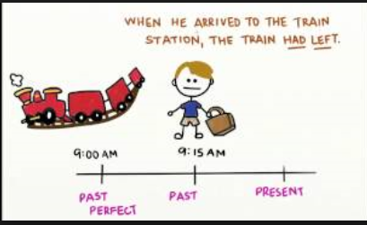

Picture 2
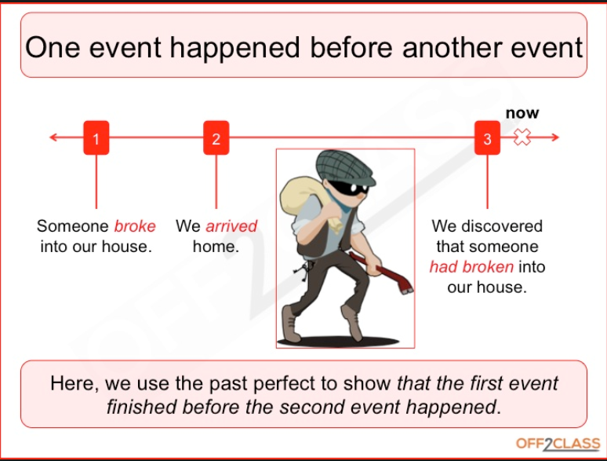

Picture 3
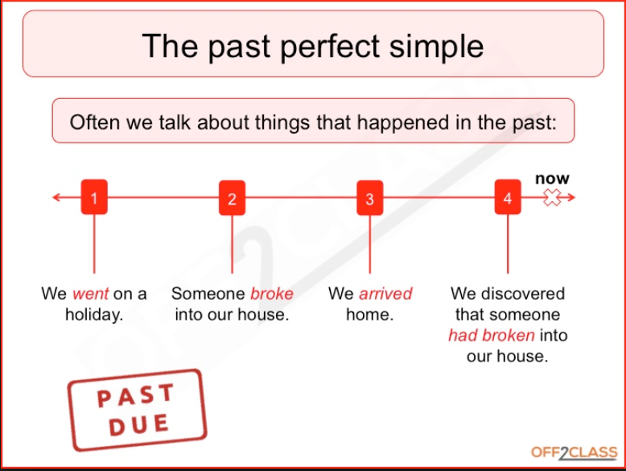

Picture 4
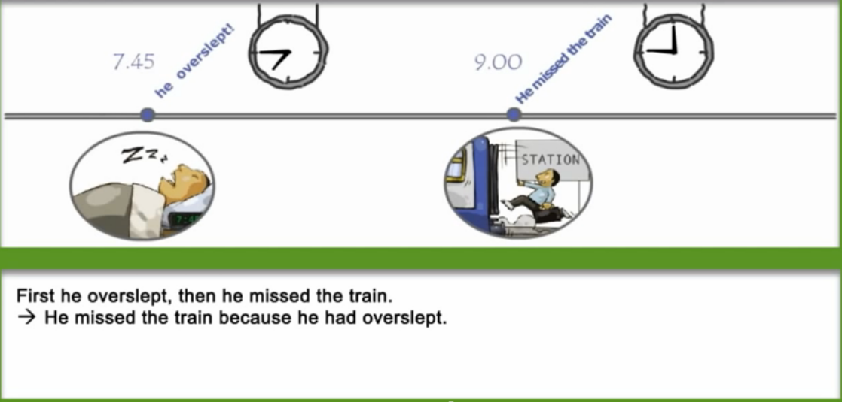

Picture 5

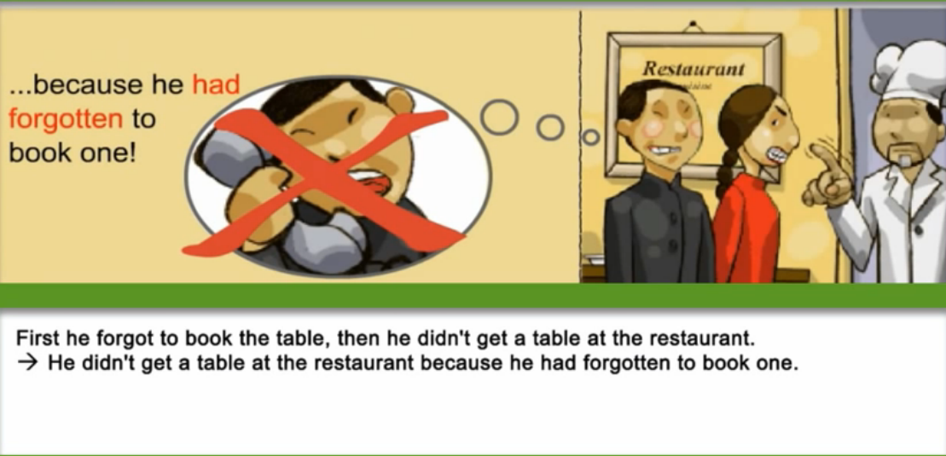

- Drilling Wall Chart

- PAST PERFECT

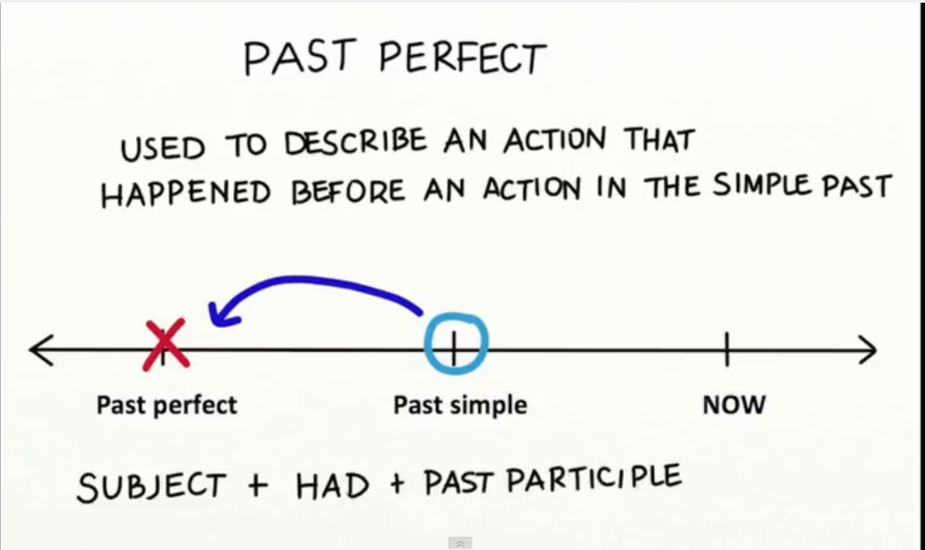

- Timeline

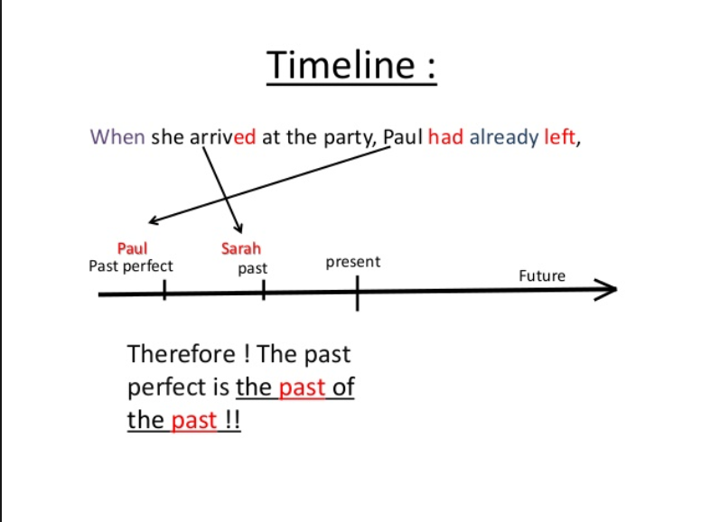

- SENTENCES
Subject + had + (adverb) + past participle
(He’d ) He had just finished his dinner.
(We’d) We had already left.
They (hadn’t) had not bought the tickets.
(I’d) I had stupidly missed the bus.

- QUESTIONS
Had (not) + subject + (adverb) + past participle
Had she deliberately left the key there?
Had they already arrived?
(Hadn’t) Had not he called to remind them?
Had he really finished school by then?

\

Truth Seekers Worksheet
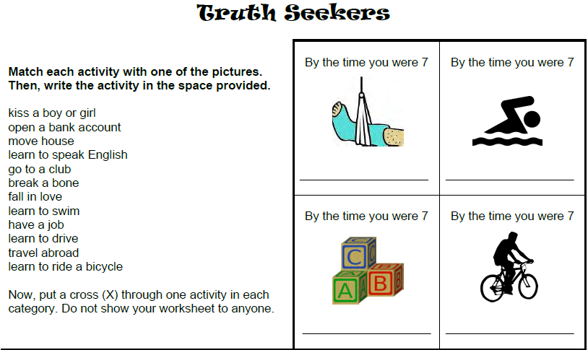

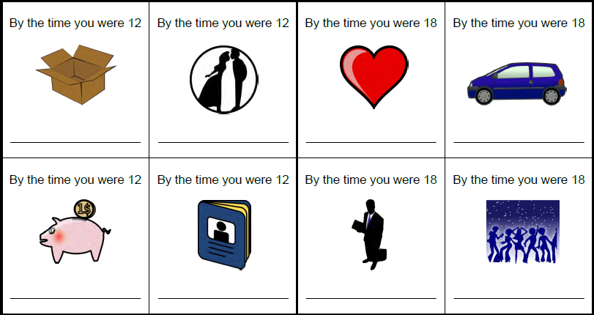

Work with a partner. Take it in turns to ask and answer questions about your experiences of growing up using the activities above. For the activities you put a cross through, you have to lie about your experiences. For the other activities, tell the truth. Use the past perfect and ask follow-up questions to help you find out if your partner is telling the truth or lying.
A: Had you broken a bone by the time you were seven?
B: Yes, I had.
A: What happened?

CLUE CARDS: John’sday
Mingling puzzle: Past perfect and past simple
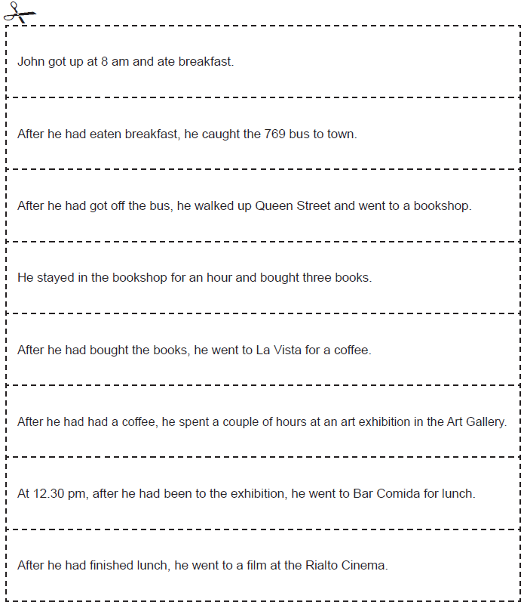
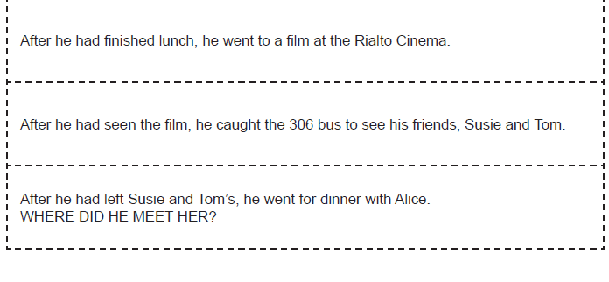

CLUE CARDS: Alice’sday

