Topic: Robots Smarter Than Humans By 2029
Instructor: | Level: | Age: | Number of Students: | Length:
Jinyong Kim | Intermediate | adults | 12 | 25 minutes
Materials:
- Pictures
- Sticky words plates
- 12 copies of the text “Robots smarter than humans by 2029”
- 12 copies of comprehension questions
- 12 copies of the discussion worksheet
- White board and board markers
Aims:
- SWBAT define some new vocabulary words in the reading material and know the usages of them by matching words with their meanings
- SWBAT describe and write future house images with Artificial Intelligence through the discussion activity
- SWBAT use the future tense through the discussion
Language Skills:
- Reading: reading article and worksheets
- Listening: listening to teacher’s eliciting, instructions and classmates’ ideas
- Speaking: sharing ideas with a partner and within groups
- Writing: answering worksheets and doing homework
Language Systems:
- Lexis: learning new vocabulary words in the article such as consistent and flirt
- Grammar: using of the future tense
- Discourse: sharing ideas and discussing with group members
- Function: describing the future house with Artificial Intelligence
Assumptions:
- Students might know the teacher style of teaching and the pace of the course
- Students might know how the class is set up and run (there will be 4 student groups at each table)
- Students may know the skimming skill from the previous class
- Students might have imagined their future house before
Anticipated Errors and Solutions:
- Students may find unfamiliar vocabulary words in the text
- Let them know the definitions of words using a word matching activity
- Students might have difficulty in answering the comprehension questions
- Teacher give extra time for them to finish
- If students finish their tasks earlier than anticipated
- Use filler activity
References:
- Robots smarter than humans by 2029. (n.d.). In Breaking News English. Retrieved December 7, 2015, from http://www.breakingnewsenglish.com/1402/140226-artificial-intelligence.html
Notes:

Presentation:
Aims:  -SWBAT define some new vocabulary words in the reading material and know the usages of them by matching words and their meanings |  |  | Materials:  -Pictures  -Sticky words plates  -White board and board markers
Time | Set Up | Student |  | Teacher
3 min  3 min | Whole class  Whole class | Students answer the question  Students answer the questions  Students listen to what teacher says  Some students step up and match the words.  Students read out loud the sentences together |  | Lead-In  Hello, everyone! Good to see you again.  How was your yesterday?  Eliciting  -What do you see in these pictures?  -Have you seen these movies?  (Bicentennial man, i, Robot and A.I.)  -Do you know what AI stands for?  AI stands for artificial intelligence, which means the intelligence exhibited by machines or software.  Today, we are going to read the article about AI and have some time to think about our high-tech future.  Let me introduce today’s outline.  (Introduce the outline)  Intro  Word-matching activity  Scanning  Reading activity  Discussion  Presentation  Homework  Matching words with the meanings  Instruction  Before reading our text, we will check the new vocabulary words in the article first.  I wrote some new words and the sentences where these words are used on the board.  Read the words and the sentences carefully and match the correct meanings next to the sentences.  Anyone can come up here and match the words. Each person can do just one word. I need 6 persons.  Let’s begin.  (Monitor discreetly. If students need some help, help them)  Let’s read the sentences together.  Faster  Louder  Slower  …
Notes:
Practice:
Aims:  -SWBAT use the future tense through the discussion |  |  | Materials:  -12 copies of the text “Robots smarter than humans by 2029”  -12 copies of comprehension questions  -White board and board markers
Time | Set Up | Student |  | Teacher
2 min  5 min  2 min (or more or less) | Whole class  In pairs  Whole class | Students answer the question  Students listen to what teacher says  Students answer the questions  Students read the article and answer the comprehension questions with a partner  Students answer the questions altogether  Students listen to what teacher says  Students share their ideas |  | Let’s move on to the main lesson.  Last class, we learned and practiced skimming skill. Do you remember?  Skimming is searching for main ideas while reading a text.  Instruction  Today, we will use the scanning skill. As you can see on the board, scanning is searching for details while reading a text. You don’t need to read and understand every single word in a passage when scanning.  A technique for scanning is to search the text from the end to the beginning, to prevent reading for meaning from occurring.  Make sure to search the text from the end to the beginning!  I will give you an article and a worksheet for each of you.  (Distribute the article and worksheet)  What you need to do is pair up with your partner next to you and find the answers of the comprehension questions using scanning skill in pairs. I will give you 5 minutes.  ICQs  What are you supposed to do now?  Do you work alone?  Let’s get started.  (Monitor discreetly. Answer students if they ask questions)  (Give time warning: 30 seconds left)  Do you need more time to do this?  (If yes – give 30 seconds extra time  If no – move on to the next)  Check the answers together. Let them answer the questions.  Filler  Instruction  Before moving on the discussion, let’s talk about future images with Artificial Intelligence.  What do you think the future classroom will look like in 2050? How about the future hospital?  Pick some of students to answer the questions.
Notes:
Production:
Aims:  -SWBAT describe and write future house images with Artificial Intelligence through the discussion activity  -SWBAT use the future tense through the discussion |  |  | Materials:  -Picture  -12 copies of the discussion worksheet  -White board and board markers
Time | Set Up | Student |  | Teacher
1 min  5 min  3 min | Whole class  In groups  Whole class | Students listen to what teacher says  Students answer the questions  Students share their ideas with group members  Representatives of each group present their groups’ ideas. |  | Group Discussions  Instruction  We talked about the future images with Artificial Intelligence. Isn’t it exciting to imagine the future images with all the high technology?  Look at this picture. This is one of the examples of our future houses.  Demonstration  In the bathroom, doctors will be able to give you virtual medical checks. And toilets will analyze your waste for medical problems such as colon cancer using Artificial Intelligence.  We will talk about what the future homes will look like in 2050 in groups of 4. Describe our future houses with Artificial Intelligence. You have 5 minutes to talk. And each group will present its ideas in front of the class.  ICQs  -How much time you have?  -What are you supposed to do after the discussion?  Let’s get started.  (Monitor discreetly. Answer students if they ask questions)  (Give time warning: 30 seconds left)  Presentation  Is there any volunteer who wants to share your group’s ideas? Okay then, I will pick one. Group#1, please come up here and describe our future house.  (Positive feedback)
Notes:
Post Production:
Aims: |  |  | Materials:  -White board and board markers
Time | Set Up | Student |  | Teacher
1 min | Whole class | Students answer the questions  Students take notes of homework |  | Closing  Good job, everyone.  CCQs  -Which reading skill you have learned today?  -Do you have to understand every single word in a passage when scanning?  -(Check the vocabulary words)  Homework  Make a poster about Artificial Intelligence and show your work to your classmates in the next lesson.  See you, next class. Bye bye.
Notes:

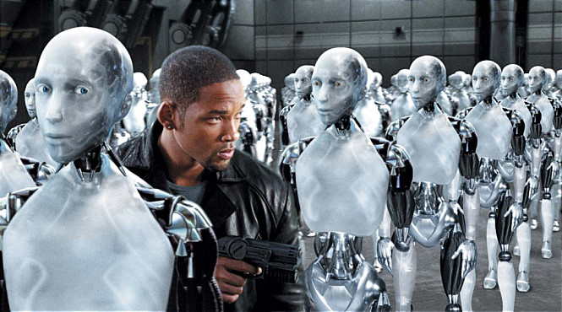
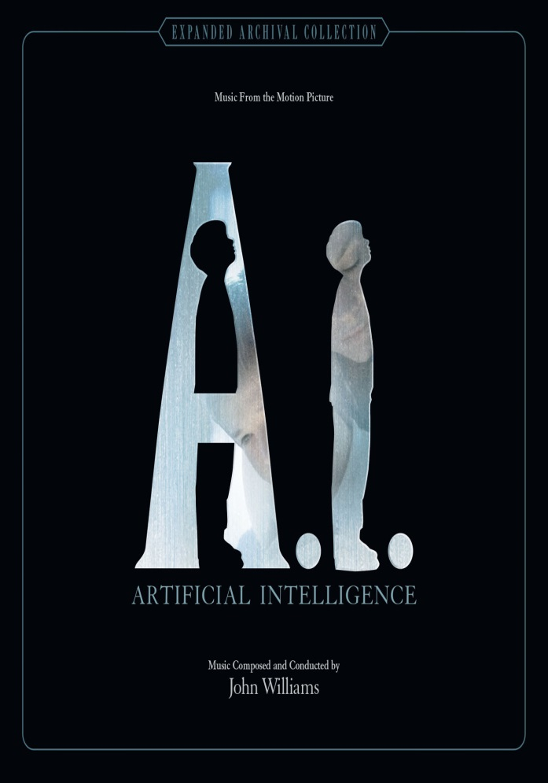
Pictures
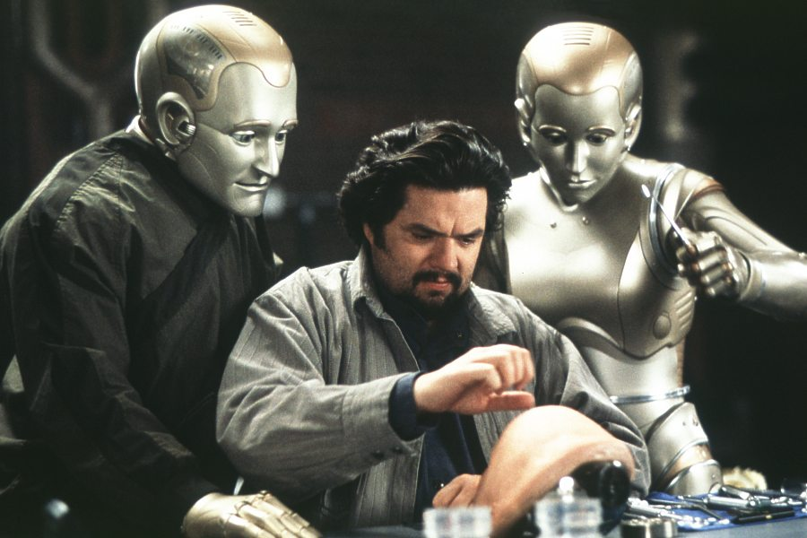

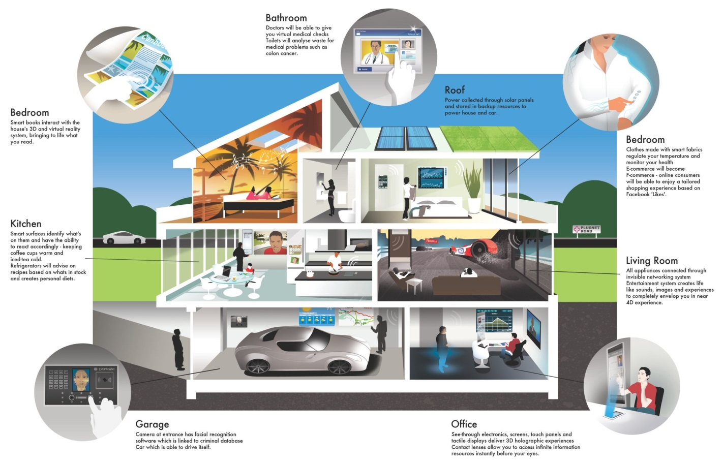
Reading material
A scientist said robots will be more intelligent than humans by 2029. The scientist's name is Ray Kurzweil. He works for Google as Director of Engineering. He is one of the world's leading experts on artificial intelligence (A.I.). Mr Kurzweil believes computers will be able to learn from experiences, just like humans. He also thinks they will be able to tell jokes and stories, and even flirt. Kurzweil's 2029 prediction is a lot sooner than many people thought. The scientist said that in 1999, many A.I. experts said it would be hundreds of years before a computer was more intelligent than a human. He said that it would not be long before computer intelligence is one billion times more powerful than the human brain.
Mr Kurzweil joked that many years ago, people thought he was a little crazy for predicting computers would be as intelligent as humans. His thinking has stayed the same but everyone else has changed the way they think. He said: "My views are not radical any more. I've actually stayed consistent. It's the rest of the world that's changing its view." He highlighted examples of high-tech things we use, see or read about every day. These things make us believe that computers have intelligence. He said people think differently now: "Because the public has seen things like Siri [the iPhone's voice-recognition technology] where you talk to a computer; they've seen the Google self-driving cars."

Comprehension questions
1. | What is Ray Kurzweil's job? | 6. | Why did people think Dr Kurzweil was a little crazy?
 | a) brain surgeon  b) IT consultant  c) director of engineering  d) search engine engineer |  | a) his eyes  b) for predicting computer intelligence  c) he put jam on his fried eggs  d) he loved bananas
2. | What is Dr Kurzweil an expert on? | 7. | What happened to Kurzweil's thinking?
 | a) artificial intelligence  b) Google  c) world jokes  d) TV |  | a) it is now very deep  b) it has become impossible to  understand  c) it has become very different  d) it has stayed the same
3. | What will computers soon be able to tell? | 8. | What things did Kurzweil use to highlight computer intelligence?
 | a) humans what to do  b) jokes and stories  c) the difference between an ant and an elephant  d) the time |  | a) a powerful torch  b) everyday high-tech things  c) Microsoft Word  d) his thumb and index finger
4. | When did scientists think it would be hundreds of years before computers were very intelligent? | 9. | What is the name of Apple's voice-recognition technology?
 | a) 1969  b) 1971  c) 1980  d) 1999 |  | a) Hello Hello  b) Siri  c) Pip  d) Apple Pie
5. | How many times more powerful than the brain will computers become? | 10. | What kind of high-tech cars have people seen?
 | a) 7  b) 897,332.610.0002  c) one billion  d) 10 trillion |  | a) Google's self-driving cars  b) the ones in the movie Star Wars  c) 999GB cars  d) blue and gold ones

What future homes will look like in 2050?

- Bedroom1:

- Bedroom2:

- Kitchen:

- Bathroom:

- Living Room:

- Dress Room:

- Garage:

