√Listening Speaking Reading Grammar Writing
Topic: The Solar system

Instructor: Nature | Level: Upper-Intermediate | Students: 9 | Length: 40 minutes

Materials:
Planets worksheet (10 copies each)
Listening file & player (Track 1~8; about 1 min each)
Listening worksheet ➀, ➁ (10 copies each)
Pictures of the planet in our solar system(Wall chart)
Visual
White board, board makers.

Aims:
Main aim : To improve student's listening skills by listening worksheet①
Secondary aim : Let students know about planets in our solar system by have student do a work sheet, dictation, and favorite planet.
Personal aim : I want to speak in English, properly, what I think to people.
I want to improve on my demonstrations.
I want to improve on my Instruction delivery.

Language Skills:
Listening : Ss will listen information of planets through "listening worksheet②"
Reading : Ss will read the planets worksheet and will read a sentence of "Information-papers"
Speaking : Ss will talk about the name of planets in our solar system and their information.
Writing : Ss will be engaged in dictation and filling in the blank of "listening worksheet①"

Language Systems:
Lexis : solar system, information, name of each planet
Phonology : None to discuss
Grammar : None to discuss
Function : None to discuss
Discourse : some story of Greek and Roman mythology

Assumptions:
Students already know :
▶ how to express what they're thinking.
▶ how to do the dictation activity.
▶ some of feature about planets in our solar system.
▶ how do the planets look like.

Anticipated Problems and Solutions:
▶ Ss don`t know the planet`s name properly.
- Through planets worksheet, check the name of planets
▶ Listening file doesn`t work properly.
- Instead, read the listening text loudly.
▶ While doing Main Activity, we don`t have a much time.
- Share just 4 planet information instead of 6 planet, while doing listening
worksheet②
▶ Students may feel boring.
- Give chocolate to Ss when they fill in the blank correctly.

References:
- Worksheet and information about each planet from the I&I READING CLUB BOOK
- Hand out form the TESOL class, "The background"

Lead-In
Materials: White Board, Board markers
Time | Set Up | Student Activity | Teacher Talk
3 min | T-WC | Guiding questions | Hello everyone, how was your new year's day? I had been very busy because I had played with two of my nephews during the new year's day. How about you SungMi? Thank you for sharing your story.  Kirix, when you look up at the sky at night, what do you see?

Pre-Activity (10 minutes)
Materials: Picture of the plane, Planets worksheet, Visual, White board, board makers. Paper of answers
Time | Set Up | Student Activity | Teacher Talk
30 sec | T-WC | Eliciting | Here`s a quiz for you all. You may think all the lights are stars, but some of them are not stars. They move around the sun in circles. What is this?  -Answer : They are planets.
30 sec | T-WC | CCQ | (I get the picture of star.) Do you think it is a planet?  (I get the picture of the Earth.) Is it a planet?
30 sec | T-WC | Demonstration  /Modeling | The name of this planet is the Earth and their are another planets in our solar system.  (Write on the white board the "solar system.")  Try to follow me guys.  Solar/system/Solar/system  Who did speak the word "Solar"?  Who did speak the word "System"?
30 sec | Ss-Ss | Creative groups | Solar team, please get up and move to the left side seat.  System team, please get up and move to the right side seat.
1sec | T-WC | Instruction | Okay class, now I will give you some papers and there are quiz about planets. Look at the pictures. Each planet has a number. Work individually. Read the explanation about planets, 'A' to 'H', match the right number '1' to '8'. We have 3 minutes.
30 sec | T-WC | CCQ | What are you going to do? = match the number of planets.  How much time do we have? = 3 minutes.  Are you working in a group? = No.  or individually? = Yes.  Are you going to start before I say "Begin"?  or when I say "Begin"?  (I give the paper to each person and I say "Begin".)
3 min | Individually | Do Planets worksheet | Monitor discreetly. Answer students if they ask questions.  Give time warning : 30 seconds left.  Be flexible with time. Give 1 more minute if they need it.)
1 min | Ss-Ss | Check answers with groups | Okay, time is off. Now, I will give you one more minute. Sharing your answer with your team members and decide the correct answer.
30 sec | Ss-Ss | Write down the answers on the board | Now, we are going to write down the number you have decided. Writer is the person who drank coffee a lot, today.  Please go back to the seat.
2 mins | T-WC | Check answers. | Ok, now we are going to check the answer.  The answer of A is 1, and it is called Mercury.  The answer of B is 7, and it is called Uranus.  The answer of C is 2, and it is called Venus.  The answer of D is 5, and it is called Jupiter.  The answer of E is 8, and it is called Neptune.  The answer of F is 3, and it is called Earth.  The answer of G is 6, and it is called Saturn.  The answer of H is 4, and it is called Mars.  (After answer 3, show prepared answers.)  Please remember Planet's name.

Main Activity(20 minutes)
Materials:
Picture of the plane, listening worksheet①,②, listening file, White board, board makers.
Time | Set Up |  | Student Activity | Teacher Talk
1 min | T-WC |  | Instruction | Please go back to the original seat.  Now, I'm going to give you a listening worksheet and  turn on the listening file about planets. Please listen carefully individually, guess planet's name, and fill in the blanks with correct words.
30 sec | T-WC |  | CCQ | What are you going to do?  Are you working individually?  Are you going to start before I say "Begin"? or when I say "Begin"?  (After that, turn on the listening file.)
3 min | Individually |  | Do listening worksheet① | Each listening file should be turned on twice times.  Monitor discreetly. Answer students if they ask questions.  Be flexible with time. Give 1 more minute if they need it.)
2 mins | T-WC |  | Check answers. | Ok, now we are going to check the answer.  The first planet name is Uranus. The right answers in the blank are listed in the chart below.  Name : Uranus  It is the seventh planet, is bigger than Earth. It is really cold, and the wind blows around it at 700 km per hour. It is surrounded by a thick fog of hydrogen and helium. It has rings too, but they are made up of chunks of black ice, so the rings of this planet are black.
30 sec | T-WC |  | Creative groups | We have learned Uranus and Venus. Now we are going to learn the other planets. Please make the groups again.
1 min | T-WC |  | Instruction | I will give you second listening worksheet. After listening to the 6 different information about each planets, please answer the following questions as you listen. Work in a group. Each planets listening time is about 30sec. Please listen carefully in a group, guess planet's name, and find information about this planet.
30 sec | T-WC |  | CCQ | What are you going to do?  Are you working individually? or in a group?  ( After that, turn on the listening file.)
5 min | Ss-Ss |  | Do listening worksheet② | Each listening file should be turned on one time.  Monitor discreetly.  Be flexible with time. Give 1 more minute if they need it.)
30 sec | T-WC |  | Instruction | Did you find the name and information of planet? I want all of you guys to share and compare the information together.
5 mins | Ss-Ss |  | Presentation | 'Solar' team, what did you find about Planet number 1, 3, and 5?  'System' team, what did you find about Planet number 2, 4, and 6?
1 min | T-WC |  | Ending | What are you able to know, through the listening worksheet ① and ②?  - Our solar system

Post Activity (10 minutes)
Materials: Picture of the plane, Secret-box, Information-papers, card
Time | Set Up | Student Activity | Teacher Talk
30 sec | T-WC | setting groups | I believe everyone knows about the planets in our solar system, so we are going to make planet's cards. So, please get up and make a line from the youngest to oldest each group.
1mins | T-WC | Instruction &  modeling | Today, I prepared a 'Secret-box' and there are pictures of planets. The youngest person in a group come out here and pick up one of cards from the box.  And I put some 'Information-papers' about the planets on the other side table. The other members should bring correct information about the planet to the youngest person. But, there is a rule. You guys should read information and the youngest person should listen and write down it. When you finish making the card, the youngest person can pick up another picture and make it again. The winner group is the group that makes more cards than the other group. We have 5 minutes.
30 sec | T-WC | CCQ | What are you going to do?  How much time do we have?  Are you working in a group?  Are you going to start before I say "Begin"?  or when I say "Begin"?  Are you going to bring just information?  or read information?
4 min | Ss-Ss | Physical Activity | Monitor discreetly.  Make sure students to follow the rule.
1 min | T-WC | Checking the card | How many cards did you make? Let's check the cards.
1 min | T-WC | Ending | How was today listening lesson?  We learned about the planet in our solar system and I want you to remember today's lesson. Thank you for listening today my class
1 min | T-WC | Error correction | I will correct any of the students oral mistakes that I`ve noted and if there are no mistakes then I will have students unscramble the word. "olsrsyamest = solar system"  Any Questions?

Planets Worksheet
Each planet has a number. Match the right number of each planet with a sentence below. (Answer is 1, 7, 2, 5, 8, 3, 6, 4)
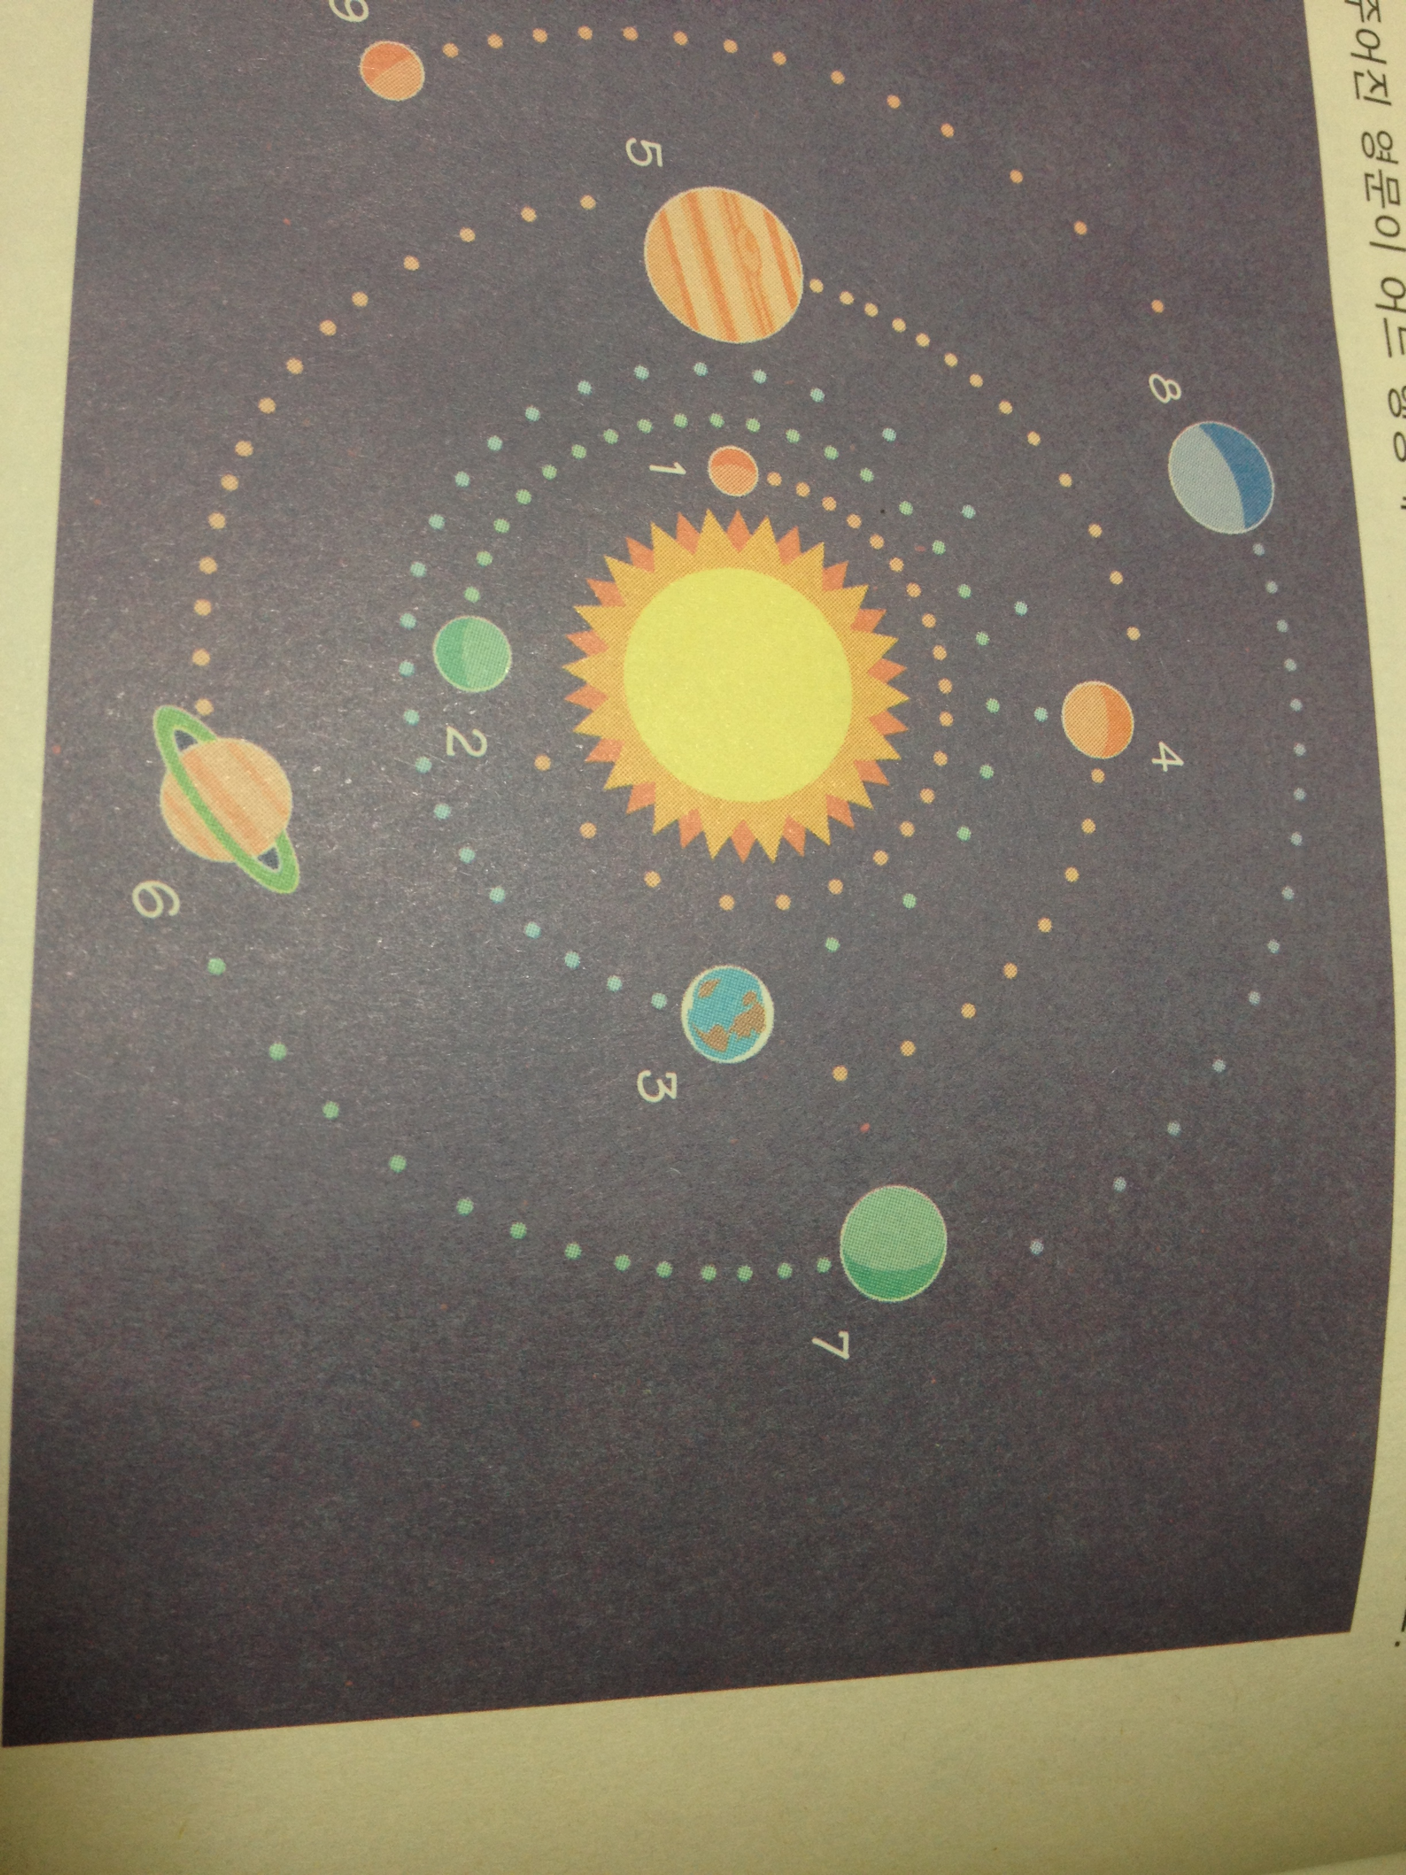
Ⓐ There are many holes, called craters, on it.
Ⓑ The wind blows around it at 700 km per hour.
Ⓒ It is covered with clouds, so we see only its clouds.
Ⓓ Its name is the name of the greatest Roman god.
Ⓔ It is thirty times farther from the sun than Earth.
Ⓕ Perhaps it is the only planet with living things on it.
Ⓖ It is the second largest planet in our solar system.
Ⓗ In 1997, the Pathfinder spacecraft landed on it.

Listening Worksheet➀
Listening to the sentences and put the words written in the blanks.
And write the name of the planet. (The underlining words will be blank)

Name : Uranus
It is the seventh planet, is bigger than Earth. It is really cold, and the wind blows around it at 700 km per hour. It is surrounded by a thick fog of hydrogen and helium. It has rings too, but they are made up of chunks of black ice, so the rings of this planet are black.

Name : Venus
It is the second planet. It is terribly hot there. In fact the temperature on this planet is around 156℃(degrees centigrade). We cannot really see Venus. It is covered with clouds, so we see only its clouds. They cover the planet like a thick blanket. It is not a star, but perhaps you have called it a star. Do you wish on a star? It is probably the first "star" you see at night, so perhaps you really wish on this planet.

Listening Worksheet➁
Listen to the 6 different information about each planets. Answer the following questions as you listen.
▶What is the order of planets from the sun?
▶What is information of each planet?
[Planet No.1] | [Planet No.2]
Name :  Order from the Sun :  Information : | Name :  Order from the Sun :  Information :
[Planet No.3] | [Planet No.4]
Name :  Order from the Sun :  Information : | Name :  Order from the Sun :  Information :
[Planet No.5] | [Planet No.6]
Name :  Order from the Sun :  Information : | Name :  Order from the Sun :  Information :

