Listening Speaking Reading █ Grammar Writing

Topic: To + infinitive vs Verb + –ing (gerund)

Instructor:  Hannah & Dian | Level:  Intermediate | Students:  16 | Length:  30 Minutes

Materials:
- Material (Images – school, studying, restaurant, eating, karaoke, singing)
- Worksheet (attached below)
- Material (Sample sentence for worksheet)
- Board Map(Sample and 4 paper) & 4 dices
- Word cards

Aims:
Main Aim – Enabling SS to improve their Grammar skills by having SS use [to + infinitive & verb + -ing (gerund)].

Secondary Aim – SS will practice [to + infinitive & verb + -ing (gerund)] by having SS writing on the blank worksheet, making a story playing board map, and writing on the white board.

Personal Aim – I want to adjust my speaking pace and teaching pace to the level of the learner. I want to improve on my C.C.Q. and time management.

Language Skills:
Speaking – SS will speak worksheet (pre-activity) & story (main-activity).
Writing – SS will write worksheet, story & sentences (post-activity).
Listening – SS will listen to other’s sentences and stories.
Reading – SS will read worksheet, story & sentences.

Language Systems:
Lexis – To study, Studying, To eat, Eating, To sing, Singing
Phonology – [|dƷerənd], [ɪn|fɪnətɪv]
Grammar – [to + infinitive & verb + -ing (gerund)]
Function – Usage of object for transitive verb
Discourse – None to discuss

Assumptions:
Most SS know [to + infinitive].
Most SS know [verb + -ing].
Most SS know transitive verb.
Most SS are confused to use [to + infinitive & verb + -ing (gerund)]

Anticipated Problems and Solutions:
SS can be wrong to use [to + infinitive & verb + -ing (gerund)].
- Teacher teaches correct usage and differences.
Post-activity will take longer time than a plan
- Teacher will get on 1/3 of SS to go.
SS can’t know some transitive verb.
- Teacher explains and show example for it.
SS can feel difficult to make a sentence using [to + infinitive & verb + -ing].
- Teacher asks other SS to help them and practice together.

References:
Images : Google images
Book: Grammar in use & Speed English engine

Lead-In
Materials:
- Loud voice

Time | Set Up | Student Activity | Teacher Talk
2min | T-WC | Greetings and casual discussion | Hello everyone.  Alice, have you been to other countries?  - How was it?  Jina, which seasons do you like?  - Why do you like it?  Thank you for sharing together.

Pre-Activity
Materials:
- Images (School, Studying, Restaurant, Eating, Karaoke, Singing)
- Material (Example of passage & Answer)

Time | Set Up | Student Activity | Teacher Talk
7 min | T- SS  T- WC  T  T- WC  SS- SS  SS  T- WC  T-WC | Follow up teacher’s eliciting  Check the concept  Grouping  Check Demo  Check the instructions  Finding correct answer  Matching correct answer  Ask confusing sentence  Finish the activity | Eliciting  - What do the students do at the school? Study  - (Show ‘School’ image) Why do the SS go to school?’ To study  - (Show ‘Studying’ image) What are the SS doing? Studying  - (Show ‘Restaurant’ image) Why do we go to the restaurant? To eat  - (Show ‘Eating’ image) What are we doing at the restaurant? Eating  - (Show ‘Karaoke’ image) Why do we go to the karaoke? To sing  - (Show ‘Singing’ image) What are we doing at the karaoke? Singing  - (Put the card of [infinitive-[ɪn|fɪnətɪv],gerund-[|dƷerənd]] to the board) Speak [infinitive], [gerund] and let SS speak too.  CCQ  - Write a sentence [The students go to school to study. They are studying at the school.] on the board.  - Ask SS ‘[go] is ‘to infinitive’? No. [to study] is ‘to infinitive’? Yes. [at] is ‘gerund’? No. [studying] is’ gerund’? Yes  Grouping  - Okay, we will make pair like Jenny & Lucy, you are one team. Angela & Juny, you are one team.  - (Make other team in this way.) Now, we are all 8 pairs.  Demonstration  - (Put material to the board) Let’s check this.  - (Read the passage) Tom plans ( to go skiing / going skiing ) next weekend.  - (Ask SS what is correct) Yes, ‘to go skiing’ is correct.  Instructions  - Like this, you will find which one is correct and check the paper in 2 min with pair.  ICQS  - What are we doing now? Find correct answer.  - Are you doing individually? No.  - Then, pair? Yes.  - So, how much time do we have? 2 min  Explicit Instruction  - I will give you a worksheet and I want you start when I say ‘Begin’.  Explicit ICQs  - Will you start once get the worksheet? No  - When I say ‘Begin?’ Yes  Run  - Give 2 min to SS and inform how much time left. (e.g. 1 min left)  - Monitor SS’ writing and give 1 more min depends on SS’ checking.  - Sarah, would you read the second passage? Yes correct. Please the neighbor student read next passage. Check the answer and show the correct answer to the board.  Close  - Have you any question? No  - Let’s move to next stage.

Main Activity
Materials:
Board map (Attached below)
4 dices
Paper (on the top, transitive verbs are typed)

Time | Set Up | Student Activity | Teacher Talk
13min | T- SS  T  T- WC  T- WC  SS- SS  SS- SS  T- SS  T- WC | Creative grouping  Check Demo  Check the subject  Check the instructions  Play  Sharing stories  Asking questions  Finish the activity | - What is our topic today? To infinitive and ing gerund.  - Please say to / infinitive / ing / gerund from the first to end.  - Who said ‘to’? This group moves to here. Who said ‘infinitive’? This group moves to here. Who said ‘ing’? This group moves to there. Who said ‘gerund’? This group moves to there.  Demonstration  - (Put a map to the board) Here is a map. (Show dice) And this is a dice.  - We will play as group and each one of you throws the dice and moves follow the number. And check the ‘to infinitive and gerund’. You have to make sentence using one of them. And next student make next sentence to connect with previous one. So one team make a one story. Let me show you. If I got the number 3. The words are ‘to clean / cleaning’. Then I can say ‘I go home early to clean my house.’ Then next number is 6. I can say ‘I do laundry to keep my clothes clean too.’ to make a one story.  Instructions  - You will make sentences to make a one story.  - This route is endless and we will play it in 8 min.  - I will give you a map, a dice and a paper (attached below). On the top of the paper I give you, you can check the useful transitive verbs for your stories.  ICQS  - What are we doing? Throw the dice and make a story as the instruction on the route.  - Are we doing it individually? No.  - By group? Yes  - How much time we will have? 8min.  - You can’t use transitive verb on the paper? No. You can use? Yes  Explicit Instruction  - There is ‘BOMB’ on the map. If you stop this area, please stand up and say “I am Bomb” three times rising two arms.  - And please start together when I say ‘begin’  Explicit ICQs  - So, what will you do when you stop ‘Bomb’ area? I am bomb! I am bomb! I am bomb!  - Can we start once we get the map and dice? No.  - When I say begin? Yes  Run  - SS will play for 8 min.  - Monitor SS’ writing and inform how much time left. (e.g. 1 min left)  - Time’s up! Let’s share the story you’ve made! Who wants to share first?  - Listen to the stories of 2-4 teams.  Close  - Have you any question? No  - To clarify, you can check that the first group of transitive verbs can be used to. Second group of verbs can be used gerund. Third group can be used together.  - Thank you for sharing your stories.

Post Activity
Materials:
- Word cards

Time | Set Up | Student Activity | Teacher Talk
8 min | T- SS  T- WC  T- WC  SS  T- WC | Grouping  Check demo  Check instructions  On Activity  Error Correction  Finish | Creative grouping  - Now, first student from the line, say [infinitive]. Next student [gerund]. And then turn around the class. Then from the first, 2 students are one pair. (e.g. Jenny and Lucy are one team, ~~)  - Who said [infinitive]? Hand up! You will be one team, please move to right and stand up in line.  - Who said [gerund]? Hand up! You will be one team, please move to left and stand up in line.  Demonstration  - (Divide the board and put the word card on it. And put the desk under the board)  - Stand a pen to the desk and choose one word and make a sentence.  Instructions  - Like this here are many words and two teams will make a sentence using this word one by one. But you must stand pen to the desk then write a sentence.  - We will play as group in 5 min.  ICQS  - What are we doing? Make a sentence using the word.  - Are we doing individually? No.  - By group? Yes  - How much time we will play? 5min  Explicit Instruction  - There are many words so please use different word before used all.  - I want you start when I say begin together.  Explicit ICQs  - Can you use words already used? No  - But if all words are used, can use again? Yes  - Will you start now? No  - When I say begin? Yes  Run  - SS race and write a sentence for 5 min.  - Monitor SS’ writing and give 1 more min depends on SS’ writing.  - Time’s up! (Calculate how many sentences they wrote.) This team wrote 2 sentences more than that team. So this team is winner.  Close  - Have you any question? No  - Put the materials of scrambled words – infinitive, gerund then let SS correct the words.  - Thank you for participation.
SOS Activities
Materials:
- Ball

Time | Set Up | Student Activity | Teacher Talk
1-2  min | T- WC  T  SS | Check the activity  Demonstration  On Activity | CCQ  - What do we study today? to infinitive and ing(gerund)  - (Write ‘transitive verbs – hope, wish, stop, quit’ to the board in line.)  - (Show a ball)Let’s play. (Throw the ball to the verbs and hit one.)  - I hit ‘hope’. Then I say “I hope to see the UFO before I die.” Like this, throw the ball first, and make a sentence use the verb you hit. Okay?  Run  - Pick a student and pass the ball.  - After then pick SS to do it again.  Close  - Thank you for getting stress off with ball.

Worksheet for Pre-Activity(Teacher)
1) Tom plans to go skiing next weekend.
2) They discussed playing golf on the weekend.
3) You finished having dinner before five o’clock.
4) Jane wants to study on her summer vacation.
5) She wanted to be rich in her childhood.
6) They tried to win the game.
7) The students tried to pass the test.
8) The students refused to take the test again.
9) Jeff’s worrying about going to Europe by himself.
10) I stopped smoking.
11) The girl wished to be grown-up soon.
12) We gave up catching taxi.
13) The girl expected to wear make-up like her mother.
14) My parents agreed to send me a medical school.
15) She enjoyed cooking dinner.
16) Mary’s talking about studying English.
17) My parents decided to make me a doctor.
18) I prepared to tell them about my dream.
19) He considered marrying her.
20) The students are complaining about taking the test tomorrow.
21) They always started studying after dinner.
22) Jane prefers to eat cookies now.
23) You forgot to turn off the lights last night.
24) Please remember to bring your homework.
25) She likes listening to music in the morning.

Worksheet for SS
1) Tom plans ( to go skiing / going skiing ) next weekend.
2) They discussed ( to go play golf / playing golf ) on the weekend.
3) You finished ( to have dinner / having dinner ) before five o’clock.
4) Jane wants ( to study / studying ) on her summer vacation.
5) She wanted ( to be rich / being rich ) in her childhood.
6) They tried ( to win / winning ) the game.
7) The students tried ( to pass / passing ) the test.
8) The students refused ( to take / taking ) the test again.
9) Jeff’s worrying about (to go to Europe / going to Europe ) by himself.
10) I stopped ( to smoke / smoking ).
11) The girl wished ( to be grown-up / being grown-up ) soon.
12) We gave up ( to catch / catching ) taxi.
13) The girl expected ( to wear make-up / wearing make-up ) like her mother.
14) My parents agreed ( to send / sending ) me a medical school.
15) She enjoyed ( to cook / cooking ) dinner.
16) Mary’s talking about ( to study / studying ) English.
17) My parents decided ( to make / making ) me a doctor.
18) I prepared ( to tell / telling ) them about my dream.
19) He considered (to marry / marrying ) her.
20) The students are complaining about ( to take the test / taking the test ) tomorrow.
21) They always started ( to study / studying ) after dinner.
22) Jane prefers ( to eat / eating ) cookies now.
23) You forgot ( to turn off the lights / turning off the lights ) last night.
24) Please remember ( to bring / bringing ) your homework.
25) She likes ( to listen / listening ) to music in the morning.

Board map & worksheet for Main-Activity
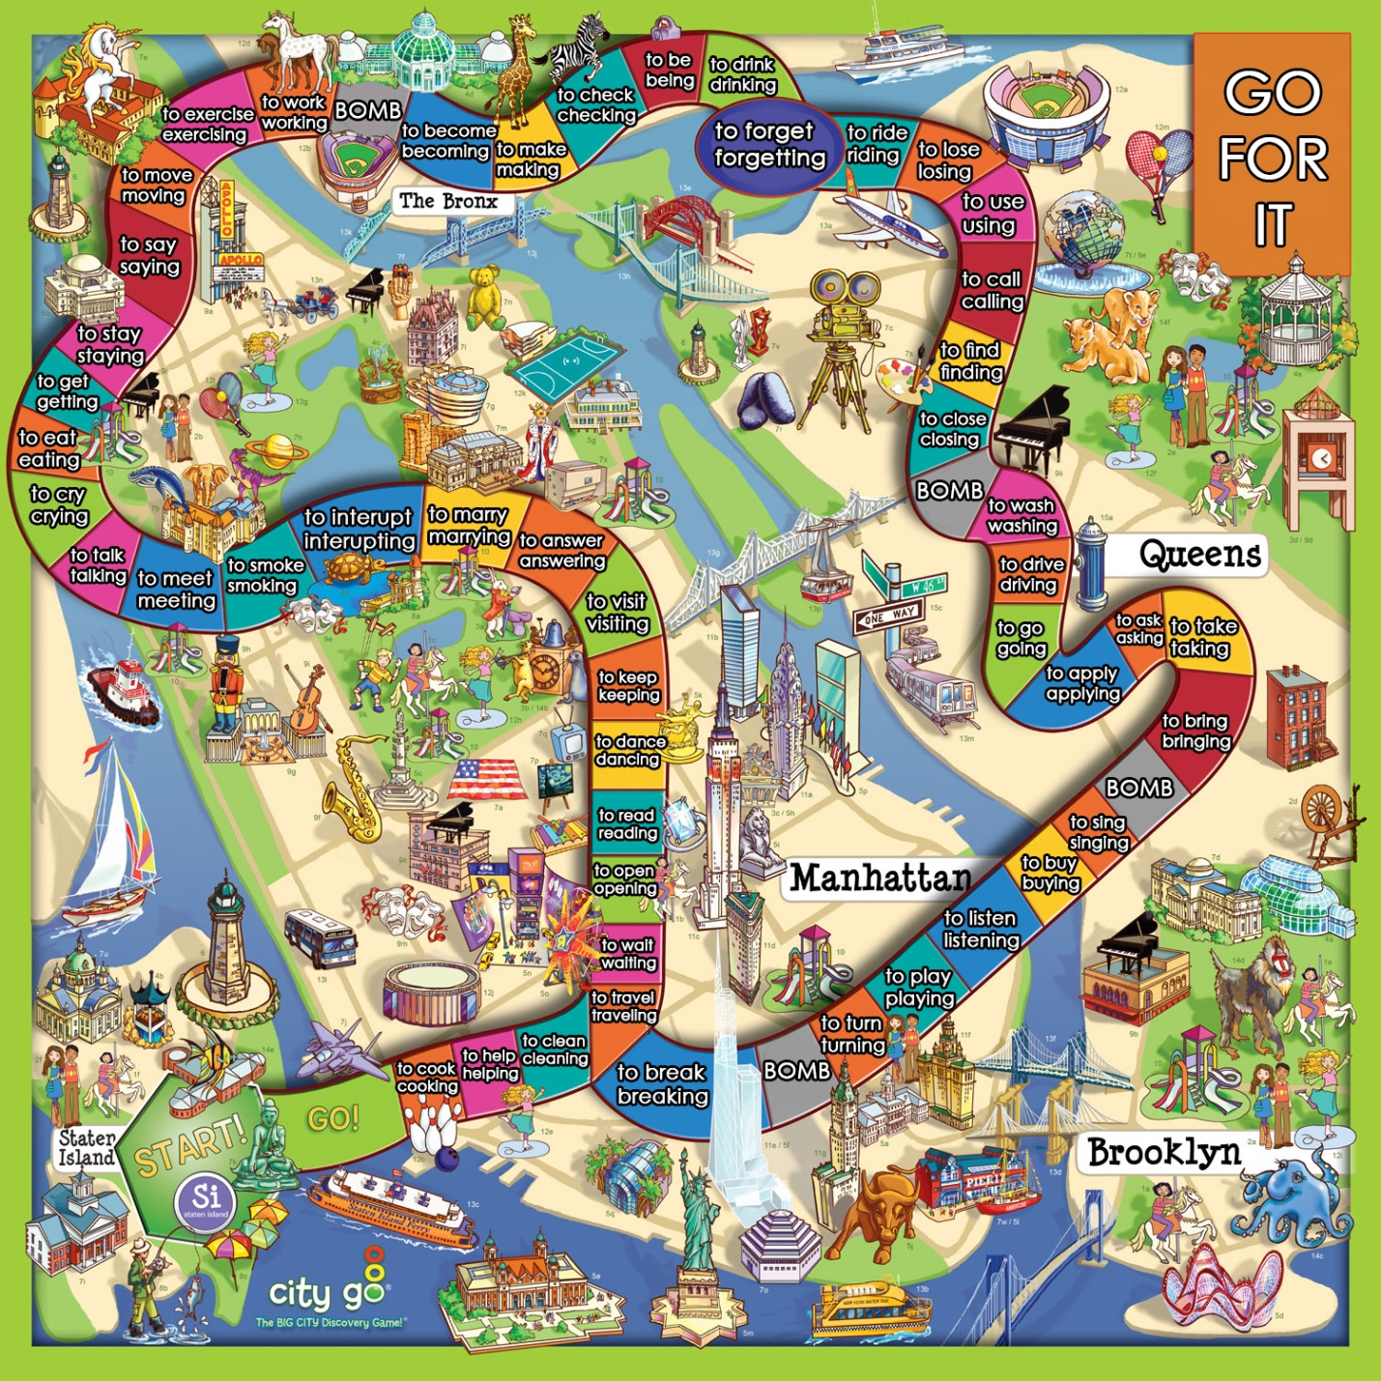

Want / plan / decide / hope / expect / offer / need / promise / refuse / fail / forget / intend / learn / wish / agree / afford
Enjoy / suggest / mind / stop / finish / avoid / consider / admit / quit / postpone / delay / practice
Try / like / love / hate / start / begin / continue / prefer

Verbs + to
Want / plan / decide / hope / expect / offer / need / promise / refuse / fail / forget / intend / learn / wish / agree / afford

Verbs + ing
Enjoy / suggest / mind / stop / finish / avoid / consider / admit / quit / postpone / delay / practice

Verbs + ing or to
Try / like / love / hate / start / begin / continue / prefer

