Listening Speaking Reading Grammar Writing
Topic: Plugging Into The SUN.

Instructor:  Claire | Students Competency Level: Intermediate | Number of Students: 3 | Lesson Length:  60 min
Materials: (List the Names of all materials used in the lesson. Materials must be shown at the end of this document)
- ‘Alternative Energy to Produce Electricity’ Work Sheet
- ‘Plugging Into The SUN’ Reading Work Sheet
- After Reading Work Sheet
- Role-Play Work Sheet
- Role Name Tags
Student A
Student B
Student C
- White Board & Marker

Aims: (What students will be able to achieve by participating in the activities of the lesson. (Ss gain or get by doing…)
- Ss improve their speaking skill by discussing about Alternative Energy System.
- Ss improve their listening skill by listening T’s introduction, questions and other Ss opinions during discussion.
- Ss improve their writing skill by writing answer on work sheet of pre-activity, main-activity.
- Ss about new vocabulary by reading activity.

Language Skills: (Lists what activities language skills students will be using by participating in the activities of the lesson.)
- Reading: (Where did reading occur in the lesson?)
Students will read reading worksheet about Solar energy system

- Listening: (Where did listening occur in the lesson?)
Students will listen to teacher’s instruction, Discuss with partner, teacher’s feed-back.

- Speaking: (Where did speaking occur in the lesson?)
Students will discuss with partners, share their opinion,
role-play and respond to teacher.

- Writing: (Where did writing occur in the lesson?)
Students will take a note, write answers & opinion on work sheet.

Language Systems: (Lists what language systems students will be using by participating in the activities of the lesson.)
- Phonology: (sound)
Discussion, Ss talk, T talk.

- Function: (situation)
Discuss with partner how to produce electricity, Role-play with partner, Asking questions.

- Lexis: (meaning)
Learning vocabulary.

- Grammar: (language structure)
General speaking grammar not emphasized.

- Discourse: (communication)
Discuss with partner to find answer in True and False, .

Assumptions: (What students must already be able to do and what concepts must already be mastered before the lesson in order to achieve the aims of the lesson.)
- Students know there is limitation of electricity supply from fossil fuel.
- Students know some alternative source of energy.
- Students have opinion about solar energy system.
- Students should able to understand when they discuss with partner.

Anticipated Errors and Solutions: (What things might go wrong in the lesson and what the solution will be. An SOS activity should also be included)
- Students may not be able to understand meaning of vocabulary :
Teacher says another word has similar meaning to help understanding.

- Students may not think ideas about ways to produce electricity.
Teacher gives her opinion first.

- Students may need more time to work activities.
Give more a little time to finish it.

References:
- A book (World Class 1) from National Geographic Learning.

Lead-In or Pre-Task Part (Warm-Up Part to activate and create interest in the lesson.)
Materials: (List the Names of all materials used in the Lead-In or Pre-Task Part of the lesson. Materials must be shown at the end of this document)

Time: | Classroom Set Up: | Student Activity and Goals: | Teacher Procedure & Instructions:
1 min  3 min  2 min | W  W  W | Try to get Ss interested in lesson.  Ss listen and think about question and then they answer. | T starts to talk about electricity and says fuel and resources are limited.  Eliciting Ss by asking “What is the worst thing for you if electricity supply is stopped?”  T says we need alternative energy.  Let’s talk about alternative energy.

Pre-Activity or Task Familiarization Part (Presentation Part Presenting the language structure to be covered in the lesson. Prepares students for the communication activity.)
Materials: (List the Names of all materials used in the Pre-Activity or Task Familiarization Part of the lesson. Materials must be shown at the end of this document)
- ‘Alternative Energy to produce electricity’ Work Sheet

Time: | Classroom Set Up: | Student Activity and Goals: | Teacher Procedure & Instructions:
1 min  4 min  8 min  2 min | W  Individual  Groups  W-S | Ss get work sheet  Ss receive worksheet and begin to think their ideas and write them.  Ss talk about their opinion with partners.  Ss listen to partner’s answer. | Hand a worksheet out and instruct.  Say T’s opinion how to produce  electricity as example (by wind power  generation or riding bicycle) and ask Ss  write an idea that way to produce  electricity with alternative energy.  Ask Ss share about their idea what they wrote with partners and then write down partner’s answer. T monitors discreetly & answers if Ss ask any questions.  Ask Ss talk about their partner’s opinion.

Main Activity or Task Realization Part (Practice to Production Part Teacher lead practice of the language presented and move to communication based more student centered activity)
Materials: (List the Names of all materials used in the Main Activity or Task Realization Part of the lesson. Materials must be shown at the end of this document)
- ‘Plugging Into The SUN’ Reading Work Sheet
- After Reading Work Sheet

Time: | Classroom Set Up: | Student Activity and Goals: | Teacher Procedure & Instructions:
1 min  8 min  3 min  7min | W  W  W  W | Try to get interest in text and Listen to teacher.  Read the text carefully.  Ss share their thought with class  Ss get the work sheet and discuss with partners. | (Eliciting) Hand out text to Ss and Introduce ‘Plugging Into The SUN’ text.  Ask Ss read the text carefully.  Ask Ss to share their thought about the text and facilitate classroom discussion and feed-back.  Hand out ‘After reading’ work sheet.  Ask Ss find the answer all together.  Facilitate S-T, S-S. (3 Ss)

Post Activity or Post Task Part (Wrap-Up Part Close the Lesson on a high note to and consolidate language learned in a communication based activity new situation.)
Materials: (List the Names of all materials used in the Post Activity or Post Task Part of the lesson. Materials must be shown at the end of this document)
- Role Name Tags
- Role-Play Work sheet

Time: | Classroom Set Up: | Student Activity and Goals: | Teacher Procedure Instructions:
1min  3min  3min  2min | W  W  W  W | Choose the Role.  Role-Play as a role.  Share thought and respond feed-back about Role-Play. | Ask Ss choose the Role Name Tag.  Ask Ss do Role-Play.  Ask Ss to share their thought about Role-Play  Wrap up the class by encouraging ss and give positive feed-back about their opinion and activity.

‘Alternative Energy to Produce Electricity’ Work Sheet

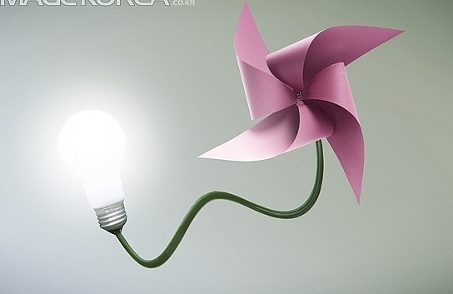

- Please describe the way to produce electricity through alternative energy if electricity supply is stopped. (1 idea)

- What is your partner’s opinion about above question 1.?

Plugging Into The Sun

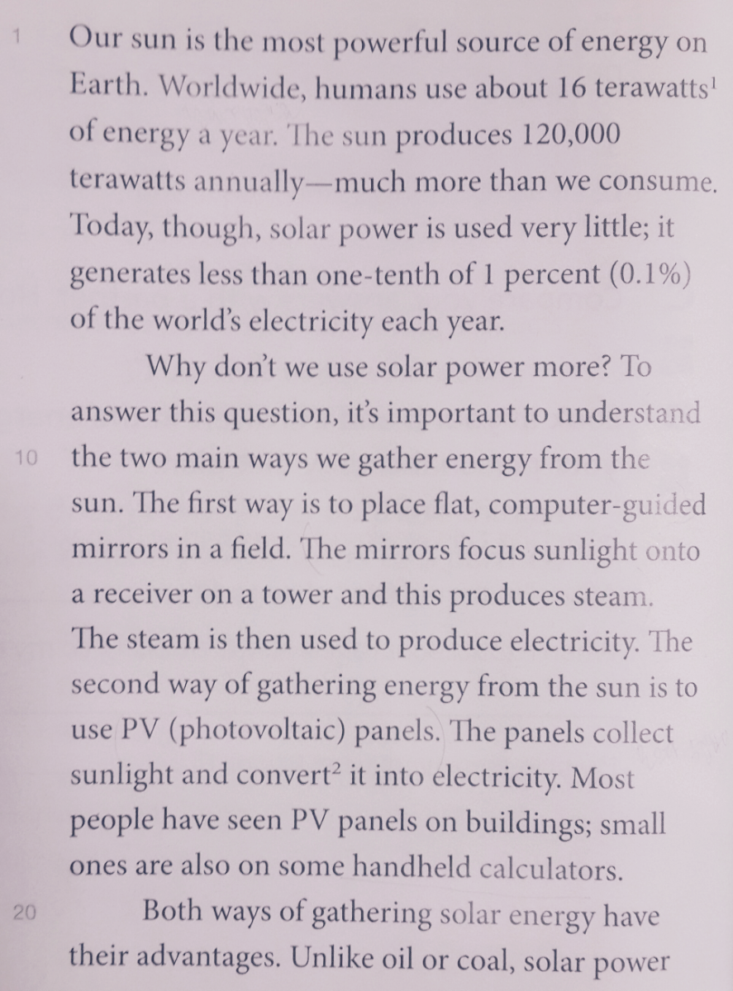

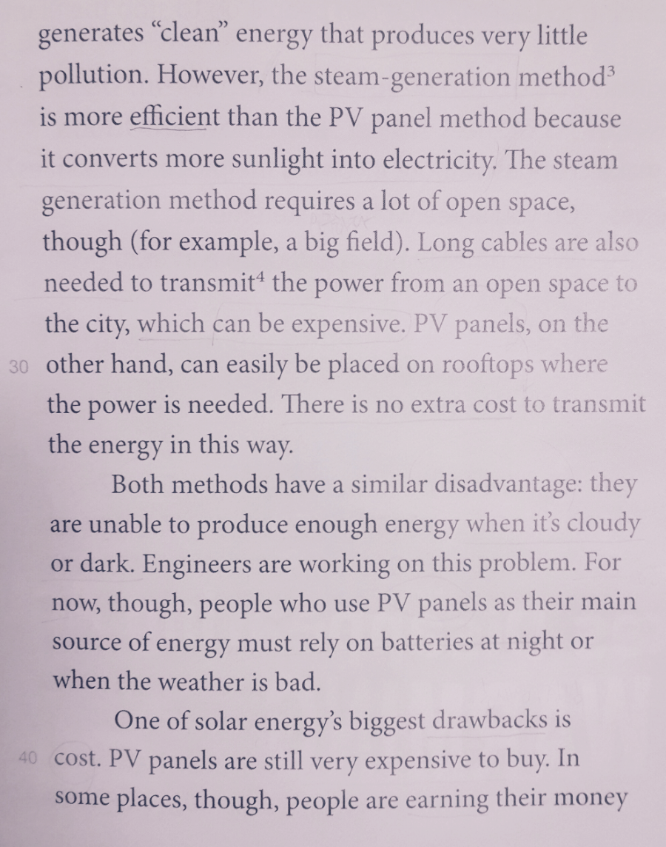

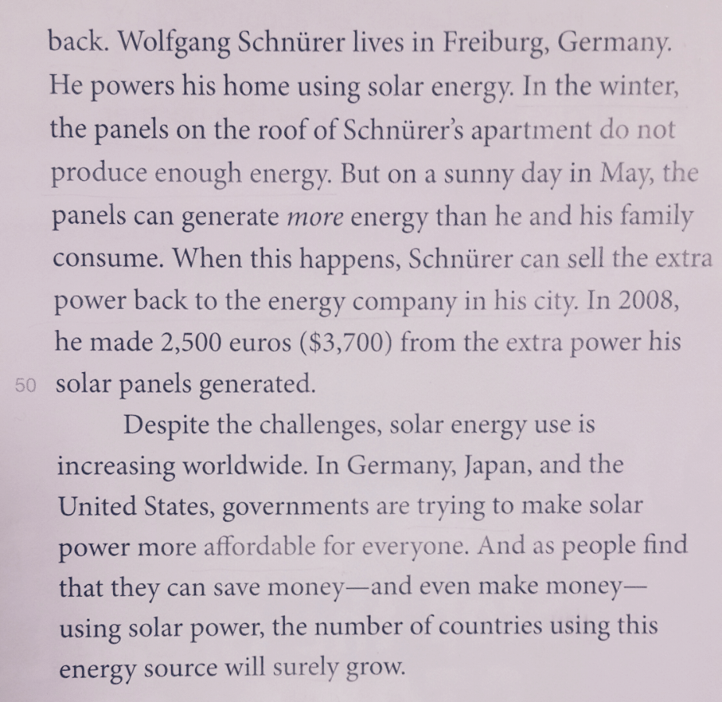

‘After Reading’ Work Sheet

- Take the quiz and compare ideas with a partner.

True False

- The sun generates more energy than humans can use.

- Worldwide, most electricity is produced using solar energy.

- Solar energy can only be used in places that get a lot of
sunlight all year.

- Solar energy generates a lot of pollution.

- One of the solar energy’s biggest drawbacks is place.

- List at least two advantages and two disadvantages of each method of gathering solar energy (steam generation and PV panels).

- Advantages

- Disadvantages

Role-Play Work Sheet

- Use your answer from Exercise B to act out this role play.

- Student A :
Imagine that you work for a solar energy company. You need to persuade the mayor of your city to invest more money in solar power.
Give two or three reasons why this is good idea.

- Student B :
Listen to your partner’s argument and ask at least 2 questions about the disadvantages.
Did your partner convince you to invest more money?

- Student C
After listen both opinions (Student A, B), you are a person who agree with above both opinions. Talk about all advantages and disadvantages of solar system.

