Listening Speaking Reading Grammar Writing

Topic:
Under surveillance

Instructor:  Angela Kim | Level:  Upper Intermediate | Students:  17 | Length:  20 Minutes

Materials:
- A word card of ‘Surveillance
- A picture of surveillance camera
- 17copies of word-definition matching worksheets
- A wall chart of correct answers
- A wall chart for demonstrate dialogue
- 3 papers of two topics
- A wall chart of idea of a new product I would make for make under surveillance
- 17 copies of reading materials
- A word card for scrambled word and correct answer

Aims:
Main aim: Ss will improve their reading skills by reading an article about under surveillance.
Secondary aim: Ss will improve their English by doing word matching, making dialogue and writing their idea about new product for surveillance
Personal aim: I want to improve on accuracy of staging and teacher’s authority

Language Skills:
Listening: Ss will listen to each other for word matching and other students opinion
Reading: Ss will read an article about ‘Surveillance’
Writing: Ss will improve writing by writing their thoughts while making a dialogue and making a product for under surveillance.
Speaking: Ss will discuss about ‘Surveillance’

Language Systems:
Lexis: surveillance, watch over, play back, tap, global positioning, suit, infringement, have a different take. invade, blur, significant other
Phonology: sur-veil-lance
Grammatical: None to discuss
Function: None to discuss
Discourse: None to discuss

Assumptions:
Most of Ss have interests about invasion of privacy.
Most of Ss already know risks of invasion of privacy.
Most of Ss are aware of they are being monitored every day.
Most of Ss already know Google has technology of satellite picture

Anticipated Problems and Solutions:
- Students may not know some vocabularies.
→ Explain them by using easier words and encourage the Ss to guess the meaning
→ If explanation doesn’t work, tell the meaning of the word to the Ss and let them to make examples using it
- Students may need more time to work on the matching word and definition cards
→ If It takes longer than 1 minute, cut answer-checking short by verbally sharing the answers instead
- If students finish their tasks earlier than anticipated.
→ Move on to SOS activity
- Students might not understand the rule of given activity.
→We will give example

References:
1. http://dictionary.cambridge.org/dictionary/english/
2. https://esllibrary.com/

Lead-In
Materials:
No need

Time | Set Up | Student Activity | Teacher Talk
1min | T-WC  T-Ss | Greeting  Answering | Good morning class! How are you?  Questions  What is your plan after this ‘TESOL’ course?  Follow-up  Good idea.  What is your plan after today’s class?  Hope you have fun.  Question  If you have a free ticket, what country do you want to visit for your summer vacation?  Follow-up  Why do you want to visit there?  I wish I can go there for that reason too.  Thank you all for sharing.

Pre-Activity
Materials:
Eliciting word card of ‘surveillance’, A picture of CCTV, 17copies of word-definition matching worksheets, A wall chart of correct answers

Time | Set Up | Student Activity | Teacher Talk
2min  2min | T-WC | Set-up | Eliciting  What is the purpose of CCTV?  What do you use that for?  (Put a CCTV picture on the board)  We call that ‘Under surveillance’  Please repeat after me.  (Put a word card of ‘Under surveillance’)  CCQ  Is under surveillance mean active monitoring? = Yes  Is under surveillance mean passive monitoring? = No  Are we under surveillance?  (Point CCTV in the classroom.)  Demonstration  Skip demonstration(worksheet)  Instruction  Now, I’ll hand you out these worksheets, please match correct definitions for each word. You will work individually. And I will give you 2 minutes to do this.  ICQs  What are you going to do?  Are you working in pairs?  Are you working individually?  How much time do you have?  Explicit Instruction  Please don’t touch the paper before I say ‘Begin’.  Explicit ICQ  Are you going to touch the paper before I say ‘Begin’?  (Distribute the worksheets)  Run  Now, begin.  (Monitoring)  1min, 30 seconds, 10 seconds…  Times up  Teacher monitors class and answer to Ss when they ask questions  Student A, will you read the word and the correct definition  (Ask few Ss to share the answer.)  You can check correct answer on the board  (Put wallchart of answers)  Okay, good job. Please stay where you are.

Main Activity
Materials:
3 papers of two topics, A wall chart for demonstrate dialogue, 17 copies of reading materials

Time | Set Up | Student Activity | Teacher Talk
1min  2min  3min  3min  1min |  |  | Let’s move on.  Please read this article in 2 minutes individually.  ICQs  What are you going to do?  Are you working in groups?  How much time do you have?  Explicit instruction  Please don’t start reading before I say ‘Begin’.  Explicit ICQs  Are you going to start reading before I say ‘Begin’?  =No  (Distribute scripts)  Run  Now, Begin  (monitoring)  Answers to Ss if they ask questions  Timing  1minute, 30 seconds, 10 seconds…  Time’s up  Grouping  Please repeat after me. ‘Sur-veil-lance’  (Make student to say ‘sur’, ‘veil’, ‘lance’ in turn.)  Who said ‘sur’, please stand up and move to this side.  Who said ‘veil’, please stand up and move to this side.  Who said ‘lance’, please stand up and move to this side.  Regrouping  From A to B will be team A.  From C to D will be team B.  From E to F will be team C.  Demonstration  Read the wall chart of dialogue  (Put a wall chart of dialogue)  Instruction  Now I’m going to give you two topics. Choose one topic and create a dialogue about that topic. Note taker will write down on the back side of the article that I have given you. You will have 3minutes to do this.  ICQS  What are you going to do?  Are you working individually?  Are you working in groups?  How much time do you have?  Explicit Instruction  Please don’t start before I say ‘Begin’.  Explicit ICQs  Are you going to start before I say ‘Begin’?  (Distribute topics)  Run  Now, Begin.  (monitoring)  Teacher monitors class and answer to Ss when they ask questions  Timing  1 minute, 30 seconds, 10 seconds…  Time’s up  Who is the most tallest person and the most shortest person? Please come out and tell us what topic you choose and present the dialogue  Thanks for sharing. Please stay where you are.

Post Activity
Materials:
A word card for scramble and correct answer, A wall chart of idea of a new product I would make for make under surveillance

Time | Set Up | Student Activity | Teacher Talk
1min  1min  1min  30sec |  |  | Let’s move on.  Demonstration  (Put the wall chart for demonstration and read.  ‘I will make a product seems like floor tile but can see everything from the invisible camera at every corner.’  Instruction  Imagine that you are making a product to make company under surveillance. Please write down your idea on the back side of the article paper. You will do this individually. I’ll give you 2minutes to do this.  ICQs  What are you going to do?  Are you working in groups? Individually?  How much time do you have?  Explicit instruction  Please don’t start before I say ‘Begin’.  Explicit ICQs  Are you going to start before I say ‘Begin’?  (Distribute blank papers to every Ss)  Run  Now, Begin.  (monitoring)  Teacher monitors class and answer to Ss when they ask questions.  Timing  30 seconds, 10 seconds, 5 seconds…  Time’s up.  (Pick a student to present)  Wow. That’s a good idea.  Error Correction  Since, I couldn’t hear error, I will scramble a word.  (Show the class word card)  Can you guess what this word is?  =Surveillance  (Show the class the correct word)  Closing  Do you have any question? If you don’t have any further question, I will end up this lesson. Thank you for your participation. I hope you enjoyed my lesson.
SOS Activities
Materials:
A wall chart of word search puzzle, A wall chart for correct answer, 17 word search puzzle work sheet

Time | Set Up | Student Activity | Teacher Talk
Demonstration
(Put a wall chart of word search puzzle and circle a word)

Instruction
Please find words below. You will work individually. You will have 1 minute to do this.

ICQs
What are you going to do?
Are you work in groups?
How much time do you have?

Explicit instruction
Please don’t touch the paper before I say ‘Begin’.

Explicit ICQs
Are you going to touch the paper before I say ‘Begin’?

(Distribute worksheets of word search puzzle.)

Run
Now, Begin.

(monitoring)

Timing
30 seconds, 10 seconds, 5seconds…
Time’s up.

(Pick a student to say a word that she found)

Well done. Please check other answers on the board.

(Put a wall chart of correct answers on the board)

A picture of surveillance camera
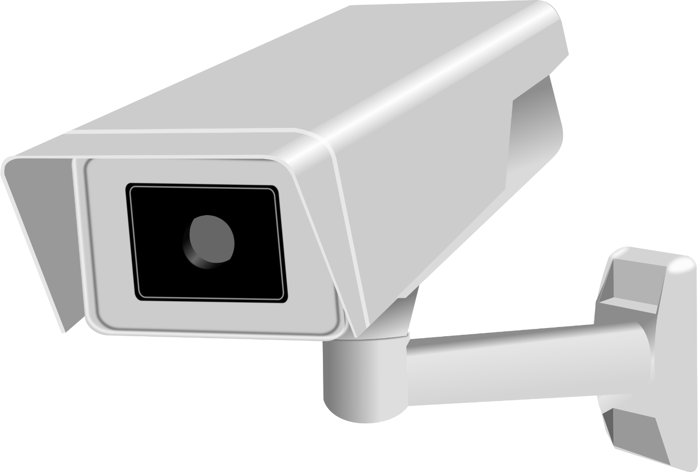

A wall chart for correct answers
1. b
2. c
3. d
4. e
5. f
6. h
7. g
8. j
9. a
10. i

A wall chart of dialogue

Topic: My parents try to put GPS into my phone.

P: We had made decision to put GPS on your phone.
M: What? Why?
P: The world is too violent and we worry about you.
M: No way, those thing won’t be happen to me.
P: Besides, you lied to us several times to skip institutions.
M: I’m so sorry that I made up mistakes but please respect my privacy

A wall chart for demonstrate post activity
I will make a product seems like floor tile but can see everything from the invisible camera at every corner.

Reading material

SURVEILLANCE
Who is keeping an eye on you today?
Look around for a moment. Do you see any cameras, officers, or computers? Chances are someone or something is watching you. The word surveillance comes from a French word meaning “to watch over.” While some forms of surveillance are for your protection, others could be used against you. After all, there is a big difference between being watched over and being watched!
Who or what is observing your everyday actions today? It could be your neighbor’s hidden security camera or an officer at your child’s school. At this very moment, the owner of your local gas station may be playing back a tape of you paying at the pump. Some parents install global positioning devices on their kids’ cell phones. In many countries, a phone can be tapped by law enforcement at any time. According to some sources, all digital communication in the US is recorded and stored.
Are you safe from surveillance in the privacy of your own home? Not if you use the Internet! Ads suited to your own interests pop up on a regular basis. Your search history provides a lot of information that marketers want! Many Internet users don’t appreciate this infringement of privacy. Key players in the communications industry have a different take on privacy. In their opinion, targeted ads exist for your convenience. Google’s former CEO Eric Schmidt said this: “If you have something that you don’t want anyone to know, maybe you shouldn’t be doing it in the first place.”
Google is often accused of invading the privacy of its users. Did Google Street View cars map out your neighborhood? Google used special technology to blur people’s faces as it mapped out streets all over the world. Many people consider this an invasion of privacy nonetheless. How would you feel if Google caught your significant other at an address where he or she shouldn’t have been?

Topics for making dialogue
Q1. What would you do if your parents keep try to put a GPS into your phone.
(Assume that you are a teenager.)

Q2. What would you do if your boyfriend or husband ask you to install ‘Tracing GPS’ application together.

Vocabulary definition matching work sheet
- Watch over
- Play back
- Tap
- Global positioning
- Suit
- Infringement
- Have a different take
- Invade
- Blur
- Significant other
- To cause something to appear fuzzy
- To observe closely in order to make sure a person or situation stays safe
- To review a recorded version
- To use a special device to spy on someone’s phone conversation
- Using satellite technology to keep track of movement
- To match well, to be appropriate
- To have a different opinion
- A violation or breaking of a contract or right
- One’s romantic partner or spouse
- To go into a place where you aren’t welcome

