Listening Speaking Reading Grammar Writing
Topic: If you avoid heavy meals at night, you’ll sleep better

Instructor:  Isabel | Level:  Upper-Intermediate | Students:  9 | Length:  30 Minutes

Materials: wallchart#1; First conditional & Indirect questions
wallchart #2 & worksheet #1; Questions for the First conditional
‘avoid’ picture, cut down on / reduce picture
wallchart #3 & worksheet #2; verbs and nouns for healthy lifestyle
wallchart #4; If you avoid heavy meals at night, you’ll sleep better
Bingo sheets

Aims: Main – Students will improve their grammar skills by doing activities about the first conditional.
Secondary – Students will learn about the first conditional by doing worksheet activities, making sentences about healthy lifestyles and bingo game.
Personal – I want to improve my teaching pace and I want to make my ICQs clearly.

Language Skills: Students will read the wallcharts and their worksheets.
Students will speak their opinions by doing pair works.
Students will write the answers of worksheet #1 and their own opinion.
Students will listen to the teacher’s demo and instruction

Language Systems: Lexis: ‘avoid’, ‘cut down on & reduce’
Grammar: First conditional.
Functional: Discuss the results about given condition.
Discourse: Sharing opinion about the healthy lifestyle
Phonology: None to discuss.

Assumptions:
- Students may know about two meanings of ‘If’.
- Some students will know the position of ‘if’ in the sentence.
- Some students will know how to match verbs and nouns.
- Students may know how to play bingo game.

Anticipated Problems and Solutions:  - If the students can’t guess ‘First conditional’ | Give more explanation or examples.
- If the number of students is odd, the teacher can’t make a pair for work. | Make one team instead of a pair.
- Students may need more time to complete their worksheet | Give students more time to work
- If the teacher is short of time to ceck the students’ opinion | Check only 4 to 5 students’ opinion

References: Cambridge free English Dictionary: http://dictionary.cambridge.org
Wallcharts : Paul Dummett, John Hughes, Helen Stephenson, National Geographic Learning, Life Level 4, 2015.
Bingo game: https://www.hueber.de/shared/elka/Internet_Muster/Red2/978-3-19-152979-9_Muster_1.pdf
Lead-In
Materials: None
Time | Set Up | Student Activity | Teacher Talk
2 min. | T-S | Answer the questions. | Hello everyone, good afternoon. Welcome to my grammar class!  Q1: When was the last time you went to a restaurant? What did you eat? (What food was the most delicious?)  Q2: What is your favorite food? (Why?)  How often do you eat it?  Thank you for sharing.

Pre Activity
Materials: wallchart#1; First conditional & Indirect questions
wallchart #2 & worksheet #1; Questions for First conditional
Time | Set Up | Student Activity | Teacher Talk
30 sec.  30 sec.  30 sec.  1 min  30 sec.  30 sec.  10 sec.  20 sec.  2 min.  2 min. | T-WC  T-WC  T-WC  T-WC  T-WC  T-WC  T-WC  T-WC  S-S  T-Ss | Elicit ‘first conditional’  Answer the CCQs  Paring  Listen and read the demo  Listen to the instruction  Answer the ICQs  Do their work in pairs  Answer their work. | - Eliciting  What do we call these sentences to talk about a possible future action or situation with the conjunction ‘If’. (And these sentences don’t lose their meaning if you change the sentence order.)  _ First conditional!  - CCQ  Do the conditionals change meaning if you switch the sentence pattern? – N  Do the conditionals keep the same context if you switch? – Y  Right, good!  Now, ~~ could you say ‘first’ (point one student) and ~~ could you say ‘conditional’ (point next student) _(make pairs)  Who said ‘first’? Come over here, and who said ‘conditional’ Come over here. Now, ~~ and ~~ are one pair. (regrouping)  - Demonstration  Okay, look at this sentence.  (prepare wallchart#1; First conditional & Indirect questions)  ~~ could you read this sentence for us?  - If you go to bed early, you will feel better.  We can change this sentence order like this.  You will feel better if you go to bed early.  And the meaning doesn’t change.  So we can say this is the conditional.  However, look at the next sentence.  - I wonder if you will come to the party.  Can we change the form like before? -N  ( If you will come to the party I wonder)  We can’t change this sentence, because it’s not the conditional. It’s indirect question.  - Instruction  (prepare wallchart #2 & worksheet #1)  Now, this time we are going to read two conditional sentences. Like we did right before, for 2 min, with your partner, read these two conditional sentences and discuss about the answer of the questions on this worksheet. (show wallchart and worksheet)  - If I study hard, I will pass the exam.  - You’ll lose weight if you don’t eat a lot of junk food.  Which tenses are used to make the first conditional? You can choose in the box below.  simple present, past progressive, present progressive, present perfect, will+base form  Where can if go in conditional sentences?  Look at the position of If in the sentences. When do we use a comma(,)?  Do the sentences refer to the past, the present, or the future? You can choose more than one option.  What is the first conditional?  - If I find any information, I’ll let you know.  - If I could fly, I would go somewhere warm.  - ICQs  What are you going to do?  Discuss about answers of the questions  How much time do you have? 2 min.  Do you work individually? No  - Explicit instruction.  I don’t want you to start before I say begin.  - Explicit ICQs  Do you start when I give you this worksheet?- N  When I say begin?- Y  Begin!  - Run  (students do their worksheet)  (Monitoring & Timing) 1 min left, 30 sec. 10 sec.  Times up!  - Close (Check the answer)  Who is older in your pair? Okay, (older) ~~ will read the question and (younger) ~~ will answer the question in number 1. Good!  Okay then, ~~ and ~~, please do N.2. (Next pair)  Good job!!

Main Activity
Materials: ‘avoid’ picture, cut down on / reduce picture
wallchart #3 & worksheet #2; verbs and nouns for healthy lifestyle
wallchart #4; If you avoid heavy meals at night, you’ll sleep better
Time | Set Up | Student Activity | Teacher Talk
1 min  30 sec.  1 min.  30 sec.  10 sec.  20 sec.  1 min.  1 min.  1 min.  1 min.  30 sec.  4 min.  2 min. | T-WC  T-WC  T-WC  T-WC  T-WC  T-WC  T-WC  T-S  T-WC  T-WC  T-WC  S-S  T-S | Elicit words  Listen and read the demo  Listen to the instruction  Answer the ICQs  Do their worksheet  Share their opinion  Listen and read the demo  Answer the ICQs  Do their pair work  Check their opinion | - Eliciting  Now, (show ‘avoid’ picture) look at this photo, what is he doing in this photo? Yes, He’s avoiding (act like avoid something) the stone written ‘problem’ on. (put the picture on the board and write ‘avoid’)  Then, what about this photo? (show cut down on / reduce picture) The amount of sugar is… (reducing), right. Also, we can say the sugar is cutting down on. (put the picture on the board and write ‘cut down on & reduce’)  - Demonstration  Okay, look at this wallchart, (prepare wallchart #3)  On the left side, we can see several verbs. And on this side, we can see the nouns that can be a help or harmful to have the healthy lifestyle.  With this ‘avoid’ in verbs part, we can make a phrase with ‘heavy meals at night’ in nouns part, like, avoid heavy meals at night.  - Instruction  (prepare worksheet #2)Like this, I’ll give you this worksheet. I want you to work in individually, for 1 min, match the verbs with nouns to make plans for a healthy lifestyle.  And you can match some verbs with more than one noun and some nouns with more than one verb, and you can also add your own idea.  - ICQs  What are you going to do?  Match the verbs with nouns  How much time do you have? 1 min  Do you work individually? Y  Can you use one noun twice? Y  - Explicit instruction.  And also don’t start before I say begin.  - Explicit ICQs  Do you start when I give you this worksheet?- N  When I say begin?- Y  Begin!  - Run  (students do their worksheet)  (Monitoring & Timing) 30 sec. 10 sec.  Times up!  - Check the answer  I chose ‘heavy meals at night’ with verb ‘avoid’  ~~, what noun did you match with verb ‘change’?  ~~, What did you choose for verb ‘cut down on’?  ~~, What did you choose for verb ‘give up?’  ~~, What did you choose for verb ‘learn?’  Good job everyone!  - Demonstration  (Prepare wallchart #4)  Now, with the first conditional, think of a specific result for each plan you made.  For example, as you know I chose avoid and heavy meals at night, so I can make the sentence;  (wallchart #4) If you avoid heavy meals at night, you’ll sleep better.  - Instruction  Like this, for 4 min, in pair (or a team like we made before in Q&A activity), let’s make the first conditional sentences and advise your partner about the healthy lifestyle with your sentences. You can write the sentences under the verb & noun chart on the worksheet.  - ICQs  What are you going to do?  Make first conditional sentences and advise the partner.  How much time do you have? 4 min.  Do you work individually? -N  Begin!  - Run  (students do their pair work)  (Monitoring & Timing) 1 min left, 30 sec. 10 sec.  Times up!  - Close  ~~, could you tell us 1 advice that you’ve got from your partner? (check the answer)

Post Activity
Materials: Bingo sheets, wallchart #5; Sentence beginning
Time | Set Up | Student Activity | Teacher Talk
30 sec.  30 sec.  1 min.  30 sec.  2 min.  1 min. | T-WC  Ss-Ss  T-WC  T-WC  T-WC  T-WC | Elicit Bingo  Make teams  Listen and read domo and instruction  Answer the ICQs  Play the bingo  Close | - Eliciting  What do we call this game, someone says something like number and then others check it on their board and if they complete checking one line, they’ll say ‘(Bingo!)’  Right! Now, ~~, ~~, ~~, ~~ and ~~ will be a team, and ~~, ~~, ~~, and ~~ will be a team. So please sit closer together. And here is a Bingo board.  (pass the bingo board)  - Demonstration & Instruction  Now, I also have one bingo board. And we will play the first conditional bingo game together!  In Bingo board, you can see sentence beginning list. So choose and say one sentence beginning for your bingo. For my board, I’ll choose “If I win some money” and then I will check the matched sentence ending on my bingo board. And you’ll also check the ending if you have it on yours. You can complete the straight and vertical line. But not diagonal. And please shout Bingo! If you complete one line!  - ICQs  What are we going to do? Bingo game  Do you work individually?  No, but I do individually.  Can you use the diagonal line for bingo? N  What do you call if you complete one line?  Bingo!  Okay, then let’s start, ~~ please choose one.  - Run  (student choose one) then, ~~ choose please.  (after several choosing, some students say ‘Bingo!’  - Close  Good!! You’re the winner!  Good job everyone~  I didn’t hear any mistake from you, so I prepare this.  (Prepare wallchart #6; scrambled word; first conditional)  Let’s unscramble these words.  Yes! Fist conditional! Good!  Thank you all for participating. This concludes my grammar micro teaching.  Thank you!

SOS Activity
Materials: None
Time | Set Up | Student Activity | Teacher Talk
10 sec.  20 sec.  20 sec.  30 sec.  1 min. | T-WC  T-WC  T-WC  T-WC  T-S | Listen and read demo  Answer the ICQs  Think about the opinion  Answer their opinion | - Demonstration  If I don’t need to go to work on March 1st, I will sleep all day. What about you?  - Instruction  I’ll give you 30 sec to think about what you will do if you don’t go to work on March 1st. And please share it.  - ICQs  What are you going to do? Think about what you will do on March 1st.  How much time do you have? 30 sec.  Begin!  - Run  (Students think about their opinion)  10 sec. Times up!  - Close  ~~, could you tell us your plan if you don’t have to work on March 1st?  Thank you for sharing.

Worksheet #1; Questions for the First conditional

Look at these sentences and answer the questions.

A. If I study hard, I will pass the exam.
B. You’ll lose weight if you don’t eat a lot of junk food.

Which tenses are used to make the first conditional?
You can choose in the box below.

simple present, past progressive, present progressive, present perfect, will+base form

Where can if go in conditional sentences?

Look at the position of If in the sentences. When do we use a comma(,)?

Do the sentences refer to the past, the present, or the future?
You can choose more than one option.

Which one is the first conditional?

a. If I find any information, I’ll let you know. □
b. If I could fly, I would go somewhere warm. ..□

Worksheet #2; Questions for the First conditional

Work in pair. Match the verbs with the nouns to make plans for a healthy lifestyle. You can match some verbs with more than one noun and some nouns with more than one verb. And also you can add your own idea.

Verbs | Nouns
avoid  change  cut down on  cut out  give up  learn  reduce  start | a new sport  an outdoor activity  bad habits  computer and TV time  fatty food  heavy meals at night  junk food  relaxation techniques  smoking  snacks between meals  stress

Bingo game with the First conditional (A)

Here is ‘sentence beginning’

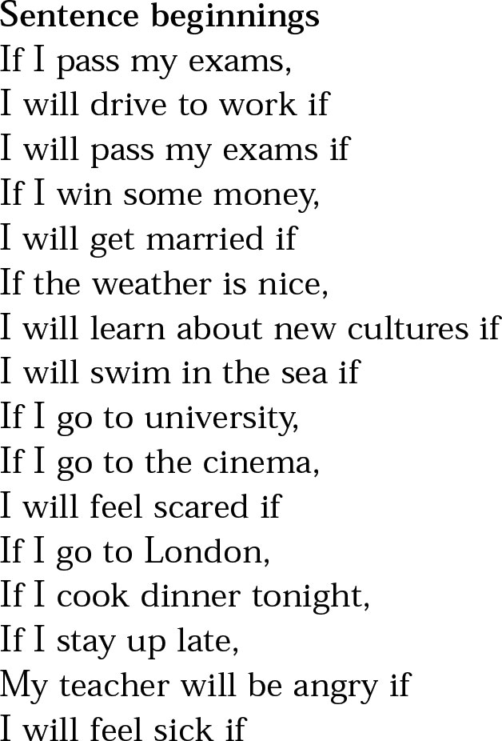

Choose one sentence beginning related with your bingo board. And check the matched ending sentence.

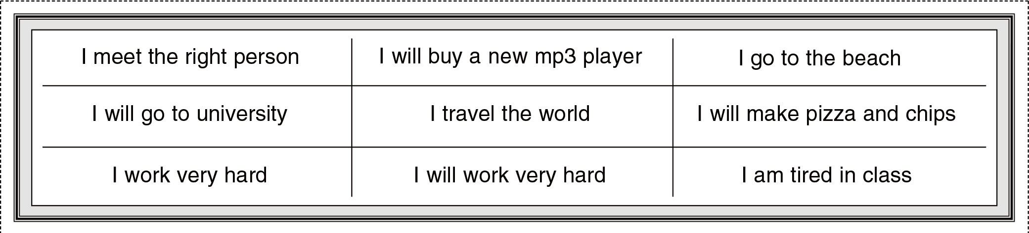

Bingo game with the First conditional (B)

Here is ‘sentence beginning’

Choose one sentence beginning related with your bingo board. And check the matched ending sentence.

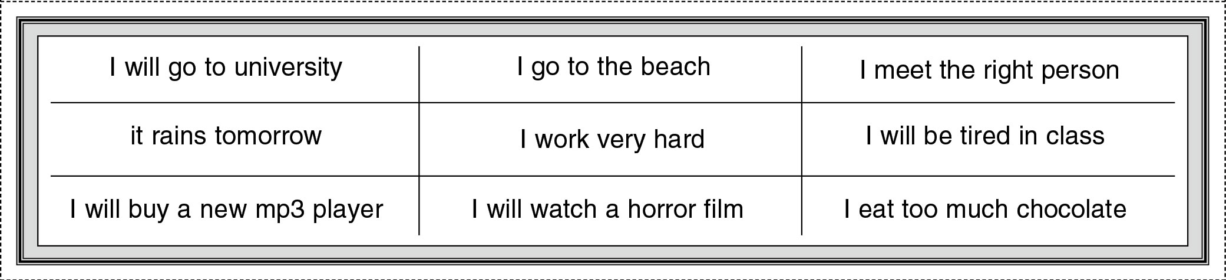

Bingo game with the First conditional (teacher’s)

Here is ‘sentence beginning’

Choose one sentence beginning related with your bingo board. And check the matched ending sentence.

