Listening Speaking Reading √Grammar Writing
Topic: Prepositions of location
Instructor: Nature | Level: Upper-Intermediate | Students: 9 | Length: 30 minutes
Materials:
Prepositions of location card
Visual
<Whare are you?> worksheet
<In the bedroom, bathroom, kitchen> worksheet
paper cups
A block
Unscramble paper
White board, board makers.

Aims:
Main aim : To improve student's Grammar skills by learning to Prepositions of location
Secondary aim :
- Ss will know prepositions of location by doing <Whare are you?>worksheet.
- Ss will make sentences with prepositions of location by doing <In the bedroom, bathroom, kitchen> worksheet.
- Each Ss understand about prepositions of location by doing post-activity.
Personal aim : I want to speak in English, properly, what I think to people.
I want to improve on my CCQ`s and demonstrations.
I want to improve on my Instruction delivery.

Language Skills:
Listening : Ss will listen to each other`s conversation.
Reading : Ss will read prepositions of location card and worksheet questions.
Speaking : Ss will talk about prepositions of location and have opportunities to talk in groups.
Writing : Ss will write down prepositions of location when their do worksheets.

Language Systems:
Lexis : Preposition, location
Phonology : Preposition [|prepə|zɪʃn]
Grammar : preposition of location(on, next to, behind, between, over, under, in front of, in)
Function : None to discuss
Discourse : None to discuss

Assumptions:
Students already know :
▶ how to do crossword
▶ the preposition changes according to the position
▶ the name of stuff in a room (ex. living room, bath room, kitchen)
▶ how to make sentences in English

Anticipated Problems and Solutions:
▶ Some Ss can ask the difference between over and above
- Expain it by drawing some situation.
▶ We might not have much time when we do pre-activity
- I will show Ss the Wall chart with answers
▶ If TTT(Teacher Talk Time) too high.
- At first, I'll listen what Ss say. After that, attract participation from students.
▶Ss may feel boring.
- Give chocolate to Ss when they correct the answer.

References:
- Whare am I worksheet http://www.eslprintables.com/grammar_worksheets/prepositions/prepositions_of_place/Prepositions_Of_Place_139211/
- Bedroom worksheet http://studyenglishaz.blogspot.kr/2013/12/the-house-where-i-am-living.html
- Preposition activity
http://www.pre-kpages.com/learning-prepositions-with-pete-the-cat/

Lead-In
Materials: n/a
Time | Set Up | Student Activity | Teacher Talk
2 min | T-S | Guiding questions | Hello everyone, how was the last week? Grace, What is your blood type?  Do you believe in the characteristic of the blood type? Why? Thank you for sharing your story.  Tim, When is your birthday? What do you want for your birthday present? Thank you for sharing.

Pre-Activity (9 minutes)
Materials: Wall chart, White board, board makers.
Time | Set Up | Student Activity | Teacher Talk
30 sec | T-WC | Elicit discussion | (Eliciting)  Good. When a word is used before nouns or pronouns, and it shows location. How do we call the word?  -Answer: preposition of location
30 sec | T-WC |  | (CCQ`s)  (show the wall chart - I like music.)  Can you see the preposition in this sentence? - No  (show the wall chart - The bookshelf is next to the window.)  Can you see the preposition in this sentence?  - Yes.
1 min | T-Ss | Ss move their seats. | Great! Let`s say NEXT / TO  (Creative groups)  next/to/next/to/next/to/next/to  Who said next? Please raise your hands and move to the left side.  Who said to? Please raise your hands and move to the right side.  (Make a pair.) Sung Mi and Kirix, you guys are in one pair. Tim, isabel, you guys are in one pair.
30 sec | T-WC |  | (Demonstration)  (Show the board maker behind my hand.)  Is this board marker in front of my hand? - No  This preposition is behind.  (Show the board maker in front of my hand.)  Is this board marker in front of my hand? - Yes. Then, look at this paper. I have a crossword paper.
30 sec | T-WC |  | (Instruction)  Now, just like me, with your pair, solve the crossword by checking where the ghost is. All answers are 'preposition'. I will give you 2 mins.
30 sec | T-WC |  | (ICQ`s)  What are you going to do?  How much time do we have? = 2 minutes.  Are you working in individually? = No.  or a pair? = Yes.  (Explicit instruction)  I don`t want you to start when I give you a paper. Please wait until I say begin.  (Explicit ICQ`s)  Are you going to start before I say "Begin"?  or when I say "Begin"? = Yes.  (I give the paper to each person and I say "Begin".)
2 min | Ss-Ss | Ss solve the crossword with partner | (Run)  Monitor discreetly. Answer students if they ask questions.  Attach the wall chart to the white board.  "The ghost is behind the box."  Give time warning : 30 seconds left. 10 seconds, and times up!
3 min | T-Ss | Ss shared answer. | Ok, until now, we shared our answer together. Please make a sentence like this.  (When Ss make the answer correctly, I'll attach the word-card to the white board.)
30 sec | T-WC |  | (Close)  Here it is answer paper. You can check the answer during the breaktime. Well done guys! Now we know the prepositions of location.

Main Activity(11 minutes)
Materials: Visuals, worksheets
Time | Set Up | Student Activity | Teacher Talk
30 sec | T-WC |  | (Eliciting)  Where is the place you can brush your teeth and wash your face in your house?  Answer-bathroom
30 sec | T-WC |  | (CCQ`s)  (Show a picture of bedroom) Is it bathroom?  (Show a picture of kitchen) Is it bathroom?  (Show a picture of bathroom) Is it bathroom?
1 min | T-WC | Ss move their seats. | Great! Let`s say bedroom / kitchen / bathroom  ((Creative groups))  Who said bedroom? Please raise your hands and move to the left side.  Who said kitchen? Please raise your hands and move to the right side.  Who said bathroom? Please raise your hands and move to the middle.  (Make a group.) You guys are one team.
30 sec | T-WC |  | (Demonstration)  Ok guys, today I`m a house agent. I need to explain the living room like this, "In this living room, there is a clock on the wall. There is a ball under the table. There are 2 pillows on the sofa. There is a lamp between some flowers and a book. A cat sits next to the sofa."
30 sec | T-WC |  | (Instruction)  As like me, each team is the house agent of your room. You want to sell a house so you need to explain how does the each room looks like. When you explain the room, you need to use 'prepositions of location'. I will give you 3 mins.
1 min | T-WC |  | (ICQ`s)  What are you going to do?  How much time do we have? = 3 min.  Are you working in individually? = No.  or a group?= Yes.  (Explicit instruction)  Make sentences as much as you can. However, you have to make sentences at least five. Please start when I say begin.  (Explicit ICQ`s)  Can you make three sentences? - No.  Can you make more than five sentences? -Yes  Are you going to start before I say "Begin"?  or when I say "Begin"? = Yes.  (I give the paper to each person and I say "Begin".)
3 min | Ss-Ss | Ss make sentences with prepositions of location | (Run)  Monitor discreetly. Answer students if they ask questions.  Give time warning : 2 mins. 1 more mins. 30 seconds left. 10 seconds, and times up!
4 min | T-Ss | Ss describing room | Bathroom team, please start describing your room to sell it.  Now, change the role. (bedroom, kitchen)  (Close)  Well done guys. I listened very well what you said.

Post Activity (8 minutes)
Materials: paper cups, A block
Time | Set Up | Student Activity | Teacher Talk
30 sec | T-WC | Elicit discussion | (Eliciting)  In a paper cup, there is a small thing. Its shape is square. We can know the number one to six to roll this. What is it?  Answer - Dice
30 sec | T-WC |  | (CCQ`s)  Right. (show a dice) Can you use this to cook? -No  (show a dice) Can you use this to board game? - Yes.
30 sec | T-Ss | Ss make a circle | Great! Let`s play by using it. Come out here and enjoy together.
30 sec | T-WC |  | (Demonstration)  Very good.  (I grab a dice over the paper cup.)  “The dice is over the cup.”
30 sec | T-WC |  | (Instruction)  As like me, we`re going to make a sentence with preposition of location. Work together, I will give 10 seconds to answer.
30 sec | T-WC |  | (ICQ`s)  What are you going to do?  How much time to answer? = 10 sec  Are you working in individually? = No.  or together? = Yes.  (Explicit instruction)  You should make only one sentence with preposition of location.  (Explicit ICQ`s)  Are you making two sentences? = No.  Are you making one sentence? = Yes.  Okay, Let` start!
4 min | T-WC |  | (Run)  I participated.  (Close)  Okay, well done guys. Please go back to the seat.
1 min | T-WC | Error correction | I didn`t hear any errors so I`ll make word unscramble. "toliacon = location"  (If Ss made mistakes, I would correct the errors.)  Thank you for listening to my grammar lesson class.
SOS Activity (3 minutes)
Materials: Visuals, Unscramble paper.
Time | Set Up | Student Activity | Teacher Talk
30 sec | T-WC |  | (Demonstration)  In my living room there is a clock on the wall.
30 sec | T-WC |  | (Instruction)  As like me, we`re going to describe our room with prepositions of location.
2 min | T-Ss | Ss describing their room | (Run)  Ss make a sentence about their room with preposition of location.  (Close)  Thank you for sharing.

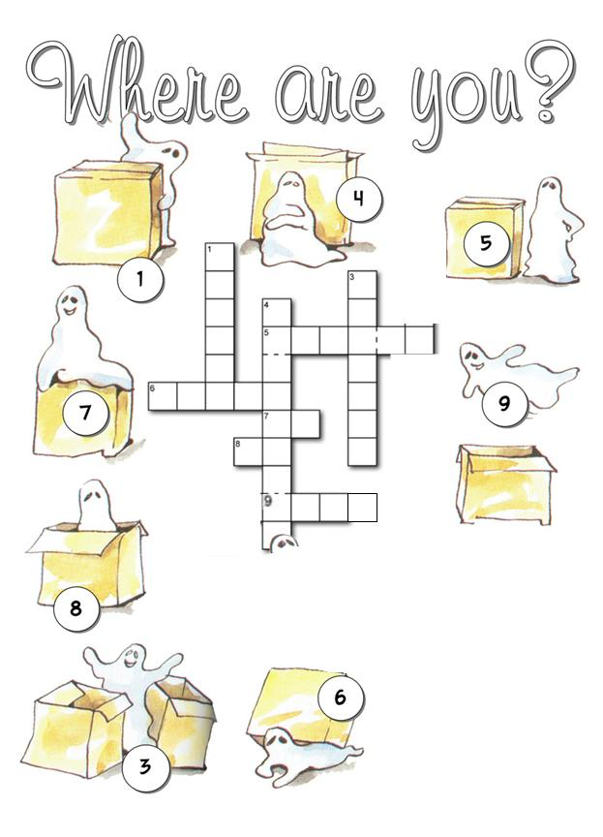
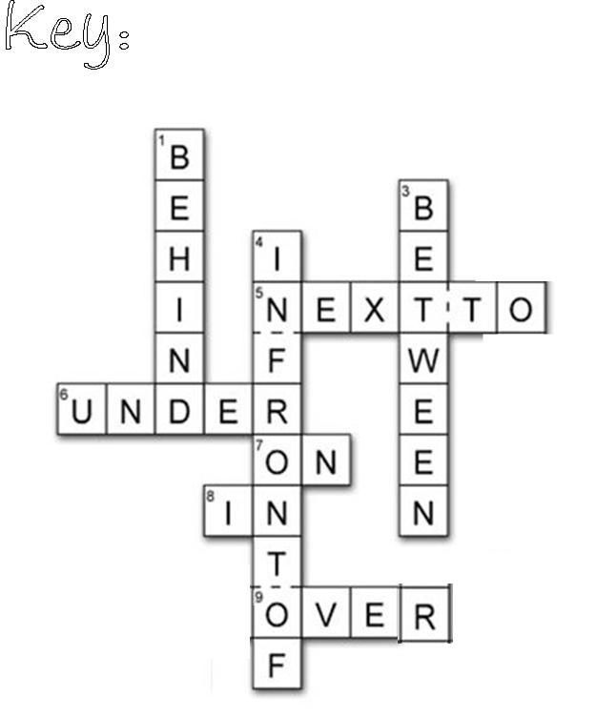

In this living room there is a clock on the wall.
There is a ball under the table. There are 2 pillows on the sofa. There is a lamp between some flowers and a book.
Cat sits next to sofa.
<In the Bedroom>
Let`s describe the bedroom with "preposition of place"
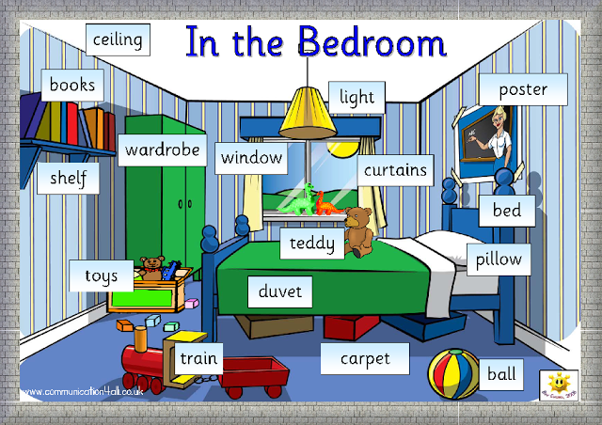

<In the Bathroom>
Let`s describe the bathroom with "preposition of place"
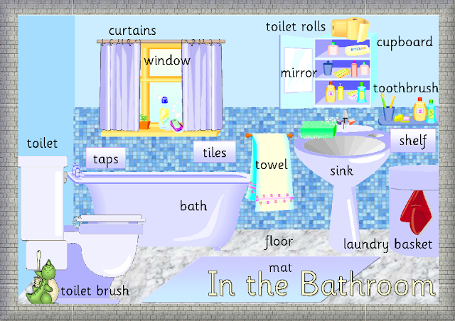

<In the Kitchen>
Let`s describe the kitchen with "preposition of place"
