Listening Speaking Reading Grammar Writing
Topic: Favorite Movies

Instructor:  Kyunam Kim | Students Competency Level  Intermediate. | Number of Students:  14 | Lesson Length:  50
Materials: (List the Names of all materials used in the lesson. Materials must be shown at the end of this document)
Whiteboard and Markers
V for Vendetta: The Revolutionary Speech Video
V for Vendetta: The Revolutionary Speech Text
Favorite Movies Worksheet
Pictures of Hugo Weaving
Lord Elrond of Rivendell
Agent Smith
Red Skull
Megatron
Projector
Overhead Screen
Computer

Aims: (What students will be able to achieve by participating in the activities of the lesson. (Ss gain or get by doing…)
-Ss will be able to listen and express their own ideas about what makes it easier to understand something by sharing their opinions with the class.
-Ss will practice expressing their thoughts about movies and actors by completing the worksheet and sharing their opinions with the class..
Language Skills: (Lists what activities language skills students will be using by participating in the activities of the lesson.)
- Reading: (Where did reading occur in the lesson?)
Reading the script of the monologue.
- Listening: (Where did listening occur in the lesson?)
Listening to what T says ( T talk, instructions, questions )
- Speaking: (Where did speaking occur in the lesson?)
Speaking in a discussion, speaking to T
- Writing: (Where did writing occur in the lesson?)
Doing the Worksheet
Language Systems: (Lists what language systems students will be using by participating in the activities of the lesson.)
- Phonology: (sound)
Watching prepared video
- Function: (situation)
Making a movie by themselves or in groups
- Lexis: (meaning)
Learning vocabulary in the monologue.
- Grammar: (language structure)
General discussion and reading, grammar is not emphasized.
- Discourse: (communication)
Talking among the class, and with the T

Assumptions: (What students must already be able to do and what concepts must already be mastered before the lesson in order to achieve the aims of the lesson.)
Ss can listen and understand movie scenes without subtitles.
Ss have favorite actors and movies.
Ss may have thought about making their own movie

Anticipated Errors and Solutions: (What things might go wrong in the lesson and what the solution will be. An SOS activity should also be included)
Ss might have little interest in movies and prefers other things
Actors do TV shows as well as movies, try to lead their interest in certain actors into the activity.

If time permits Favorite Movies worksheet Q4 can be done in class, not as homework.
References:

Lead-In or Pre-Task Part (Warm-Up Part to activate and create interest in the lesson.)
Materials: (List the Names of all materials used in the Lead-In or Pre-Task Part of the lesson. Materials must be shown at the end of this document)

Time: | Classroom Set Up: | Student Activity and Goals: | Teacher Procedure & Instructions:
1  3  5  1 | W  W  S-W  W | Greet T  S listen  Share experiences  Ss agree and listen | Greet Ss  T story about seeing a movie last week  Example : Batman V Superman, T complain about the  Ask Ss about their disappointing movie experience, and why.  Transition - Let me introduce you to a nice movie!
10
Pre-Activity or Task Familiarization Part (Presentation Part Presenting the language structure to be covered in the lesson. Prepares students for the communication activity.)
Materials: (List the Names of all materials used in the Pre-Activity or Task Familiarization Part of the lesson. Materials must be shown at the end of this document)
V for Vendetta: The Revolutionary Speech Video?
Projector
Overhead Screen
Computer

Time: | Classroom Set Up: | Student Activity and Goals: | Teacher Procedure & Instructions:
3  4  7  1 | W  S-W  S-W  W | Ss watch and listen  Ss answer questions  Ss discuss with the teacher  Ss receive script | Watch the video with Ss  Check students knowledge about the content of the video  Discuss with students about why they were not able to focus, or take in the whole information.  Transition. Give out printout of the script
15/25
Main Activity or Task Realization Part (Practice to Production Part Teacher lead practice of the language presented and move to communication based more student centered activity)
Materials: (List the Names of all materials used in the Main Activity or Task Realization Part of the lesson. Materials must be shown at the end of this document)
V for Vendetta: The Revolutionary Speech Text
Pictures of Hugo Weaving
Lord Elrond of Rivendell
Agent Smith
Red Skull
Megatron
Favorite Movies Worksheet
Projector
Overhead Screen
Computer

Time: | Classroom Set Up: | Student Activity and Goals: | Teacher Procedure & Instructions:
4  2  3  3  1  10 | W  W  W  W  W  S- W | Ss read monologue  Ss read monologue  Ss watch video  Ss look at the pictures  Ss receive worksheet  Ss do worksheet. | Give Ss time to read the monologue  Read monologue with students  Show video again  Show pictures of Hugo Weaving  Give students Favorite Movies worksheet  Give students time to do Q1,2 and do Q3 together.
23
Post Activity or Post Task Part (Wrap-Up Part Close the Lesson on a high note to and consolidate language learned in a communication based activity new situation.)
Materials: (List the Names of all materials used in the Post Activity or Post Task Part of the lesson. Materials must be shown at the end of this document)
Favorite Movies Worksheet

Time: | Classroom Set Up: | Student Activity and Goals: | Teacher Procedure Instructions:
2 | G | Ss get into groups and discuss Q4 on worksheet | Divide students into teams for HW

V for Vendetta: The Revolutionary Speech Text
Good evening, London. Allow me first to apologize for this interruption. I do, like many of you, appreciate the comforts of every day routine- the security of the familiar, the tranquility of repetition. I enjoy them as much as any bloke. But in the spirit of commemoration, thereby those important events of the past usually associated with someone's death or the end of some awful bloody struggle, a celebration of a nice holiday, I thought we could mark this November the 5th, a day that is sadly no longer remembered, by taking some time out of our daily lives to sit down and have a little chat. There are of course those who do not want us to speak. I suspect even now, orders are being shouted into telephones, and men with guns will soon be on their way. Why? Because while the truncheon may be used in lieu of conversation, words will always retain their power. Words offer the means to meaning, and for those who will listen, the enunciation of truth. And the truth is, there is something terribly wrong with this country, isn't there? Cruelty and injustice, intolerance and oppression. And where once you had the freedom to object, to think and speak as you saw fit, you now have censors and systems of surveillance coercing your conformity and soliciting your submission. How did this happen? Who's to blame? Well certainly there are those more responsible than others, and they will be held accountable, but again truth be told, if you're looking for the guilty, you need only look into a mirror. I know why you did it. I know you were afraid. Who wouldn't be? War, terror, disease. There were a myriad of problems which conspired to corrupt your reason and rob you of your common sense. Fear got the best of you, and in your panic you turned to the now high chancellor, Adam Sutler. He promised you order, he promised you peace, and all he demanded in return was your silent, obedient consent. Last night I sought to end that silence. Last night I destroyed the Old Bailey, to remind this country of what it has forgotten. More than four hundred years ago a great citizen wished to embed the fifth of November forever in our memory. His hope was to remind the world that fairness, justice, and freedom are more than words, they are perspectives. So if you've seen nothing, if the crimes of this government remain unknown to you then I would suggest you allow the fifth of November to pass unmarked. But if you see what I see, if you feel as I feel, and if you would seek as I seek, then I ask you to stand beside me one year from tonight, outside the gates of Parliament, and together we shall give them a fifth of November that shall never, ever be forgot
Favorite Movies Worksheet

1. What movie do you like? Why?

2. Who is your favorite actor? What movies did he/she star in? Why do you like this person?

3. Let's pretend you are a movie director and was able to cast your favorite actor! Please describe the movie that you are directing!!
Genre :

4. Discuss as a group what kind of characteristics make a successful movie, include ALL of your favorite actors and write a short preview of the movie.

Pictures of Hugo Weaving
Lord Elrond of Rivendell (LOTR )
Agent Smith ( Matrix )

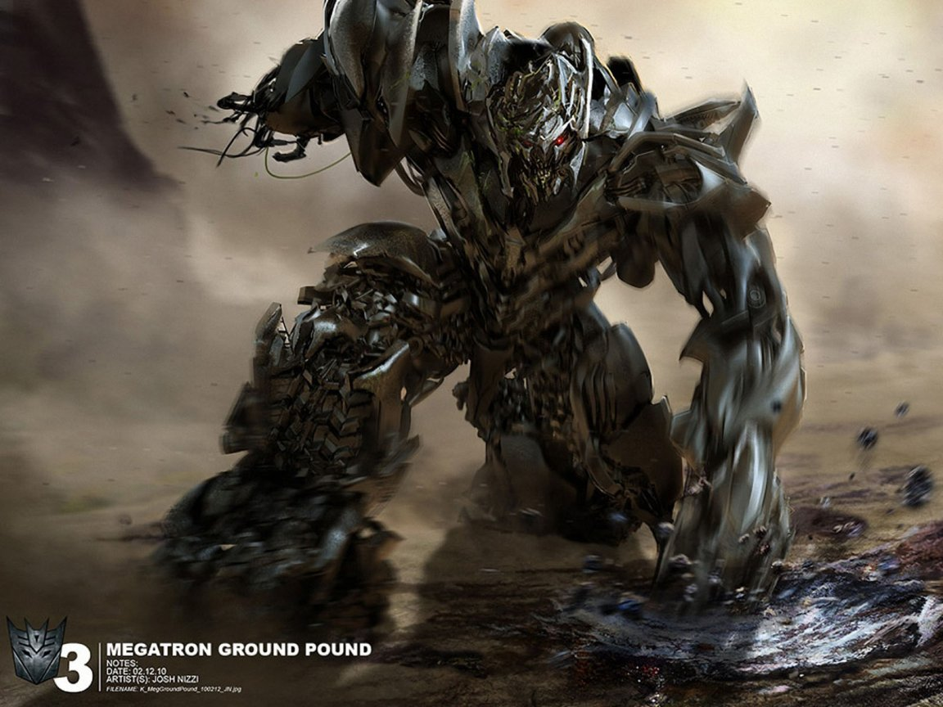
Megatron ( Voice Only) -Transformers

Red Skull ( Captain America )

