Listening Speaking Reading Grammar Writing
Topic: Celebrities are Coming.

Instructor:  Sunny Lee | Students Competency Level  Upper-Intermediate | Number of Students:  13 | Lesson Length:  55 minutes
Materials: (List the Names of all materials used in the lesson. Materials must be shown at the end of this document)
Nelson Mandela’s 4 quotes printed in A3 size
- It always seems impossible until it’s done.
- Education is the most powerful weapon which you can use to change the world.
- A winner is a dreamer who never gives up.
- Do not judge me by my success, judge me how many times I fell down and got back up again.

4 speech cards of 4 celebrities
Tom Hanks with ‘?’ on back
Steven Spielberg
Oprah Winfrey
Johnny Depp

4 celebrities faces photos (actual face size) / each photo attaches to a stick
Tom Hanks
Steven Spielberg
Oprah Winfrey
Johnny Depp

52 pieces of paper (students will use the paper to write the information they listen: 13students x 4 celebrities = 52)

Aims: (What students will be able to achieve by participating in the activities of the lesson. (Ss gain or get by doing…)

- Improve listening skills by listening to the speech.
- Improve speaking skills by discussing with group members.
- Improve interaction and communication skills by having discussion in a group

Language Skills: (Lists what activities language skills students will be using by participating in the activities of the lesson.)
- Reading: (Where did reading occur in the lesson?)
Note taking, Reading speech card

- Listening: (Where did listening occur in the lesson?)
Celebrity talk (teacher and peers), discussion

- Speaking: (Where did speaking occur in the lesson?)
Group discussion, telling who the celebrity is

- Writing: (Where did writing occur in the lesson?)
Note taking

Language Systems: (Lists what language systems students will be using by participating in the activities of the lesson.)
- Phonology: (sound)
Teacher talk, discussion

- Function: (situation)
Celebrities background

- Lexis: (meaning)
Vocabulary about date, life

- Grammar: (language structure)
Past tense and present perfect

- Discourse: (communication)
Discussion

Assumptions: (What students must already be able to do and what concepts must already be mastered before the lesson in order to achieve the aims of the lesson.)

- All Ss have some knowledge of famous celebrities.
- All Ss have already seen or heard some movies that are mentioned on information cards.

Anticipated Errors and Solutions: (What things might go wrong in the lesson and what the solution will be. An SOS activity should also be included)

- If Ss may not know the answer after they discuss each other ☞ Solution: T gives them more information about the celebrity.
- If activity finished too soon ☞ Solution: T use extra card and also Ss can take turns to be a famous celebrity and let other Ss guess.

References:
x

Lead-In or Pre-Task Part (Warm-Up Part to activate and create interest in the lesson.) 11
Materials: (List the Names of all materials used in the Lead-In or Pre-Task Part of the lesson. Materials must be shown at the end of this document)

Nelson Mandela’s 4 quotes printed in A3 size
- It always seems impossible until it’s done.
- Education is the most powerful weapon which you can use to change the world.
- A winner is a dreamer who never gives up.
- Do not judge me by my success, judge me how many times I fell down and got back up again.

Time: | Classroom Set Up: | Student Activity and Goals: | Teacher Procedure & Instructions:
1 min  4 min  5min  1min | Whole  Wh  S-Wh  Wh | Greet Teacher  Listen well  Become interested  Participate actively,  Share opinions  Show curiosity | Greet Students  T reads Ss well-known quotes of Nelson Mandela without telling the name.  Ask Ss if they know who said those quotes. Ask Ss if they know other quotes to share with classmates.  Transition: T tells Ss that T invites famous celebrities to the class to share their story.

Pre-Activity or Task Familiarization Part (Presentation Part Presenting the language structure to be covered in the lesson. Prepares students for the communication activity.) 7
Materials: (List the Names of all materials used in the Pre-Activity or Task Familiarization Part of the lesson. Materials must be shown at the end of this document)

Johnny Depp photo reverse side

Time: | Classroom Set Up: | Student Activity and Goals: | Teacher Procedure & Instructions:
1 min  1 min  5 min | Wh-G  Wh  Wh | Move into groups  Receive paper  Listen attentively  Show curiosity | Divide Ss into 3 groups (4/4/5)  T hands out information notes  T tells Ss a well-known celebrity is waiting outside and before Ss meet the celebrity, listen to the story and guess who the celebrity is. T asks Ss to greet nicely and listen to the celebrity / take notes /  Teacher walks out

Main Activity or Task Realization Part (Practice to Production Part Teacher lead practice of the language presented and move to communication based more student centered activity) 25
Materials: (List the Names of all materials used in the Main Activity or Task Realization Part of the lesson. Materials must be shown at the end of this document)

4 speech cards of 4celebrities
Tom Hanks
Steven Spielberg
Oprah Winfrey
Johnny Depp

4 celebrities faces photos (actual face size) / each photo attaches to a stick
Tom Hanks
Steven Spielberg
Oprah Winfrey
Johnny Depp

52 pieces of paper (students will use the paper to write the information they listen: 13students x 4 celebrities = 52)

Time: | Classroom Set Up: | Student Activity and Goals: | Teacher Procedure & Instructions:
1 min  2 min  4 min  2min | Wh  Wh  G  G | Greet the guest  Listen carefully  Take notes  Group discussion  Share ideas  Tell what they think | (Teacher walks in the classroom, cover the face with a blank side of the celebrity mask and pretend to be a celebrity)  T (Celebrity) starts the speech.  T (Celebrity) asks Ss if they have any questions about speech.  Celebrity walks out and T comes back to class. T tells Ss to share their notes and discuss who the celebrity is.  T asks each group who the celebrity is and show the face.  Everything below happens 3 times.

Post Activity or Post Task Part (Wrap-Up Part Close the Lesson on a high note to and consolidate language learned in a communication based activity new situation.) 12
Materials: (List the Names of all materials used in the Post Activity or Post Task Part of the lesson. Materials must be shown at the end of this document)

4 celebrities faces photos (actual face size) / each photo attaches to a stick
Tom Hanks
Steven Spielberg
Oprah Winfrey
Johnny Depp

Time: | Classroom Set Up: | Student Activity and Goals: | Teacher Procedure Instructions:
5 min  6 min  1 min | G  Wh | Talk with group members  Ss individually speak out their thought  Applaud and respond positively | T asks Ss to choose which celebrity’s speech is the most touching.(Group discussion)  T listens to each S and gives positive feedback.  Give thanks Ss on an activity well done

Mandela quotes : A3 size each
It always seems impossible until it’s done. | A winner is a dreamer who never gives up.
Education is the most powerful weapon which you can use to change the world. | Do not judge me by my success, judge me how many time I fell down and got back up again.

4 Celebrities speech cards

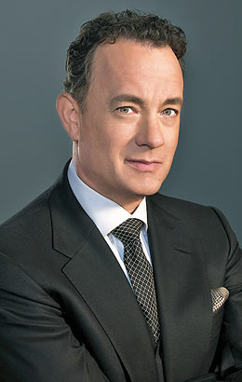  Ladies and gentlemen, thank you for inviting me. Sunny gave me this to cover my face because it is your job to guess who I am.  I was born on July 9, 1956, in Concord, California. Wow, I’m turning 70 this summer. I’m still working energetically.  I grew up in a ‘fractured’ family. My parents got divorced and I moved a lot after that. I didn’t really have serious problem, just had a confused childhood.  I am a well known actor now. However, I had no acting experience in college, and I couldn’t get cast in a college. Still do not know who I am?  Well, I lost almost 13 kilograms for my role in Philadelphia. I was AIDS patient in the movie.  My good friend, Meg Ryan, and I have been co-starts in movies as love interests: Sleepless in Seattle, and You’ve Got Mail. I starred in Cast Away, which earned me a Golden Globe Award for Best Actor. Wilson, the volleyball, was my good friend.  I received the Distinguished Public Service Award, the U.S Navy’s highest civilian honor, on Veterans Day 1999 for my work in the movie Saving Private Ryan. By now you should know who I am. Right? | 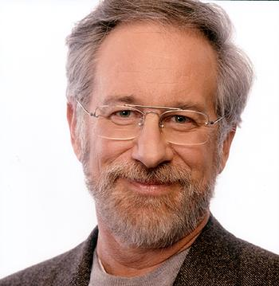  I don’t dream at night, I dream all day: I dream for a living.  It’s a real pleasure to be here today. Thank you Sunny.  Let me tell you about me. I was born on December 18, 1946 in Cincinnati, Ohio. Old man~  I am Orthodox Jews and that’s why I suffered from acts of anti-Semitic prejudice (hate Jewish people) and bullying during high school period.  I applied to the University of Southern California’s film school, but was turned down because of my “C”grade average. Guess I wasn’t very smart student. Anyway I went to California State University Long Beach, but dropped out to pursue my entertainment career. I was offered a small unpaid intern job at Universal Studios. It was a really good chance for me.  My first short film was ‘Amblin’ in 1968 and it made me the youngest director ever to be signed for a long-term deal with a major Hollywood studio. That point I had to drop out the school.  My latest movie is ‘Bridge of Spies’ in 2015.  Anyone can tell my name? (Steven Spielberg)

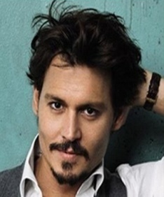  Hi, class. Life is amazing. Who knows I would fly to Korea and met you guys here today.  Here are some well known quotes from me.  “Just keep moving forward and don’t give a shit about what anybody thinks. Do what you have to do for you.”  “If you catch me saying ‘I’m a serious actor’ I beg you to slap me.”  “Life is pretty good, and why wouldn’t it be? I’m a pirate, after all.”  Familiar with these quotes? I was born in Kentucky in 1963. Through my childhood, I lived in more than 20 different places.  You might not know that I started out as a musician. I guess I was pretty good at music because my high school principal encouraged me to follow my dream instead of coming back to school. Later Nicolas Cage advised me to try acting.  I was almost fired by Disney Executives because they couldn’t understand my portrayal of the fictional pirate. Here are the names of my roles in movies: Gilbert Grape, Rango, Donald Trump, Tonto, Willy Wonka, and Captain Jack Sparrow.  Who am I? If you guess it right, I will give you round trip tickets to Hollywood. (Johnny Depp) | 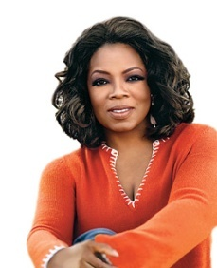  I am the highest-paid performer on television, the richest self-made woman in America, and the richest African-America of the 20th century.  I was born on January 29, 1954 in Mississippi, U.S.A.  My life has not been easy. I was sexually abused for years as a child by male relatives and female friends. You must know that the big secret in life is that there is no big secret, and whatever your goal, you can get there if you are willing to work.  Much of my success has come from my self-reliance and willingness to work around the clock.  In 1986, I launched a talk show named after me. The show placed on 120 channels and with an audience of 10 million people. I made my debut as a film actress in the 1985 period drama film, The Color Purple. I played a troubled housewife named Sofia.  I am the first woman in history to own and produce my own talk show.  I was also chosen by “People” magazine as one of the 50 most beautiful people in the world in 1997.  You should know Who I am by now.  (Oprah Winfrey)

New celebrity information card
New Celebrity ? | New Celebrity ?

Note taking cards
Write the information while you are listening.  - Gender:  - Date of Birth:  - Words, phrases or sentences you think it’s important: | Write the information while you are listening.  - Gender:  - Date of Birth:  - Words, phrases or sentences you think it’s important:
Write the information while you are listening.  - Gender:  - Date of Birth:  - Words, phrases or sentences you think it’s important: | Write the information while you are listening.  - Gender:  - Date of Birth:  - Words, phrases or sentences you think it’s important:
4 celebrities faces (Tome Hanks/ Oprah Winfrey / Steven Spielberg / Johnny Depp)
