Listening Speaking Reading Grammar Writing
Topic:Feelings Expression

Instructor:  sora | Students Competency Level  Intermediate | Number of Students:  14 | Lesson Length:  50
Materials:(List the Names of all materials used in the lesson. Materials must be shown at the end of this document)
-EmotionPictures
Happy
Sad
Depressed
Angry
-Draw Your Feelings Worksheet
-Emotions Word Cards
Happy
Elated
Delighted
Sad
Unhappy
Feel Blue
Depressed
Angry
Annoyed
Irritated
Mad
Furious
- Vocabulary Paper Worksheet
Expressions Worksheet
-White Board and Marker
Aims: (What students will be able to achieve by participating in the activities of the lesson. (Ss gain or get by doing…)
-Student will know about feeling vocabulary by matching picture and word card.
-Student expresses a variety of feelings by elicit their story.
-Improve speaking, listening, interaction skills by presentation their emotion drawing.
Language Skills: (Lists what activities language skills students will be using by participating in the activities of the lesson.)
- Reading: (Where did reading occur in the lesson?)
Vocabulary worksheet
- Listening: (Where did listening occur in the lesson?)
Teacher’s talking, Student, talking
- Speaking: (Where did speaking occur in the lesson?)
Answering teacher, presentation about their drawing
- Writing: (Where did writing occur in the lesson?)
Making a sentence using of emotion word
Language Systems: (Lists what language systems students will be using by participating in the activities of the lesson.)
- Phonology: (sound)
Teacher talk, Student presentation
- Function: (situation)
Finding words, Expression their drawing
- Lexis: (meaning)
Vocabulary about feeling
- Grammar:(language structure)
Verb about -ed or -ing
- Discourse: (communication)
Responding the teacher, present for describe their drawing
Assumptions: (What students must already be able to do and what concepts must already be mastered before the lesson in order to achieve the aims of the lesson.)
- Students are familiar with the expressing feelings.
- Students know some easy vocabulary like happy, sad.
- Students have experience to express their feeling
Anticipated Errors and Solutions: (What things might go wrong in the lesson and what the solution will be. An SOS activity should also be included)
-If Ss finish activities too soon → T ask them to make a sentence by words.
- If Ss may take time too long → T cuts the unnecessary parts.
- If Ss may not understand → T shows demonstration.
- If Ss are shy → T encourages them, gives positive feedback.
References:
http://www.myenglishpages.com/site_php_files/vocabulary-lesson-feelings.php
http://do2learn.com/activities/SocialSkills/EmotionsWorkSheet/index.html

Lead-In or Pre-Task Part (Warm-Up Part to activate and create interest in the lesson.)
Materials: (List the Names of all materials used in the Lead-In or Pre-Task Part of the lesson. Materials must be shown at the end of this document)
None
Time: | Classroom Set Up: | Student Activity and Goals: | Teacher Procedure & Instructions:
1m  5m  6-7m | Whole  Whole  Whole | Students greet the teacher.  Students listen to teacher’s talking  Students talk their stories. | Greeting  Tell Teacher’s story about pleasure, sad or angry thing.  Elicit the stories from Students.  Let’s do a game and role play about finding and guessing emotion

Pre-Activity or Task Familiarization Part (Presentation PartPresenting the language structure to be covered in the lesson. Prepares students for the communication activity.)
Materials: (List the Names of all materials used in the Pre-Activity or Task Familiarization Part of the lesson. Materials must be shown at the end of this document)
Emotion Pictures
Happy
Sad
Depressed
Angry
-Emotions Word Cards
Happy
Elated
Delighted
Sad
Unhappy
Feel Blue
Depressed
Angry
Annoyed
Irritated
Mad
Furious
-White Board and Marker
Time: | Classroom Set Up: | Student Activity and Goals: | Teacher Procedure & Instructions:
3m  2m  7m | Whole  Whole  White board | Answer teacher’s question  Listen to teacher’s talking.  Match with picture and word card | Ask students what is his feeling  Introduce activity about matching with picture and word card.It is 4 pictures for emotion and a variety of feeling word cards on white board. Matching appropriately with picture and word card. Then they make a sentence using of the word like “He is disappointed. Because a team he is cheering lost the game.”  Make student to do activity.  Let’s a drawing about guessing emotion.

Main Activity or Task Realization Part(Practice to Production PartTeacher lead practice of the language presented and move to communication based more student centered activity)
Materials: (List the Names of all materials used in the Main Activity or Task Realization Part of the lesson. Materials must be shown at the end of this document)
-Draw Your Feelings Worksheet
-Emotions Word Cards
Happy
Elated
Delighted
Sad
Unhappy
Feel Blue
Depressed
Angry
Annoyed
Irritated
Mad
Furious
- Vocabulary Paper Worksheet
-White Board and Marker
Time: | Classroom Set Up: | Student Activity and Goals: | Teacher Procedure & Instructions:
4m  1m  5m  2m  1-2m  4m | Whole class  Whole class  Whole class  Whole class  pairs  Pairs | Student listen teacher’s talk.  Pick up the paper and get drawing worksheet  Draw their feeling  Listen what teacher says  Find or move with pairs.  Student discusses their drawing. | Introduce activity about drawing of emotion. Student pick one paper(it is written feeling word) and are going to draw a picture of feeling that student picked on worksheet.  Ask to pick one paper of emotion and share drawing worksheet.  ask to draw on worksheet about word that is picked them  Letattention to teacher. Tell about student explain their emotion drawing to partner, and then partner guess her or his emotion. (it will do with pairs)  Divide students with pairs  Ask they start to explain about their drawing with partner.  Transition now time to present about drawing

Post Activity or Post Task Part (Wrap-Up PartClose the Lesson on a high note to and consolidate language learned in a communication based activity new situation.)
Materials: (List the Names of all materials used in the Post Activity or Post Task Part of the lesson. Materials must be shown at the end of this document)
Draw Your Feelings Worksheet
-Emotions Word Cards
Happy
Elated
Delighted
Sad
Unhappy
Feel Blue
Depressed
Angry
Annoyed
Irritated
Mad
Furious
- Vocabulary Paper Worksheet
Expressions Worksheet
-White Board and Marker
Time: | Classroom Set Up: | Student Activity and Goals: | Teacher Procedure Instructions:
5m  3m | Whole  Whole | Present about their drawing  Listen what teacher says | Ask present about describe their drawing (student explained their feeling drawing to their partner at main activity.I will try to student present to describe their drawing in front of others)  Close by giving students feedback about their accomplishment and improvement.

Emotion Pictures
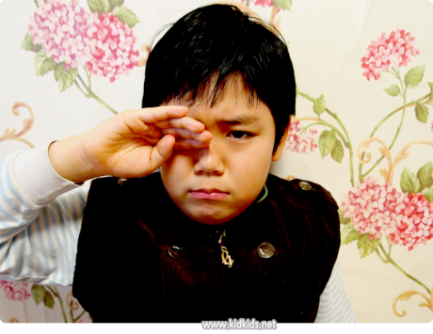
<Happy><Sad>
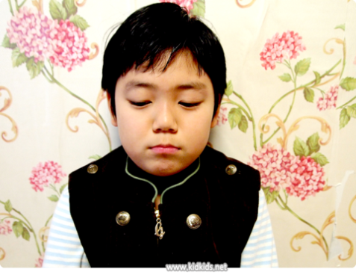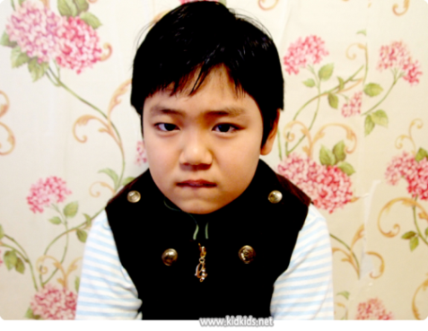
<Depressed><Angry>

VocabularyPaper Worksheet
Happy | Elated | Delighted
Sad | Unhappy | Feel
Depress | Angry | Annoyed
Irritated | Mad | Furious
Glad | Excited

Draw Your Feelings Worksheet

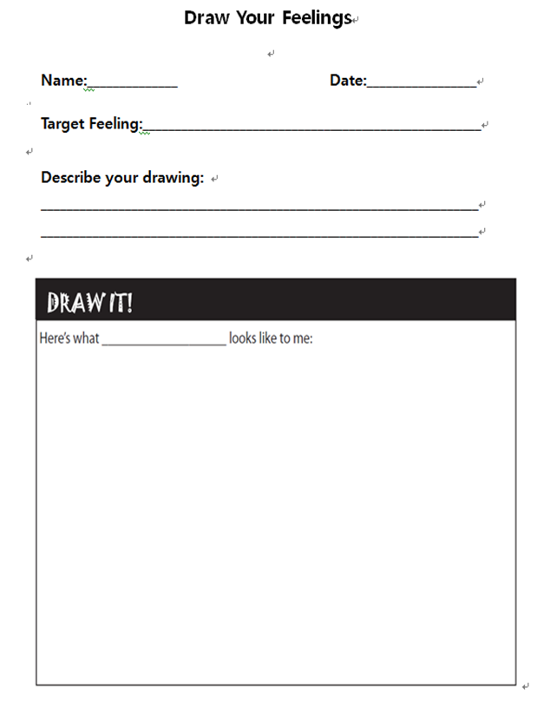

Expressions Worksheet
Expression | Definition | Example
Happy / glad | Marked by pleasure, satisfaction, or joy. | She seemed to be the happiest bride I've ever seen.
content / contented | Satisfied or showing satisfaction with things as they are. | She was a contented wife.
elated | Exultantly proud and joyful; in high spirits. | The winner felt elated and excited.
joyful | Full of joy. | It was a joyful occasion.
joyous | Full of or characterized by joy. | I heard a joyous laughter.
euphoric | Exaggerated feeling of well-being or elation. | They received a euphoric welcome
delighted | Feeling or showing great pleasure. | She had a delighted smile.
gleeful | Exuberantly or triumphantly joyful. | She gave a gleeful smile.
mirthful | Full of mirth; merry or amusing. | A mirthful laughter.
jubilant | Feeling or expressing great happiness and triumph. | I met a jubilant crowd.
sad / unhappy | Feeling or showing sorrow. | I can't bear the tears of a sad child.
feel blue | Feel sad. | She's feeling blue after what has happened to her son.
feel low / down | Feel dispirited or be sad and gloomy. | I am feeling low because my best friend is very ill.
depressed | Low in spirit; downcast. | He was depressed by the loss of his son.
downhearted | Marked by low spirits. | Fans were downhearted by the the defeat.
angry | Experience a strong of displeasure or hostility. | She was angry about the insult.
cross | Be quite angry. | I was cross with her because she didn't invite me to her party.
annoyed | Aroused to impatience or anger. | Her comments have always annoyed me.
irritated | Made impatient, annoyed or angry. | Her tone irritated him.
mad | Angry, resentful. | Are you mad at me because I didn't come to your party?
furious | Very angry. | My father was furious because I went out without his permission.
vexed | Annoyed, frustrated, or worried. | I'm vexed with you
indignant | Feeling or showing anger or annoyance at what is perceived as unfair treatment. | She was indignant at being the object of suspicion.
irate | Extremely angry; enraged. | She received an irate letter from her husband.
seething | Be filled with intense but unexpressed anger. | He was inwardly seething at the offense.

Emotions Word Cards
Happy
Elated
Delighted
Sad
Unhappy
Feel Blue
Depressed
Angry
Annoyed
Irritated
Mad
Furiouss

