Listening Speaking Reading Grammar Writing
Topic: Cinema English 'Frozen'

Instructor:  Shine | Students Competency Level  Elementary Beginner ,  Pre Intermediate | Number of Students: 13 | Lesson Length:  65 minutes
Materials: (List the Names of all materials used in the lesson. Materials must be shown at the end of this document)
- 'Frozen' DVD
- Computer, Speaker, Beam Projector & Screen
- Lyrics of the Song 'Let It Go'
- Script of the Movie 'Frozen'
- Picture 'Frozen Movie Main Characters'
- Picture 'Frozen Movie Poster'

Aims: (What students will be able to achieve by participating in the activities of the lesson. (Ss gain or get by doing…)
- Improve Listening and Speaking skills by singing a song and role playing with a group.
- Activate, increase interest, and participate with fun in English activities.
- Improve writing skills by making a different ending story.
- Improve interaction and communication skills by having discussion in a group and
making a different ending for the movie.
- Build team work and cooperation skills by acting the roles in the movie with a group.
- Practice and use expressions in role play situations.

Language Skills: (Lists what activities language skills students will be using by participating in the activities of the lesson.)
- Reading: (Where did reading occur in the lesson?)
Lyrics handout, Script handout

- Listening: (Where did listening occur in the lesson?)
Teacher Talk, listening the song, watching the DVD, during the role play, Discussion

- Speaking: (Where did speaking occur in the lesson?)
Singing, Role play, small group discussion

- Writing: (Where did writing occur in the lesson?)
Notes for planning and making the ending

Language Systems: (Lists what language systems students will be using by participating in the activities of the lesson.)
- Phonology: (sound)
Listen and sing a song, Role play, Discussion, Teacher talk

- Function: (situation)
The scenes of the movie

- Lexis: (meaning)
Vocabulary from the movie

- Grammar: (language structure)
Declarative sentences, Interrogative sentences

- Discourse: (communication)
Role Play, Discussion

Assumptions: (What students must already be able to do and what concepts must already be mastered before the lesson in order to achieve the aims of the lesson.)
- All Ss can listen and sing a song.
- All Ss understand the basic of role play and will enjoy playing the roles.
- All Ss can make English sentences.

Anticipated Errors and Solutions: (What things might go wrong in the lesson and what the solution will be. An SOS activity should also be included)
- If Ss may not sing a song. > Solution: T sing the song first and then sing together.
- If activity lasts too long. > Solution: T cuts the unnecessary parts.
- If activity finished too soon. > Solution: T can let them watch the movie more.
- If certain Ss are shy. > Solution: T encourages them, gives positive feedback, and
changes roles for them.

References:
- 'Frozen' DVD from Disney
- Screen English Conversation Book 'Disney FROZEN' from Gilbut Easy Talk

Lead-In or Pre-Task Part (Warm-Up Part to activate and create interest in the lesson.)
Materials: (List the Names of all materials used in the Lead-In or Pre-Task Part of the lesson. Materials must be shown at the end of this document)
- 'Frozen' DVD
- Computer, Speaker, Beam Projector & Screen
- Lyrics of the Song 'Let It Go'
- Picture 'Frozen Movie Poster'

Time: | Classroom Set Up: | Student Activity and Goals: | Teacher Procedure & Instructions:
1min  3min  7min | Whole  Whole  Whole | Ss greet the teacher  Ss listen to teacher  Ss listen and sing | Greeting  Tell T's stories about favorite movies and Original Sound Track  T introduce the movie 'Frozen' and its Original Sound Track  Let's listen and sing 'Let It Go' watching the 'Frozen' DVD

Pre-Activity or Task Familiarization Part (Presentation Part Presenting the language structure to be covered in the lesson. Prepares students for the communication activity.)
Materials: (List the Names of all materials used in the Pre-Activity or Task Familiarization Part of the lesson. Materials must be shown at the end of this document)
- 'Frozen' DVD
- Computer, Speaker, Beam Projector & Screen
- Script of the Movie 'Frozen'
- Picture 'Frozen Movie Main Characters'

Time: | Classroom Set Up: | Student Activity and Goals: | Teacher Procedure & Instructions:
10min  2min  5min | Whole  Group  Group | Ss listen what T says  Ss watch the movie  Ss move into group  Ss read the script and choose roles | Introduce the role play and show the beginning and ending parts of the movie  Divide Ss into groups  Hand out 'Frozen' script  Ask Ss discuss to pick roles  Transition now time to practice and present role plays

Main Activity or Task Realization Part (Practice to Production Part Teacher lead practice of the language presented and move to communication based more student centered activity)
Materials: (List the Names of all materials used in the Main Activity or Task Realization Part of the lesson. Materials must be shown at the end of this document)
- 'Frozen' DVD
- Computer, Speaker, Beam Projector & Screen
- Script of the Movie 'Frozen'

Time: | Classroom Set Up: | Student Activity and Goals: | Teacher Procedure & Instructions:
7min  15min  5min | Group  Group  Whole | Ss get ready and practice for role play  Ss do activity  One group at a time other group watches listens and enjoys  Ss listen what T says  Ss applaud students | Ask Ss to prepare for Role Play  Help them practice each role actively  T gives instruction for each group to come  To in front and present and enjoy role play  T monitors role playing  Gives encouragement to each group  Give Ss positive feedback, and comments  Facilitate class members' feedback

Post Activity or Post Task Part (Wrap-Up Part Close the Lesson on a high note to and consolidate language learned in a communication based activity new situation.)
Materials: (List the Names of all materials used in the Post Activity or Post Task Part of the lesson. Materials must be shown at the end of this document)
None

Time: | Classroom Set Up: | Student Activity and Goals: | Teacher Procedure Instructions:
5min  5min | Whole  Whole | Ss listen and think about the topic  Ss talk their ideas  Ss listen | T asks Ss to try to make different ending story of the movie  Ask Ss to present their ideas  Close by giving Ss feedback about their accomplishment and improvement

* Picture - Frozen Movie Main Characters *

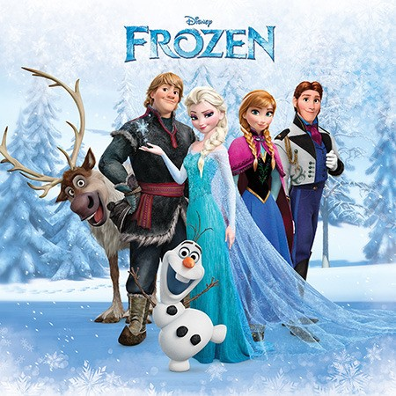

* Picture - Frozen Movie Poster *

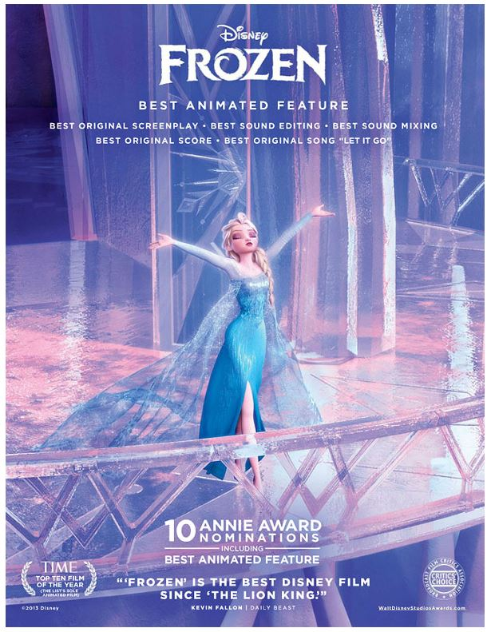
* Lyrics of the song 'Let It Go' *

The snow glows white on the mountain tonight
Not a footprint to be seen
A kingdom of isolation
and it looks like I'm the queen
The wind is howling like this swirling storm inside
Couldn't keep it in
Heaven knows I've tried
'Don't let them in, Don't let them see'
'Be the good girl you always have to be'
'Conceal, don't feel, Don't let them know'
Well, now they know
Let it go, Let it go
Can't hold it back anymore
Let it go, Let it go
Turn away and slam the door
I don't care
What they're going to say
Let the storm rage on
The cold never bothered me anyway

It's funny how some distance
Makes everything seem small
And the fears that once controlled me
Can't get to me at all
It's time to see what l can do
To test the limits and break through
No right, No wrong, No rules for me
I'm free
Let it go, Let it go
I'm one with the wind and sky
Let it go, Let it go
You'll never see me cry
Here l stand
and here I'll stay
Let the storm rage on
My power flurries through the air into the ground
My soul is spiraling in frozen fractals all around
And one thought crystallizes like an icy blast
I'm never going back
The past is in the past
Let it go, Let it go
And I'll rise like the break of dawn
Let it go, Let it go
That perfect girl is gone
Here I stand in the light of day
Let the storm rage on
The clod never bothered me anyway

* Script of the Movie 'Frozen' - 1 Beginning Part *

[ Characters: 1-YOUNG ANNA / 2-YOUNG ELSA / 3- KING & QUEEN /
4- YOUNG KRISTOFF / 5- TROLLS or BULDA / 6- GRAND PABBIE ]

YOUNG ANNA: Elsa! Wake up, wake up, wake up!
YOUNG ELSA: Anna, Go back to sleep.
YOUNG ANNA: I just can't. The sky's awake. so I'm awake, so we have to play!
YOUNG ELSA: Go play by yourself!
YOUNG ANNA: Do you want to build a snowman?
Come on, come on, come on, come on.
Do the magic! Do the magic!
YOUNG ELSA: Ready?
YOUNG ANNA: This is amazing!
YOUNG ELSA: Watch this!
YOUNG ELSA: Hi, I'm Olaf and I like warm hugs.
YOUNG ANNA: I love you, Olaf.
YOUNG ELSA: Hang on!
YOUNG ANNA: Catch me!
YOUNG ELSA: Gotcha!
YOUNG ANNA: Again!
YOUNG ELSA: Wait! Slow down! Anna! Anna!
Mama! Papa! You okay, Anna? I got you.
KING: Elsa, what have you done? This is getting out of hand!
YOUNG ELSA: It was an accident! I'm sorry, Anna.
QUEEN: She's ice cold.
KING: I know where we have to go.
YOUNG KRISTOFF: Ice? Faster, Sven!
KING: Please... Help! My daughter!
TROLLS: It's the king!
YOUNG KRISTOFF: Trolls...?
BULDA: Shush. I'm trying to listen! Cuties. I'm gonna keep you.
GRAND PABBIE: Your Majesty! Born with the powers or cursed?
KING: Born. And they're getting stronger.
GRAND PABBIE: You are lucky it wasn't her heart.
The heart is not so easily changed,
But the head can be persuaded.
KING: Do what you must.
GRAND PABBIE: I recommend we remove all magic, even memories of magic, to be safe. But don't worry, I'll leave the fun. She will be okay.
YOUNG ELSA: But she won't remember I have powers?
KING: It's for the best.
GRAND PABBIE: Listen to me, Elsa, your power will only grow.
There is beauty in it... But also great danger. You must learn to control it.
Fear will be your enemy.
KING: No. We'll protect her. She can learn to control it, I'm sure.
Until then, We'll lock the gates. We'll reduce the staff.
We will limit her contact with people, and keep her powers hidden from everyone...
including Anna.

* Script of the Movie 'Frozen' - 2 Ending Part *

[ Characters: 1- HANS / 2- ANNA / 3- KRISTOFF / 4- ELSA / 5- OLAF /
6- FRENCH DIGNITARY or KAI / 7- DUKE ]

HANS: I tried to save her, but it was too late. Her skin was ice, her hair turned white... Your sister is dead! Because of you!
ANNA: No... Kristoff...?
KRISTOFF: Anna!
ANNA: Elsa...? No!
ELSA: Anna! Oh, Anna... no... no, please, no...
OLAF: Anna...
ELSA: Anna?
ANNA: Oh, Elsa!
ELSA: You sacrificed yourself for me?
ANNA: I love you.
OLAF: "An act of true love will thaw a frozen heart."
ELSA: Love will thaw... Love... Of course,
ANNA: Elsa?
ELSA: Love!
ANNA: I knew you could do it.
OLAF: Hands down, this is the best day of my life. And quite possibly the last.
ELSA: Olaf! Hang on, little guy.
OLAF: My own personal flurry!
HANS: Anna? But she froze your heart.
ANNA: The only frozen heart around here is yours.
FRENCH DIGNITARY: I will return this scoundrel to his country.
We shall see what his twelve big brothers think of his behavior.
KAI: Arendelle thanks you, my lord.
DUKE: This is unacceptable! I'm a victim of fear!
I've been traumatized. Ow! My neck hurts.
Is there a doctor I could see...? No, I demand to see the Queen!
KAI: I have a message from the Queen. Arendelle will henceforth and forever no longer do business of any sort, with Weaseltown.
DUKE: Weselton. It's Weselton!
ANNA: Come on, come on, come on! Oh, ow, okay, okay, we're come.
KRISTOFF: Ow! Pole.
ANNA: Oops, so sorry. Okay, okay, here we are. I owe you a sled.
KRISTOFF: Are you serious?
ANNA: Yes! And it's the latest model.
KRISTOFF: No. I can't accept this.
ANNA: You have to. No returns, no exchanges. Queen's orders.
She's named you the official Arendelle Ice Master and Deliverer.
KRISTOFF: What? That's not a thing.
ANNA: Sure it is, and it even has a cup holder. Do you like it?
KRISTOFF: Like it? I love it! I could kiss you! I could. I mean I'd like to. I'd...
may I? We me... I mean, may we? Wait, what?
ANNA: We may.
ELSA: Are you ready?
ANNA: I like the open gates.
ELSA: We are never closing them again.
ANNA: What? Oh, Elsa, they're beautiful, but you know I don't ska...
Come on, you can do it!
KRISTOFF: Look out! Reindeer coming through!

