Listening Speaking Reading Grammar Writing
Topic: Traveling the World

Instructor:  Jin | Students Competency Level: Intermediate | Number of Students: 13 | Lesson Length:50 min
Materials: (List the Names of all materials used in the lesson. Materials must be shown at the end of this document)
- Travel Brochure worksheet
- Teacher’s example brochure

Aims: (What students will be able to achieve by participating in the activities of the lesson. (Ss gain or get by doing…)

- Ss will discuss about traveling the world with group
- Ss will present and speak in front of others about their picked country
- Ss will understand about the brochure by completing it and discussing it
- Ss will gain more information about other countries by listening to students

Language Skills: (Lists what activities language skills students will be using by participating in the activities of the lesson.)
- Reading: (Where did reading occur in the lesson?)
- Note taking and brochure worksheet
- Listening: (Where did listening occur in the lesson?)
- Teacher talk, during the activity, presentation
- Speaking: (Where did speaking occur in the lesson?)
- activity, small group work, presentation
- Writing: (Where did writing occur in the lesson?)
- Notes, thoughts, planning, completing brochure

Language Systems: (Lists what language systems students will be using by participating in the activities of the lesson.)
- Phonology: (sound)

- Function: (situation)
Share ideas about travel
- Lexis: (meaning)
Name of countries, brochure, vocabulary about travel
- Grammar: (language structure)
Have you been-, I have been to-.
- Discourse: (communication)
Discuss the idea with groups, responds to teacher, presenting brochures

Assumptions: (What students must already be able to do and what concepts must already be mastered before the lesson in order to achieve the aims of the lesson.)
- Ss must already be able to discuss about the countries they have been to or want to live in
- Ss should know about traveling

Anticipated Errors and Solutions: (What things might go wrong in the lesson and what the solution will be. An SOS activity should also be included)
- Ss may have questioning about Teacher’s experience about traveling other countries, then Teacher share with Ss as an example of the answer

References:

Lead-In or Pre-Task Part (Warm-Up Part to activate and create interest in the lesson.)
Materials: (List the Names of all materials used in the Lead-In or Pre-Task Part of the lesson. Materials must be shown at the end of this document)

Time: | Classroom Set Up: | Student Activity and Goals: | Teacher Procedure & Instructions:
1 min  5 min  4 min | Whole  Whole  S - W | Ss greet the teacher  Ss listen to teacher  Ss share stories about travel | Greeting  Tell T’s story about traveling the world  Elicit Ss stories about travel  transition

Pre-Activity or Task Familiarization Part (Presentation Part Presenting the language structure to be covered in the lesson. Prepares students for the communication activity.)
Materials: (List the Names of all materials used in the Pre-Activity or Task Familiarization Part of the lesson. Materials must be shown at the end of this document)

Time: | Classroom Set Up: | Student Activity and Goals: | Teacher Procedure & Instructions:
1 min  3 min  1 min  3 min | Whole  Ss  Whole  Ss - W | Ss listen to teacher  Ss respond to T  Ss listen to teacher  Ss respond to T and S | T ask Ss question where if you favorite country?  Elicit the stories from Ss  T asks another question where you want to visit or live  Elicit Ss stories about where they want to live  T Lead Ss to next steps

Main Activity or Task Realization Part (Practice to Production Part Teacher lead practice of the language presented and move to communication based more student centered activity)
Materials: (List the Names of all materials used in the Main Activity or Task Realization Part of the lesson. Materials must be shown at the end of this document)
Teacher’s example brochure, Travel brochure worksheet

Time: | Classroom Set Up: | Student Activity and Goals: | Teacher Procedure & Instructions:
3min  2 min  15min  5 min  (X3)  3 min | Whole  Groups  Groups  Groups  Ss | Ss listen what T says  Ss move into groups of 3  Ss discuss and start making brochure  Ss have a presentation in front of the class  Ss respond to T and other groups | Introduce about activity  - Each group will pick one country to promote  - Each group make one brochure about country they pick  - Brochure should be informative and persuasive to others  Divide Ss into groups of 3  Make sure that Ss understand what they have to do, and if not, explain more details to Ss  T ask Ss groups to present their brochures  T monitors Ss present, Gives encouragement to everyone and make sure give them a feed back  After every presentation, ask other Ss what they thought about other groups brochure

Post Activity or Post Task Part (Wrap-Up Part Close the Lesson on a high note to and consolidate language learned in a communication based activity new situation.)
Materials: (List the Names of all materials used in the Post Activity or Post Task Part of the lesson. Materials must be shown at the end of this document)

Time: | Classroom Set Up: | Student Activity and Goals: | Teacher Procedure Instructions:
5 min  1 min | Whole  Whole | Ss listen and respond  Ss say goodbye and listen | T wrap-up by asking questions about main activity  - What are the countries we’ve discussed today?  - Where do you want to visit? And why?  - Etc  Close class, and thanks Ss for participating

Travel Brochure Worksheet

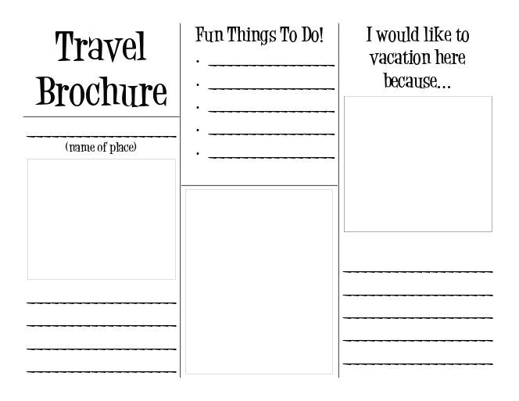

Teacher’s example brochure

