Listening/Speaking Reading Grammar Writing
Topic: Artificial Intelligence

Instructor:  SKY | Students Competency Level  Intermediate | Number of Students:  13 | Lesson Length:  50 minutes
Materials: (List the Names of all materials used in the lesson. Materials must be shown at the end of this document)
- White Board and Markers
- Movie Picture 1 (Matrix)
Movie Picture 2 (Wall-E)
Movie Picture 3 (A.I.)
- Survey #1 text
- Survey #2 text
- Reading Text 1 (ARTIFICIAL INTELLIGENCE)
- Vocabulary Text
- Reading Text 2 (Advantages and Disadvantages for Artificial Intelligence)
- Discussion Text

Aims: (What students will be able to achieve by participating in the activities of the lesson. (Ss gain or get by doing…)
- Improve Ss Reading Skill by reading the work sheets.
- Ss will be able to learn the vocabularies regarding the ‘Artificial Intelligence’ through guessing the new vocabularies.
- Ss will be improving the speaking skills by telling the movie story in the pre-activity
and by sharing their opinions in the main activity.
- Ss will be improving listening skill by listening the teacher’s introduction, explanation, and the other students talk.
- Participate with fun in the main activity by sharing the ideas of the new A.I.

Language Skills: (Lists what activities language skills students will be using by participating in the activities of the lesson.)
- Reading: (Where did reading occur in the lesson?)
Text and Worksheets.
- Listening: (Where did listening occur in the lesson?)
Teacher’s instruction and explanation, discussion.
- Speaking: (Where did speaking occur in the lesson?)
Responding to teacher, Sharing the opinions with other students in group discussion,
- Writing: (Where did writing occur in the lesson?)
Writing the work sheets of the main activity “Discussion questions”

Language Systems: (Lists what language systems students will be using by participating in the activities of the lesson.)
- Phonology: (sound)
Discussion, Teacher talk, Activity participation.
- Function: (situation)
Expressing ideas
- Lexis: (meaning)
Vocabulary and phrases
- Grammar: (language structure)
General discussion grammar
- Discourse: (communication)
Responding the teacher, talking to a partner and a class

Assumptions: (What students must already be able to do and what concepts must already be mastered before the lesson in order to achieve the aims of the lesson.)
- Ss have opinion about the ‘Artificial Intelligence’
- Ss will enjoy discussion and sharing their opinions
- Ss know a few movies regarding the ‘Artificial Intelligence’.

Anticipated Errors and Solutions: (What things might go wrong in the lesson and what the solution will be. An SOS activity should also be included)
- If activity lasts too long
: Teacher cuts the unnecessary parts.
- Some Ss might not be confident in the reading text
: Teacher explains the main theme of the text.
- If some Ss don’t give their opinions during the group discussion
: Teacher gives the opinion first
- If activity finishes too soon.
: Teacher makes suggestions.
(such as the new A.I machines you would like to have in the future.)

References:

Lead-In or Pre-Task Part (Warm-Up Part to activate and create interest in the lesson.)
Materials: (List the Names of all materials used in the Lead-In or Pre-Task Part of the lesson. Materials must be shown at the end of this document)

- Movie Picture 1 (Matrix)
Movie Picture 2 (Wall-E)
Movie Picture 3 (A.I.)

Time: | Classroom Set Up: | Student Activity and Goals: | Teacher Procedure & Instructions:
1 min  5 min  3 min | Whole  Whole  W - S | Ss greet the teacher  Ss listen to teacher  Ss talk the movie stories and  Listen to teacher | Greeting.  Tell the recent event of the Baduk Match between ‘Lee Sae Dol’ and ‘Alphago’.  And show the pictures of the movies regarding A.I.  Ask Ss “Do you know any other movies regarding the A.I”. And let them share their feeling of the world of the movies.  Let’s look at the general people’s opinion of the A.I.

Pre-Activity or Task Familiarization Part (Presentation Part Presenting the language structure to be covered in the lesson. Prepares students for the communication activity.)
Materials: (List the Names of all materials used in the Pre-Activity or Task Familiarization Part of the lesson. Materials must be shown at the end of this document)
- Survey #1 text
- Survey #2 text

Time: | Classroom Set Up: | Student Activity and Goals: | Teacher Procedure & Instructions:
1 min  3 min | Whole  Whole | Ss listen what Teacher says  Ss make pair and guess the answers of the survey #2 | Teacher explains the Survey #1 “How much will AI replace the human Jobs?”  Hand out the Survey #2 “What is the humans ability which A.I. can’t replace?” And the Ss fill in the blanks in the Text.

Main Activity or Task Realization Part (Practice to Production Part Teacher lead practice of the language presented and move to communication based more student centered activity)
Materials: (List the Names of all materials used in the Main Activity or Task Realization Part of the lesson. Materials must be shown at the end of this document)

- Reading Text 1 (ARTIFICIAL INTELLIGENCE)
- Vocabulary Text
- Reading Text 2 (Advantages and Disadvantages for Artificial Intelligence)
- Discussion Text

Time: | Classroom Set Up: | Student Activity and Goals: | Teacher Procedure & Instructions:
7 min  4 min  8 min  3 min  3 min  7 min  3 min | Whole  Pair  Whole  Individual  Whole  Group  Whole | Ss read the text.  Ss fill in the blanks and share with partners.  And Ss listen what teacher says.  Ss read the text.  Ss make their answers in the full sentence.  Ss share the opinions with the class.  Ss discuss the questions  Ss share the opinions with the class | Teacher hands out the Reading Text 1.  Ask students to read the text carefully.  Teacher hands out the vocabulary Text.  And ask students to fill in the blanks and share the answers with their partners.  Teacher summarizes the reading text and share some advantages and disadvantages of the A.I.  Let’s look at more detail of some advantages and disadvantages of the A.I.  Teacher hands out the Reading Text 2.  Ask students to read the text carefully.  Teacher hands out the Discussion Text.  Ask students to write down their answers for the questions 1 to 5.  Let the students present their opinions to the class  Divide Ss in groups  Let them discuss the questions 6 to 8  Let the students present their group‘s opinions to the class

Post Activity or Post Task Part (Wrap-Up Part Close the Lesson on a high note to and consolidate language learned in a communication based activity new situation.)
Materials: (List the Names of all materials used in the Post Activity or Post Task Part of the lesson. Materials must be shown at the end of this document)

Time: | Classroom Set Up: | Student Activity and Goals: | Teacher Procedure Instructions:
2 min  1 min  1 min | Whole  Whole  Whole | Ss listen teacher  Ss tell the opinions  Ss listen teacher. | Let Ss think of the question 9  Let several Ss share their opinions  Wrap up the class by giving homework about their own A.I. machine.

Movie Picture 1 (Matrix) Movie Picture 2 (Wall-E)

Movie Picture 3 (A.I.)
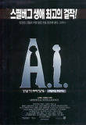

Survey #1 text

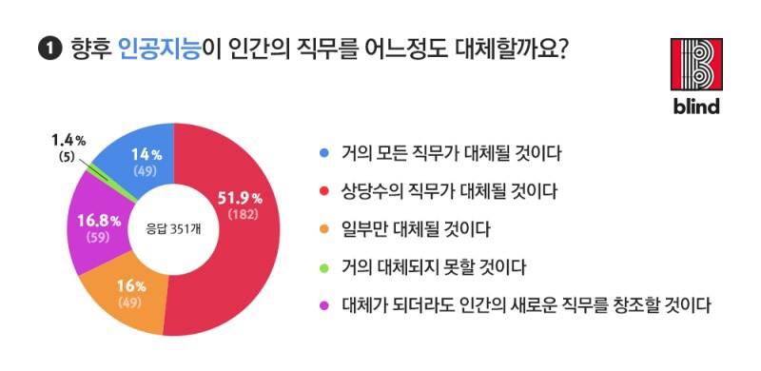
How much will AI replace the Human Jobs?
New jobs will be created even if AI replaces Human.(16.8%)

Very few jobs will be replaced. (1.4%)
A few jobs will be replaced. (16%)
Most of jobs will be replaced. (51.9%)
Almost every job will be replaced. (14%)
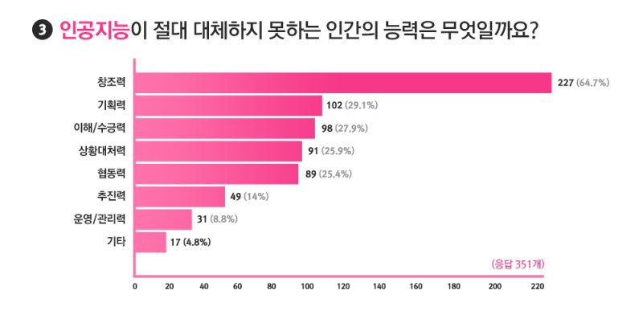
Survey #2 text

etc

What is the human’s ability which AI can’t replace?

➀Cooperation, ➁Driving force, ➂Understanding, ➃Creativity, ➄Planning ability
➅Responding ability to circumstances, ➆Management & Administration

Reading Text 1 (ARTIFICIAL INTELLIGENCE)

[ARTIFICIAL INTELLIGENCE]

Although most people think artificial intelligence is something new, it is not. AI research was born with the first electronic computer in 1941, and the first experiments in robotics were begun in the late 1950s.

Most people think of talking robots, sometimes referred to as androids, when they think of artificial intelligence, but different forms of AI have been in our lives for decades.
One example of AI in our world is the thermostat which controls the temperature inside our cars and buildings. A thermostat determines the temperature of the air around it, compares it to the desired temperature, then turns the heat or cooling up or down according to whichever is needed. Today we take them for granted, but creating a thinking device like this was no small task.

To date scientific research has produced many devices that can perform small thinking tasks, and we find them all around our homes. They’re in our car engines, cameras, telephones and computers.

Today the emphasis in AI research is on creating machines that can behave in ways that humans consider intelligent. Researchers are now creating systems which can imitate human thought, understand speech, and do many things thought to be science fiction not long ago. Advancements in AI are being made so fast that it is expected that in just a few years’ time we will have humanoid machines with the ability to teach things to us humans. Some are predicting that we’ll soon have androids capable of being our friends or even roommates. That may not be as farfetched as it sounds.
The most challenging task facing researchers has been to build machines that can imitate the human brain. It’s thought that a computer can be called intelligent if it can deceive a human into believing that it is also human.
This test was first passed in 1997 when a computer named “Big Blue” defeated world chess champion Gray Kasparov at a game of chess. The world was shocked that any machine could have the ability to beat a man at such an exercise of mental strength. But it was just the beginning.

There’s no doubt that we’ll be able to produce machines smarter than us, and the possibilities are endless. Machines will be taught to do jobs that require them to follow detailed instructions and be mentally alert at the same time. Machines can’t get tired, so accidents caused by fatigue will never happen. Machines will also be designed for specific tasks that humans hate, but unlike humans, they won’t complain.

What worries computer scientists about AI is not that they may not be able to create the machines but that they might not able to teach them to be wise and not make the same foolish mistakes that we humans make.
They must be taught to be kind, well mannered, and to behave intelligently. If we expect them to make important decisions, they should be wise, not foolish like us.

The question is, Will they learn man’s love of money and power and then wage war to get them, or will they be smarter than that?

Vocabulary Text
■ Vocabulary

: the field of making machines that performs tasks that humans perform

: human-like machines

: device by which temperature is controlled.

: never think much about them, just expect them to be there when
we need them

: very difficult to do

: until now

: things that makes our lives convenient. Example: cellular phones, calculators, CD players, ATM machines, TV or VTR remote controls, etc.

: similar to a human

: almost impossible to believe or imagine

: extreme tiredness. Many factory accidents are caused because workers are tired

: start wars
Reading Text 2 (Advantages and Disadvantages for Artificial Intelligence)

[Advantages and Disadvantages for Artificial Intelligence]

The Advantages for Artificial Intelligence (AI)
❶ Jobs – depending on the level and type of intelligence these machines receive in the future, it will obviously have an effect on the type of work they can do, and how well they can do it (they can become more efficient). As the level of AI increases, so will their competency to deal with difficult, complex even dangerous tasks that are currently done by humans.
❷ They don’t stop – as they are machines there is no need for sleep, they don’t get ill, there is no need for breaks or Facebook, they are able to go, go, go! There obviously may be the need for them to be charged or refueled, however the point is, they are definitely going to get a lot more work done than we can. Take the Finance industry for example, there are constant stories arising of artificial intelligence in finance and that stock traders are soon to be a thing of the past.
❸ No risk of harm – when we are exploring new undiscovered land or even planets, when a machine gets broken or dies, there is no harm done as they don’t feel, they don’t have emotions.
❹ Act as aids – they can act as 24/7 aids to children with disabilities or the elderly, they could even act as a source for learning and teaching. They could even be part of security alerting you to possible fires that you are in threat of, or fending off crime.
❺ Their function is almost limitless – as the machines will be able to do everything (but just better) essentially their use, pretty much doesn’t have any boundaries. They will make fewer mistakes, they are emotionless, they are more efficient, and they are basically giving us more free time to do as we please.

The Disadvantages for Artificial Intelligence (AI)
❶ Over reliance on AI – as you may have seen in many films such as The Matrix, iRobot or even kids films such as WALL.E, if we rely on machines to do almost everything for us we become very dependent, so much so they have the potential to ruin our lives if something were to go wrong. Although the films are essentially just fiction, it wouldn’t be too smart not to have some sort of backup plan to potential issues on our part.
❷ Human Feel – as they are machines they obviously can’t provide you with that ‘human touch and quality’, the feeling of a togetherness and emotional understanding, that machines will lack the ability to sympathize and empathize with your situations, and may act irrationally as a consequence.
❸ Inferior – as machines will be able to perform almost every task better than us in practically all respects, they will take up many of our jobs, which will then result in masses of people who are then jobless and as a result feel essentially useless. This could then lead us to issues of mental illness and obesity problems etc.
❹ Misuse – there is no doubt that this level of technology in the wrong hands can cause mass destruction, where robot armies could be formed, or they could perhaps malfunction or be corrupted. Then we could be facing a similar scene to that of terminator.
❺ Ethically Wrong? – People say that the gift of intuition and intelligence was God’s gift to mankind, and so to replicate that would be then to kind of ‘play God’. Therefore not right to even attempt to clone our intelligence.

The truth is we don’t know what is going to happen (can’t predict the future), until mankind eventually gives birth to AI and let it be. Currently all we can do is speculate, so many of the points of ‘advantages and disadvantages for artificial intelligence’ above are just guesses, we might (and probably) will face an entirely different array of benefits and problems.

Discussion Text
[Discussion Questions]

1. Do you think it’s possible that machines will someday be taught to be as smart as or even smarter than human beings? Why or why not?
(Yes, it will be smarter than human beings since they don’t stop In learning)

2. If machines are someday made to be as smart as humans, is it possible that they could also be our friends or companions? Why or why not?

3. Would you like to have a robot as a friend or a roommate? Why or why not?

4. What would be the advantages of having an android instead of a human as a friends or roommates? Would there be arguments? Why or why not?

5. What would be the disadvantages of having an android instead of a human as a companion?

6. In which of these jobs would machines perform better than humans? In which would humans be better?

■ Teaching: Would they be good teachers?
■ Drivers: Would they have accidents?
■ Computer operators. Would they make mistakes?
■ Factory workers. Would they be injured?
■ Cashier and store clerks. Would they make mistakes?
■ Babysitters. Would the children like them?
■ Bank employees. Would they steal money?
■ Policeman: Wouldn’t they be stronger?

7. Will AI computer programmers ever be able to teach the machines to be kinder, more polite, and wiser than humans, or will the machines learn to make the same mistakes that we do? How can humans teach machines to be smarter than we are?

8. How long will it be before machines that think like humans become a reality? 10 years, 20 years, never? Tell why you think so.

9. How will human society change if machines are taught to take their place in many jobs or other roles? Will we become lazy? Will machines, which never get tired of lazy or make mistakes, someday take over the control of society? Would you like to live in a world controlled by computers? Why or why not?

