Listening Speaking Reading Grammar Writing
Topic: Going To A Hospital

Instructor:  Casey | Students Competency Level  Intermediate | Number of Students:  13 | Lesson Length:  59 mins
Materials: (List the Names of all materials used in the lesson. Materials must be shown at the end of this document)

- White board and markers
- Vocabulary and Worksheets
- Symptom vocabulary sheets
- Health problem and role play worksheets
- Health problem vocabulary sheets

Aims: (What students will be able to achieve by participating in the activities of the lesson. (Ss gain or get by doing…)

- Improve vocabulary by repeating the words after the teacher
- Improve speaking skills by role play and discussion with a group and answering teacher
- Improve listening skills by role play and discussion with a group, responding teacher
- Improve interaction and communication skills by having discussion in a group and planning a role play

Language Skills: (Lists what activities language skills students will be using by participating in the activities of the lesson.)

- Reading: (Where did reading occur in the lesson?)
Vocabulary sheet, role play
- Listening: (Where did listening occur in the lesson?)
Teacher talk, during role play, discussion
- Speaking: (Where did speaking occur in the lesson?)
Role play, discussing, repeating after the teacher
- Writing: (Where did writing occur in the lesson?)
Discussing, taking notes

Language Systems: (Lists what language systems students will be using by participating in the activities of the lesson.)

- Phonology: (sound)
Role play, discussion, teacher talk
- Function: (situation)
Describing and discussing health problems, how to go to a hospital
- Lexis: (meaning)
Health vocabulary and medical vocabulary
- Grammar: (language structure)
Description from medical role play
- Discourse: (communication)
Discussion, responding teacher, role play

Assumptions: (What students must already be able to do and what concepts must already be mastered before the lesson in order to achieve the aims of the lesson.)

- All Ss understand basic of role play
- All Ss understand and know the importance of hospital
- All Ss visited the hospital
- All Ss have experiences, directly or indirectly of saying the symptoms in English

Anticipated Errors and Solutions: (What things might go wrong in the lesson and what the solution will be. An SOS activity should also be included)

- If Ss may not have many ideas ☞ Solution: T gives then little examples
- If activity lasts too long ☞ Solution: T cuts the unnecessary parts
- If activity finished too soon ☞ Solution: T makes suggestions and shares ideas
- If students may not understand ☞ Solution: T show demonstration
- If certain Ss are shy ☞ Solution: T encourages them, gives positive feedback, and changes roles for them.

References:

Lead-In or Pre-Task Part (Warm-Up Part to activate and create interest in the lesson.)
Materials: (List the Names of all materials used in the Lead-In or Pre-Task Part of the lesson. Materials must be shown at the end of this document)

Time: | Classroom Set Up: | Student Activity and Goals: | Teacher Procedure & Instructions:
1 min  5min  6 min | Whole  Whole  Ss | Ss greet the teacher.  Ss listen to teacher.  Ss talk their stories | Greeting.  Tell T’s stories about a funny episode about saying a symptom wrong.  Elicit the stories from Ss.  Let’s learn some symptoms vocabulary

Pre-Activity or Task Familiarization Part (Presentation Part Presenting the language structure to be covered in the lesson. Prepares students for the communication activity.)
Materials: (List the Names of all materials used in the Pre-Activity or Task Familiarization Part of the lesson. Materials must be shown at the end of this document)

- White board and markers
- Vocabulary and Worksheets
- Symptom vocabulary sheets
- Health problem and role play worksheet
- Health problem vocabulary sheets

Time: | Classroom Set Up: | Student Activity and Goals: | Teacher Procedure & Instructions:
3 min  2 min  4 min  1 min  1min | Whole  Whole  Whole  Whole  Whole | Ss listen to what T says.  Ss repeat after what T says.  Ss look at the sheet carefully  Ss listen to what T says.  Ss get the worksheets | Hand out the vocabulary sheets (material 1) and make the students to repeat after the T.  T says what’s on the paper out loud.  The T tells the students to look at the sheet, and try to remember the words  Now let’s do a work sheet about health problems (material 2)  The T hands out the worksheets.

Main Activity or Task Realization Part (Practice to Production Part Teacher lead practice of the language presented and move to communication based more student centered activity)
Materials: (List the Names of all materials used in the Main Activity or Task Realization Part of the lesson. Materials must be shown at the end of this document)

- White board and markers
- Vocabulary and Worksheets
- Symptom vocabulary sheets
- Health problem and role play worksheet
- Health problem vocabulary sheets

Time: | Classroom Set Up: | Student Activity and Goals: | Teacher Procedure & Instructions:
2 min  1min  5 min  2 min  2 min  7 min | Whole  Pairs  Pairs  Whole  Whole  Pairs | Ss listen to what T says. Get ready answer the worksheet.  Get in a pair.  Ss do activity.  Ss check the answers  Ss listen to what T says and get the vocabulary sheets.  The Ss do the role play. | T demonstrates what to do with a worksheet.  Tell the class to get in pairs and do the activity  T monitors the class and see if anyone is in trouble and tries to help them  T calls out the answers out loud and see if everyone understood well  The T now tells that the class will do the role play and hands out the health problem vocabulary sheets (material 3) to help through the role play.  T monitors the pairs in the class and see if anyone is in trouble and tries to help them by giving them the ideas.

Post Activity or Post Task Part (Wrap-Up Part Close the Lesson on a high note to and consolidate language learned in a communication based activity new situation.)
Materials: (List the Names of all materials used in the Post Activity or Post Task Part of the lesson. Materials must be shown at the end of this document)

- White board and markers
- Vocabulary and Worksheets
- Symptom vocabulary sheets
- Health problem and role play worksheet
- Health problem vocabulary sheets

Time: | Classroom Set Up: | Student Activity and Goals: | Teacher Procedure Instructions:
6X  2min  5 min | Groups  Groups  Whole | The next activity repeats 6 times.  Each group shows a short role play to the whole class.  Ss give other ideas of how to help their friends with phobia, especially the Ss are not professionals  Ss listen | The next activity repeats 6 times.  T monitors role playing. Gives encouragement to each pair and facilitates class feed back to role play group  T listens to the students opinions and elicits more answers.  Close by giving Ss feedback about their accomplishment and improvement.

- Symptom vocabulary sheet
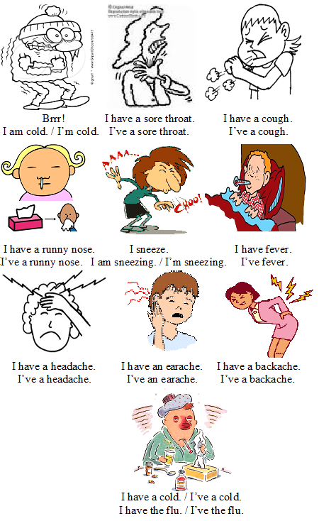

- Health problem and role play worksheet
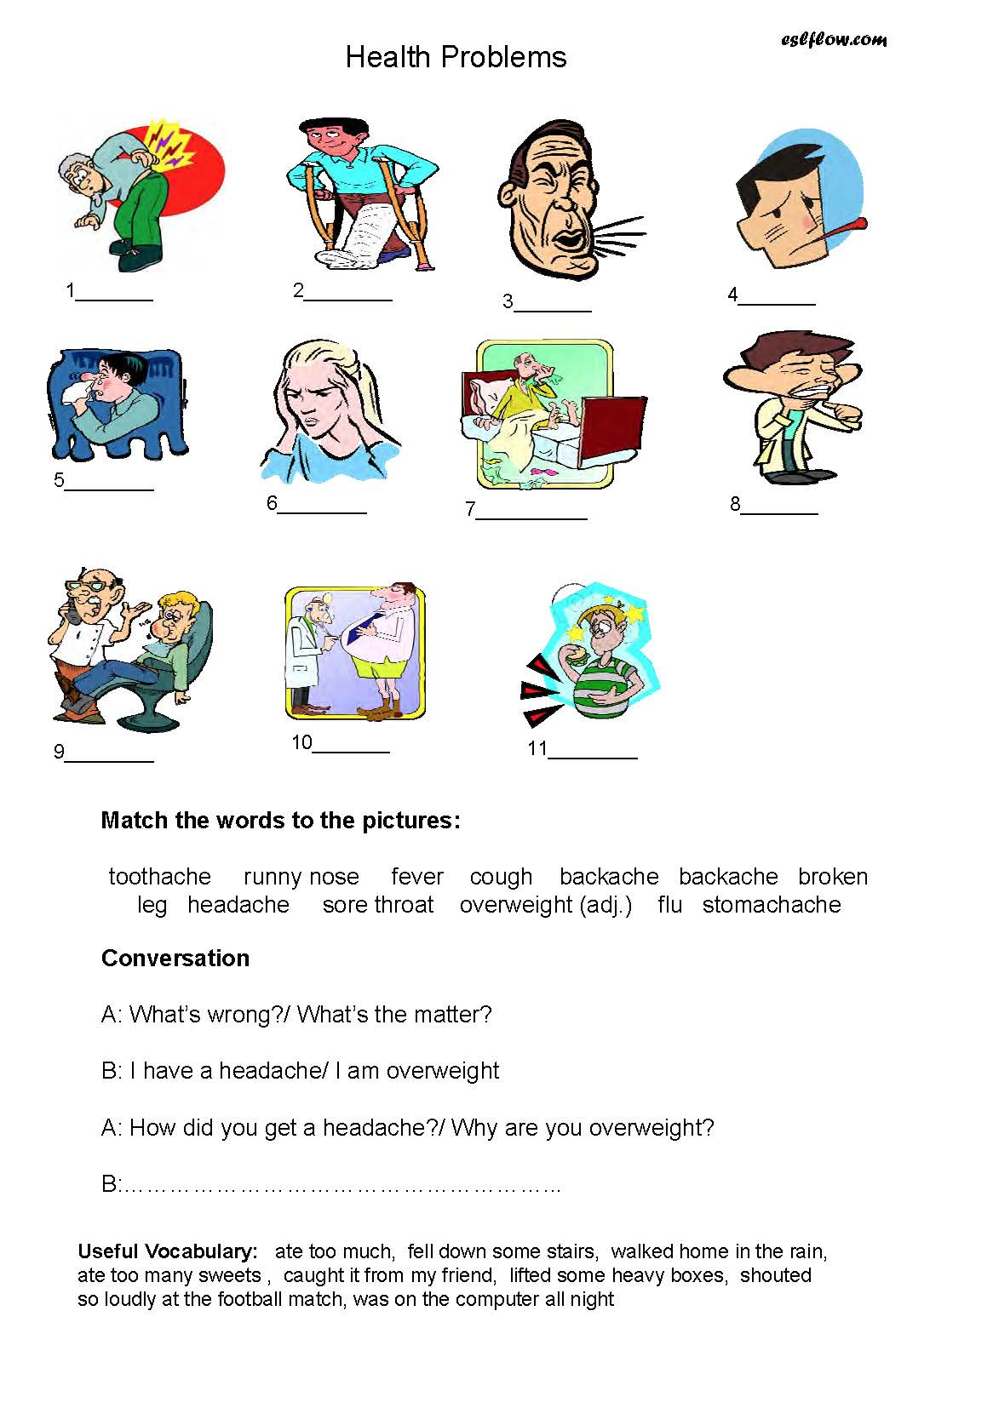

- Health problem vocabulary sheet

