Listening Speaking Reading Grammar Writing
Topic: Reading Body Language

Instructor:  Babette | Students Competency Level: Intermediate | Number of Students: 13 | Lesson Length:  50
Materials: (List the Names of all materials used in the lesson. Materials must be shown at the end of this document)

Illustration Work Sheet
The Body Language Text.
The Discussion Worksheet.
The Board and Markers
Aims: (What students will be able to achieve by participating in the activities of the lesson. (Ss gain or get by doing)
- Improve Ss listening skill by listening T introduction, questions and ICQ-CCQs and listening to other Ss statements during brain storming and group discussion.
- Improve Ss speaking skills by brain storming, discussing in groups and responding to T questions.
- Improve Ss wring skills by completing worksheets
- Improve Ss reading skills by reading the material.

Language Skills: (Lists what activities language skills students will be using by participating in the activities of the lesson.)
- Reading: (Where did reading occur in the lesson?)
Text, Worksheets
- Listening: (Where did listening occur in the lesson?)
T instruction and explanation, discussion
- Speaking: (Where did speaking occur in the lesson?)
Responding to T, CCQs & questions, discussion
- Writing: (Where did writing occur in the lesson?)
Work sheet
Language Systems: (Lists what language systems students will be using by participating in the activities of the lesson.)
- Phonology: (sound)
Discussion, T talk, Ss talk
- Function:(situation)
Trying to communicate with aliens in discussion
- Lexis: (meaning)
Vocabulary in the text
- Grammar:(language structure)
Not emphasized.
- Discourse: (communication)
Discussion, Talking b/w S-S, T-S
Assumptions: (What students must already be able to do and what concepts must already be mastered before the lesson in order to achieve the aims of the lesson.)
All Ss have opinion about the topic and what is the meaning of body language.
All Ss will enjoy discussion and sharing their opinions.
All Ss enjoy completing their own work sheets.
Anticipated Errors and Solutions: (What things might go wrong in the lesson and what the solution will be. An SOS activity should also be included)
- If Ss may not understand clear the meaning.
→ Provide more examples.
- If some of the Ss are too shy to participate during the group discussion.
→ Encourage Ss to participate and give positive feedback.
- If some Ss don’t give their opinion during the group discussion.
→ T gives her/him opinion first.
- If activity takes too long.
→ Give time warning.
- If activity finishes too soon.
→ Give Ss more time for the discussion.

References:

Lead-In or Pre-Task Part (Warm-Up Part to activate and create interest in the lesson.)
Materials: (List the Names of all materials used in the Lead-In or Pre-Task Part of the lesson. Materials must be shown at the end of this document)

Time: | Classroom Set Up: | Student Activity and Goals: | Teacher Procedure &Instructions:
2min  3min | Whole  Whole | Ss greet the T and watch the T.  Ss answer about T’s question. | <Greeting>  Start with a mime about starting a day.  Ask Ss what we can learn from the mime.  Let’s talk about “Body Language” .

Pre-Activity or Task Familiarization Part (Presentation Part Presenting the language structure to be covered in the lesson. Prepares students for the communication activity.)
Materials: (List the Names of all materials used in the Pre-Activity or Task Familiarization Part of the lesson. Materials must be shown at the end of this document)

Illustration Work Sheet

Time: | Classroom Set Up: | Student Activity and Goals: | Teacher Procedure &Instructions:
1min  3min  5min | Whole  Whole  Whole | Ss get the Work sheet.  Ss match the illustrations.  Ss describe their thoughts about illustrations | Introduce Illustration Work sheet and hand it out.  Ask Ss to read the Work sheet and match each illustration with descriptions.  Ask Ss to share their thoughts and experiences about body language with other group members.

Main Activity or Task Realization Part(Practice to Production Part Teacher lead practice of the language presented and move to communication based more student centered activity)
Materials: (List the Names of all materials used in the Main Activity or Task Realization Partof the lesson. Materials must be shown at the end of this document)

The Body Language Text.
The Discussion Worksheet.
The Board and Markers
Time: | Classroom Set Up: | Student Activity and Goals: | Teacher Procedure &Instructions:
5min  1min  10min  20min | Whole  Whole-Group  Group  Group | Listen to T.  Receive the text and read it.  Get the worksheet.  Students enjoy activity.  Ss share the answers with other groups. | Introduce the Body Language Text and Hand it out.  Ask Ss to read the text.  Hand out the Discussion Worksheet.  Ask students to work in pairs.  Do an activity using the Discussion Worksheet Using the 2nd Q,  - Aliens like certain body parts, write body parts on the board and students must use that specific body part it in the body language they make.  Ask Ss to share their answers with other groups

Post Activity or Post Task Part (Wrap-Up Part Close the Lesson on a high note to and consolidate language learned in a communication based activity new situation.)
Materials: (List the Names of all materials used in the Post Activity or Post Task Part of the lesson. Materials must be shown at the end of this document)
Time: | Classroom Set Up: | Student Activity and Goals: | Teacher Procedure Instructions:
3min | Whole | Ss listen to the teacher’s talk. | Thank everyone for participation and end class,  If there's time left, do the "extra thought"  discussion in the Discussion Worksheet before ending the class

Illustration Work Sheet

For each of these sentences, write its letter on the line under the illustration that matches it best.

A. Hello!
B. I don’t know
C. Nice to meet you.
D. I’m so happy to see you. It’s been so long!
E. Everything is great. Ok
F. I’m really worried.

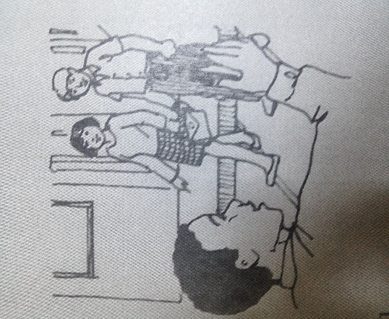 | 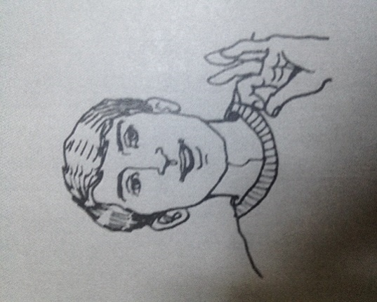 | 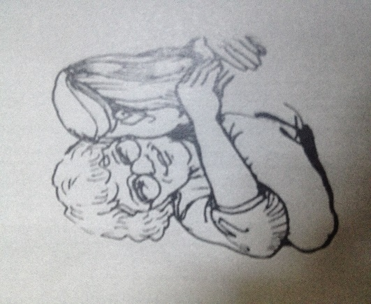
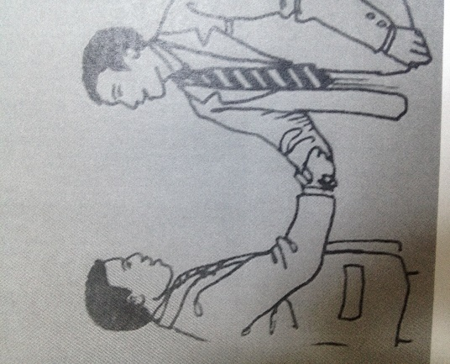 | 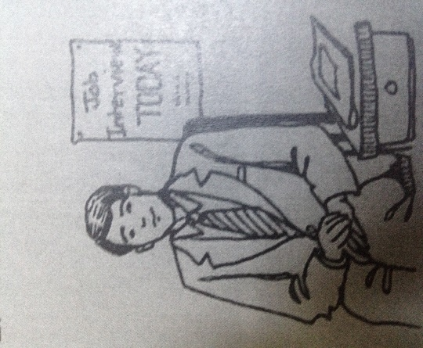 | 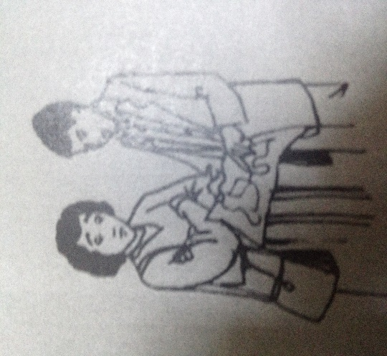

The Body Language Text

What language does our body speak?

Body language isn’t a language of words in English, Spanish, Arabic, or Japanese. It is a language without words. Body language isn’t verbal; it’s nonverbal. People communicate nonverbally in many ways. It’s natural to use our bodies to communicate. Gestures are powerful communicators of our thoughts and emotions. What are some of the important ways people communicate with body language? It body language the same all over the world, or does it change from one culture to another?

Head
Let’s start with the head. Most people around the world nod their heads up and down to mean “yes” or “I agree with you” and side to side to mean “no”.these are almost universal signs, but there are a few places where it has the opposite meaning. It is possible that people first communicated with these signs thousands of years ago.

Eye
Our eyes communicate meaning. But people from different counties communicate differently with theirs eyes. In the United States, it is important to look into the eyes of the people you are talking to. But if you look for more than a few seconds, people will think that you are staring. Staring is impolite. People will ask themselves, why is that person staring at me? In other countries, such as England or lsrael, it is usually polite to look for a longer time at the person you are talking to. It shows you are interested in talking to the person. In japan it is better to lower your eyes when you meet someone.

Hands
We often use our hands to communicate ideas and emotions. In many countries, people greet each other with a handshake. In the United States, the custom is to take the other person’s hand and hold it firmly. But tin the Middle East, the custom is to take the other person’s hand gently. All over the world, people wave their hands to say hello or goodbye. But people wave differently in different countries. In Europe the correct way is to put your palm out and keep your hand straight, moving your fingers up and down. Americans wave their whole hand.
We can use hand signals to send a short message. But we need to be careful. We don’t want to send the wrong message and cause a misunderstanding. In the United States, for example, people make a circle with their thumb and forefinger to say “ok” or “very good”. In France that hand signal has the opposite meaning. And in South American countries, that signal is an insult! In japan, it is the symbol for money. In the middle and Far East, it is impolite to point with the index finger. Showing the “thumb up” signal is an almost universal sign that means “ok”.

The whole body
We show emotion nonverbally with our whole body. We open our arms to show welcome or to hug someone. We turn away from someone we disagree with. People tap their feet or their fingers. This shows that they feel angry or impatient. When we feel comfortable, our bodies look relaxed. When we feel uncomfortable, our bodies look tense and nervous. In the United States, people cross their arms In front of their chest when they feel anxious.

In these days of global communication, people do realize that this are done differently in different cultures. So people will understand if you make a mistake and sent the wrong signal. The best advice ti follow is to watch what people do, and follow what they do. A careful look at how people act will teach you how to communicate. Although body language has a lot to say, it doesn’t use words.

The Discussion Worksheet

Which body part do you use most to show your emotions?

If you met an Alien from outer space, come up with body language you can use to welcome them, and invite them to lunch

Extra thought: How do you think you can improve your body language abilities??

