|  |  |  |  |
| --- | --- | --- | --- |
| Listening  Speaking 🗹 Reading  Grammar  Writing | | | |
| **Topic: What Will We Wear in 2016?** | | | |
| Instructor:  **Shine** | **Students Competency Level**  **Intermediate** | **Number of Students: 13** | **Lesson Length:**  **55 minutes** |
| Materials: **(List the Names of all materials used in the lesson. Materials must be shown at the end of this document)**  - Computer, Beam Projector & Screen  - What Will We Wear in 2016?  - Pictures Related to the Article  Title  Puffed Up  Cold Shoulder  To Tie-Dye For  Latin Lovers  Shine On  Fifties Fun  Plant Life  Neck It  Show Your Stripes  Get Shorty  - Group Discussion Question List | | | |
| Aims: **(What students will be able to achieve by participating in the activities of the lesson. (Ss gain or get by doing…)**  - Ss will be able to learn the vocabulary related to fashion styles by reading the Article.  - Ss will be able to read and practice pronouncing the text of the Article by reading out loud.  - Ss will be able to present their ideas by discussing in groups.  - Ss will be able to improve communication ability by discussing in groups. | | | |
| Language Skills: **(Lists what activities language skills students will be using by participating in the activities of the lesson.)**   * Reading: **(Where did reading occur in the lesson?)**   Reading the Article 'What Will We Wear in 2016?'   * Listening: **(Where did listening occur in the lesson?)**   Listening to what T says, what classmates say in groups, what the other Ss say during the presentation   * Speaking: **(Where did speaking occur in the lesson?)**   Answering to T's questions, Speaking to partners during discussion, Presenting Ss' ideas to the class   * Writing: **(Where did writing occur in the lesson?)**   Taking notes on the worksheet during discussion | | | |
| Language Systems: **(Lists what language systems students will be using by participating in the activities of the lesson.)**   * Phonology: **(sound)**   Repeating after T, Classroom participation and discussion   * Function: **(situation)**   Fashion Styles (The Article 'What Will We Wear in 2016?')   * Lexis: **(meaning)**   Learning the vocabulary related to fashion styles of the Article   * Grammar: **(language structure)**   General discussion Grammar not emphasized   * Discourse: **(communication)**   Discussing in groups | | | |
| Assumptions: **(What students must already be able to do and what concepts must already be mastered before the lesson in order to achieve the aims of the lesson.)**  - Ss can read and pronounce an Article in English.  - Ss are interested in fashion styles.  - Ss can discuss in groups. | | | |
| Anticipated Errors and Solutions: **(What things might go wrong in the lesson and what the solution will be. An SOS activity should also be included)**  - If Ss cannot pronounce vocabulary of the Article. > Solution: T pronounce it first and then practice pronouncing together.  - If activity lasts too long. > Solution: T cuts the unnecessary parts.  - If activity finished too soon. > Solution: T can let them discuss more.  - If certain Ss do not participate. > Solution: T encourages them, gives more detail instructions and feedback them. | | | |
| References:  http://www.bbc.com/culture/story/20151223-what-will-we-wear-in-2016 | | | |

|  |  |  |  |
| --- | --- | --- | --- |
| **Lead-In or Pre-Task Part (Warm-Up Part to activate and create interest in the lesson.)** | | | |
| Materials: **(List the Names of all materials used in the Lead-In or Pre-Task Part of the lesson. Materials must be shown at the end of this document)**  None | | | |
| **Time:** | **Classroom Set Up:** | **Student Activity and Goals:** | **Teacher Procedure & Instructions:** |
| 1min  3min  3min | Whole  Whole  Whole | Ss greet T  Ss listen to what T says  Ss listen and answer | Greeting  Talk about what T is wearing today  Eliciting Ss by asking what kind of fashion styles would you like to wear nowadays  Let's take a closer look to today's Article |

|  |  |  |  |
| --- | --- | --- | --- |
| **Pre-Activity or Task Familiarization Part (Presentation Part Presenting the language structure to be covered in the lesson. Prepares students for the communication activity.)** | | | |
| Materials: **(List the Names of all materials used in the Pre-Activity or Task Familiarization Part of the lesson. Materials must be shown at the end of this document)**  - Computer, Beam Projector & Screen  - Pictures Related to the Article  Title  Puffed Up  Cold Shoulder  To Tie-Dye For  Latin Lovers  Shine On  Fifties Fun  Plant Life  Neck It  Show Your Stripes  Get Shorty | | | |
| **Time:** | **Classroom Set Up:** | **Student Activity and Goals:** | **Teacher Procedure & Instructions:** |
| 5min  3min  5min | Whole  Group  Group | Ss listen what T says  Ss look at the pictures  Ss move into group  Ss discuss in groups and present their ideas | T introduce and show the pictures related to the Article  Divide Ss into groups  Ask Ss which style looks best  Transition to reading the Article and discussing in groups |

|  |  |  |  |
| --- | --- | --- | --- |
| **Main Activity or Task Realization Part (Practice to Production Part Teacher lead practice of the language presented and move to communication based more student centered activity)** | | | |
| Materials: **(List the Names of all materials used in the Main Activity or Task Realization Part of the lesson. Materials must be shown at the end of this document)**  - Computer, Beam Projector & Screen  - What Will We Wear in 2016?  - Pictures Related to the Article  Title  Puffed Up  Cold Shoulder  To Tie-Dye For  Latin Lovers  Shine On  Fifties Fun  Plant Life  Neck It  Show Your Stripes  Get Shorty | | | |
| **Time:** | **Classroom Set Up:** | **Student Activity and Goals:** | **Teacher Procedure & Instructions:** |
| 5min  10min  5min  10min | Group  Group  Group  Group | Ss read the Article  Several Ss speak out the Article  Ss listen and answer  Ss discuss and present their ideas | Distribute the Article to Ss  Let Ss read it  Ask some students to speak out the Article from 1 to 10  Ask Ss to answer some questions  Distribute the Handout for discussing  Let Ss discuss about some Questions related the fashion styles of the Article  T monitors and gives encouragement to each group  Give Ss positive feedback and comments |

|  |  |  |  |
| --- | --- | --- | --- |
| **Post Activity or Post Task Part (Wrap-Up Part Close the Lesson on a high note to and consolidate language learned in a communication based activity new situation.)** | | | |
| Materials: **(List the Names of all materials used in the Post Activity or Post Task Part of the lesson. Materials must be shown at the end of this document)**  None | | | |
| **Time:** | **Classroom Set Up:** | **Student Activity and Goals:** | **Teacher Procedure Instructions:** |
| 5min | Whole | Ss listen and answer | Ask Ss to present their emotion after Activity  Close by giving Ss feedback about their accomplishment and improvement |

**\* What will we wear in 2016? \***

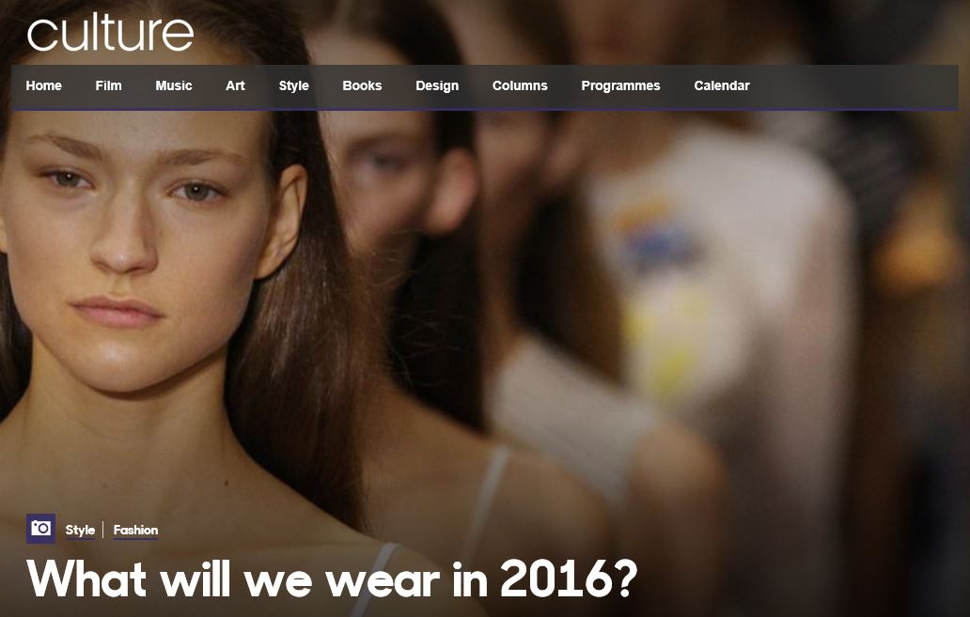

**What will we wear in 2016?**

Lindsay Baker chooses the biggest upcoming trends for men and women, from feminine ruffles and tie-dye to pinstripes and puffs.

**By Lindsay Baker**

**23 December 2015**

**\* References:**

**http://www.bbc.com/culture/story/20151223-what-will-we-wear-in-2016**

**# 1**

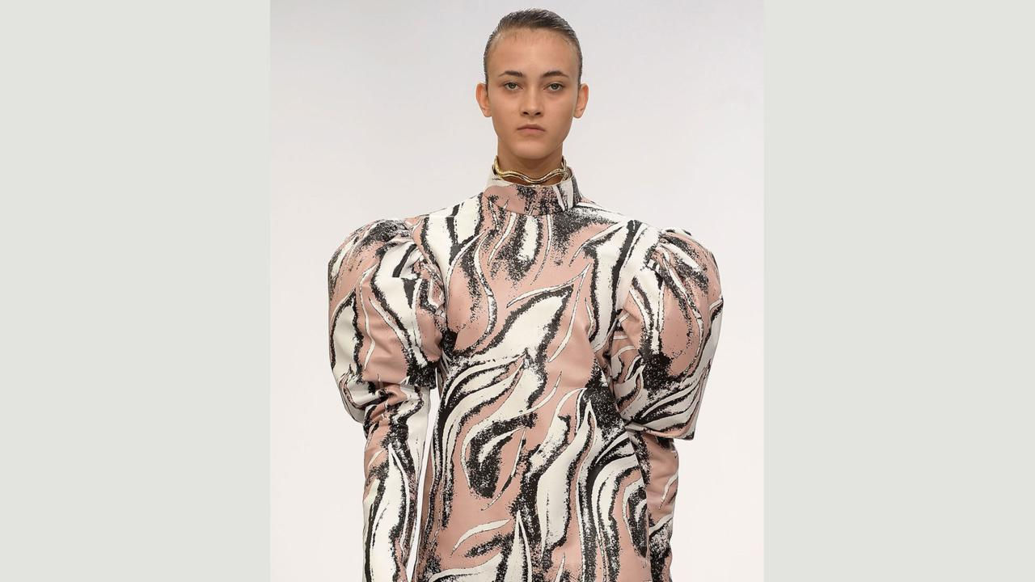

**Puffed up**

The voluminous puffy sleeve is set to be big in 2016 – very big. With a hint of 1980s New Romantic, and a touch of Victoriana, the leg o’ mutton sleeve will be back with a vengeance. JW Anderson’s extreme silhouettes and Simone Rocha’s romantic, diaphanous dresses are notable examples that many a high-street retailer will be following. Even the queen of pared-back, minimalist understatement, Phoebe Philo at Celine, has gone for the eccentric, over-the-top shape. The big sleeve is the ultimate arm candy for the coming year.  
  
As seen at: Celine, Simone Rocha, JW Anderson, Erdem. (Picture: JW Anderson/Credit: Getty Images)

**# 2**

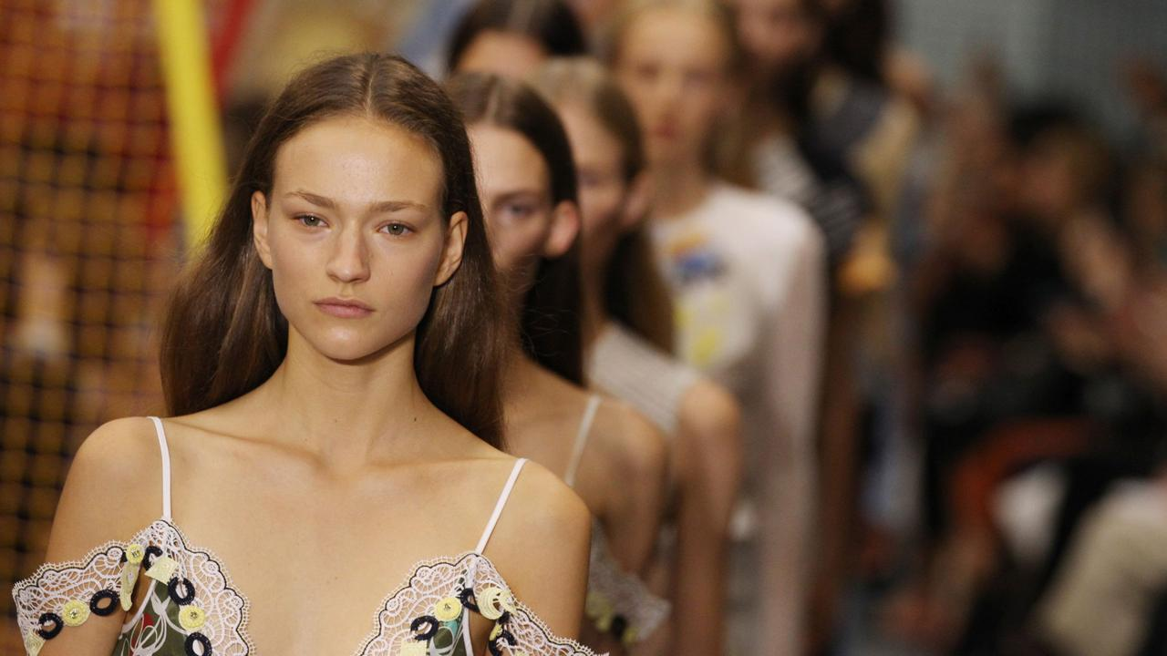

**Cold shoulder**

The shoulder-baring trend will continue its reign in 2016, if collections by Chloe and Peter Pilotto among others are anything to go by. And now the shape is being further adapted, with the arrival of the dramatic, cut-out-shoulder style, seen on dresses at Derek Lam, Sonia Rykiel and Proenza Schouler, and on tops at Hood by Air. A modern, playful look, the exposed-shoulder look is a good option for those who prefer more subtle skin baring.   
  
As seen at: Rachel Zoe, Derek Lam, Sonia Rykiel, Proenza Schouler, Wes Gordan. (Picture: Peter Pilotto / Credit: WireImage)

**# 3**

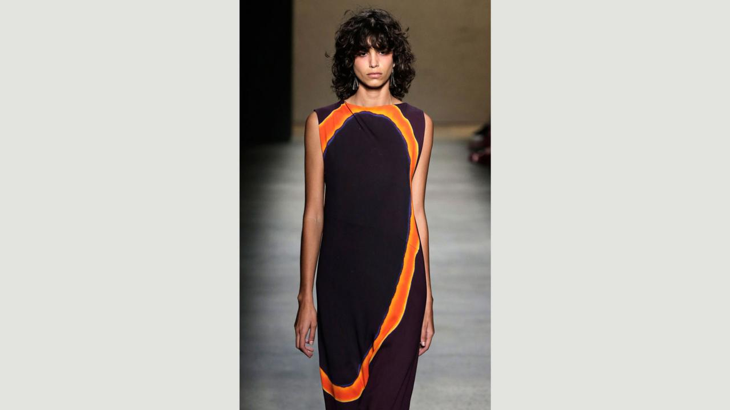

**To tie-dye for**

Love it or loathe it, tie-dye looks set to make an impact this coming year, particularly in the summer when the easy-going print comes into its own. The occasionally show-stopping, always boho style will be everywhere, creating woozy, trippy vibes wherever it appears. The new tie-dye has a sophisticated, haute-hippy feel, with Spring 2016 offerings including Joseph Altuzarra’s boldly dyed shirtdresses, Emilio Pucci’s pretty pastel shades and Narciso Rodriguez’s stunning sheath dress.   
  
As seen at: Baja East, Thakoon, Narciso Rodriguez, Emilio Pucci, Joseph Altuzarra. (Picture: Narciso Rodriguez / Credit: Getty Images)

**# 4**

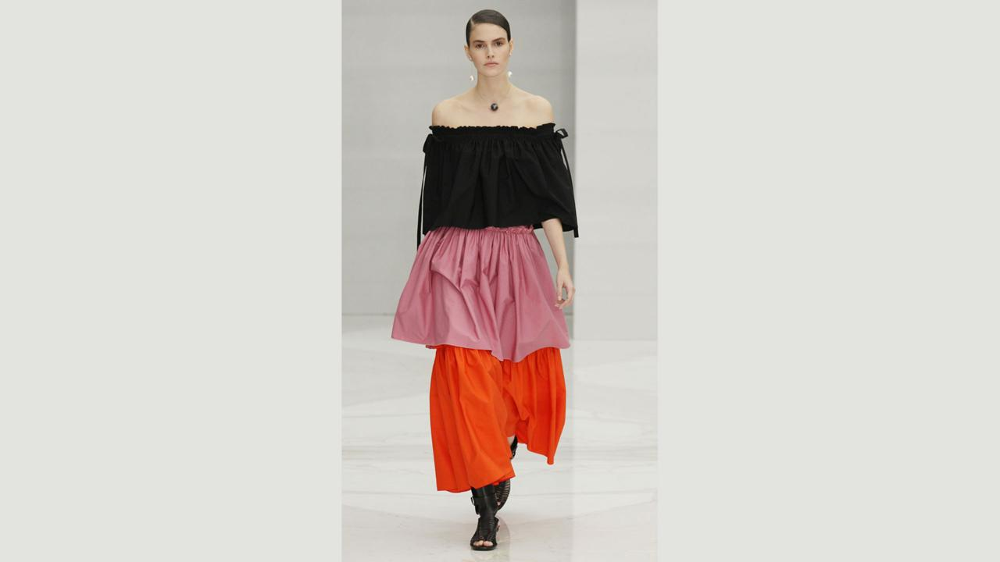

**Latin lovers**

There will be no escaping the ruffle in 2016, with numerous designers bringing a touch of Latin influence to their collections. The flamenco-tinged tiers and ruffles feature in hot orange at Balmain, in a high-neck number at JW Anderson and in the vibrant, tiered dresses at Salvatore Ferragamo. Perhaps the most exquisite use of ruffles for Spring/Summer 2016 is by Sarah Burton at Alexander McQueen, whose ultra-feminine, romantic white gown is a masterpiece of ruffled structural engineering.   
  
As seen at: Michael Kors, Alexander McQueen, Roberto Cavalli, Osman, Balmain, JW Anderson, Proenza Schouler, Salvatore Ferragamo. (Picture: Salvatore Ferragamo Credit: WireImage)

**# 5**

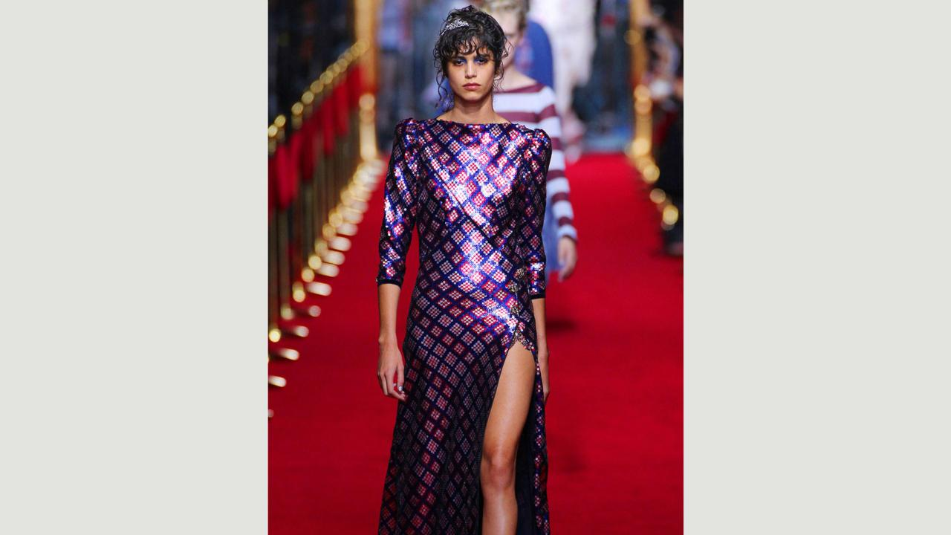

**Shine on**

Metallic and sparkly looks are set to shine in 2016, with an emphasis on reflective fabrics and elaborate use of sequins. Silver will be shining brightly, as seen at the collections in slip dresses at Victoria Beckham, voluminous dresses by Vetement and at Isabel Marant in the shape of cute silver shorts. Leading the way with sequins are Emilio Pucci in electric blue creations, Marc Jacobs with bold, geometric styles and Tom Ford, whose full-length, slinky, patchwork-sequin gown is an indisputable show stopper. There will even be a broken-mirror effect in evidence, if the wild and wonderful creations by Loewe and Marni creations are anything to go by.  
  
As seen at: Tom Ford, Loewe, Lanvin, Vetement, Marni, Isabel Marant, Emilio Pucci. (Picture: Marc Jacobs / Credit: WireImage)

**# 6**

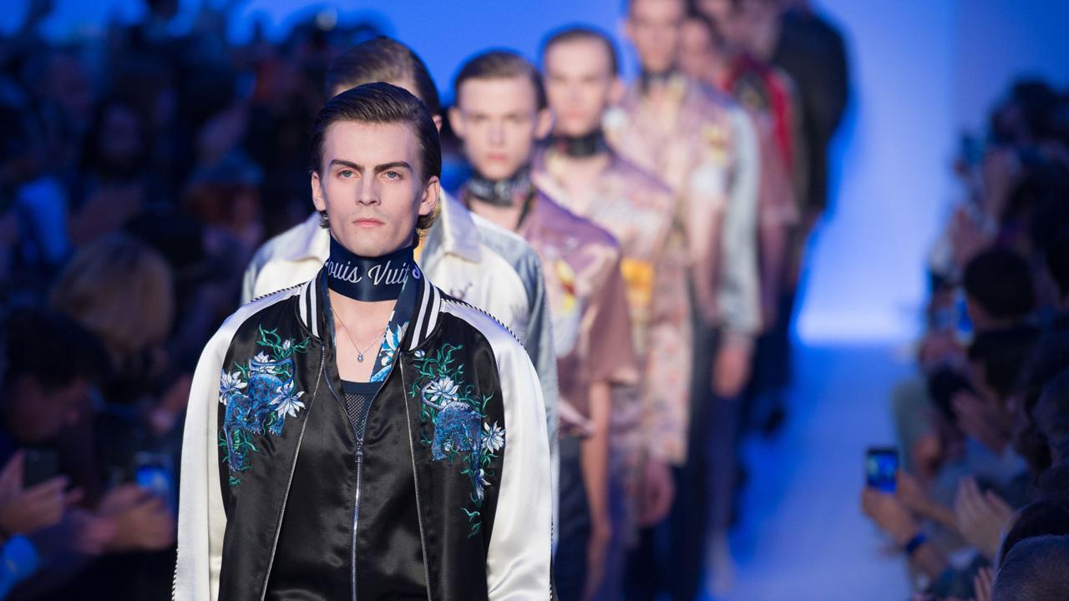

**Fifties fun**

There is a distinctly retro vibe on the way in menswear with the 1950s in particular looking set to be big. Shirts in particular will have a ‘50s feel, with bowling styles and textured fabrics as well as oversized polos in evidence at Louis Vuitton and Lanvin. The retro silhouette is also being interpreted by Dries van Noten, which has added embroidery, Raf Simons who favours checks, and E Tautz which has created bold prints in monochrome. On trend but also wearable, the ideal combination.  
  
As seen at: Lanvin, Louis Vuitton, Canali, Umit Benan, E Tautz. (Picture: Louis Vuitton Credit: WireImage)

**# 7**

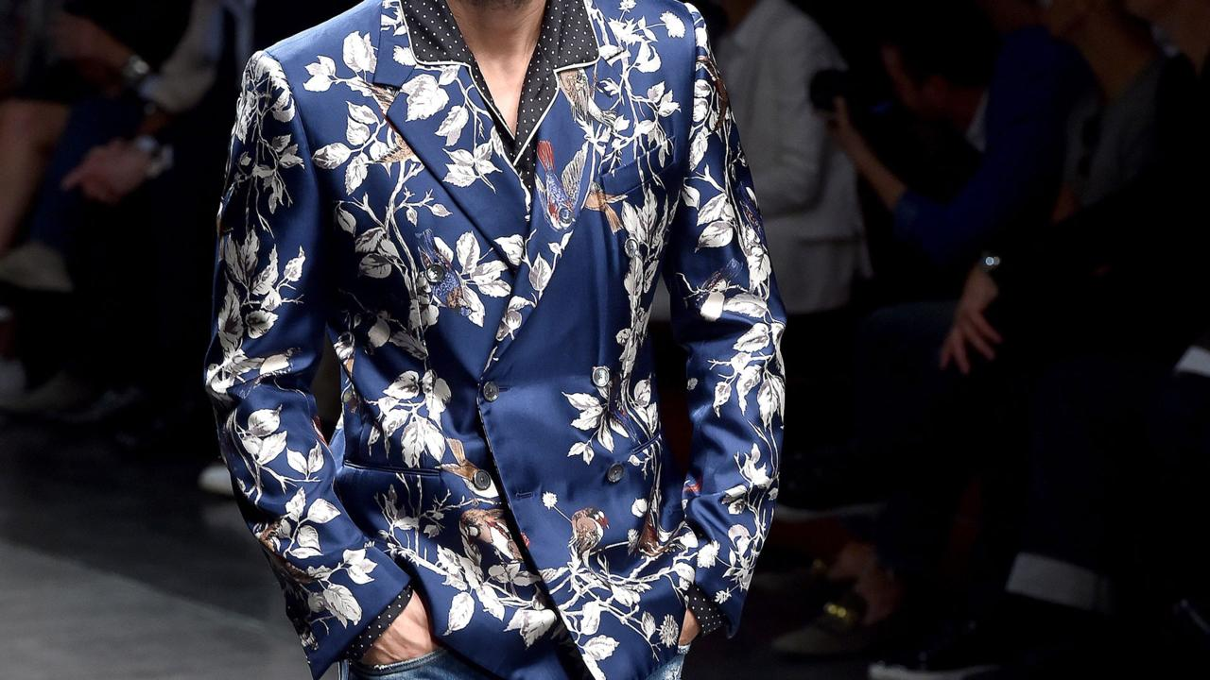

**Plant life**

Botanical prints have been a major trend in womenswear for several seasons, and are now spreading their tendrils into menswear in 2016. One for the more flamboyant man, the plant print feels luxurious and fun. Gucci’s vibrantly-hued suits complete with vine-and-leaf print look set to be big, while Dolce & Gabbana has created a suit in darker colours with a glamorous plant print that is elegant and also vaguely menacing-looking. The daring JW Anderson meanwhile offers a big and bold turquoise-on-white print.   
  
As seen at: Hermes, Saint Laurent, Dolce & Gabbana, Gucci, JW Anderson. (Picture; Dolce & Gabbana/Credit: Getty Images)

**# 8**

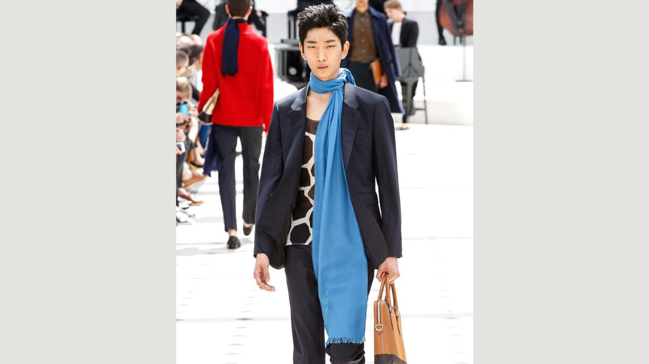

**Neck it**

The long scarf is set to be the major accessory for men in 2016. With a rakish feel, the look is guaranteed to add a little rock-star swagger to the wearer. Gucci are going floral with theirs, while other more sober designs are on offer from the likes of Emporio Armani and Saint Laurent. Burberry Porsum’s elegant cobalt-blue number is another likely hit. An easy way for men to add an on-trend hint of louche and languid charm to their wardrobe in 2016.  
  
As seen at: Burberry Porsum, Emporio Armani, Gucci, Saint Laurent, Missoni. (Picture: Burberry/Credit: SIPA/Rex/Shutterstock)

**# 9**

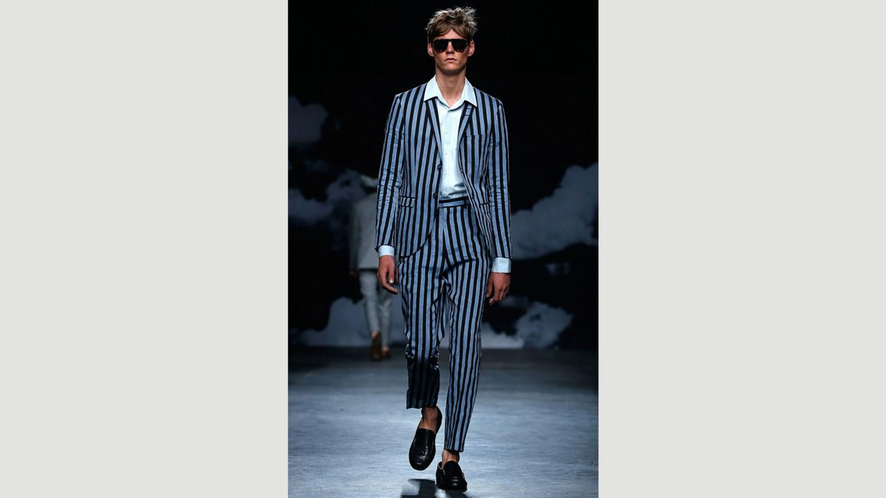

**Show your stripes**

The pinstripe will be a menswear staple in the coming year, but not as we currently know it. Forget the conventional pinstripe business suit, the new interpretation of the look is graphic and big. The adventurous duo Agi & Sam’s dramatically oversized suits are emblazoned with a similarly oversized stripe print, while Haider Ackermann’s neat, cropped pinstripe jackets are a whole new take on tradition. Tiger of Sweden’s pale blue-and-black suiting in super-bold stripes is among other highlights for 2016.   
  
As seen at: Haider Ackermann, Agi & Sam, Tiger of Sweden, Bottega Veneta, Phillip Lim. (Picture: Tiger of Sweden / Credit: Getty Images)

**# 10**

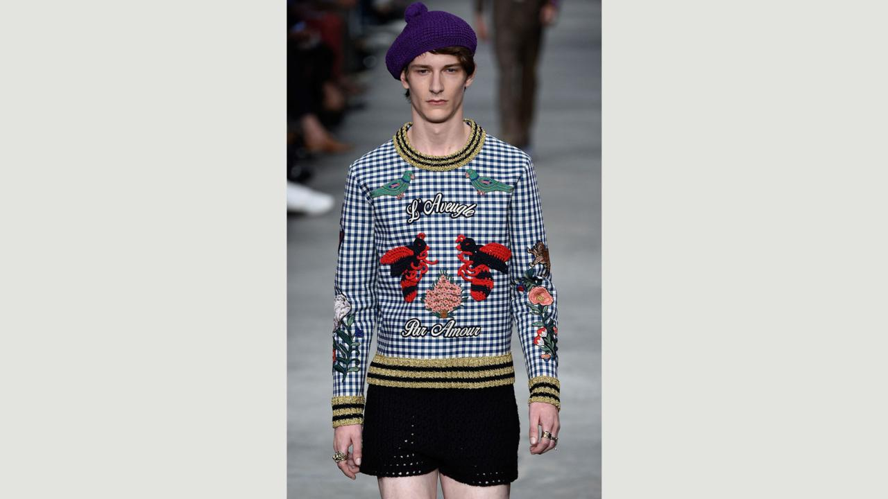

**Get shorty**

For the summer months of 2016, short shorts will be a male-fashionista trend – for those brave enough to sport the look. Prada and Gucci in particular are offering up the look in bright hues and a variety of fabrics. J Crew are also on the case, in understated hues and hi-tech fabrics. A tricky look to get right when not on the beach, but guaranteed to keep you cool in both senses of the word.   
  
As seen at: Top Shop Design, Prada, Gucci. (Picture: Gucci / Credit: Getty Images)

**\* Group Discussion Question List \***

**1) If you are a buyer for a clothes company in Korea, which fashion style would you like to buy for selling to Koreans? And why do you choose that?**

|  |
| --- |
|  |

**2) If you are a designer, what kind of clothes would you like to create? And why do you want to make it?**

|  |
| --- |
|  |