- Appendix 1 (2 copies)
What is the most
popular Korean shopping items
among foreign tourists?

Material 1 – Pre-activity

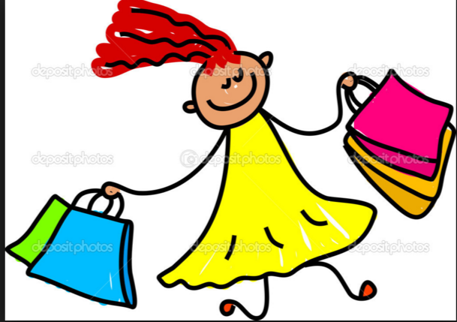
Rank | Item | Why is it popular?
1
2
3
4
5

- Appendix 2 (4 copies)
Today is my birthday and my girlfriend didn’t send any messages. She seems to forget it. What would you do?
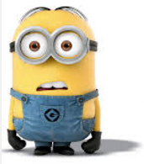
- If I were you, I would ….
say nothing and revenge on her birthday

- Why don’t you…

- How about …

- Maybe you should …

- I think you should

- I suggest you
- …
Dave

Carl

- Appendix 3 ( 2 copies) – front side
1. 2.  1. 2.  - 2.  1. 2.  1. 2.  - 2. | 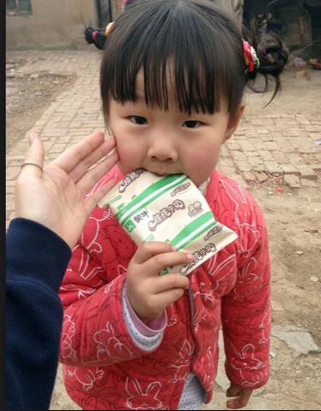
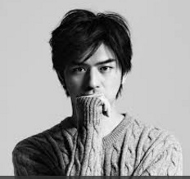 | 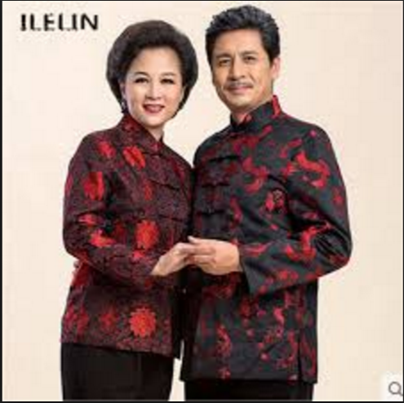
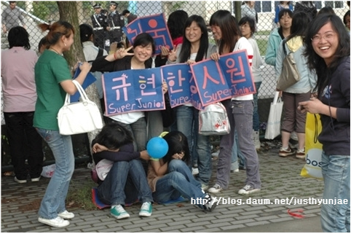 | 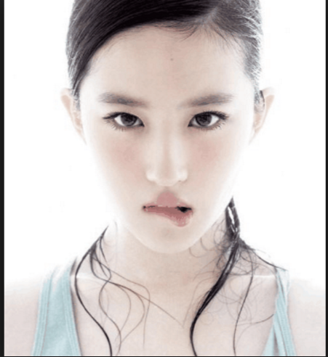
I want to buy a gift for my friend. Can you help me out ?

- Appendix 3 – back side (2 copies)

Girl friend-Tang  Age : 30  She buys Luxurious goods. Her hobby is shopping and hard to say whether she has any other hobbies | Child-BingBing  Age : 5  She owes every latest toy and eats everything
Husband-Jin  Age : 38  He travels for work a lot but he cooks on weekends. | Parents  Age : 64(Father), 60(Mother)  Mom told me that she doesn’t need anything and she’s a stay at home mother  Dad really care about his health and I got him a scarf but I never saw him wear it
Younger sister-Changchun  Age : 17  She’s into K-pop music and her favorite singer is Siwon from Super junior. | My BFF-Danna  Age : 27  She updates her SNS every day and she’s very trendy and doesn’t go anywhere without makeup.

- Appendix 4 ( 4 copies)
Recipients :
Title : Thank you.

Hi, _______________

Thank you so much for _______________________________________________________________

How did you know that ____________________________________________________________________?

When you said that ,

1) If I _____ you, I would _____________________________,
I _____________________________________ .

2) I would ________________________________________,

I _____________________________________ .

3) ____ don't you ________________________________,

I _____________________________________ .

4) How ___________________________________________,

I _____________________________________ .

5) ______ you should ___________________________________

, I _____________________________________ .

6) I think you ________________________________________,
I _____________________________________ .

7) I ________ you __________________________________,

I_____________________________________ .

I love the way the _____________________________ looks on _________________________?

All ____________________ will be jealous that

_____________________________________.

Thank you for ______________________________________________ !

Sincerely, __________________________

- Appendix 5 ( 1 copies)
Key word – A team
- ginseng
- Cosmetics
- BBF
- Gift
- Luxurious

Key word – B team
- Seeweed
- Snacks
- K-pop
- Shopping
- Health

