Listening Speaking Reading Grammar Writing

Topic: Make an order who is worst and who is best.

Instructor:  Luna  (Noh Poo Reun) | Level:  Intermediate  (Adults) | Students:  4 | Length:  30 Minutes

Materials:
-Story hand out paper
-Grammar hand out paper
-Grammar hand out paper answer key
-Pictures for role play

Aims:
-Main aim: Students will be able to persuade others.
-Second aim : Students will be able to use comparative and superlative
-Personal aim: Students get confidence of performing in front of people.

Language Skills:
-Reading: Ss will read the story and questions on the hand out paper.
-Listening: Ss will listen to the other students and teacher.
-Speaking: Ss will talk about their opinion about questions and persuade other students.
Ss will act and talk like the character which they get by role play.
-Writing: Students will think and write the order number.
Students will fill in the blanks on worksheet.
Students will write about how they will do if they are A in the story.

Language Systems:
-Phonics: pronounce ‘cleverer’ fluently
-Lexis: New vocabularies( embrace and bluntly )
-Grammar: comparative and superlative
-Discourse: Getting skill to persuade other by talking their opinion. Role play

Assumptions:
Students already know
-How the class is set up and run
-What is role play
-Some ideas of comparative and superlative

Anticipated Problems and Solutions:
- If Ss have difficulty to role play
→Make them into the character and encourage Ss to do role play
- If Ss have difficulty to persuade others
→Give them hints and encourage and help students to persuade others
“If you have a lot of boats, think how you will use the boats.”
“We need boats to import and export and also we travel by boats.”

References:
-Grammar
http://englishteachervictoria.weebly.com/blog/degrees-of-comparison-of-agjectives#/
http://busyteacher.org/8231-comparative-or-superlative-degrees-worksheet.html
-Picture
https://www.google.co.kr/search?q=money&hl=en&biw=1030&bih=751&site=webhp&tbm=isch&tbo=u&source=univ&sa=X&ved=0ahUKEwjRvYXS0JrMAhXCJJQKHUIlCMgQsAQIGQ#hl=en&tbm=isch&q=money+clipart&imgrc=0KfqjxcyzNjgwM%3A
https://www.google.co.kr/search?q=money&hl=en&biw=1030&bih=751&site=webhp&tbm=isch&tbo=u&source=univ&sa=X&ved=0ahUKEwjRvYXS0JrMAhXCJJQKHUIlCMgQsAQIGQ#hl=en&tbm=isch&q=love&imgrc=_VUOrNFqt3iU6M%3A
https://www.google.co.kr/search?q=money&hl=en&biw=1030&bih=751&site=webhp&tbm=isch&tbo=u&source=univ&sa=X&ved=0ahUKEwjRvYXS0JrMAhXCJJQKHUIlCMgQsAQIGQ#hl=en&tbm=isch&q=boat+clipart&imgrc=0-Hnag5Dzm_1pM%3A
https://www.google.co.kr/search?q=money&hl=en&biw=1030&bih=751&site=webhp&tbm=isch&tbo=u&source=univ&sa=X&ved=0ahUKEwjRvYXS0JrMAhXCJJQKHUIlCMgQsAQIGQ#hl=en&tbm=isch&q=books+clipart&imgrc=ppYhNUyDVrSclM%3A
https://www.google.co.kr/search?q=money&hl=en&biw=1030&bih=751&site=webhp&tbm=isch&tbo=u&source=univ&sa=X&ved=0ahUKEwjRvYXS0JrMAhXCJJQKHUIlCMgQsAQIGQ#hl=en&tbm=isch&q=river+clipart&imgrc=OFToS3gW5gZPDM%3A
https://www.google.co.kr/search?q=money&hl=en&biw=1030&bih=751&site=webhp&tbm=isch&tbo=u&source=univ&sa=X&ved=0ahUKEwjRvYXS0JrMAhXCJJQKHUIlCMgQsAQIGQ#hl=en&tbm=isch&q=money+clipart+black+and+white&imgrc=3fj-HxThYERWQM%3A
https://www.google.co.kr/search?q=money&biw=1280&bih=930&source=lnms&tbm=isch&sa=X&ved=0ahUKEwi3tIicxprMAhWk5aYKHdq7CFUQ_AUIBigB#tbm=isch&q=boat+drawing+for+kids&imgrc=qFmrrdv6Pi_nIM%3A

Lead-In
Materials:
Time | Set Up | Student Activity | Teacher Talk
2 min | Whole  class | Listening and answering T’s warm-up questions | “Hello, everyone! How are you? What did you do last weekend? Any special happening? I have Starbucks coffee every day. I think Starbucks coffee is better than other coffee that is has lots of Starbucks on the streets. What do you think?”

Pre-Activity
Materials: Grammar hand out paper
Time | Set Up | Student Activity | Teacher Talk
5 min | Whole class | Listening to the explanation about grammar ‘comparative and superlative’  Answer the question  Answer the question and if they don’t understand fully then ask what they don’t understand. | (Hand out the paper)  “Look at this hand out paper.  “We will learn about comparative and superlative with this.  What kind of words do you know in this hand out paper?  (Wait for students reply)  When we compare with two things you could use comparative and normally it has basic form that you should put ‘–er or -ier’ + than on adverb or more than two syllables you could put ‘more’ in front of the adverb+ than. But there is exceptional case such as good-better and bad-worse.”  “Let’s make comparative of good. Who can make it?”  (Waiting for students respond)  “Good!”  “Next when we compare with more than two things, we can use superlative and it has basic form that you should put the+‘-est or -iest’ with adverb or more than two syllables you could put ‘the most’ in front of the adverb. But there is exceptional case such as good-better-best and bad-worse-worst.”  “Do you understand how to make comparative and superlative?”  (Waiting for students’ answers and if there are students who couldn’t understand well then give comparative and superlative example to make understand this grammar.)

Main Activity
Materials: Story hand out paper
Role play pictures
Time | Set Up | Student Activity | Teacher Talk
5 min  2 min  2 min  8min | Whole class  Pair work | Read the story  Write the order from worst person to better person on the hand out paper  Respond of the question  Students will try to persuade their partner according to their ordering.  Pick one the role play pictures and check the pictures and think how you will persuade others that you are better than others.  Act role play together | Instruction  “Ok, read this story and think about the answer of this questions on the hand out paper.”  “Did you finish make order from worst to better?”  (Waiting for students reply)  “Let’s share your order. First Sherry what is you order?”  (Waiting for Sherry’s order and one by one make them talk about their order.)  (Make the students be pair who doesn’t have same order.)  Instruction  “This time you will persuade your partner. How can we persuade others?”  Model  “For example, I think A is better than B because she tries to find the way to meet her lover not to betray him.”  Instruction  “Like this you could persuade other using comparative. I will give you two minutes to persuade your partner.”  “Ok! Time’s up. Did anybody change your mind?”  (Waiting for Ss reply)  Instruction  “This time we will do role play. Each of you will pick one of the piece of role play pictures and do role play together to persuade people that you are better than others. Pick the picture everybody.”  (Make them pick the pictures and make them think how to persuade others.)  “Who picks Money? Love? Intelligent? Boats? Ok good. Think how you will persuade others that you are better than others. I will give you 2 minutes to think”  (Wait for them to think)  “Ok! Are you ready to do role play? Try to persuade other that you are better than others as much as you can.”  (Students start role play actively)

Post Activity
Materials:
Time | Set Up | Student Activity | Teacher Talk
4 min  1 min | Whole class | Students write about if they are A how they will do. | Instruction  “Let’s think if you are A, how will you do. I will give you two minutes to think and write about it.  (waiting for students to think and write)  Model  “Ok. If I was A, I will borrow money from C and ask D to send my message to B to come to me. Any other idea as A?”  (Wait for students reply and share their writing)  Conclude lesson  “Okay, Today we learned about comparative and superlative and try to persuade others who has different opinion with you. Good job everybody. Home work is on grammar hand out. Fill in the blank to make comparative and superlative. Next time we will share what you write about it. See you tomorrow”
SOS Activities
Materials:
Time | Set Up | Student Activity | Teacher Talk
5 min | Whole class | Make them think if they are A how will they react with others and talk about it. | Instruction  “Let’s think if you are A, how will you react with all characters in the story.  I will give you two minutes to think about it and then let’s talk about it all together.”  (waiting for students to think)  “Ok time’s up! Does anyone can be upset with E?”  (Wait for students reply)  “Ok. Sherry? Why will you be upset with E and how will you react with other characters?  (Let Sherry talks about it.)  “Ok. Good. Anyone will react different way?  (Wait for students reply)  “Very good. I hope you all enjoy this topic.”

Comparative and Superlative

How to make comparative and superlative.

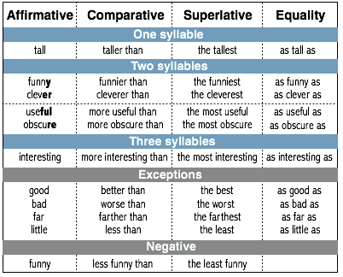

Fill the blanks with the right form of the adjective in brackets.

- Your bag is ______________(Heavy/light) than mine.
- Its _______________(difficult) rule of all.
- This pen writes ________________(good) than my previous one.
- This athlete is _________________(strong) than his competitor.
- This pupil is __________________(clever) in the class.
- This is ___________________(old) castle in Britain.
- Health is ___________________(important) than money.
Answers

Fill the blanks with the right form of the adjective in brackets.

- Your bag is heavier/lighter(Heavy/light) than mine.
- It’s the most difficult(difficult) rule of all.
- This pen writes better(good) than my previous one.
- This athlete is stronger(strong) than his competitor.
- This pupil is the cleverest(clever) in the class.
- This is the oldest(old) castle in Britain.
- Health is more important(important) than money.

Make an order from worst to best?

A loves B who lives on the other side of the river. A flood has destroyed all bridges across the river. A wants to cross the river to meet B. C has lots of money. A asks him to help her to cross the river. C replies that if A gives him money then he can help her. D has a boat. A asks D to help her to cross the river. D replies that if she sleep with him then he can help her. A sleeps with D. D takes A to cross the river by his boat. A runs to B to happily embrace him and tell him everything that has happened. B pushes her away bluntly and A runs away. Not far from B’s house A meets E who admires A for long time and saw A how and what she did to cross the river. E wants to be A’s lover.

Worst---------------------------------------------------------------------------Best

___________ ---- ___________ ---- __________ ---- __________ ---- __________

Who do you think is the worst person and why do you think so?
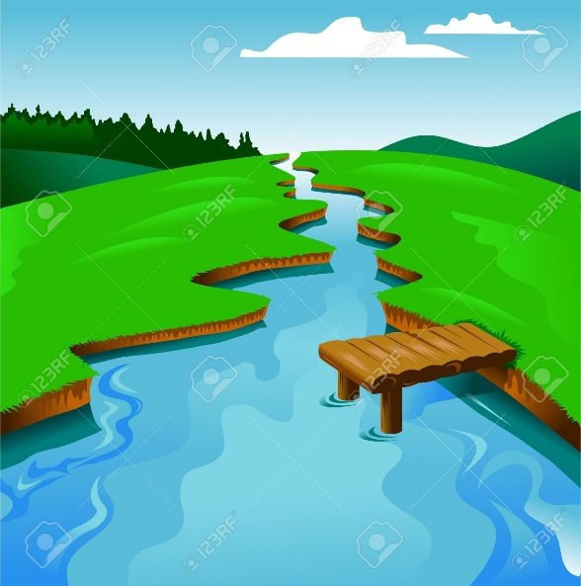

A B
c E
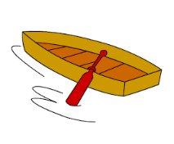
D
Money for role play

Boats for role play

Love(Romantic) for role play

Intelligent for role play
If you are A, how will you do?

