Listening Speaking Reading X Grammar Writing
Topic: Let’s travel Je-Ju Island in a day.
(Language Target : Conjunctions)
Instructor:  Choi | Students Competency Level: Pre - Intermediate | Number of Students:12 | Lesson Length:  50
Materials: (List the Names of all materials used in the lesson. Materials must be shown at the end of this document)
White Board & Markers
Je-Ju Video
- Computer
- Projector
- Overhead Screen
Worksheet For Conjunctions
Drilling Wall Chart 1
Drilling Wall Chart 2
Pictures Of Je-Ju Island
- The 7 Unexpected Land
- The 7 Specialties

Aims: (What students will be able to achieve by participating in the activities of the lesson. (Ss gain or get by doing…)-
- Improve Ss listening skills by listening to T’s story, Ss stories, drilling and presentations
- Improve Ss speaking skills by answering T, Ss presentations, sharing stories and
drilling
- Improve Ss grammar skills about conjuctions by T’s story and drilling.T responding and rephrasing Ss thoughts, drilling, writing and presentations
Language Skills: (Lists what activities language skills students will be using by participating in the activities of the lesson.)
- Listening: (Where did listening occur in the lesson?)
T talk, Ss talk
- Speaking: (Where did speaking occur in the lesson?)
Sharing T’s stories about their trip to Je-Ju island.
Language Systems: (Lists what language systems students will be using by participating in the activities of the lesson.)
- Phonology: (sound)
Drilling, T and Ss talk.
- Lexis: (meaning)
Conjuctions used to tell about their stories.
- Grammar: (language structure)
Conjuctions
- Discourse: (communication)
T talk and ask, Ss answer the question and tell their stories.

Assumptions: (What students must already be able to do and what concepts must already be mastered before the lesson in order to achieve the aims of the lesson.)
All Ss are over pre- intermediate level.
All Ss know the verb changes like regular,irregular.
All Ss can talk about their experience about trip in English.

Anticipated Errors and Solutions: (What things might go wrong in the lesson and what the solution will be. An SOS activity should also be included)
- If Ss cannot have any idea about the trip. Tell Ss if they have a trip plan where do they want to go.
- If Ss take a long time to make sentences with the topic. Never push students. Give more time and encourage them.

References:
None

Lead-In or Pre-Task Part (Warm-Up Part to activate and create interest in the lesson.)
Materials: (List the Names of all materials used in the Lead-In or Pre-Task Part of the lesson. Materials must be shown at the end of this document)

White Board and Markers
Je-Ju Video
- Computer
- Projector
- Overhead Screen

Time: | Classroom Set Up: | Student Activity and Goals: | Teacher Procedure & Instructions:
1 min  7 min  3 min | Whole  Whole  Whole | Greet T  Listen to T and  Ss watch the video  Ss answer | Greets Ss  Talk about my trip to Je-Ju island  Show the videos about Je-Ju island.  Ask Ss to share their story about the trip

Pre-Activity or Task Familiarization Part (Presentation Part Presenting the language structure to be covered in the lesson. Prepares students for the communication activity.)

Materials: (List the Names of all materials used in the Pre-Activity or Task Familiarization Part of the lesson. Materials must be shown at the end of this document)

White Board and Markers
Drilling Wall Chart 1
Drilling Wall Chart 2
Worksheet For Conjunctions

Time: | Classroom Set Up: | Student Activity and Goals: | Teacher Procedure & Instructions:
5min  5min  3min | W – Ss  Whole  S -Whole | Ss read, listen, speak and drill to learn and become familiar with conjunctions  Ss receive the worksheet and do activity  Other Ss listen. | Put drilling wall charts on the white board  Do drilling with students. Accuracy important.  T hand out the worksheet and do the activity  Ask Ss to present the answers

Main Activity or Task Realization Part (Practice to Production Part Teacher lead practice of the language presented and move to communication based more student centered activity)
Materials: (List the Names of all materials used in the Main Activity or Task Realization Part of the lesson. Materials must be shown at the end of this document)
White Board & Marker
Pictures Of Je-Ju Island
- The 7 Unexpected Land
- The 7 Specialties
Time: | Classroom Set Up: | Student Activity and Goals: | Teacher Procedure & Instructions:
1  2min  5min  4min | Whole  Whole  Pairs  Whole | Ss listen and respond.  Ss listen T and think about what T said  Ss work in pairs and take note of them  Ss listen and talk | T shows pictures of Je-Ju island and ask Ss know.  Ask Ss that if you have just one day to  Visit Je-Ju island with your foreign friend  Where do you want to go and what to eat  Pick 3 places  Put Ss in pairs to communicate using conjunctions in grammar and let them take a note.  Let Ss tell about partner’s plan made using conjunctions.

Post Activity or Post Task Part (Wrap-Up Part Close the Lesson on a high note to and consolidate language learned in a communication based activity new situation.)
Materials: (List the Names of all materials used in the Post Activity or Post Task Part of the lesson. Materials must be shown at the end of this document)

Time: | Classroom Set Up: | Student Activity and Goals: | Teacher Procedure Instructions:
3Min  5min  1min | Whole  Whole  Whole | Listen T and prepare the game  Ss play the game  Thank T and say goodbye | Introduce Go to Je-Ju game Let Ss tell  If they go to Je-ju, What do they want to visit and eat.  Each Ss must use conjunctions like ‘if’ ‘and’, ‘when’ in the sentences. The next Ss must remember and state what the previous student said in turns.  Close the game if someone don’t remember what the previous Ss said.  Thank Ss for actively participating in the lesson. Close by giving feedback about their work done.

Drilling Wall Chart 1

Joe was frightened when the glass broke.
Pat arrived before the party started.
Jeff talked to his teacher after the class was over.
Before I was finished with my test, the class was over.

We were out when you called our home.
When you called our home, we were out.

I knew her before she was famous.
Before she was famous, I knew her.

Her music became popular after she passed away.
After she passed away, her music became popular.

Drilling Wall Chart 2

At Tom’s house…
He washes the dishes after he eats dinner.
Mama went to sleep before he came.
Dad will call him when he comes home.

At Jane’s house…
Jane takes a bath when she comes home.
Mom watched movies before she arrived.
Dad will get home after she finishes.

<<Work sheet For Conjunctions>>

When, Before, and After

When We were out when you called our home.
When you called our home, we were out.

Before I knew her before she was famous.
Before she was famous, I knew her.

After Her music became popular after she passed away.
After she passed away, her music became popular.

<<Practice>>

7:00 Get ready 1.Brian gets ready______he eats breakfast.
7:30 Eat breakfast 2.Brian goes to school_______It’s 8:00
8:00-3:30 School 3.Brian studies ______ school finishes.
3:30 Study/Listen to music 4.Brian plays outside ________ he eats dinner.
7:00 Eat dinner
7:30 Play

Tenses in subordinating conjunctions
Main Clauses Subordinate Clauses Examples
Present Present I leave when the bell rings.
She gets home before I do.
Sam watches a movie after he cleans his room.
Past Past I left when the bell rang.
She got home before I did.
Sam watched a movie after he cleaned his room.
Future Present I will leave when the bell rings.
She will get home before I do.
Sam will watch a movie after he cleans his room.
- The student will raise her hand after she(complete)____________her assignment.
- Jane talked to her friend before she(start)________her homework.
- Tony cooks spaghetti after he (wash)__________ his hands.
- The boy ate dinner before he(sing)_________ his song.
- Mike will go to a play after he(shine)________his shoes.
- He plays computer games when he (have)________ free time.

<<Pictures>>
The Seven Unexplored Land
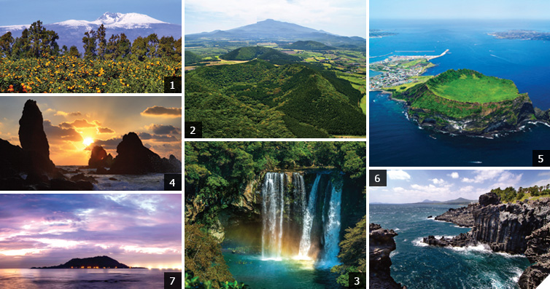
01. View of Mt. Halla from tangerine garden
Halla Mountain covered with snow is the best in winter. No snowscape is more beautiful than the landscape of snow-capped Mt. Halla.
02. View of crater from Geomun Oreum
Many caves are widely distributed around Geomun Oreum.
A lava flow erupted from craters during the formation of oreum has created almost 20 caves, such as KimNyung Cave, and Manjanggul Cave, as it flowed down to the coastline.
03. View of Cheonjiyeon Fall from Seogwip Chilsim ni Park
Cliffs of Cheonjiyeon Falls high in the sky makes us feel ecstasy as if we are entering into the house of Taoist herm it.
04. Sunrise in Seopjikoji Chotdaebawi
Seopjikoji is a place crowded with tourists due to the influence of a drama, 'All in'. The sunrise of Chotdaebawi under the cliff is ‘magnificent’ in a word.
05. Ilchulbong and Udo above the blue sea
Seongsan Ilchulbong is the main contributor which initiated listing on the 2007 World Natural Heritage along with Geomunoreum Lava Tube System. ‘An island inside an island’.
As years go by, its popularity is growing together with Udo.
06. A wonderful sight of Jisatgae Jusangjeolli and Jungm un Beach
Jusangjeolli Cliff located in Jisatgae, the old name of east coast near Jungmun Resort Complex, is where you can feel the greatness and exquisiteness of nature at the same time.
07. An evening glow at Hyupjae Beach
A beautiful beach wherein white sand mixed with shell powder, beautiful cobalt blue sea, and dense forest are combined into a stunning scene.

<<Pictures>>
The Seven Specialties
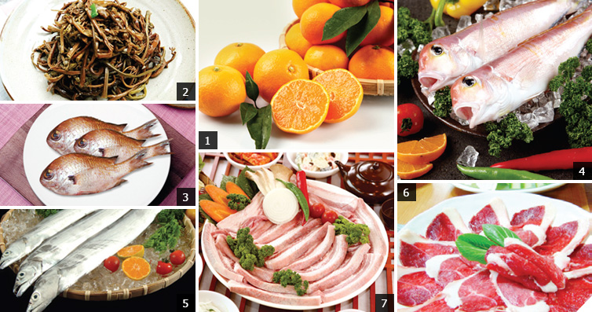
01. Tangerine
Good for weight loss as they are alkaline foods, also help with the absorption of calcium. It helps to speed up our metabolism, care skin with plenty of vitamin C, and relieve fatigue.
02. Bracken
Plenty of minerals, such as protein, cellulose, calcium, and potassium. In particular, it works well with Chuja dried corvinas, Jeju pork and is cooked into soup, seasoned vegetable, and hot spicy meat stew.
03. Damselfish
In season between May~August! Cooked into cold raw fish soup, small roll of boiled dropworts, roasted fish, fermented fish, and boiled fish. It is adequate to the obese people as calories are low, of the mild taste and little fat, easier for digestion.
04. Tilefish
It had been served as valuable foods for the royal family since the Chosun Dynasty. Firm flesh, less fat and rich in calcium. Rich in vitamines A, B1, B2, and minerals, such as calcium, phosphorus, and iron.
05. Cutlassfish
In season between November~September! White and soft flesh, good for a diet meal and promoting growth for children. Cooked into fish boiled in spiced soy sauce, pumpkin soup, roasted fish, and fried fish.
06. Horsemeat
It has been used as medicines for nervous disorders and itching, and is a magic bullet for leg bones including arthritis and neuralgia.
Helpful for the prevention of colds for children.
07. Pork
Almost every part of Jeju pork is used for cooking. High quality of meat and tastes much better with less fat.

