Listening Speaking Reading Grammar Writing
Topic: Daily Routine

Instructor:  Jin | Students Competency Level: Upper Beginner | Number of Students: 14 | Lesson Length:  50 min
Materials: (List the Names of all materials used in the lesson. Materials must be shown at the end of this document)
- 14 Copies of Grammar Dictation Worksheet
- Grammar Dictation Answer Sheet for Teacher
- 14 Copies of Grammar Word Search Worksheet
- Grammar Word Search Answer Sheet for Teacher
- White Board and Markers
- Drilling Wall Chart – Present Simple, 3rd Person Singular Form

Aims: (What students will be able to achieve by participating in the activities of the lesson. (Ss gain or get by doing…)
- Ss gain grammar skills about 3rd person singular by T using 3rd person singular form, T responding and rephrasing Ss answers, drilling, writing, and do activities with other Ss.

Language Skills: (Lists what activities language skills students will be using by participating in the activities of the lesson.)
- Reading: (Where did reading occur in the lesson?)
Drilling wall chart, writing answers

- Listening: (Where did listening occur in the lesson?)
T talk, Ss talk, activity

- Speaking: (Where did speaking occur in the lesson?)
Sharing Ss thoughts, answering

- Writing: (Where did writing occur in the lesson?)
Writing answers on the worksheet

Language Systems: (Lists what language systems students will be using by participating in the activities of the lesson.)
- Phonology: (sound)
Drilling, T and Ss talk

- Lexis: (meaning)
3rd person singular form

- Grammar: (language structure)
3rd person singular

- Discourse: (communication)
T-S-T, Ss answer, sharing their thought, drilling, and do activities

Assumptions: (What students must already be able to do and what concepts must already be mastered before the lesson in order to achieve the aims of the lesson.)
- All Ss know about simple present
- All Ss know how to use do and don’t when they talk.

Anticipated Errors and Solutions: (What things might go wrong in the lesson and what the solution will be. An SOS activity should also be included)
- If Ss cannot figure out how to use 3rd person singular form, T will explain to them more easily so they can understand it more clearly.

References:
- None

Lead-In or Pre-Task Part (Warm-Up Part to activate and create interest in the lesson.)
Materials: (List the Names of all materials used in the Lead-In or Pre-Task Part of the lesson. Materials must be shown at the end of this document)

Time: | Classroom Set Up: | Student Activity and Goals: | Teacher Procedure & Instructions:
1min  4 min  3 min | W  W  Ss | Greet T  Listen to T’s story  Share Ss story | Greet Ss  Talk about T’s daily routine and T’s father’s daily routine. (concentrate on pronounced 3rd person singular verb form)  Ask Ss to share about their daily routine.  T gives positive feedback to Ss, and then Now, Let’s look at the board!

Pre-Activity or Task Familiarization Part (Presentation Part Presenting the language structure to be covered in the lesson. Prepares students for the communication activity.)
Materials: (List the Names of all materials used in the Pre-Activity or Task Familiarization Part of the lesson. Materials must be shown at the end of this document)
- White Board and Markers
- Drilling Wall Chart – Present Simple, 3rd Person Singular Form
- 14 Copies of Grammar Dictation Worksheet
- Grammar Dictation Answer Sheet for Teacher

Time: | Classroom Set Up: | Student Activity and Goals: | Teacher Procedure & Instructions:
5 min  3 min  5 min  3min  3 min | W- Ss  W  W- Ss  Ss  W | Ss listen, read, speak and drill to learn and become familiar with 3rd person singular form  Listen to T and get the worksheet from T  Ss write the correct spelling of the verbs  Ss listen to T and do the activity  Picked Ss answer | Put drilling wall chart on the white board  Do drilling with student. Accuracy important.  T introducing Grammar dictation worksheet to Ss and explain what to do  - Hand out the worksheet to Ss  - T will say the verb then Ss complete with correct spelling of the verbs  T say the verb  Ask Ss if they are able to follow the rule and do the activity. If not, help them  After #16, do the correction together  T randomly ask student to answers  Lead Ss to the next activity!

Main Activity or Task Realization Part (Practice to Production Part Teacher lead practice of the language presented and move to communication based more student centered activity)
Materials: (List the Names of all materials used in the Main Activity or Task Realization Part of the lesson. Materials must be shown at the end of this document)
- 14 Copies of Grammar Word Search Worksheet
- Grammar Word Search Answer Sheet for Teacher

Time: | Classroom Set Up: | Student Activity and Goals: | Teacher Procedure & Instructions:
2 min  15min  3 min | W  W - Ss  W | Listen to T and pair up  Listen to T what do to, and then, start the activity with partner  Ss respond to T | Give out Grammar word search worksheet to Ss and tell Ss to pair up  Tell Ss to look at the word on the middle of the worksheet and find their matching 3rd person singular forms in the word search worksheet  - Make sure Ss change the word to the right forms  Ask if Ss finished, then go over the activity together  Every time Ss answer, make sure give Ss positive feedback and response

Post Activity or Post Task Part (Wrap-Up Part Close the Lesson on a high note to and consolidate language learned in a communication based activity new situation.)
Materials: (List the Names of all materials used in the Post Activity or Post Task Part of the lesson. Materials must be shown at the end of this document)

Time: | Classroom Set Up: | Student Activity and Goals: | Teacher Procedure Instructions:
3 min | W | Ss listen to T and say good bye to T | T tell Ss about the post activity  - Describe your best friend’s daily routine  - Tell Ss to write short story about what does he / she do every day?  Close class, and thanks Ss for participating
Grammar Dictation Worksheet 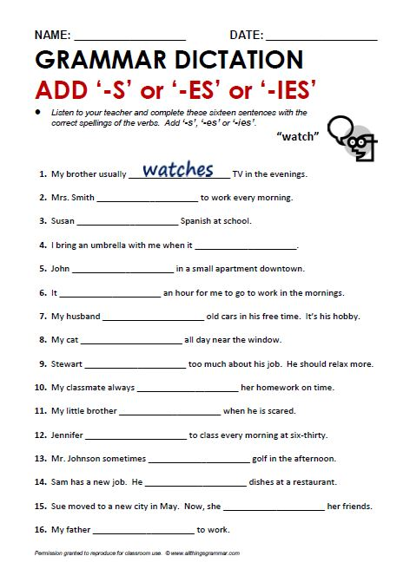
Grammar Dictation Answer Sheet
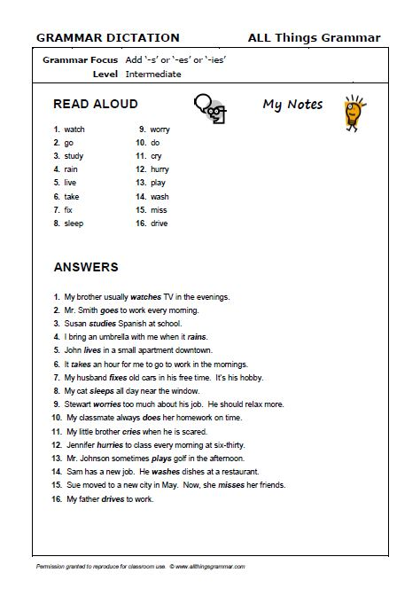
Grammar Word Search Worksheet
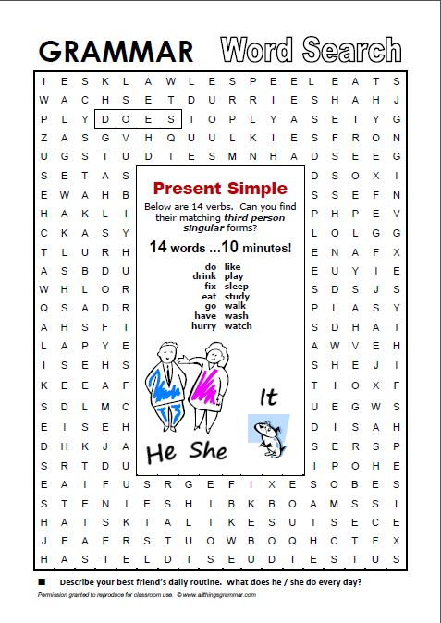
Grammar Word Search Answer Sheet
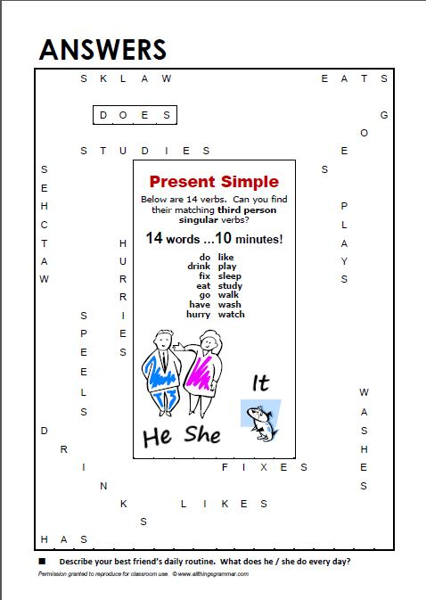
Drilling Wall Chart – Present Simple, 3rd Person Singular Form

