Listening Speaking Reading Grammar Writing
Topic: Sally Loves Food!
(Language Target : Countable, Uncountable nouns and Quantifiers)

Instructor:  Casey | Students Competency Level  Intermediate | Number of Students:  13 | Lesson Length:  59 mins
Materials:(List the Names of all materials used in the lesson. Materials must be shown at the end of this document)

- White Board and Markers
- Quantifier Worksheet
- Countable and Uncountable Worksheet 1
- Countable and Uncountable Worksheet 2
- Example pictures

Aims:(What students will be able to achieve by participating in the activities of the lesson. (Ss gain or get by doing…)

- Improve Ss listening skill by listening to T introduction, questions and listening to other Ss statements during brain storming and group discussion.
- Improve Ss speaking skills by discussing in groups and responding to teacher questions.
- Improve Ss grammar skills by worksheets.
- Improve interaction, imagination and communication skills by having discussion and doing activity in groups.

Language Skills:(Lists what activities language skills students will be using by participating in the activities of the lesson.)

- Reading: (Where did reading occur in the lesson?)
Worksheets.
- Listening:(Where did listening occur in the lesson?)
T instruction and explanation, discussion
- Speaking: (Where did speaking occur in the lesson?)
Discussing, responding to teacher, questions and presentation
- Writing: (Where did writing occur in the lesson?)
Discussing, taking notes

Language Systems: (Lists what language systems students will be using by participating in the activities of the lesson.)

- Phonology: (sound)
Discussion, teacher talk
- Function:(situation)
Learning quantifiers
- Lexis: (meaning)
Reading skills and learning countable, uncountable nouns
- Grammar:(language structure)
Description from texts
- Discourse: (communication)
Discussion, responding teacher, presentation

Assumptions:(What students must already be able to do and what concepts must already be mastered before the lesson in order to achieve the aims of the lesson.)

- All Ss have basic information about quantifiers
- All Ss will enjoy discussion and sharing their opinions.
- All Ss enjoy completing their own work sheets
- All Ss enjoy doing activities and using imagination during group discussions.

Anticipated Errors and Solutions:(What things might go wrong in the lesson and what the solution will be. An SOS activity should also be included)

- If Ss may not understand the clear meaning
Solution: Provide more examples.
- If activity lasts too long
Solution: T cuts the unnecessary parts
Give time warning
- If activity finished too soon
Solution: T makes suggestions and shares ideas
Give Ss more time for discussion.
- If students may not understand
Solution: T show demonstration
- If certain Ss are shy
Solution: T encourages them, gives positive feedback, and changes roles for them.

References:

Lead-Inor Pre-Task Part (Warm-Up Part to activate and create interest in the lesson.)
Materials: (List the Names of all materials used in the Lead-Inor Pre-Task Partof the lesson. Materials must be shown at the end of this document)

- White Board and Markers
- Example pictures
- Countable and Uncountable Worksheet 1

Time: | Classroom Set Up: | Student Activity and Goals: | Teacher Procedure &Instructions:
1 min  5min  3min | Whole  Whole  Ss | Ss greet the T  Ss listen to the T  Reply to the T | Greeting.  Lead in by saying a short story of Sally who likes food but don’t know saying quantifiers and uncountable, uncountable nouns  Ask Ss their opinions about food  Let’s learn more about quantifiers and uncountable, uncountable nouns

Pre-Activity or Task Familiarization Part (Presentation PartPresenting the language structure to be covered in the lesson. Prepares students for the communication activity.)
Materials: (List the Names of all materials used in the Pre-Activity or Task Familiarization Part of the lesson. Materials must be shown at the end of this document)

- White board and markers
- Quantifier worksheet 1
- Countable and Uncountable worksheets 2

Time: | Classroom Set Up: | Student Activity and Goals: | Teacher Procedure &Instructions:
2 min  5 min  2 min  1 min | Whole  Whole  Whole  Pairs | Ss listen to what T says.  Ss repeat after the T  Ss get the sheets, get in pairs  Ss answer and discuss the questions | Show example sheets and clarify the countable and uncountable nouns  T drills some examples on the board  The T hands out uncountable and countable sheet 1, and get the class in pairs  T waits and answers to any questions from the Ss.

Main Activity or Task Realization Part(Practice to Production PartTeacher lead practice of the language presented and move to communication based more student centered activity)
Materials: (List the Names of all materials used in the Main Activity or Task Realization Partof the lesson. Materials must be shown at the end of this document)

- White board and markers
- Quantifier worksheet 1
- Countable and Uncountable worksheet 1
- Countable and Uncountable worksheet 2

Time: | Classroom Set Up: | Student Activity and Goals: | Teacher Procedure &Instructions:
2 min  1min  7 min | Whole  Pairs  Pairs | Ss listen to what T says.  Get in to pairs  Ss do role play. | T demonstrates the class about the next activity. The class will be in pairs and they will get the list of countable and uncountable sheets, and guess what food Sally likes and do a role play  T divide the whole class into pairs  T hands the countable and uncountable sheets  T monitors the class and see if anyone is in trouble and tries to help them

Post Activity or Post Task Part (Wrap-Up PartClose the Lesson on a high note to and consolidate language learned in a communication based activity new situation.)
Materials: (List the Names of all materials used in the Post Activity or Post Task Part of the lesson. Materials must be shown at the end of this document)

- White board and markers
- Quantifier worksheet 1
- Countable and Uncountable worksheets 2

Time: | Classroom Set Up: | Student Activity and Goals: | Teacher Procedure Instructions:
6X  2min  5 min | Pairs  Pairs  Whole | The next activity repeats 6 times.  Each pair do role play  Ss listen to the T | The next activity repeats 3 times.  T monitors role play. Gives encouragement to each group and see if they did any errors and correct them if they did.  T explains about the quantifiers, uncountable and countable nouns once more.  T hands out the quantifier worksheet which they will do in the next class.  Close by giving Ss feedback about their accomplishment and improvement.

- Quantifier worksheet
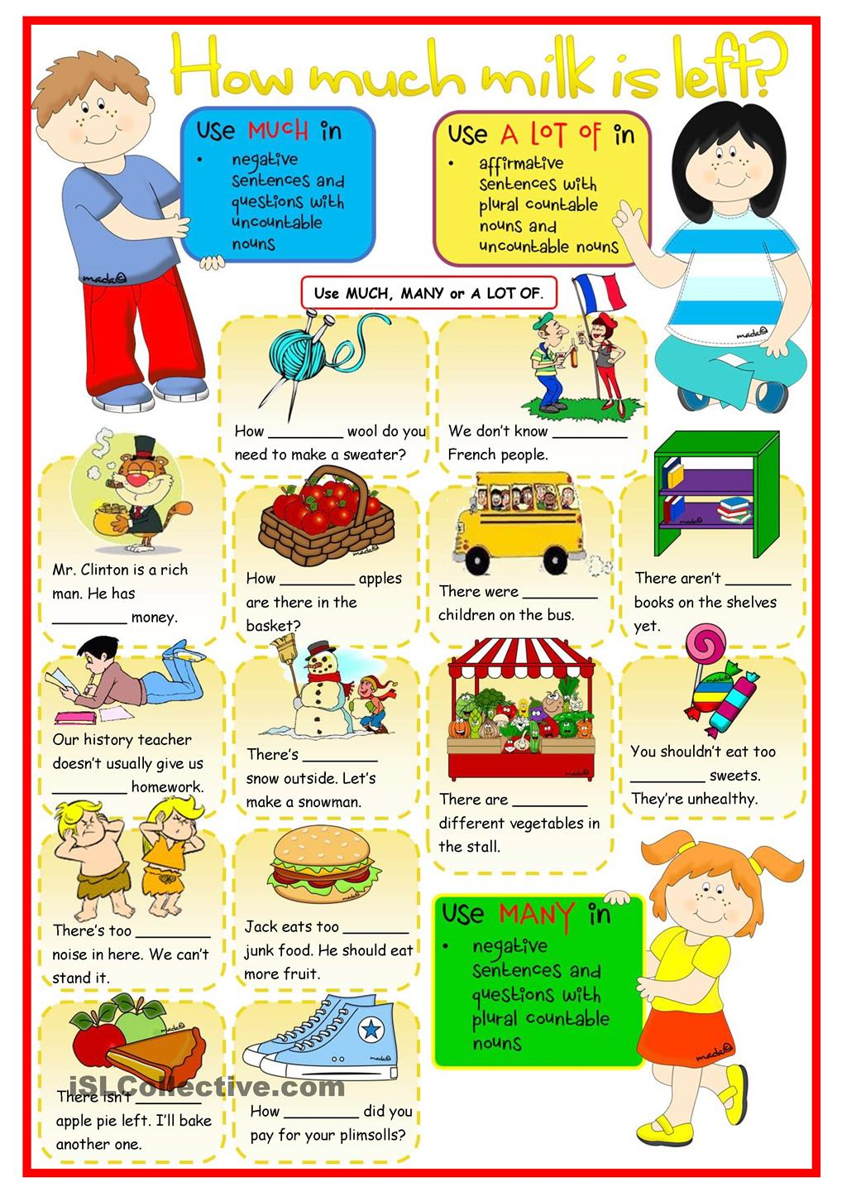
Much, Many, A lot of

- Countable and Uncountable worksheet 1
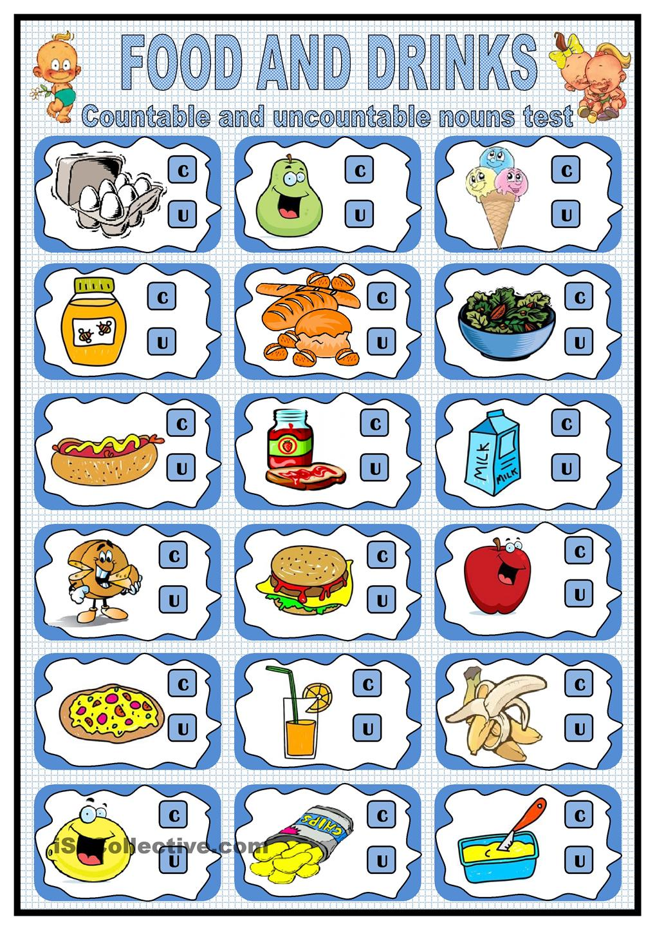

- Countable and Uncountable worksheet 2

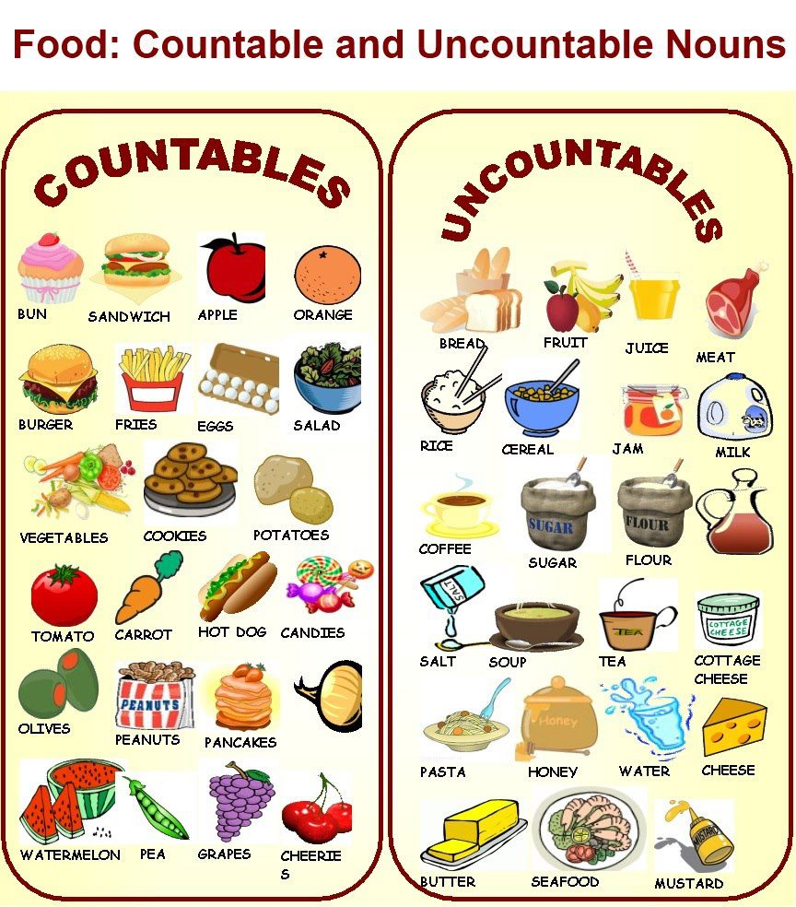

- Example Pictures

