Listening Speaking
Topic: Weather and Forecast

Instructor:  Kim | Students Competency Level  Intermediate | Number of Students:  15 | Lesson Length:  60min
Materials: (List the Names of all materials used in the lesson. Materials must be shown at the end of this document)
- White Board and Markers
- Weather Video
- Forecast Video
- Computer and Projector
- Weather Flash cards:
Cold/Warm/Hot/Snowy/Rainy/Thunder/Cloudy/Sunny/Windy
- Words Of Weather Worksheet
- Weather For A Week Worksheet

Aims: (What students will be able to achieve by participating in the activities of the lesson. (Ss gain or get by doing…)
- Learn vocabularies and expressions about weather
- Interact by sharing their experiences
- Improve speaking and listening skills by role play and discussion with a group
- Build team work and cooperation skills by discussing with a group

Language Skills: (Lists what activities language skills students will be using by participating in the activities of the lesson.)
- Reading: (Where did reading occur in the lesson?)
Worksheet, Note taking
- Listening: (Where did listening occur in the lesson?)
Teacher’s talk, Watching video, Role play, Discussion
- Speaking: (Where did speaking occur in the lesson?)
Answering teacher, Role play, Discussion
- Writing: (Where did writing occur in the lesson?)
Notes, Planning

Language Systems: (Lists what language systems students will be using by participating in the activities of the lesson.)
- Phonology: (sound)
Teacher’s talk, Role play, Discussion
- Function: (situation)
Forecast the weather
- Lexis: (meaning)
Vocabularies about weather
- Grammar: (language structure)
Interrogative sentence, Present and future tense of verb
- Discourse: (communication)
Role play, Discussion

Assumptions: (What students must already be able to do and what concepts must already be mastered before the lesson in order to achieve the aims of the lesson.)
- All Ss understand the basic of role play
- All Ss know there are four seasons and what they are.
- All Ss know there are different cities in the world.
- All Ss know the name of several countries and cities in the world.
- All Ss know different cities in the world have different weather.

Anticipated Errors and Solutions: (What things might go wrong in the lesson and what the solution will be. An SOS activity should also be included)
- If Ss may don’t know the name of countries and cities in the world.
→ Solution: T gives them examples.
- If Ss may not understand.
→ Solution: T shows demonstration.
- If activity finished too soon.
→ Solution: T gives extra questions and let them answer about the topic.
- If activity lasts too long.
→ Solution: T cuts the unnecessary parts.

References:
- How’s the weather? : https://www.youtube.com/watch?v=uwTinezUx-Y
- The world weather forecast : https://www.youtube.com/watch?v=x2ZAYPGz7bs&feature=youtu.be
- Weather image : https://www.google.co.kr/?gfe_rd=cr&ei=Ku8CV-fvKvLC8gfTj5vYCg&gws_rd=ssl#newwindow=1&q=weather+image
- Weather for a week : https://www.google.co.kr/?gfe_rd=cr&ei=Ku8CV-fvKvLC8gfTj5vYCg&gws_rd=ssl#newwindow=1&q=weather+for+a+week

Lead-In or Pre-Task Part (Warm-Up Part to activate and create interest in the lesson.)
Materials: (List the Names of all materials used in the Lead-In or Pre-Task Part of the lesson. Materials must be shown at the end of this document)
None
Time: | Classroom Set Up: | Student Activity and Goals: | Teacher Procedure & Instructions:
1min  5min  5min  1min | Whole  Whole  S-W  Whole | Greet T  Listen to T  Talk and share opinions  Ready to participate | Greet Ss  Tell T’s story about traveling countries having different weather compared to Korea  Ask Ss today’s season/weather,  opinions which season/weather they like or not and ask the reasons.  Let’s have some activities

Pre-Activity or Task Familiarization Part (Presentation Part Presenting the language structure to be covered in the lesson. Prepares students for the communication activity.)
Materials: (List the Names of all materials used in the Pre-Activity or Task Familiarization Part of the lesson. Materials must be shown at the end of this document)
- Weather Video
- Computer and Projector
- Words Of Weather Worksheet
- Weather Flash Cards

Time: | Classroom Set Up: | Student Activity and Goals: | Teacher Procedure & Instructions:
3min  4min  3min | Whole  T-S  T-S | Watch the video  Listen and repeat  Answer T | Introduce the activity and show the video about the weather  Give Ss worksheet(words of weather) and read the words  Remind the words and expression with flash cards

Main Activity or Task Realization Part (Practice to Production Part Teacher lead practice of the language presented and move to communication based more student centered activity)
Materials: (List the Names of all materials used in the Main Activity or Task Realization Part of the lesson. Materials must be shown at the end of this document)
- White Board and Markers
- Forecast Video
- Computer and Projector

Time: | Classroom Set Up: | Student Activity and Goals: | Teacher Procedure & Instructions:
3min  2min  2min  6min  1min  X3  6min  2min | Whole  Group  Group  Group  Whole  Group  Group  Whole | Watch the video  Move into groups  Discuss and pick roles  Prepare for role play  Get ready  Everything below happens 3times  Actively participate  One group at a time  The other groups watch, listen and enjoy  Listen to T | Introduce the role play and show the video about world weather forecast  Divide Ss into groups  Ask Ss to discuss roles and pick roles  (one for an announcer and the others for weather forecasters)  Ask Ss to prepare for role play  T facilitates  Make notes to help their plan for role play  - Make a name for broadcasting station  - Choose the cities and countries where they forecast the weather  - Weather forecaster should describe the street scene and predict the weather for tomorrow.  T gives instruction for each group to come to front and start role play  Everything below happens 3times  T monitors role playing  Gives encouragement to each group and facilitates class feed back to role play group  Give Ss positive feedback and comments

Post Activity or Post Task Part (Wrap-Up Part Close the Lesson on a high note to and consolidate language learned in a communication based activity new situation.)
Materials: (List the Names of all materials used in the Post Activity or Post Task Part of the lesson. Materials must be shown at the end of this document)
- Weather For A Week Worksheet

Time: | Classroom Set Up: | Student Activity and Goals: | Teacher Procedure Instructions:
3min  1min | T-S  T-S | Fill in the blanks with the words Ss learned today  Listen to T | Give Ss the worksheet(weather for a week)  Close by giving Ss positive feedback and improvement

Words Of Weather Worksheet
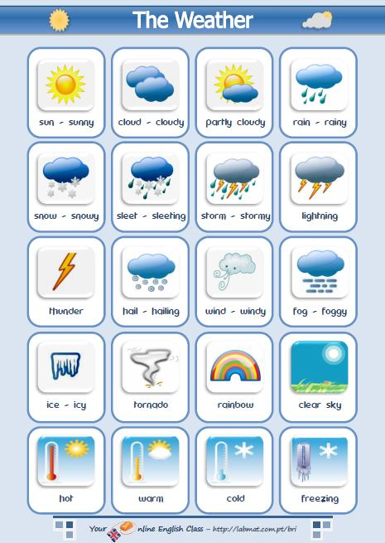
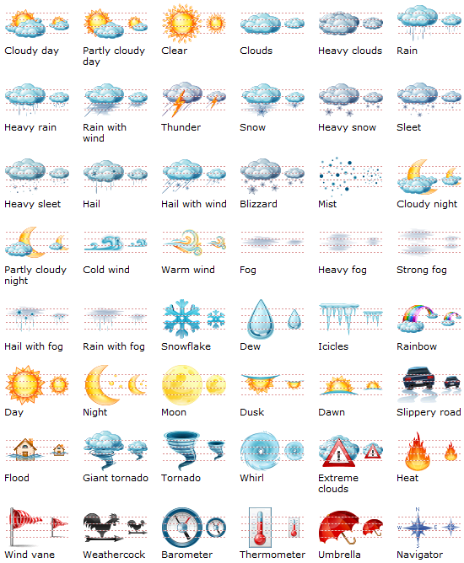

Weather For A Week Worksheet

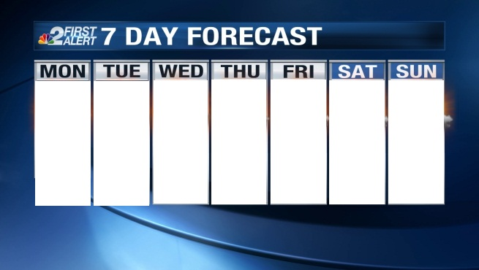

Weather Flash cards:
Cold/Warm/Hot/Snwwy/Rainy/Thunder/Cloudy/Sunny/Windy
