Grammar
Topic: Bad Day
(Language Target: irregular verbs)

Instructor:  Kim | Students Competency Level  Pre-Intermediate | Number of Students:  12 | Lesson Length:  54min
Materials: (List the Names of all materials used in the lesson. Materials must be shown at the end of this document)
- Bad Day Video
- Bad Day PPT
Bad Day Script
Bad Day Script Marked Irregular Verbs
My Friend’s Bad Day Example
- Computer and Projector
- Irregular Verbs List
- My Friend’s Bad Day Worksheet
- Activity Pictures
At Home
At Work
At a Restaurant
In the mountain
In the Airplane
In the Amusement Park
- Bingo Worksheet
Aims: (What students will be able to achieve by participating in the activities of the lesson. (Ss gain or get by doing…)
- Improve listening skills by listening skills by listening to T’s story, Ss’s stories, video, drilling and presentation
- Improve speaking skills by answering T, sharing Ss’s stories, drilling, and working on presentation.
- Improve reading skills by reading the sentences on the PPT and T’s note
- Improve grammar skills about irregular verbs by T using irregular verbs, T responding and rephrasing Ss thoughts, drilling and writing about my friend’s bad day.

Language Skills: (Lists what activities language skills students will be using by participating in the activities of the lesson.)
- Reading: (Where did reading occur in the lesson?)
Drilling sentences on the PPT, T’s note
- Listening: (Where did listening occur in the lesson?)
T’s talk, Ss’s talk, Watching video, Presentation
- Speaking: (Where did speaking occur in the lesson?)
Answering T, Sharing Ss’s stories, Drilling, Presentation
- Writing: (Where did writing occur in the lesson?)
Writing sentences about bad day

Language Systems: (Lists what language systems students will be using by participating in the activities of the lesson.)
- Phonology: (sound)
T’s talk, Ss’s talk, Drilling, Watching video, Presentation
- Function: (situation)
Bad Day
- Lexis: (meaning)
Irregular verbs with a bad day story
- Grammar: (language structure)
- Irregular verbs
- Discourse: (communication)
T-S-T, Sharing T’s and Ss’s stories, Drilling, Presentation

Assumptions: (What students must already be able to do and what concepts must already be mastered before the lesson in order to achieve the aims of the lesson.)
- All Ss know there are several types of verb tense.
- All Ss know there are regular and irregular verbs.
- All Ss can talk about their bad day.

Anticipated Errors and Solutions: (What things might go wrong in the lesson and what the solution will be. An SOS activity should also be included)
- If Ss may don’t think a bad day
→ Solution: T gives them a situation(on vacation, at school, etc)
- If Ss may not understand.
→ Solution: T shows demonstration.
- If activity finished too soon.
→ Solution: T gives extra questions or let Ss make more sentences.
- If activity lasts too long.
→ Solution: T cuts the unnecessary parts.

References:
- Bad Day Video : https://www.youtube.com/watch?v=DZRQaLfWKW4
- Irregular Verbs List :https://www.google.co.kr/?gfe_rd=cr&ei=NVkaV4qzMMq6mgWizpXQBw&gws_rd=ssl#newwindow=1&q=irregular+verbs+list
- Activity Pictures
At Home :https://www.google.co.kr/search?q=home&newwindow=1&biw=1366&bih=643&source=lnms&tbm=isch&sa=X&ved=0ahUKEwj0x-vIhaPMAhUJjZQKHbtYBLoQ_AUIBigB
At Work :https://www.google.co.kr/search?q=home&newwindow=1&biw=1366&bih=643&source=lnms&tbm=isch&sa=X&ved=0ahUKEwj0x-vIhaPMAhUJjZQKHbtYBLoQ_AUIBigB#newwindow=1&tbm=isch&q=work
At a Restaurant
:https://www.google.co.kr/search?q=home&newwindow=1&biw=1366&bih=643&source=lnms&tbm=isch&sa=X&ved=0ahUKEwj0x-v IhaPMAhUJjZQKHbtYBLoQ_AUIBigB#newwindow=1&tbm=isch&q=restaurant
In the mountain
:https://www.google.co.kr/search?q=home&newwindow=1&biw=1366&bih=643&source=lnms&tbm=isch&sa=X&ved=0ahUKEwj0x-vIhaPMAhUJjZQKHbtYBLoQ_AUIBigB#newwindow=1&tbm=isch&q=mountain
In the Airplane
:https://www.google.co.kr/search?q=home&newwindow=1&biw=1366&bih=643&source=lnms&tbm=isch&sa=X&ved=0ahUKEwj0x-vIhaPMAhUJjZQKHbtYBLoQ_AUIBigB#newwindow=1&tbm=isch&q=airplane
In the Amusement Park
:https://www.google.co.kr/search?q=home&newwindow=1&biw=1366&bih=643&source=lnms&tbm=isch&sa=X&ved=0ahUKEwj0x-vIhaPMAh UJjZQKHbtYBLoQ_AUIBigB#newwindow=1&tbm=isch&q=amusement+park

Lead-In or Pre-Task Part (Warm-Up Part to activate and create interest in the lesson.)
Materials: (List the Names of all materials used in the Lead-In or Pre-Task Part of the lesson. Materials must be shown at the end of this document)
- None

Time: | Classroom Set Up: | Student Activity and Goals: | Teacher Procedure & Instructions:
1min  3min  3min | Whole  Whole  S-W | Greet T  Listen to T, become aware of target language structure.  Share Ss’s story | Greet Ss  Tell T’s story about a bad day  Ask Ss their story about their bad day.  T rephrases and responds using irregular verbs.  Let’s look at how you have a bad day.

Pre-Activity or Task Familiarization Part (Presentation Part Presenting the language structure to be covered in the lesson. Prepares students for the communication activity.)
Materials: (List the Names of all materials used in the Pre-Activity or Task Familiarization Part of the lesson. Materials must be shown at the end of this document)
- Bad Day Video
- Bad Day PPT
Bad Day Script
Bad Day Script Marked Irregular Verbs
My Friend’s Bad Day Example
- Computer and Projector
- Irregular Verbs List
- My Friend’s Bad Day Worksheet

Time: | Classroom Set Up: | Student Activity and Goals: | Teacher Procedure & Instructions:
6min  2min  8min  5min | Whole  T-S  W  Pairs  W-S | Watch the video  Listen, read, speak and drill to learn and become familiar with irregular verbs.  Listen to T  Receive Irregular Verbs List and My Friend’s Bad Day Worksheet  Start to share their bad day with partners and make 5 sentences using irregular verbs  Present their partner’s story to class | Introduce Bad Day Video and show it to Ss  Show the sentences on video with PPT slide.  Do drilling with Ss.  T introduces what we do with an example on PPT.  Give Irregular Verbs List and My Friend’s Bad Day Worksheet  Put Ss in pairs  Ask Ss to share their bad day with their partner and to write 5 sentences using irregular verbs  Ask Ss to present their partner’s story to class

Main Activity or Task Realization Part (Practice to Production Part Teacher lead practice of the language presented and move to communication based more student centered activity)
Materials: (List the Names of all materials used in the Main Activity or Task Realization Part of the lesson. Materials must be shown at the end of this document)
- Activity Pictures:
At Home
At Work
At a Restaurant
In the mountain
In the Airplane
In the Amusement Park
- Computer and Projector

Time: | Classroom Set Up: | Student Activity and Goals: | Teacher Procedure & Instructions:
3min  5min  X6  1min  1min  1min | Whole  Pairs  Pairs  W-Pairs  T-Pairs  T-Pairs | Listen to T and answer what can be happened each place  Create a bad day story related to the pictures using irregular verbs in pairs  Everything below happens 6 times  Present My Bad Day story to class  Listen to T  Listen to T | Show Activity Pictures and ask Ss what can be happened each place  Introduce My Bad Day Activity with the pictures  Put Ss in pairs, pick the picture and create a bad day story related to the pictures using irregular verbs.  Ask pairs to present My Bad Day to class  T monitors, gives encouragement to Ss and facilitates class feed back  Give Ss positive feedback and comments

Post Activity or Post Task Part (Wrap-Up Part Close the Lesson on a high note to and consolidate language learned in a communication based activity new situation.)
Materials: (List the Names of all materials used in the Post Activity or Post Task Part of the lesson. Materials must be shown at the end of this document)
- Irregular Verbs List
- Bingo Worksheet

Time: | Classroom Set Up: | Student Activity and Goals: | Teacher Procedure Instructions:
2min  7min  1min | Whole  Whole  T-S | Listen to T and receive the Bingo Worksheet  Fill the grid in the past form of irregular verbs from the Irregular Verbs List that T gave Ss in the class, in any order.  Do the Bingo activity  Listen to T | Introduce ‘Bingo’ rules and hand out Bingo Worksheet  Ask Ss to fill the grid in the past form of irregular verbs from the Irregular Verbs List that T gave Ss in the class, in any order.  First student will call out the present tense of an irregular verb, and others will mark the past tense if they have it on their grid.  Continue one by one until a S yells “Bingo!”  Yell out “Bingo!” when a S has one horizontal, one vertical, and one diagonal line checked off.  The first S to get three lines(horizontal, vertical, and diagonal lines) wins.  Congratulate the winner and thank all Ss for participating in the lesson.  Close by giving Ss positive feedback about their work done.

Irregular Verbs List
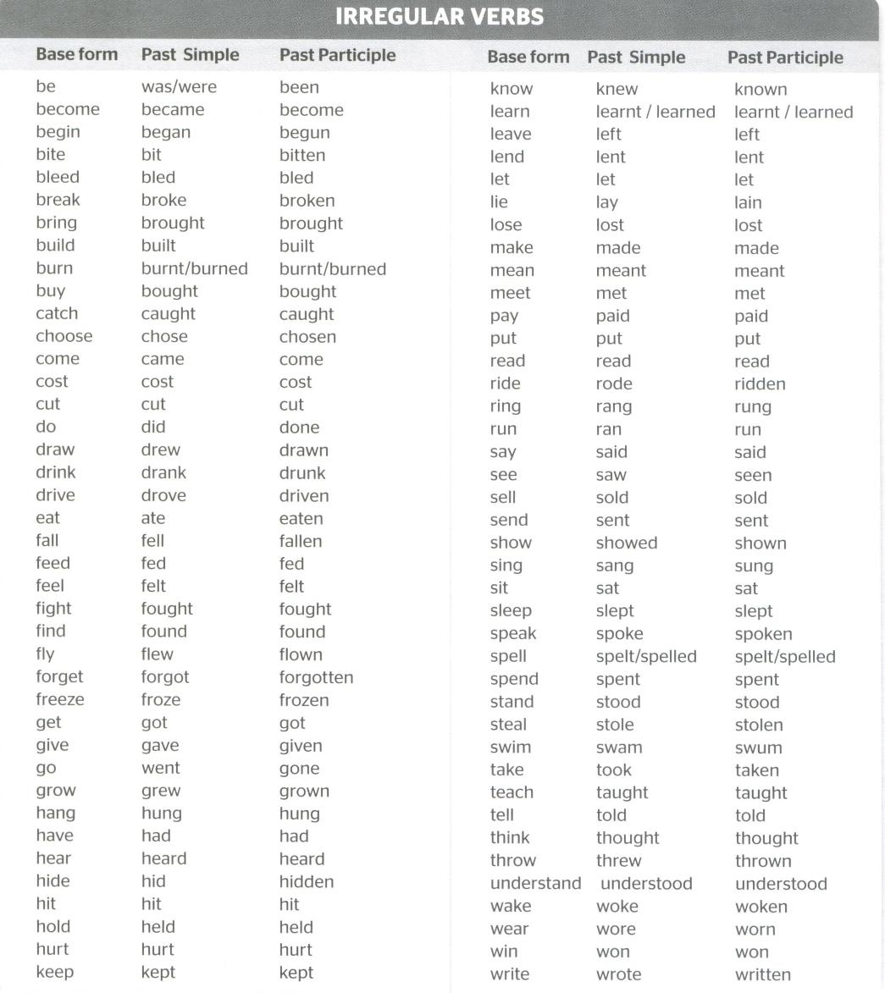
Bad Day PPT

Bad Day Script Bad Day Script Marked Irregular Verbs
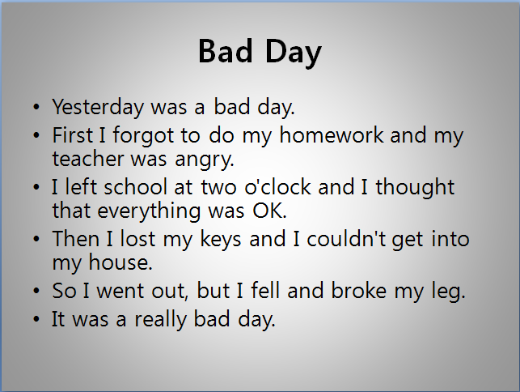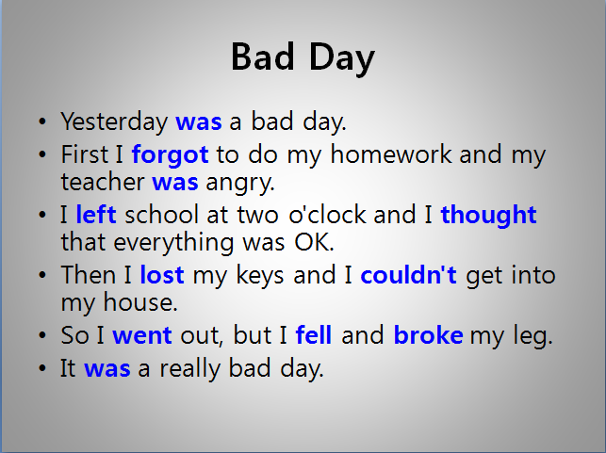
My Friend’s Bad Day Example
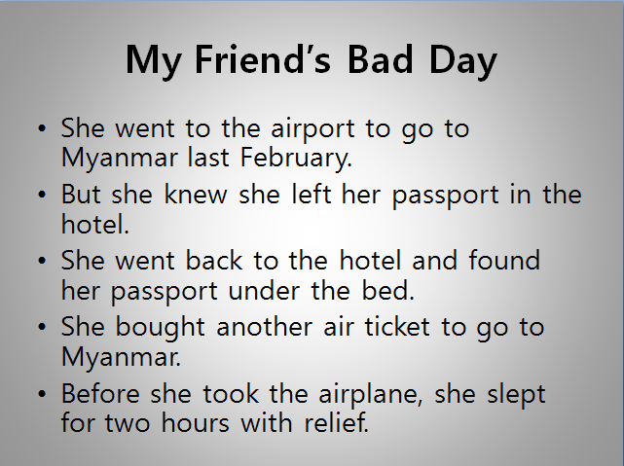

Activity Pictures

At Home At Work
At a Restaurant In the Mountain
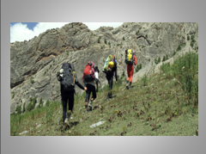
In the Airplane In the Amusement Park

My Friend’s Bad Day Worksheet
Write my friend’s bad day using irregular verbs(making 5 sentences).

Bingo Worksheet
1.Fill the grid in the past form of irregular verbs from the Irregular Verbs List that teacher gave you in the class, in any order.
2.First student will call out the present tense of an irregular verb, and others will mark the past tense if they have it on their grid.
3.Continue one by one until a student yells “Bingo!”
4.Yell out “Bingo!” when you have one horizontal, one vertical, and one diagonal line checked off.
5.The first student to get three lines(horizontal, vertical, and diagonal lines) wins.

