Listening Speaking Reading Grammar Writing
Topic: Making a Lively Story

Instructor:  Jessica | Students Competency Level  Pre- Intermediate | Number of Students:  13 | Lesson Length:  51 min
Materials: (List the Names of all materials used in the lesson. Materials must be shown at the end of this document)

- Whiteboard and Markers
- <The Frog Prince> Story Pictures:
- The Princess playing with the ball
- Frog appears
- Princess runs away
- Princess takes the frog in
- The frog becomes a prince
- The prince and the princess live happily ever after
- Making a Lively Story Worksheet
- Drilling Wall Chart 1 : Subject + Verb + Adverb
- Drilling Wall Chart 2 : Subject + Verb + Object + Adverb
- Adverb Check-Up Worksheet
- Verb List for <Act Out Activity>
- Adverb List for <Act Out Activity>
- Two containers
- Verb
- Adverb
Aims: (What students will be able to achieve by participating in the activities of the lesson. (Ss gain or get by doing…)

- Improve Ss listening skills by listening to <The Frog Prince> story, Ss stories, drilling, playing a game, and presentations.
- Improve Ss speaking skills by answering T, Ss presentations, discussing ideas, drilling, and playing game.
- Improve Ss writing skills by filling out the worksheet and making a story.
- Improve Ss grammar skills about adverbs by T using adverbs, playing game, T rephrasing Ss answers, drilling, and writing.

Language Skills: (Lists what activities language skills students will be using by participating in the activities of the lesson.)
- Reading: (Where did reading occur in the lesson?)
Drilling wall chart, writing sentences.
- Listening: (Where did listening occur in the lesson?)
T speaking, Ss speaking, playing game
- Speaking: (Where did speaking occur in the lesson?)
Ss presentation, playing game, answering T
- Writing: (Where did writing occur in the lesson?)
Writing the story, filling out the worksheet

Language Systems: (Lists what language systems students will be using by participating in the activities of the lesson.)
- Phonology: (sound)
T speaking, Ss speaking, drilling, playing game
- Function: (situation)
Respecting Ss
- Lexis: (meaning)

- Grammar: (language structure)
Adverbs
- Discourse: (communication)
Ss presentations, playing game, drilling, discussing in groups

Assumptions: (What students must already be able to do and what concepts must already be mastered before the lesson in order to achieve the aims of the lesson.)
- All Ss know simple verbs and subject verb order.
- All Ss can talk about action.
- All Ss can understand adverbs.
Anticipated Errors and Solutions: (What things might go wrong in the lesson and what the solution will be. An SOS activity should also be included)
- If Ss do not understand how to make an adverb. Tell the Ss about the simple adverbs that add –ly and give examples.
- If Ss have trouble with making a lively story. Give them examples by showing actions.
References:
- educationworld.com
- Youtube

Lead-In or Pre-Task Part (Warm-Up Part to activate and create interest in the lesson.)
Materials: (List the Names of all materials used in the Lead-In or Pre-Task Part of the lesson. Materials must be shown at the end of this document)

- <The Frog Prince> Story Pictures:
- The Princess playing with the ball
- Frog appears
- Princess runs away
- Princess takes the frog in
- The frog becomes a prince
- The prince and the princess live happily ever after

Time: | Classroom Set Up: | Student Activity and Goals: | Teacher Procedure & Instructions:
1 min  5 min  3 min | Whole  Whole  Whole | Ss greet the T  Ss listen to T  Ss listen and answer | Greet Ss  T show tells <The Frog Prince> story without the adverbs. Then Tells the story again with the adverbs.  Ask Ss the difference between the two stories and how they feel about it.  Let’s find out what the added words tell us.

Pre-Activity or Task Familiarization Part (Presentation Part Presenting the language structure to be covered in the lesson. Prepares students for the communication activity.)
Materials: (List the Names of all materials used in the Pre-Activity or Task Familiarization Part of the lesson. Materials must be shown at the end of this document)

- Whiteboard and Markers
- Drilling Wall Chart 1 : Subject + Verb + Adverb
- Drilling Wall Chart 2 : Subject + Verb + Object + Adverb
- Verb List for <Act Out Activity>
- Adverb List for <Act Out Activity>
- Two containers
- Verb
- Adverb

Time: | Classroom Set Up: | Student Activity and Goals: | Teacher Procedure & Instructions:
5 min  4 min  8 min | W -Ss  Whole  S-W | Ss read, listen, speak, and drill to learn and become familiar with adverbs.  Ss listen to T  A student performs and the rest tries to guess the words. Ss drill after the T. | Put drilling wall chart on the whiteboard.  Do drilling with students.  T introduces acting out activity and shows how it is done.  Draw out one word from each container that is labeled [Verb] and [Adverb]. Act out the two words without saying anything. Let the other students guess what the words are.  T chooses a student to perform first. Drill each time the students get it right  After everyone got a chance to act out, proceed to the main activity.

Main Activity or Task Realization Part (Practice to Production Part Teacher lead practice of the language presented and move to communication based more student centered activity)
Materials: (List the Names of all materials used in the Main Activity or Task Realization Part of the lesson. Materials must be shown at the end of this document)
- Making a Lively Story Worksheet
- Adverb Check-Up Worksheet

Time: | Classroom Set Up: | Student Activity and Goals: | Teacher Procedure & Instructions:
2 min  8 min  10 min | Whole  Group  Group | Ss listen. They get into groups and discuss how to make the story.  Ss discuss and make a story.  Ss present their story in groups. | T introduces the activity <Making a lively Story> and shows activity pictures. Puts the Ss into 3 groups and hand out activity pictures. Tell the Ss to make a story with adverbs.  T gives Ss time to do activity in their groups.  Ask each group to present their story. Praise and give feedback.

Post Activity or Post Task Part (Wrap-Up Part Close the Lesson on a high note to and consolidate language learned in a communication based activity new situation.)
Materials: (List the Names of all materials used in the Post Activity or Post Task Part of the lesson. Materials must be shown at the end of this document)
- Making a Lively Story Worksheet

Time: | Classroom Set Up: | Student Activity and Goals: | Teacher Procedure Instructions:
3 min  1 min  1 min | W-S  Whole  Whole | Ss listen and present  Ss listen  Ss listen and say goodbye. | Ask the Ss which story they liked best and why.  Praise the Ss for their good work  Dismiss class.

<The Frog Prince> Story Pictures

- The Princess playing with the ball
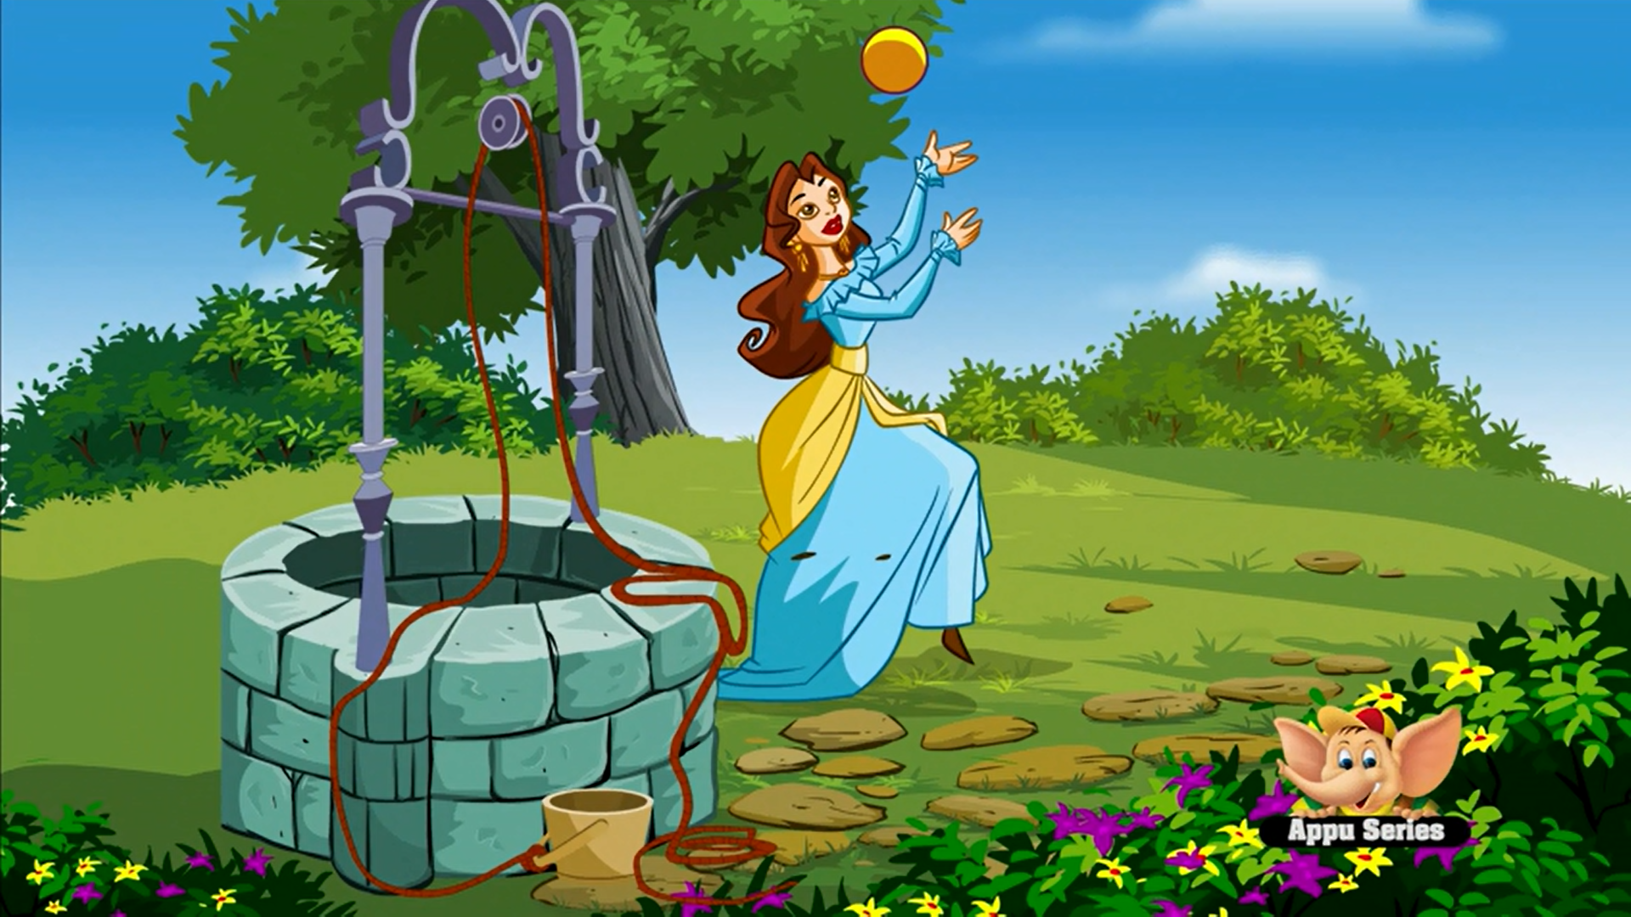

- Frog appears
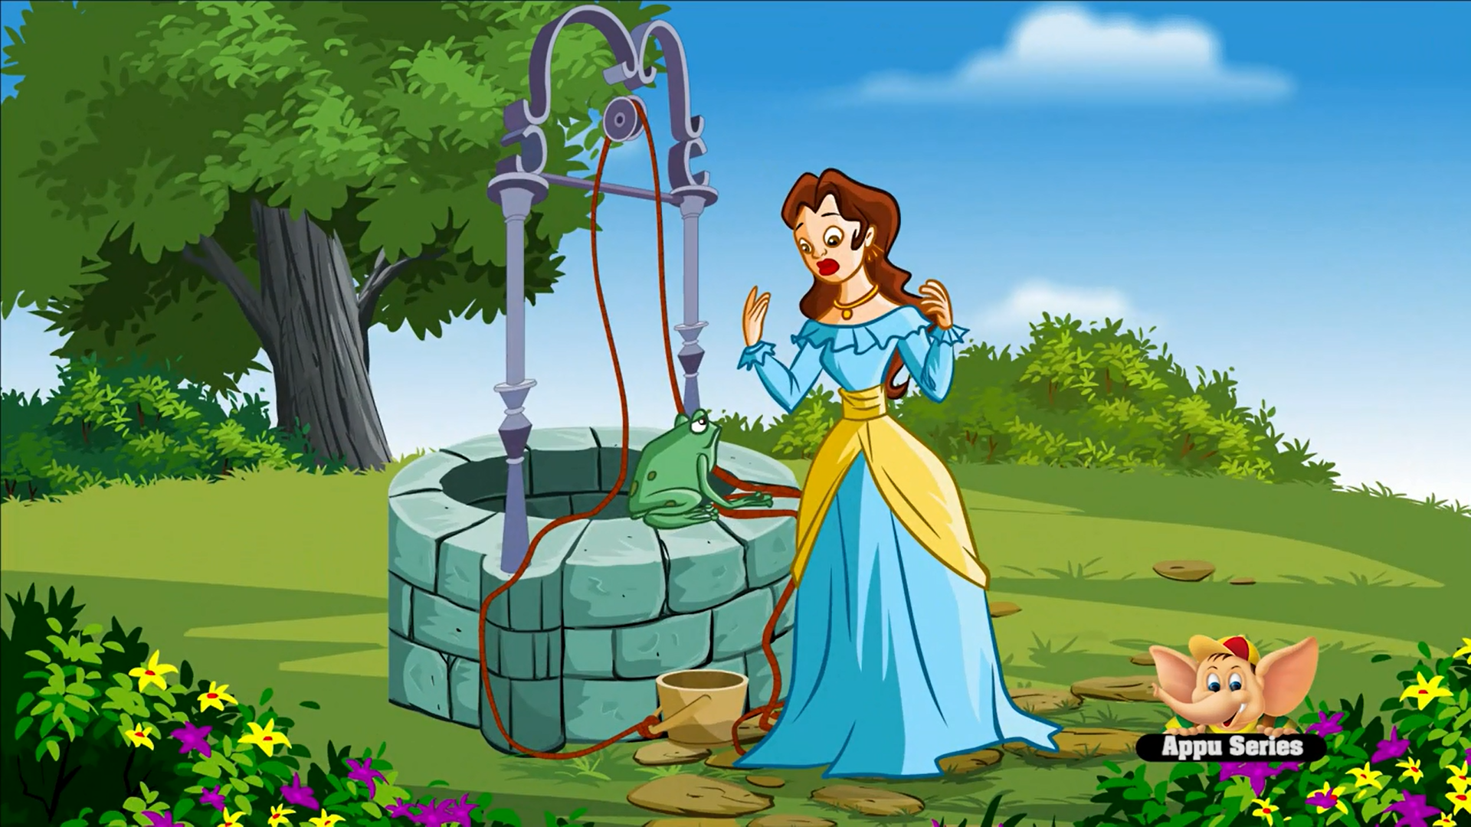

- Princess runs away
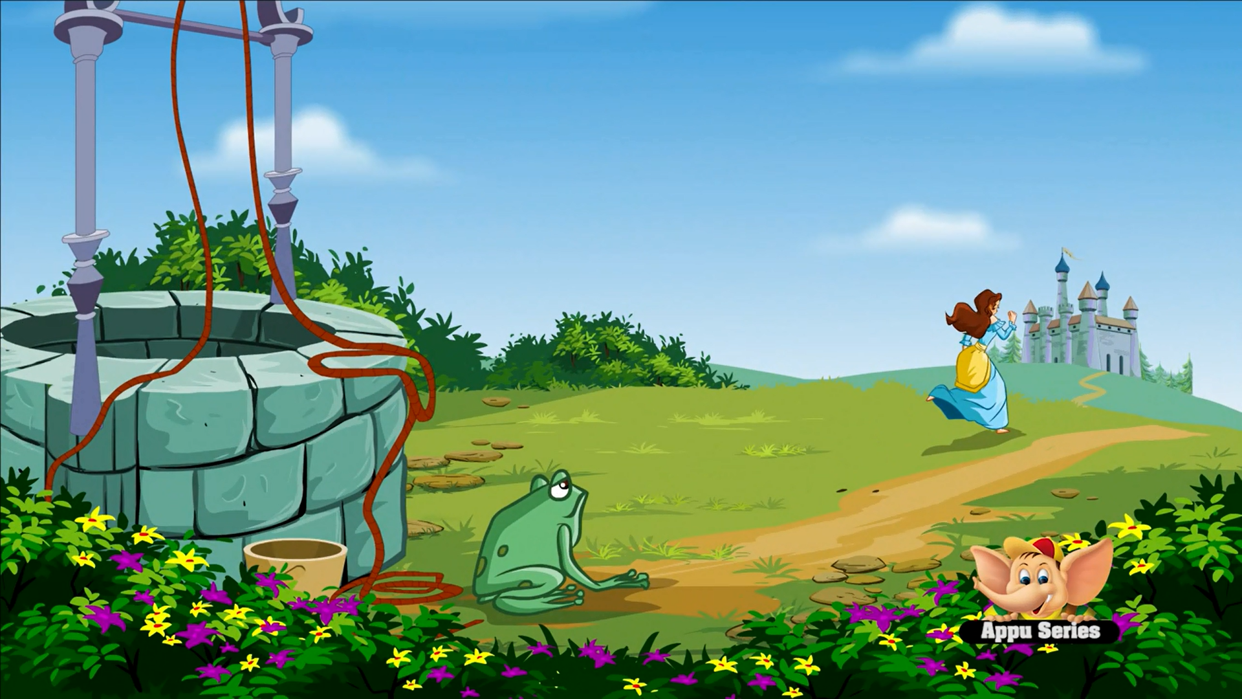

- Princess takes the frog in
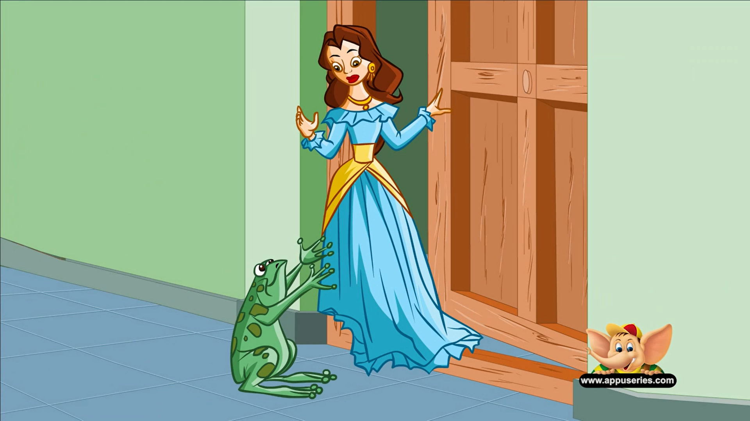

- The frog becomes a prince
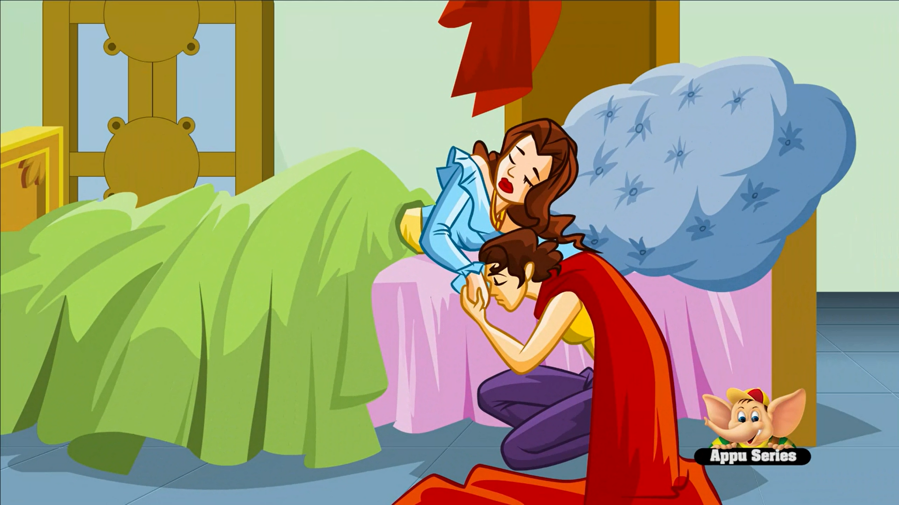

- The prince and the princess live happily ever after
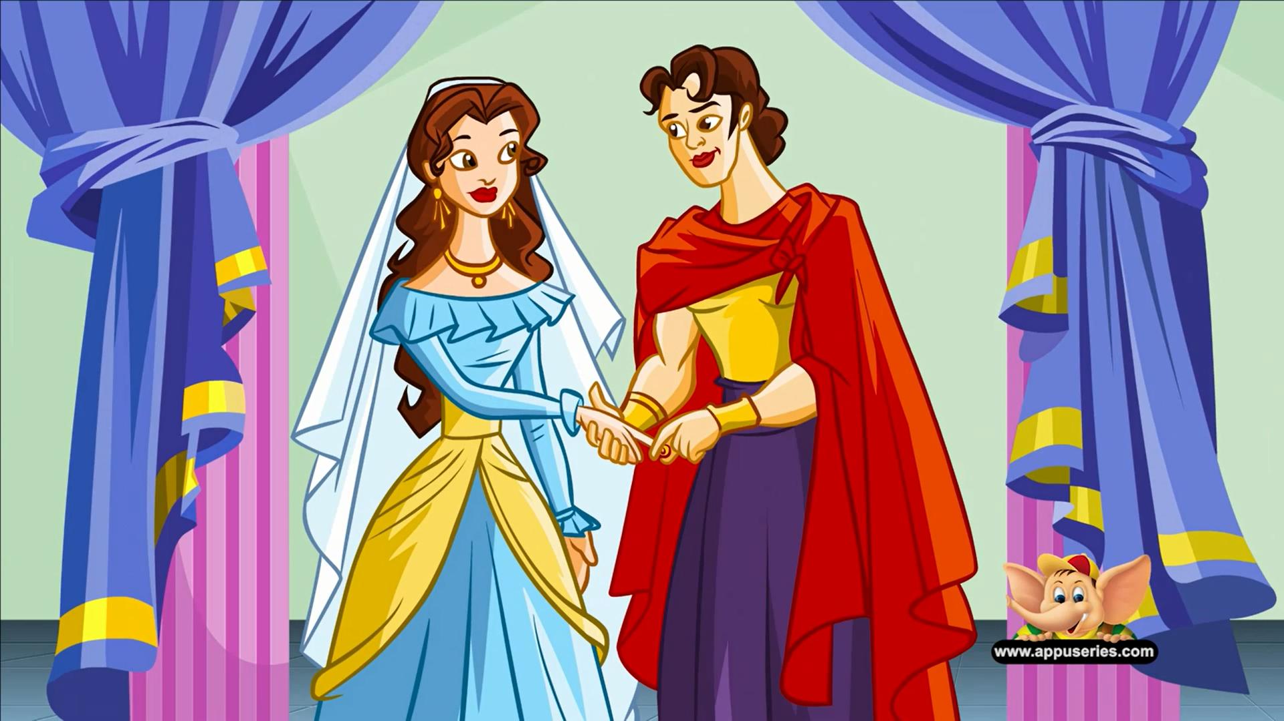

Making a Lively Story Worksheet

<The Christmas Present>

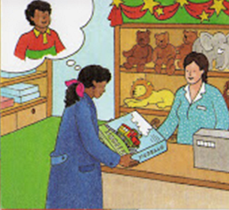Sarah went to the toy shop  and bought a choo-choo  train. ‘I am sure that my son,Felix, will love this for christmas!’, thought Sarah happily. | 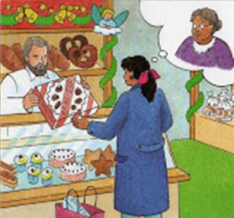 | 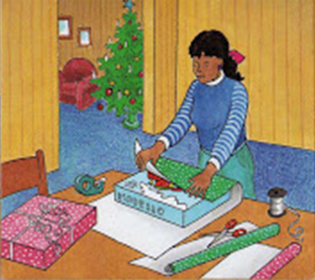
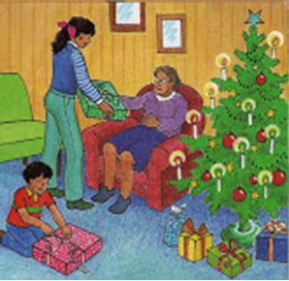 | 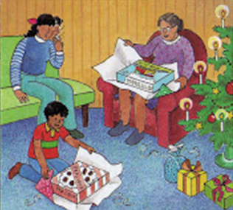 | 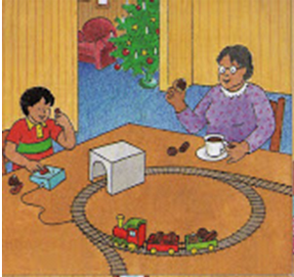
- Drilling Chart 1 : Subject + Verb + Adverb
The princess cried.

How did the princess cry?

The princess | cried | sadly
 |  | happily
 |  | ?

The frog asked the princess.

How did the frog ask the princess?

The frog | asked | the princess | curiously
 |  |  | anxiously
 |  |  | ?

- Drilling Chart 2 : Subject + Verb + Object + Adverb

Adverb Check-Up Worksheet

< List of Adverbs>
accidentally angrily anxiously badly blindly bravely briefly busily calmly carelessly cautiously doubtfully easily elegantly enthusiastically
courageously fiercely foolishly frantically gently gladly gracefully greedily happily hastily hungrily innocently inquisitively lazily loudly madly merrily mysteriously neatly nervously noisily obnoxiously politely quickly quietly rapidly recklessly reluctantly rudely sadly selfishly seriously shyly silently sleepily slowly solemnly speedily suspiciously swiftly thoughtfully victoriously violently wearily wildly

Rewrite the sentences adding the given adverbs given above

- The baby is sleeping. ______________________________
- My grandmother walks. ______________________________
- Nora played the piano. ______________________________
- Jason can play the drums. ______________________________

Explain four things you did today with adverbs.

- _______________________________________
- _______________________________________
- _______________________________________
- _______________________________________

Verb List for <Act Out Activity>

Cry | Drive | Knock
Cut | Open | Laugh
Sleep | Wave | Write
Kick | Dig | Drink
Throw | Think | Eat
Listen | Kiss | Study

Adverb List for <Act Out Activity>

Cheerfully | Happily | Sadly
Rapidly | Angrily | Lazily
Badly | Noisily | Shyly
Sleepily | Thoughtfully | Quickly
Slowly | Silently | Gently
Quietly | Loudly | Elegantly

