Listening Speaking Reading Grammar Writing
Topic: The Hidden Catch!
(Language Target: Preposition of Location)

Instructor:  Sarah | Students Competency Level  Pre Intermediate level | Number of Students: 14 | Lesson Length:  59 Mins
Materials: (List the Names of all materials used in the lesson. Materials must be shown at the end of this document)
- Board and Markers
- The Hidden Catch Pictures:
The Cleaned Table, Before & After.
- Activity Pictures of Under the Table.
On the Box.
Next to the Box.
Behind the Box.

Aims:(what students will be able to achieve by participating in the activities of the lesson.(See gain or get by doing…)
- Improve Ss grammar skills by having Ss learn preposition of place.
- Increase Ss interest, and participate with fun in an English communication activity by sharing stories of teacher and students.
- Improve Ss listening skills by answering T, Ss presentation, responding to teacher, drilling.
- Improve Ss writing skills by writing work sheet.
- Improve Ss interaction and communication skills by having discussion in a group and planning the ideas.

Language Skills: (Lists what activities language skills students will be using by participating in the activities of the lesson.)
- Reading: (Where did reading occur in the lesson?)
Drilling wall chart, writing sentence.
- Listening:
Teacher talk, Ss talk, Ss presentation.
- Speaking:
Small group discussion, answering teacher, Ss presentation.
- Writing: (Where did writing occur in the lesson?)
Notes, Work sheet

Language Systems: (Lists what language systems students will be using by participating in the activities of the lesson.)
- Phonology: (sound)
Teacher talk, Ss talk, group presentation.
- Function: (situation)
Introduction, respect
- Lexis: (meaning)
- On, Under, In front of, Behind, Next to.
- Grammar: (language structure)
Preposition of Location.
- Discourse: (communication)
Ss presentations, drilling, responding the teacher

Assumptions: (What students must already be able to do and what concepts must already be mastered before the lesson in order to achieve the aims of the lesson.)

- All Ss know about on, under, in front of, behind, next to.
- All Ss can talk about proper location of things.
- All Ss enjoy how to describe the location of things.

Anticipated Errors and Solutions: (What things might go wrong in the lesson and what the solution will be. An SOS activity should also be included)
- If Ss may not have many ideas. -> Solution: T gives them little examples.
- If activity finished too soon -> Solution: T makes suggestions and shares ideas.
- If Ss may not understand -> Solution: T shows demonstration.
- If certain Ss are shy -> Solution: T encourage them, gives positive feedback, and changes roles for them.
- If Ss do not follow drilling - > Solution: T repeat several times and encourage Ss.

References:

Lead-In or Pre-Task Part (Warm-Up Part to activate and create interest in the lesson.)
Materials: (List the Names of all materials used in the Lead-In or Pre-Task Part of the lesson. Materials must be shown at the end of this document)
- Board and Markers
- The Hidden Catch Pictures:
The Cleaned Table, Before & After.
Time: | Classroom Set Up: | Student Activity and Goals: | Teacher Procedure & Instructions:
1min  2mins  1min  2mins  1min | W  S - W  S - W  S - W  W | Ss greet the teacher.  Ss answer about T’s question.  Ss see and identify differences between two pictures  Ss answer about T’s question.  Ready to participate. | Greet Ss  “Hi guys, my name is Sarah and I am your teacher today.”  Ask Ss “Do you like hidden pictures?”  “Have you ever played it?”  “ In my case, I love hidden pictures so much!”  Show Ss the hidden catch pictures “The Cleaned Table.” and give Ss time to identify.  Ask Ss to find the differences between two pictures.  “What is missing? and what are the differences in the pictures?”  “Where is the trash can?”  Now Let’s see how those things are located differently.

Pre-Activity or Task Familiarization Part (Presentation Part Presenting the language structure to be covered in the lesson. Prepares students for the communication activity.)
Materials: (List the Names of all materials used in the Pre-Activity or Task Familiarization Part of the lesson. Materials must be shown at the end of this document)
- Activity Pictures of Under the Table.
On the Box.
Next to the Box.
Behind the Box.

Time: | Classroom Set Up: | Student Activity and Goals: | Teacher Procedure & Instructions:
5mins  3mins  2mins  2mins  X4 | W  W  W  Individual  X4 | Ss listen, speak and drill to learn or be familiar with prepositions.  Ss listen carefully what T introduces and repeat after T.  Ss listen again and repeat what T says.  S listen and repeat after T.  Everything above happens four times. | Put pictures on the white board  Do drilling with Ss. Do not forget to write drilling sentence on the board.  T says “Listen carefully.”  “Listen carefully and repeat after me.”  Ask Ss to listen whole sentence and repeat after me.  Point out one of students and ask S to listen and repeat after T.  Everything above happens four times.

Main Activity or Task Realization Part (Practice to Production Part Teacher lead practice of the language presented and move to communication based more student centered activity)
Materials: (List the Names of all materials used in the Main Activity or Task Realization Part of the lesson. Materials must be shown at the end of this document)
- 4 Types of Paper Named:
Top Banana (3 papers)
Tough Cookie (3 papers)
Big Cheese (4 papers)
Egghead (4 papers)
Time: | Classroom Set Up: | Student Activity and Goals: | Teacher Procedure & Instructions:
2mins  1min  2mins  1min  8mins  8mins | G  G  G  G  G  G | Listen carefully what T introduces and observe T’s demonstration well.  Ss pick the paper.  Ss move into group.  Ss receive the papers.  Now Ss begin to make their own hidden catch pictures.  Ss share their drawings and talk about the differences between pictures. | T introduce the drawing activity by making Ss own hidden catch pictures in group.  Provide 14 pieces of paper.  Ask Ss to gather into each group.  Provide papers to draw The Hidden Catch pictures. Two papers for each group.  Ask Ss to discuss with group members and drawing together.Tell Ss to use drilling situation which is related with prepositions.  Ask Ss to share their drawings and present to class.

Post Activity or Post Task Part (Wrap-Up Part Close the Lesson on a high note to and consolidate language learned in a communication based activity new situation.)
Materials: (List the Names of all materials used in the Post Activity or Post Task Part of the lesson. Materials must be shown at the end of this document)
- Board and Markers

Time: | Classroom Set Up: | Student Activity and Goals: | Teacher Procedure Instructions:
2mins  1min  2min  3mins  2mins  1min  1min | W  S - W  W  W  W  W  W | Ss listen what T says, respond to teacher.  Ss respond.  Ss listen and respond.  Ss find their item and speak out sentence.  Ss respond and have a seat.  Ss take note.  Ss say good bye | Tell Ss just pick anything from what they have. For example, pencil, eraser, ball pen, pen, ruler etc.  Ask Ss to give the item they picked to the right person who sits beside.  Ask Ss to put partner’s item in any place in the class but somewhere not hard to find.  Now, ask Ss to find their item and make sentence with 8 words and speak it out using preposition of location.  For example,  “ I found my eraser on the yellow table!”  Give Ss time warning and after 5 Ss found their items let Ss have a seat.  Homework: ‘Describe your room using 5 preposition of location.  T dismisses Ss and thank Ss for their active participation.

Pictures of Pre-Activity
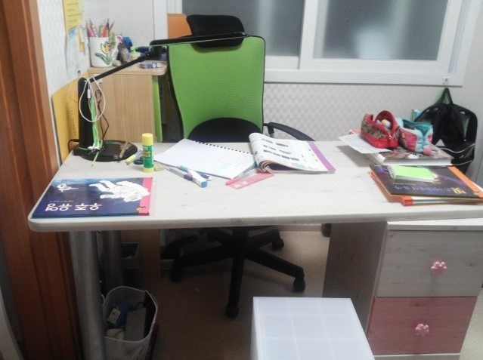

The Cleaned Table (Before)
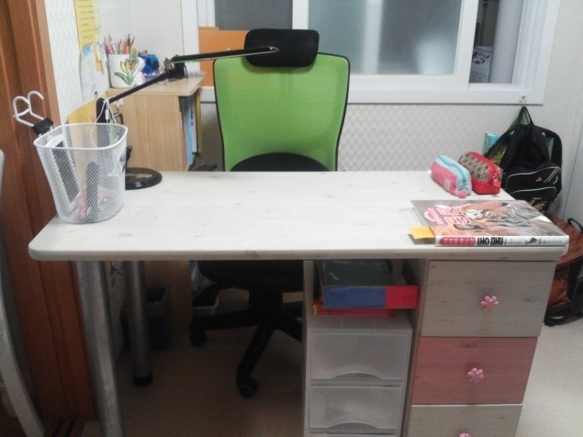

The Cleaned Table (After)

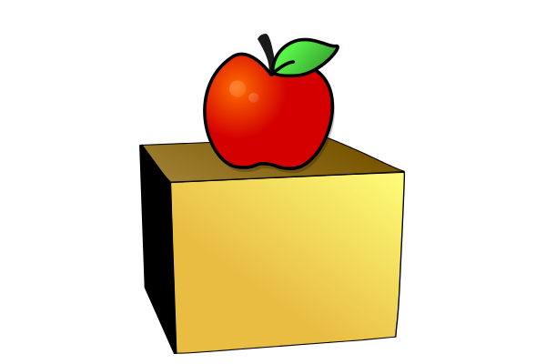
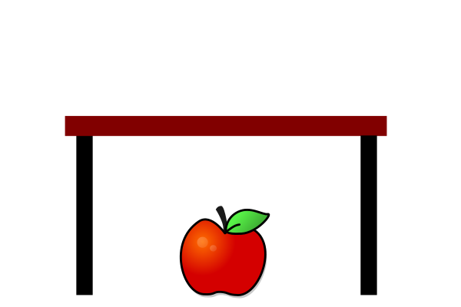

Under the Table On the Box

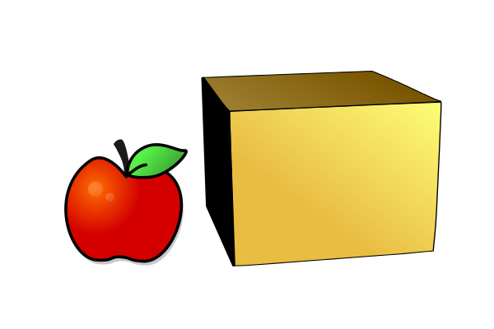
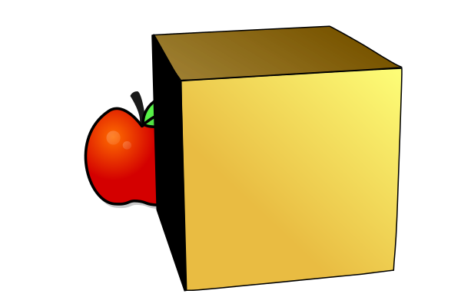

Next to the Box Behind the Box

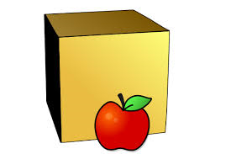

In Front of the Box

Top  Banana | Egghead | Tough  Cookie | Big  Cheese
Top  Banana | Egghead | Tough  Cookie | Big  Cheese
Top  Banana | Egghead | Tough  Cookie | Big  Cheese
 | Egghead |  | Big  Cheese

