Listening – Speaking X Reading Grammar Writing
Topic: Plastic Surgery

Instructor:  Mina | Students Competency Level : Intermediate | Number of Students: 15 | Lesson Length:  55 minutes
Materials:(List the Names of all materials used in the lesson. Materials must be shown at the end of this document)
- White Board and Markers
- Reading Texts
About Face Text
Appearance-oriented Standards Text
- Things to Talk About Worksheet
- Pictures Related to Plastic Surgery
TV Show ‘Let Me In’ Before-After Pictures # LMI 1
# LMI 2
# LMI 3
# LMI 4
# LMI 5
# LMI 6
Celeb ‘Before-After’ Pictures # Celeb 1
# Celeb 2
# Celeb 3
# Celeb 4
# Celeb 5
# Celeb 6
Aims:(What students will be able to achieve by participating in the activities of the lesson. (Ss gain or get by doing…)
- Ss will be able to learn vocabularies related to plastic surgery by reading the texts and discussion in groups.
- Ss will be able to get the gist of social controversy about plastic surgery by reading the texts.
- Ss will be able to present their opinion well to the class by listening to their partner and taking notes regarding the key points.
- Ss will be able to express their own opinion about ‘why South Korea became the world’s plastic surgery capital’ and ‘the advantage/disadvantage of a plastic surgery’ by participating in a group discussion.
Language Skills:(Lists what activities language skills students will be using by participating in the activities of the lesson.)
- Reading: (Where did reading occur in the lesson?)
Reading the texts related to plastic surgery and appearance-oriented standards of flight attendants, and ‘Things to Talk About’ Worksheet.
- Listening:(Where did listening occur in the lesson?)
Listening to what T says(T talk, instructions, feedback, etc.), Listening to what partner says in a pair work, listening to what other Ss say in group discussion and during the presentation.
- Speaking: (Where did speaking occur in the lesson?)
Speaking to a partner, to group members, to the class about partners and the result of group discussions, answering T’s instructions and questions.
- Writing: (Where did writing occur in the lesson?)
Taking notes on the worksheet during a pair work and a group discussion.
Language Systems: (Lists what language systems students will be using by participating in the activities of the lesson.)
- Phonology: (sound)
Repeating after T(vocabulary), classroom participation and discussion.
- Function:(situation)
Delivering what other Ss say to the others, talking about what the partner says to the class)
- Lexis: (meaning)
Learning vocabulary related to plastic surgery.
- Grammar:(language structure)
General discussion grammar not emphasized.
- Discourse: (communication)
Discussion, responding a teacher, talking to a partner and discussing in groups.
Assumptions:(What students must already be able to do and what concepts must already be mastered before the lesson in order to achieve the aims of the lesson.)
- Ss have opinion about plastic surgery.
- Ss have opinion about ‘appearance-oriented standards’.
- Ss are interested in advantages/disadvantages of people changing their appearance through surgical methods.
Anticipated Errors and Solutions:(What things might go wrong in the lesson and what the solution will be. An SOS activity should also be included)
- If Ss has not thought about plastic surgery seriously. ☞ Solution: Let them think about
- If Ss may have trouble to understand the text. ☞ Solution: T finds what troubles they have and gives more detailed explanation.
- If some Ss might not be active in group discussion. ☞ Solution: T encourages them to participate.
References:

Lead-In or Pre-Task Part (Warm-Up Part to activate and create interest in the lesson.)
Materials: (List the Names of all materials used in the Lead-Inor Pre-Task Partof the lesson. Materials must be shown at the end of this document)

Time: | Classroom Set Up: | Student Activity and Goals: | Teacher Procedure &Instructions:
1min  3min  4min | Whole  Whole  Ss | Ss greet the teacher.  Ss listen to the teacher and respond  Ss talk their stories. | Greeting.  T tells a story related to the topic.  T elicits the stories from Ss.  Let’s look more closely at plastic surgry.

Pre-Activity or Task Familiarization Part (Presentation Part Presenting the language structure to be covered in the lesson. Prepares students for the communication activity.)
Materials: (List the Names of all materials used in the Pre-Activity or Task Familiarization Part of the lesson. Materials must be shown at the end of this document)
- White Board and Markers
- Pictures Related to Plastic Surgery
TV Show ‘Let Me In’ Before-After Pictures # LMI 1
# LMI 2
# LMI 3
# LMI 4
# LMI 5
# LMI 6
Celeb ‘Before-After’ Pictures # Celeb 1
# Celeb 2
# Celeb 3
# Celeb 4
# Celeb 5
# Celeb 6
Time: | Classroom Set Up: | Student Activity and Goals: | Teacher Procedure &Instructions:
2min  1min  2min  3min  3min  3min  3min | Whole  Whole  Whole  Whole  Pair  Whole  whole | Ss listen what T says and respond.  Ss listens to T.  Ss listen what T says and answer.  Ss listen what T says and answer.  Ss discuss to make a list and take a note.  Ss present the list and respond to what T says.  Ss listen to T and respond. | T puts TV show ‘Let Me In’ pictures randomly on the board and asks Ss to make pairs.  T shows the right pairing and explains about pictures.  T asks Ss what they think about the difference of each pair.  T shows more pictures (celebs’ ‘before-after’ plastic surgery).  T asks how different people in the pictures would feel about themselves.  T pairs up Ss and asks to discuss advantages/disadvantages of plastic surgery with the partner.  T write down Ss’ list on the board and go over them with Ss.  Ask Ss what they think how popular plastic surgery is in Korea.

Main Activity or Task Realization Part(Practice to Production Part Teacher leads practice of the language presented and move to communication based more student centered activity)
Materials: (List the Names of all materials used in the Main Activity or Task Realization Part of the lesson. Materials must be shown at the end of this document)
- White Board and Markers
- Reading Texts
About Face Text
Appearance-oriented Standards Text
- Things to Talk About Worksheet
- Pictures Related to Plastic Surgery
TV Show ‘Let Me In’ Before-After Pictures # LMI 1
# LMI 2
# LMI 3
# LMI 4
# LMI 5
# LMI 6
Celeb ‘Before-After’ Pictures # Celeb 1
# Celeb 2
# Celeb 3
# Celeb 4
# Celeb 5
# Celeb 6
Time: |  | Classroom Set Up: |  | Student Activity and Goals: |  | Teacher Procedure &Instructions:
3min  2min  1min  2min  3min  1min  2min  3mins  5min |  | Whole  Whole  Whole  Pair  Whole  Whole  Pair  Whole  Group  Group |  | Ss read texts by skimming focusing on the key information.  Ss answers.  Ss receive the worksheet and one S reads Q1 out.  Ss talk about Q1 with their partner. Ss take a note about key words while listening to what the partner says.  Several Ss present about the partner’s answer.  One S reads Q2 out.  Ss talk about Q2 with their partner. Ss take a note about key words while listening to what the partner says.  Several Ss present about the partner’s answer.  Ss share their opinions on Q3/Q4 in groups.  Two Ss from each group take a note about Q3/Q4. |  | T distributes the reading texts to Ss. Let Ss read through texts briefly.  T asks Ss what texts are about.  T distributes the worksheet to Ss. Let one S read Q1 to the class.  T divides class into pairs ask to talk about Q1 with the partner. T asks Ss to listen to what the partner says and take a note about key words to prepare the presentation.  T chooses several Ss and have them present Q1 to the class.  Let one S read Q2 to the class.  T asks Ss to talk about Q2 with the partner and listen to what the partner says. T has Ss take a note about key words to prepare the presentation.(This time, Ss will take turns)  T chooses several Ss and have them present Q2 to the class.  T divides Ss in 3 groups and let each group share their opinions on Q3 / Q4  T picks two Ss from each group and has them take a note about key words to prepare the presentation.(One for Q3, and the other for Q4)  T monitors Ss’ discussion.
Post Activity or Post Task Part (Wrap-Up Part Close the Lesson on a high note to and consolidate language learned in a communication based activity new situation.)
Materials: (List the Names of all materials used in the Post Activity or Post Task Part of the lesson. Materials must be shown at the end of this document)
- White Board and Markers
- Reading Texts
About Face Text
Appearance-oriented Standards Text
- Things to Talk About Worksheet
- Pictures Related to Plastic Surgery
TV Show ‘Let Me In’ Before-After Pictures # LMI 1
# LMI 2
# LMI 3
# LMI 4
# LMI 5
# LMI 6
Celeb ‘Before-After’ Pictures # Celeb 1
# Celeb 2
# Celeb 3
# Celeb 4
# Celeb 5
# Celeb 6
Time: | Classroom Set Up: |  | Student Activity and Goals: |  | Teacher Procedure Instructions:
3min  3min  1min  1min | Whole  Whole  Whole  Whole |  | One S from each group present what they discussed in their groups for Q3.  One S from each group present what they discussed in their groups for Q4.  Ss listen.  Ss listen. |  | T let the student from each group who took a note about Q3 present to the class.  T let the student from each group who took a note about Q4 present to the class.  T encourages Ss and gives positive feedbacks  Close the class by reviewing what we talked about.

<LMI 1>
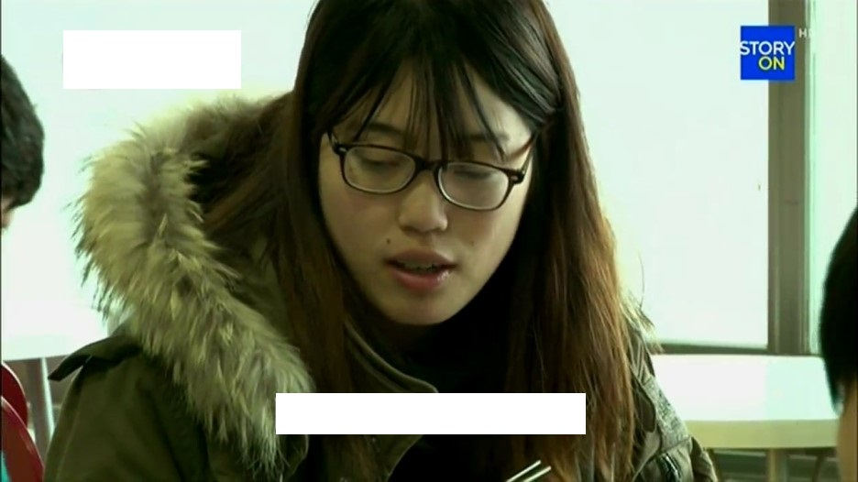
< LMI 2>
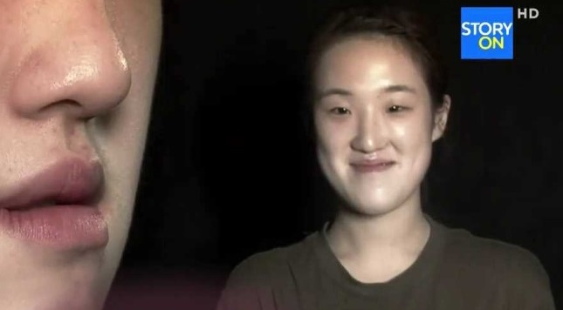
< LMI 3>

< LMI 4>

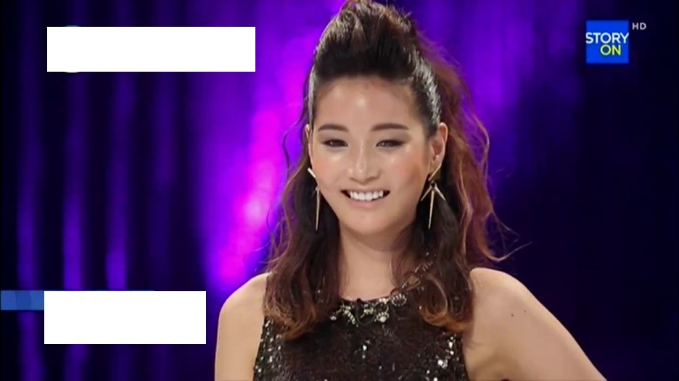
< LMI 5>

< LMI 6>

<Celeb 1>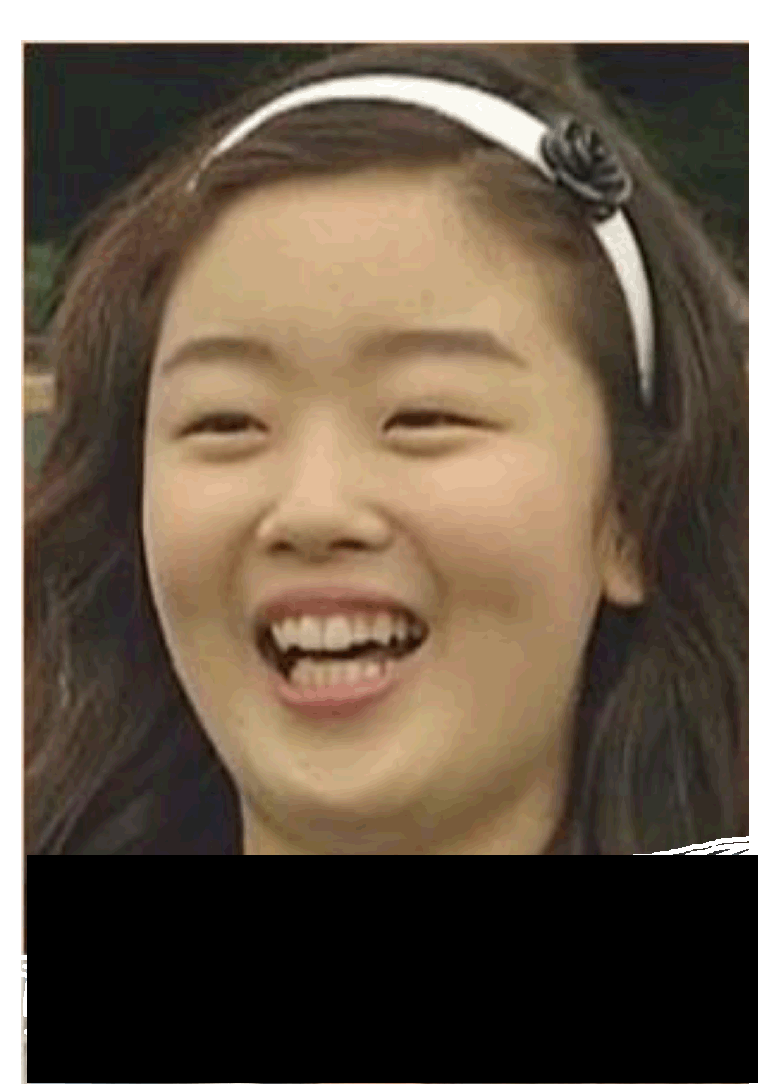
<Celeb 2>

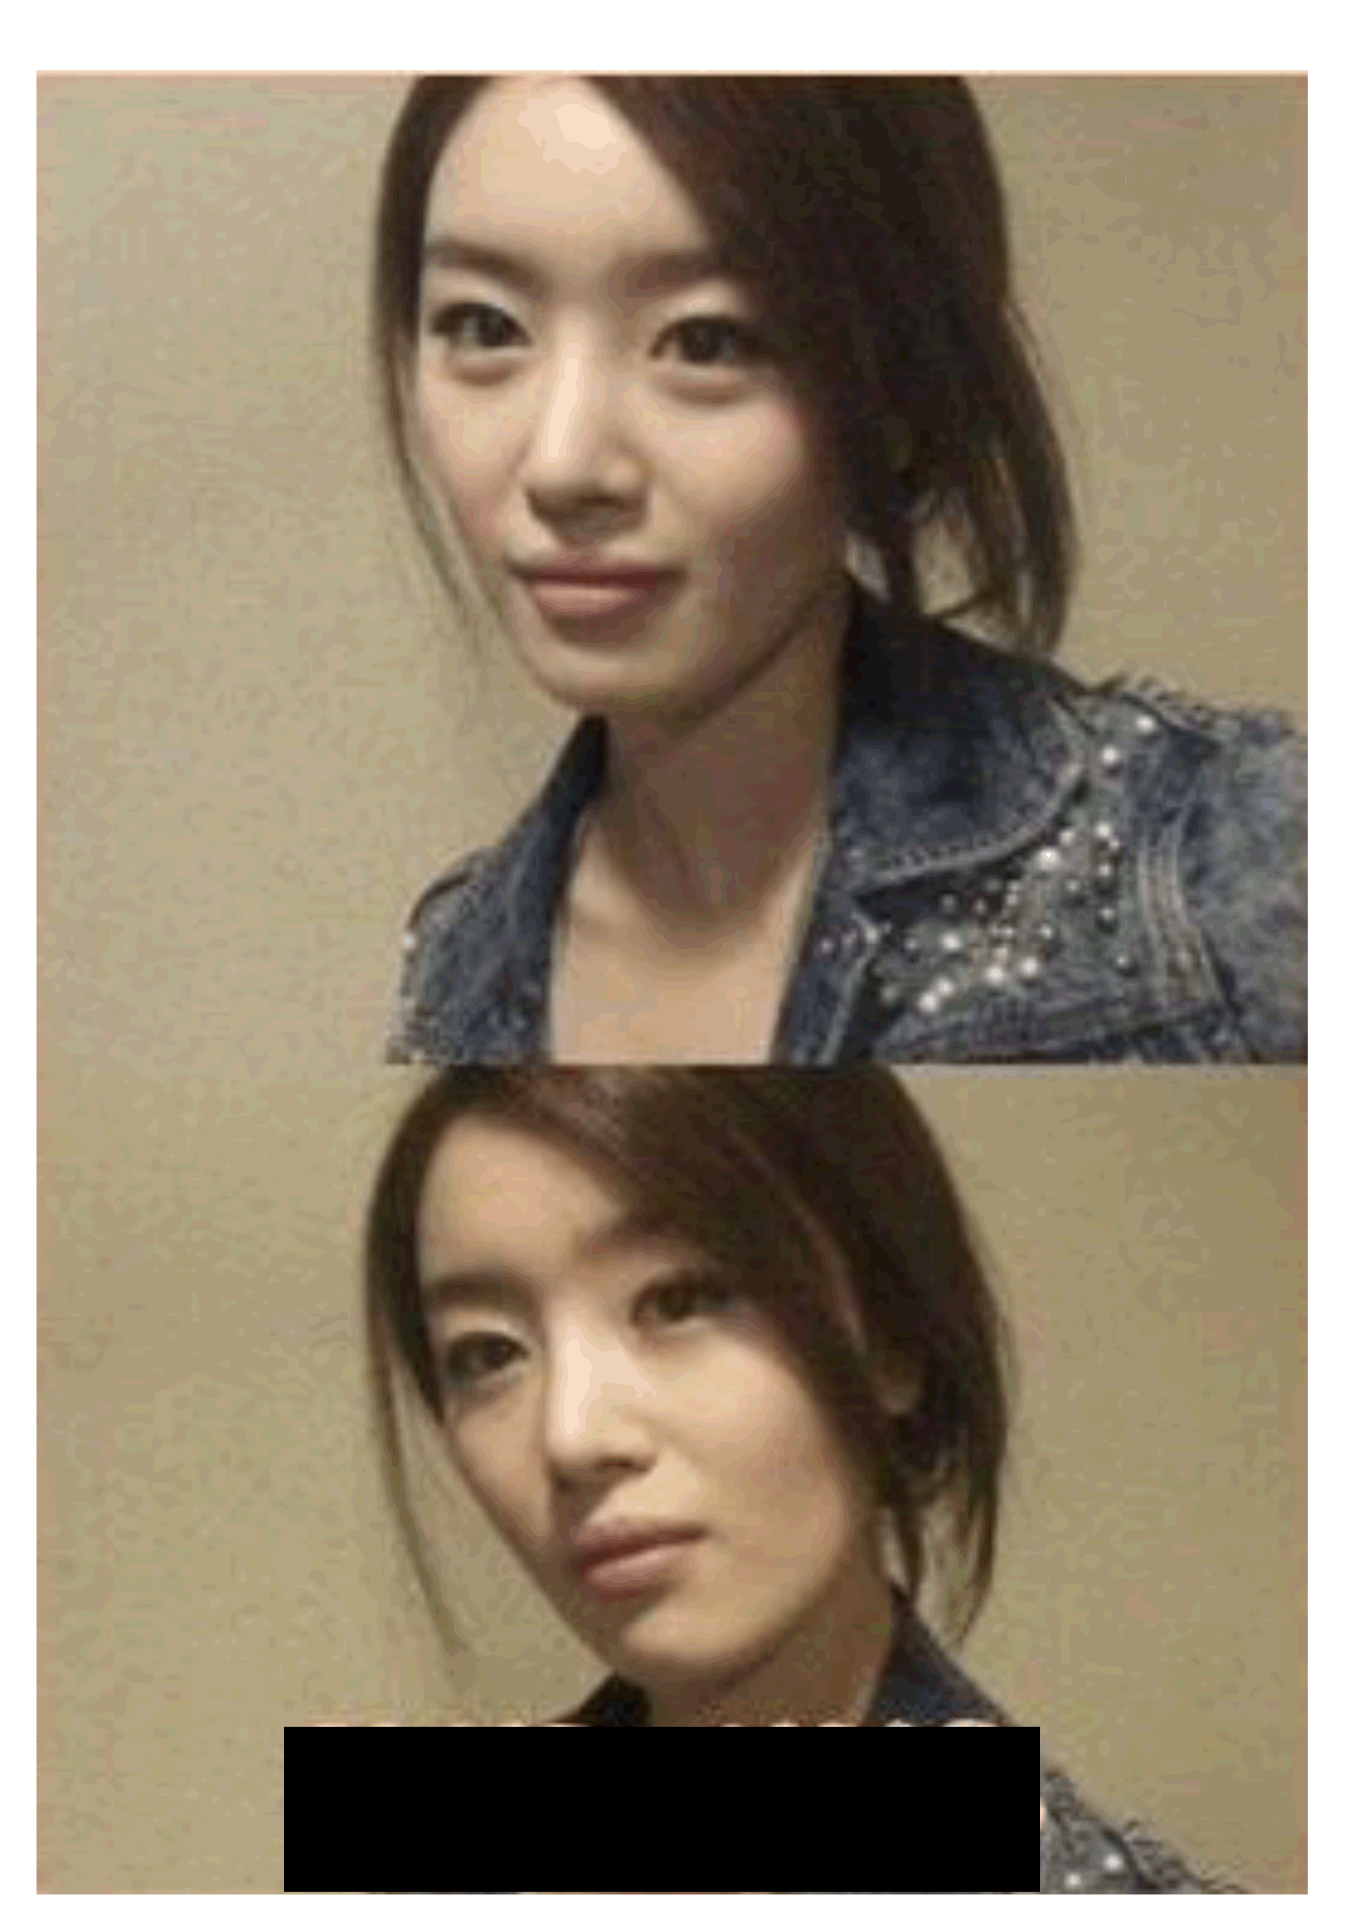
<Celeb 3>

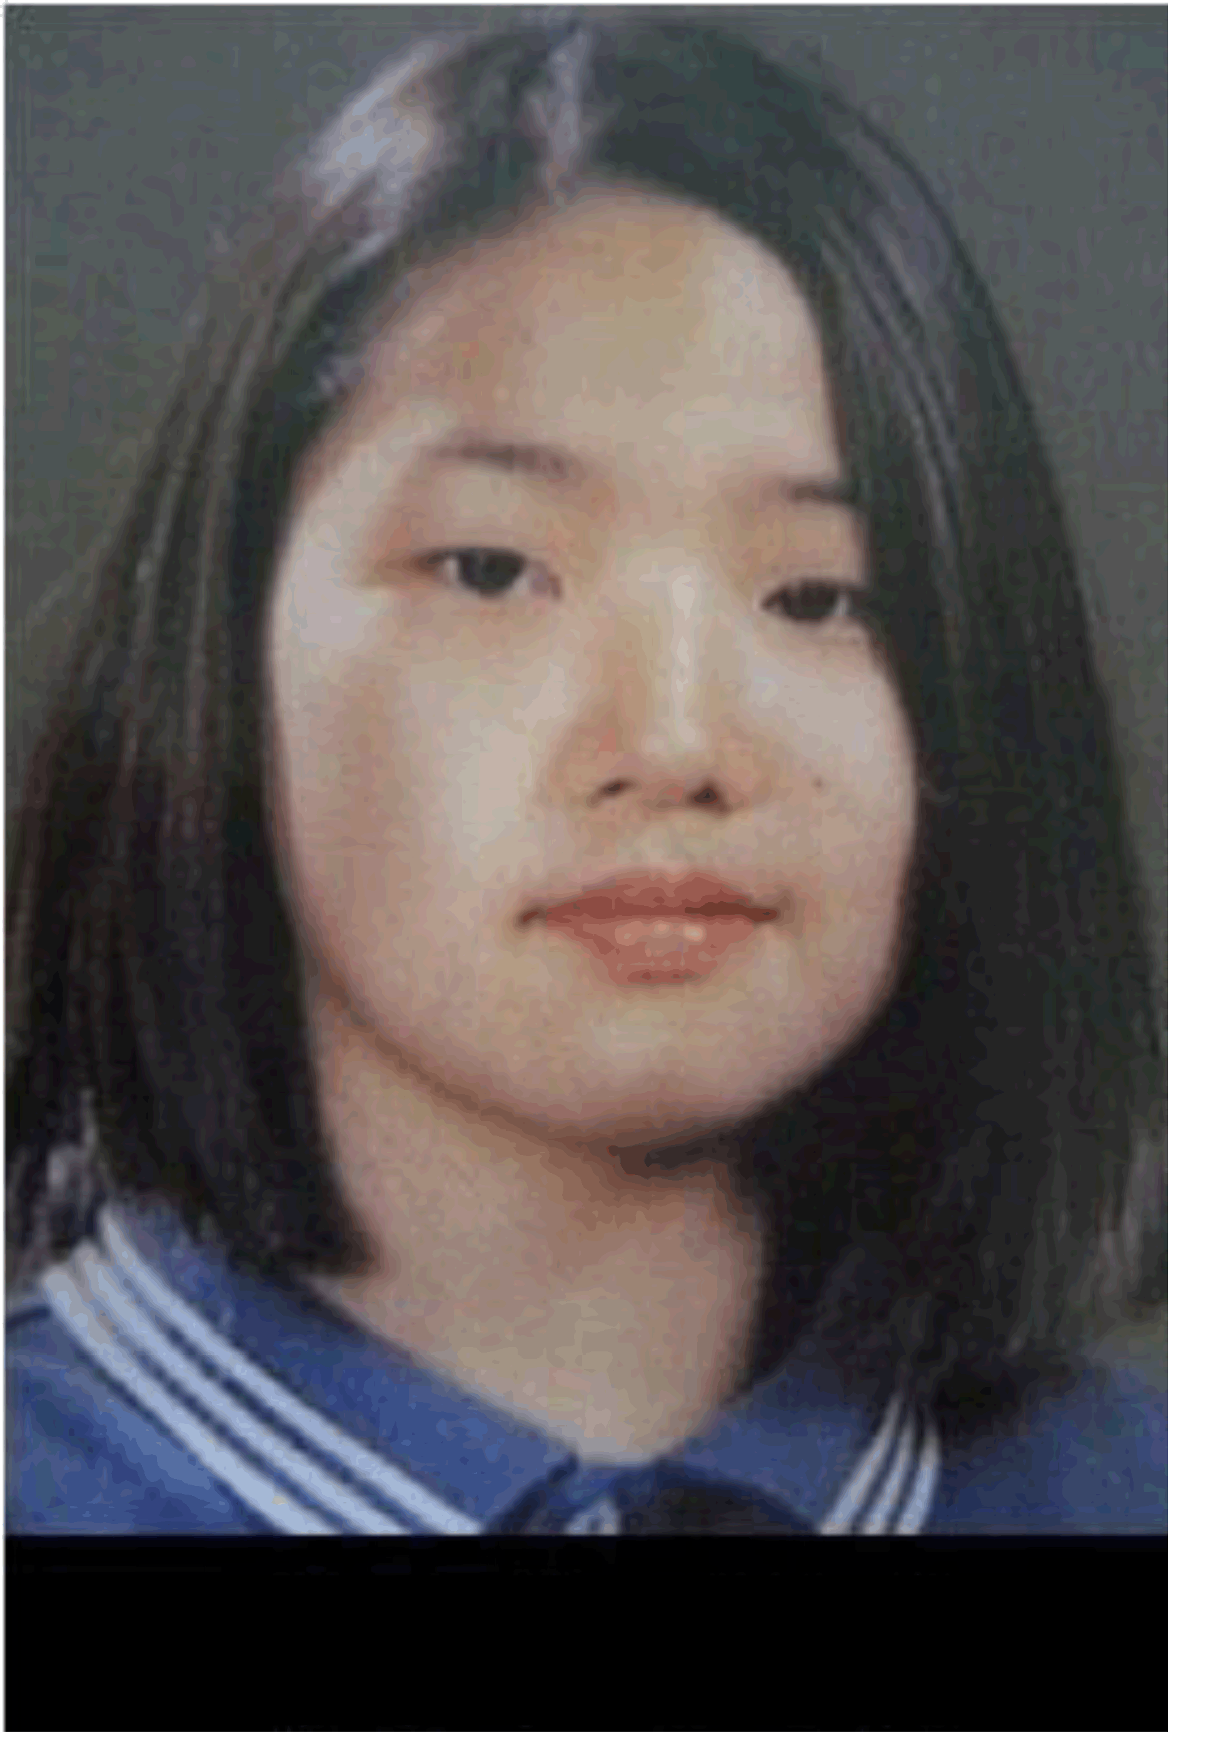

<Celeb 4>

<Celeb 5>

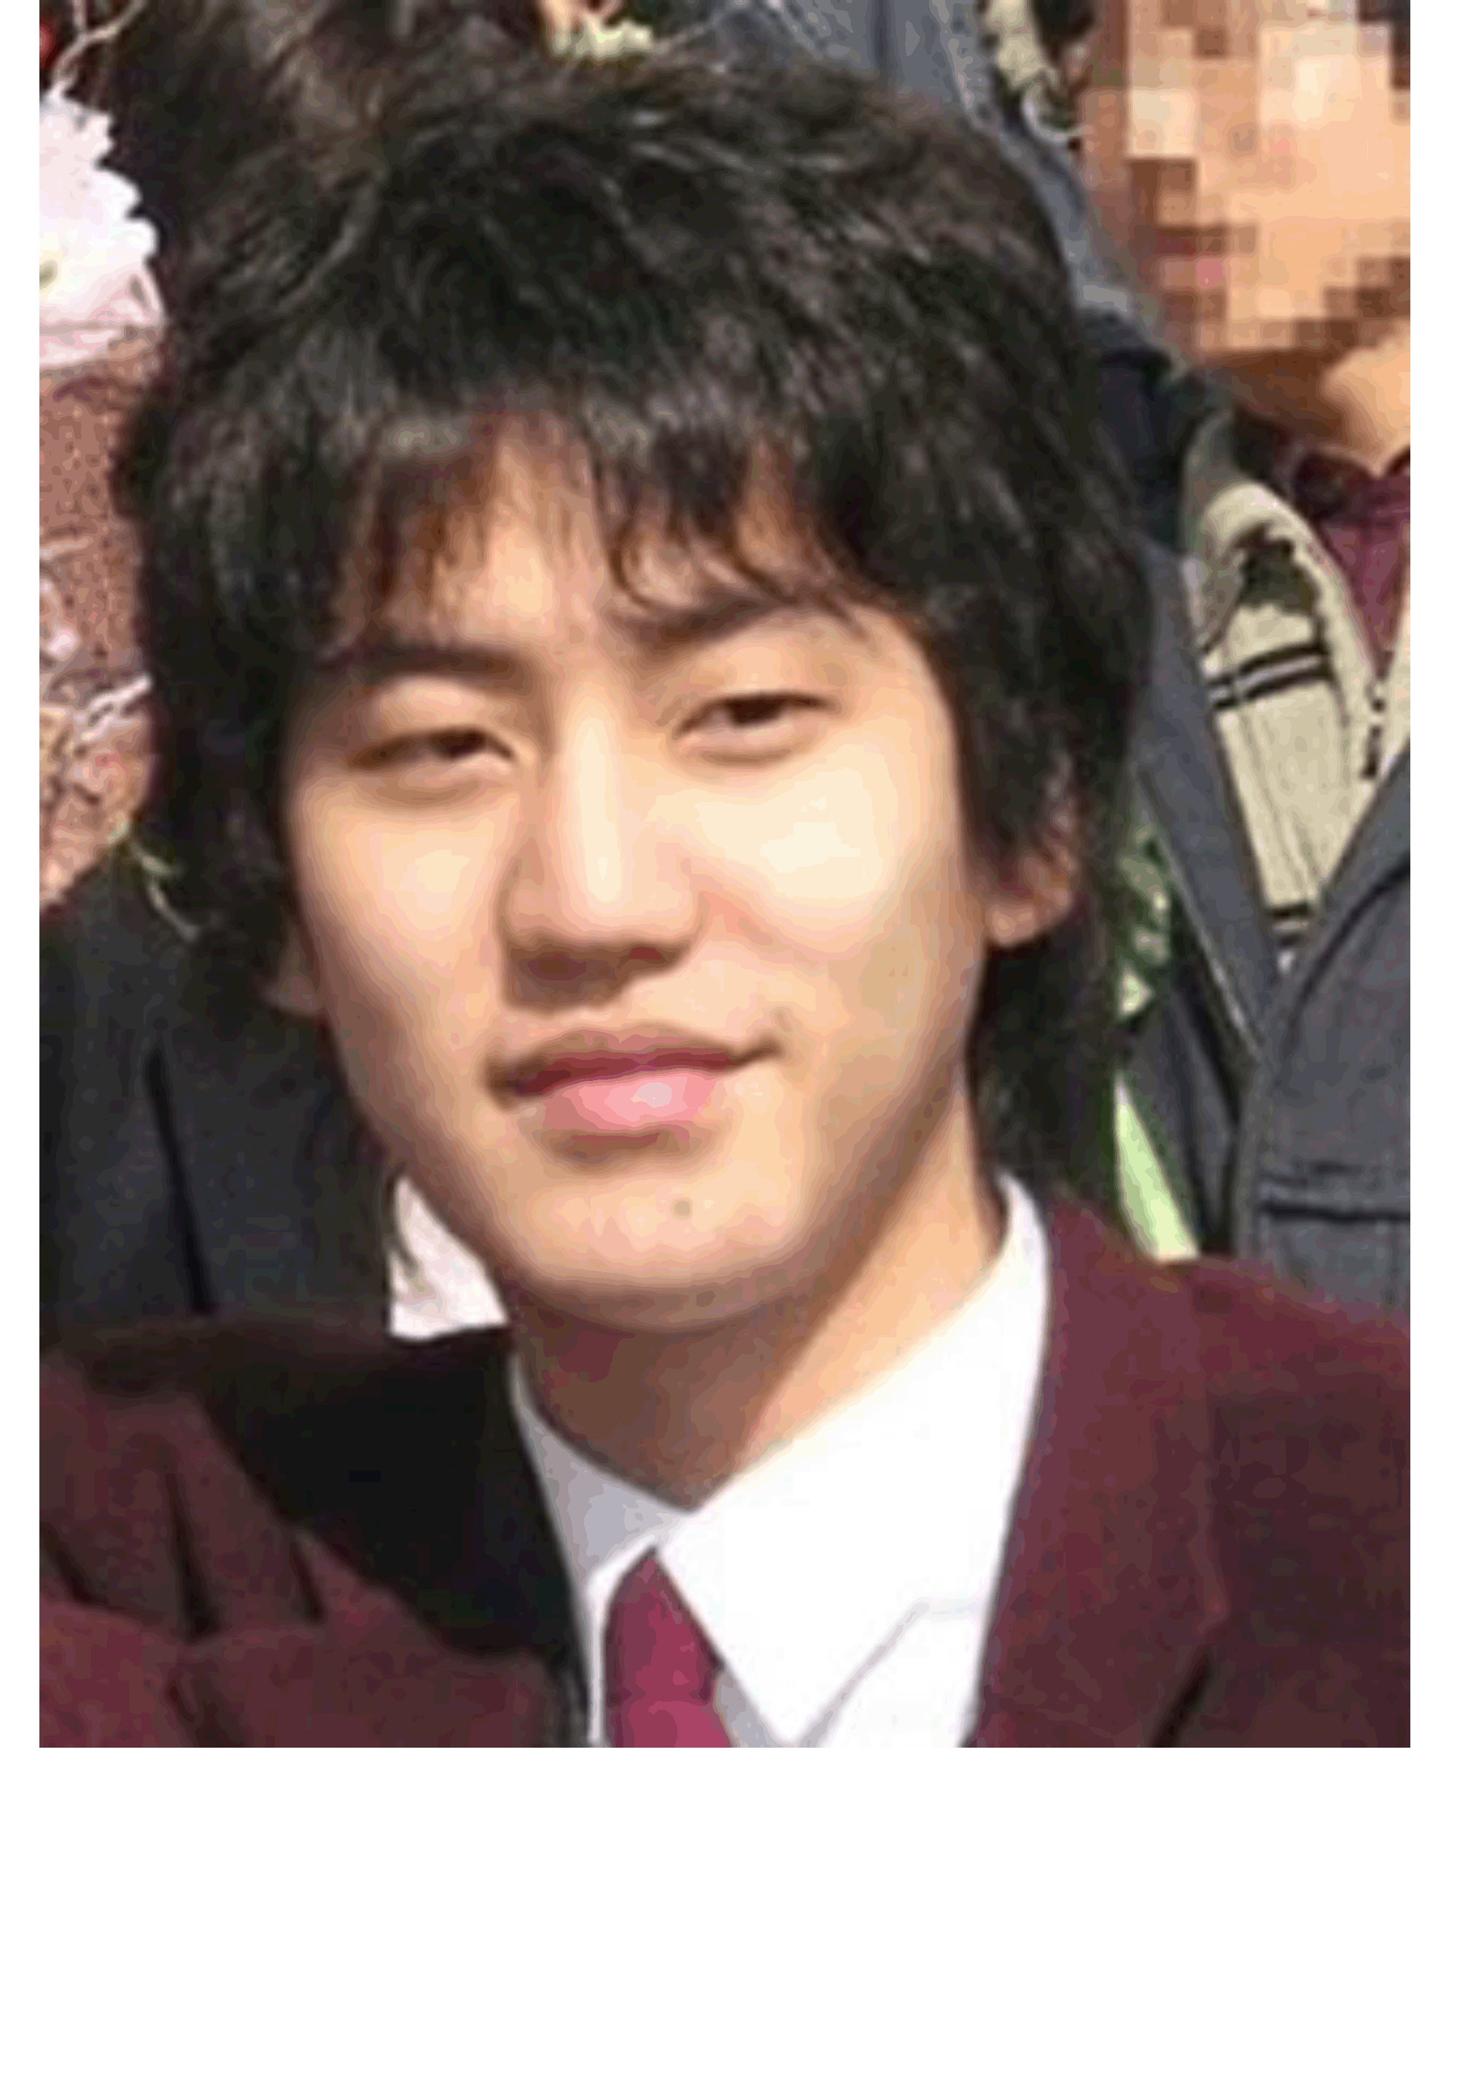
<Celeb 6>

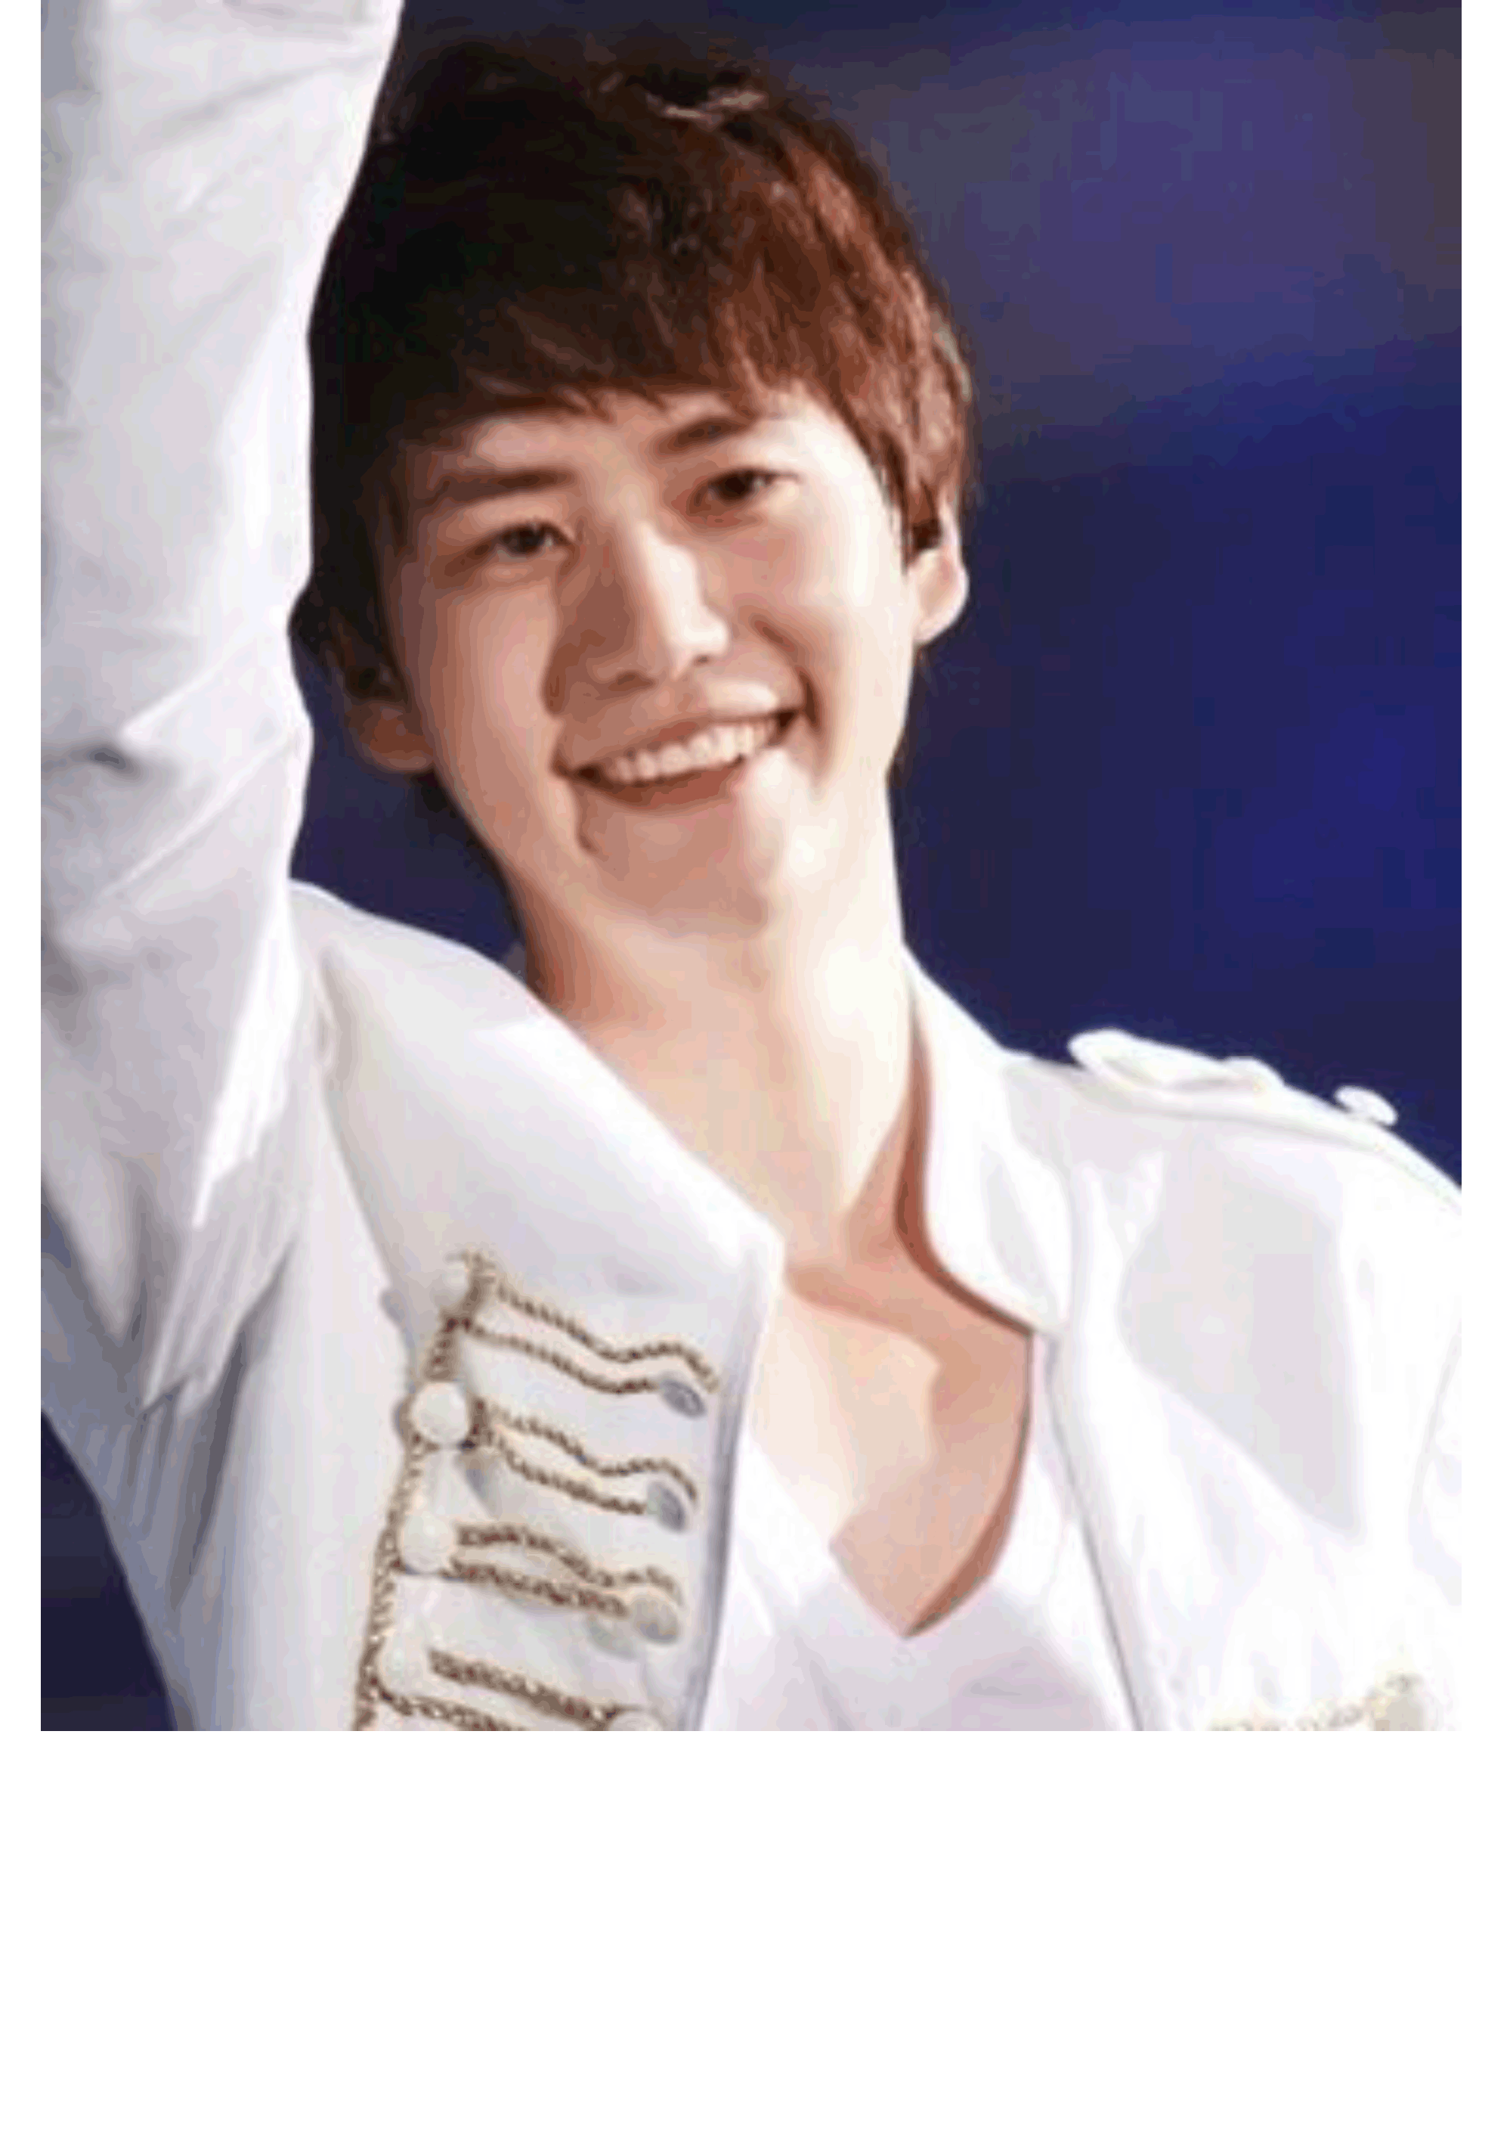

About Face

South Korea has the highest rate of plastic surgery per capita in the world and The United States is No. 6. Between one-fifth and one-third of women in Seoul have gone under the knife. The walls of the subway stations are covered with ads for plastic-surgery clinics and ‘before-after’ pictures.
A typical high-school graduation gift for a Korean teen-ager is either a nose job or a double-eyelid surgery. “When you’re nineteen, all the girls get plastic surgery, so if you don’t do it, after a few years, your friends will all look better.”, college student who’d had a double-eyelid procedure told me. “We want to have surgeries while we are young so we can have our new faces for a long time,” another young woman said. Every doctor I interviewed said that he had patients who’d brought in photographs of celebrities like Kim Tae-hee or Lee Min-jung. One doctor told me that he had a patient who showed him a cartoon that she wanted to resemble.
“I never thought about doing plastic surgery,” said Stella Ahn, whom I met at a coffee shop with her friends Jen Park and Sun Lee, all college students. “But then my father told me, ‘I spoke to a plastic surgeon who’ll make you more beautiful.’ Afterward, I regretted it a lot. I felt: I’m not me, I lost my true self.” Lee also said, “My father told me that beauty could be a big advantage for girls. For instance, when you go on a job interview if the interviewer saw two women who had similar abilities, of course he’d go with the better-looking one.”

‘Appearance-oriented Standards’

Do pretty flight attendances sell more tickets?

It is not easy to become a female flight attendant in Asia. In South Korea, for example, new flight attendants should hold a university degree and speak fluent English. But one thing that sets this job apart from others is the emphasis on physical appearance. A face can often be a deal-breaker in the airline industry.
The Korean Air is notorious for taking looks very seriously. First-time Korean Air flight attendants should be below the age of 27 and have a "healthy complexion" and "straight, white teeth." Asiana Airlines flight attendants can only wear skirts, are restricted from wearing glasses while in uniform and keep their nails manicured and about 3 millimeters long. But the women are now speaking out and criticizing the airlines for outdated regulations.

Things to Talk About Work Sheet

- A nose job and a double-eyelid surgery seem to have become widely accepted. What do you think about it? Tell your opinion to your partner.

- What do you think about strict codes in physical appearance for flight attendants? Tell your opinion to your partner.

- What you do think about the reasons that South Korea became the world’s plastic surgery capital? Tell us what you think.

- Do you agree with the idea that better looking will bring benefits for job interviews, marriage, better career, and better social relationship? If so, why? If not, why not? Tell us what you think.

