Listening Speaking Reading Grammar Writing

Topic: family dinner at a restaurant to celebrate mother’s day

Instructor:  Park Chan Hee(Steffy),  Kang Sarah(Sara) | Level:  Intermediate | Students:  4 students | Length:  30 Minutes

Materials:

- Pictures, markers, board -pre activity
- Restaurant vocabulary worksheet, board, markers– pre activity
- Bow tie, name tags, menu, prompt cards, order sheets, pencils – main activity
- Video clip, projector, speakers, order sheet - post activity

Aims:

- Main aim: S will be able to listen and understand restaurant conversation and make orders with various food vocabularies and key expressions.
- Secondary aim: S will practice to speak about different topics such as making a restaurant orders and complaints.
- Personal aim : I want to be able to speak with more confidence in front of the students in the class / I want to adjust my class to the level of the learners

Language Skills:

- Listening: S will listen to other S’s restaurant order.
- Speaking: Swill speak the order she/he heard to another S.
- Writing: S will write down the order from the video.
- Reading: S will read vocabulary worksheet.

Language Systems:

- Phonology :none
- Lexis : new restaurant vocabularies in the worksheet
- Grammar :I’d like(natural way of saying what I want)
- Function :making orders and complaints at a restaurant(request)
- Discourse :role play

Assumptions:

Students already know
- Restaurant vocabularies
- How to work in pairs and groups
- Students understand their role and play them with their own ideas

Anticipated Problems and Solutions:

- Students might not understand the rules for the role play of the main activity
-let a student who understands the rules explain them to the students
- Running time for a role play will vary(the running time for the main activity cannot be anticipated exactly)
-adjust the number of times for role playing
- The video cannot be played due to the technical difficulties
-we as teachers read the scripts ourselves
- Students have difficulty in understanding the video clip
-go over the sentences one by one and give them more time

References:

pictures
http://blog.rockbot.com/blog/restaurant-background-music
http://cdn2.hubspot.net/hub/385216/file-795879736-jpg/Restaurant_Customer_Service.jpg

post-activity dialog
http://blog.naver.com/sgk76/60011154292

order sheet
http://www.photonesta.com/waitress-order-form-template.html

prompt card
https://www.speaklanguages.com/english/phrases/at-a-restaurant

menu
http://mendezmendez.com/?attachment_id=450

restaurant new vocabularies
http://www.enchantedlearning.com/wordlist/restaurant.shtml

Lead-In
Materials:
picture, marker, board

Time | Set Up | Student Activity | Teacher Talk
2min | Whole class | Looking at the pictures and guessing and answering | Hello, how are you?  What do you think of this picture?  (elicit restaurant vocabularies and write them on the board)

Pre-Activity
Materials:
Restaurant vocabulary worksheet, pencils, marker, board

Time | Set Up | Student Activity | Teacher Talk
7 min | Pairs  Whole class | Writing the worksheet | Instruction  (distribute vocabulary worksheet)  Match the definition on the top with the words on the bottom.  Work with your desk partner for 5min.  CCQ  Where do you go to eat when you are hungry?  Model  Let’s do #8  KJ, what do you think “maitre d’” means?  (ask a student to read the definition from the worksheet)  Yes, that’s right  Write “maitre d’” for #8  (write “maitre d’” on the board)  ICQ  What do you write in the blanks on the bottom?  How much time do you have?  (Monitor and help students)  Time warning  There’s 30 second left  Check answers  Compare your answers with the other pair  Let’s check the answers together  What comes in the first blank?  Are there any words you are not sure of the meanings?

Main Activity
Materials:
Bow ties, name tags, menu, prompt cards, order sheets, pencils

Time | Set Up | Student Activity | Teacher Talk
12min | Whole class  individual | Listening, role-playing, speaking | Instruction  There will be conversations between customers and a waiter at a restaurant. The waiter will get orders from the customers and write them down on the order sheet.  The waiter will whisper it to the chef.  The chef will tell everyone what he/she heard.  The customers will make complaints if what the chef tells is different from their orders.  ICQ  Who does the waiter give the order sheet to?  Is this for group work or individual work?  (assign Ss who will play mother, daughter, waiter, and chef  )  Start playing when I say “go”  (monitor while S role play)  Did you enjoy the activities?  Do you feel more comfortable using restaurant words and expressions?

Post Activity
Materials:
Video clip, computer, speakers, pencils, order forms, board, marker

Time | Set Up | Student Activity | Teacher Talk
9min | Whole class | Listen and write down the orders | Instruction  Now we will watch a video clip of a restaurant conversation. As you listen to the talk write down what customers order on the order sheet.  CCQ  What do waiters do to remember when they take orders from customers?  ICQ  What do you write on your order form?  (monitor Ss discreetly and help the ones struggling)  Wrap-up  What would you like to order for tonight’s dinner?  (Finish up the lesson by asking each students what they like to order if they decide to eat out tonight)  Error correction  What errors did you hear?  How can we change it?  (go over mistakes students say when answering the question, write them on the board and try to elicit corrections)  Close  Good job! Everybody!  Now you can use the restaurant vocabularies and expressions when you go to a restaurant.  Have a good day!
SOS Activities
Materials:
Restaurant crossword puzzle, pencils, markers, board

Time | Set Up | Student Activity | Teacher Talk
5min. | Whole class | Guessing and writing | Can you remember some restaurant vocabularies?  I will hand out a crossword puzzle.  Try to fill out the boxes.  I hope it will help you remember what we learned today

Lean-in

s.o.s activity
AT THE RESTAURANT
 |  |  |  |  | 10
 |  |  |  | 8 |  |  | 6
 |  |  |  |  |  |  |  |  |  |  | 4
 |  | 14 |  |  |  |  | 1 |  | 2
 | 13 |  |  |  |  |  |  |  |  |  |  |  | 7
 |  |  |  |  |  |  |  |  |  |  | 5
 |  |  | 11 |  |  |  | 12
 | 3
 |  |  |  |  |  |  |  |  | 9
WORDS
Horizontal
1. | Uncooked.
3. | The most substantial course of a meal
5. | It's the money you give to the waiter as a reward for his service.
8. | It's something you use to cut meat, bread, etc...
9. | The sweet course eaten at the end of a meal.
13. | It's what you ask for at a restaurant.
10. | Express dissatisfaction.

Vertical
2. | The person that serves customers.
4. | The people that eat at a restaurant.
6. | It's something you use to eat chips.
7. | It's something you use to have soup.
10. | Where the food and drinks are cooked in a shop.
11. | The piece of paper that specifies what you must pay.
12. | Reach the temperature at which water bubbles and it vapors.
14. | Cook in hot fat oil.  Answers  Horizontal  1. Uncooked.– raw  3. The most substantial course of a meal.-appetizer  5. It's the money you give to the waiter as a reward for his service.- tip  8. It's something you use to cut meat, bread,etc.. knife  9. The sweet course eaten at the end of a meal-dessert  13. It's what you ask for at a restaurant. -order  10. Express dissatisfaction.– complaint  Vertical  2. The person that serves customers.- waiter  4. The people that eat at a restaurant.-customers  6. It's something you use to eat chips.-fork  7. It's something you use to have soup.-spoon  10 Where the food and drinks are cooked in a shop. ---kitchen  11. The piece of paper that specifies what you must pay.-bill  12. Reach the temperature at which water bubbles and it vapors. -boil  14. Cook in hot fat oil.– grill
Post activity
Video script
Dialogue 1
Waitress: Have you been served?
Mr. Kim: No...
Waitress: Then, may I take your order, sir?
Mr. Kim: Let me see the menu first.
Waitress: Here you are, sir..
Mr. Kim: Okay.
Mr. Kim: Well... what do you recommend?
Waitress: Today's special is steak, sir.
Mr. Kim: I'd like to have a steak, please.
Waitress: How would you like your steak?
Mr. Kim: Medium, please?
Waitress: Soup or salad? Mr. Kim: Salad with French dressing, please.
Waitress: Would you care for anything to drink?
Mr. Kim: No, thanks. Just water will be fine.
Dialogue 2
Waitress: May I take your order, please?
Peter: Yes. I'd like a hamburger and French fries, please.
Waitress: All right, and would you like a salad?
Peter: Yes, I'll have a small salad.
Waitress: OK. What kind of dressing would you like? We have French and Italian dressing.
Peter: Italian, please.
Waitress: And would you like anything to drink?
Peter: I'd like a small Coke, please.
Waitress: It'll only be a few minutes.

Order form
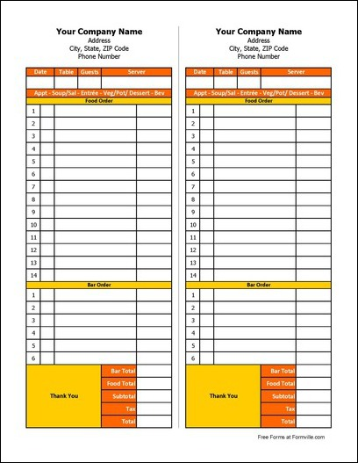

Menu

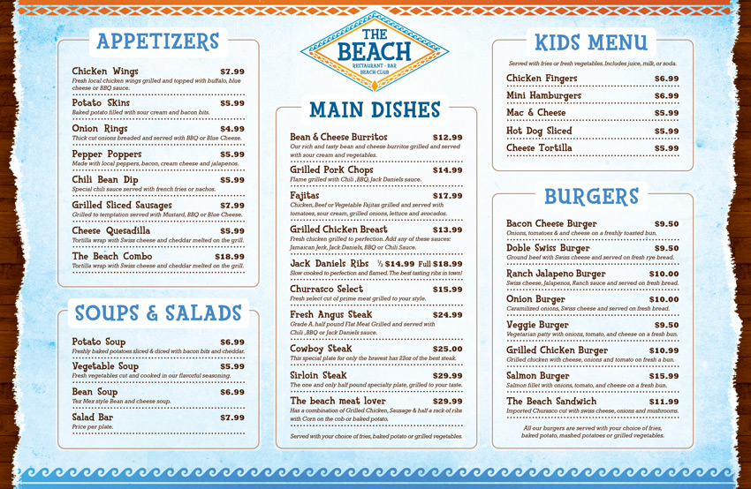

Restaurant vocabulary worksheet

- An itemized list or statement of fees or charges.
- A meal that server as both breakfast and lunch.
- Something in a central position, especially a decorative object or arrangement placed at the center of a table.
- Cutting instruments and tools.
- A therapeutic or protective material applied to a wound.
- The main dish of a meal.
- A connoisseur of fine food and drink; epicure.
- Head of waiter.
- A large shallow dish or plate, used especially for serving food.
- A cloth to cover a table, especially during a meal.

- Cutlery
- Dressing
- Gourmet
- Platter
- Tablecloth
- Maître d’
- Bill
- Brunch
- Centerpiece
- Entrée

Answer keys

- An itemized list or statement of fees or charges.
- A meal that server as both breakfast and lunch.
- Something in a central position, especially a decorative object or arrangement placed at the center of a table.
- Cutting instruments and tools.
- A therapeutic or protective material applied to a wound.
- The main dish of a meal.
- A connoisseur of fine food and drink; epicure.
- Head of waiter.
- A large shallow dish or plate, used especially for serving food.
- A cloth to cover a table, especially during a meal.

- Bill (g)
- Brunch (h)
- Centerpiece (i)
- Cutlery (a)
- Dressing (b)
- Entrée (j)
- Gourmet (c)
- maitre d’ (f)
- platter (d)
- tablecloth (e)

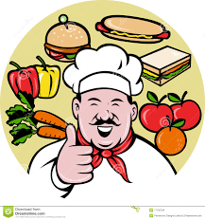Prompt cards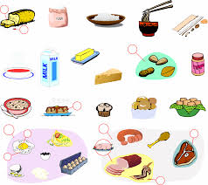

\I'm on a diet

\this doesn't taste right
\this isn't what I ordered
\?I don’t eat
meat
pork

\enjoy your meal!

\would you like any coffee or dessert?
\could I see the dessert menu?
\we've been waiting a long time
\what's the soup of the day?
\would you like to taste the wine?
\would you like anything else?
\are you ready to order?
\this is too salty
\could I see the menu, please?

\how would you like your steak?
Medium, rare, well-done

