Listening Speaking Reading Grammar Writing

Topic: The most important things to take to survive on an deserted island

Instructor:  Park Chan Hee  (Steffy) | Level:  Intermediate | Students:  5 students | Length:  30 Minutes

Materials:

- Realias, board, markers –lead in
- Worksheet A & B, board, markers– pre/ main activity
- Debate expressions sheet – main activity
- Vocabulary cards – post activity
- Search word puzzle – S.O.S activity

Aims:

- Main :Students will be able to express their ideas and opinions about the most important needs for survival on an deserted island using related words and expressions
- Secondary :Students will practice debate skills such as careful listening, critical thinking, persuasive speaking, public speaking, etc
- Personal : I like to work on finishing each activities on time

Language Skills:

- Listening : Students will need to listen carefully to the opposite teams’ opinion to
rebut
- Speaking : Students will practice different forms of speaking in debate (persuasive, Defending, empathizing, etc)
- Reading : Students will read survival vocabularies on the worksheet
- Writing : Students will write the 5 most important survival items and the reasons
for choosing them

Language Systems:

- Phonology :sound F (rifle, fishing rod, flare gun, etc)
- Lexis : new survival vocabularies(Water purifier, insect repellent, etc)
- Function : agree/disagree expressions( on the contrary, so do I, etc)
- Grammar : making “wh”,”h” questions
(What do you think is the most important item for survival on an island?
- Discourse : debate

Assumptions:

- Students are familiar with survival vocabularies
- Students understands the setting and the rules of debate

Anticipated Problems and Solutions:

- Students have difficulty negotiating their opinions
-take votes
- Students get too emotional during debate
-teacher steps in remind them it’s only a debate
- Students can feel it’s unfair to have more team members in a particular team
-teacher should give equal number of taking turns and amount of time

References:

Worksheet A&B
https://smorgasbordinvitation.wordpress.com/2015/05/18/a-challenge-a-desert-island-and-a-choice-of-which-four-items/

Crossword puzzle
http://www.thepotters.com/puzzles/survival.html

Debate Expressions
https://en.islcollective.com/resources/printables/worksheets_doc_docx/giving_opinions/debate-intermediate-b1/17248

Lead-In
Materials:
Board, markers, realias

Time | Set Up | Student Activity | Teacher Talk
4min. | Whole class | Answer teachers’ question | Hello, everyone`  What do you think this is?  Do you know the name of it?  (show them realias and try to elicit survival item vocabularies  write them on the board)  In what kind of situation would you need them?

Pre-Activity
Materials:
Worksheet A & B, board, markers

Time | Set Up | Student Activity | Teacher Talk
4min | Whole class  Small groups | Fill out the gaps on worksheet A&B | Instruction  Work with your team.  Find out the names of the items on your worksheet by asking questions to your partners and write them down.  Do not show your paper to your partners.  (divide the class into 2 groups)  (distribute worksheets)  ICQ  Can you show your worksheet to your partners?  Model  Do you see the picture of a roll of white paper?  (Ask a student if he/she has the name of the picture on the paper, if not let him ask a question to his/her partner.  Ask the student what it is)  Yes, that’s right  Write “toilet paper” under the picture of a roll of white paper  (draw toilet paper and write “toilet paper” under the picture)  (monitor the students and help discreetly)  Time warning  There’s 30 second left  Check answers  Compare your answers with your partners

Main Activity
Materials:
Worksheet A & B, board, marker

Time | Set Up | Student Activity | Teacher Talk
13min | Small groups | Discuss and choose 5 items to take along  State, rebut and defend opinions | Instruction  Now you will work with your team to discuss and choose the most important things to take with you. You can only take 5 things from your worksheet.  You can add things to your list which is not from your list.  Write them down as well as your reasons for choosing them on the back of your worksheet.  ICQ  How many things can you take with you?  Answer check  Now, one person from each team comes out and write their 5 most important island survival items on the board  (compare how the list differs or corresponds to each other)  Instruction  Now, we are going to have a mini debate.  Team A will state their opinion about the 5 things to take for 2 min.  Team B will rebuttal for 1 min.  Then team A will have 1 min. for the final statement.  You will take the same turns for team B’s opinion.  Here’s a handout for different debate expressions. You can start your debate sentence with one of them.  (distribute the handout)  CCQ  Whose opinion do you defend in a debate?  ICQ  How many minutes do you get for your final statement?  (monitor as the students debate  And mediate when it gets too emotional)  (time students’ speaking and give them warning)  Wrap-up  (let the student know it is time for the last final statement)  Students!  Let’s listen to team B’s final statement before the end of the debate

Post Activity
Materials:
Vocabulary cards

Time | Set Up | Student Activity | Teacher Talk
9min. | Whole class | Review the vocabs by writing the meanings and guessing the words | Each student gets a random word.  Don’t show it to others.  Write down 3 uses of the item for  2 min.  And you will take turns reading your uses and the class will guess the word.  (give students 2 min. to write the uses)  Play the game  KJ, can you read you uses?  (play guessing game by taking turns)  What do you think KJ’s word is?  (write the word on the board)
SOS Activities
Materials:
Search word puzzle, board, markers

Time | Set Up | Student Activity | Teacher Talk
10min | The whole class | Guessing and writing | Can you remember some island vocabularies we studied today?  Instruction  I will hand out a word search.  Try to find the words listed on the bottom and circle the words.  Check answer  Let students compare their answer with desk partner

A Sheet
You are stranded on a deserted island
You need these items to survive
What are these called?
(Write the namesof the items below the pictures)
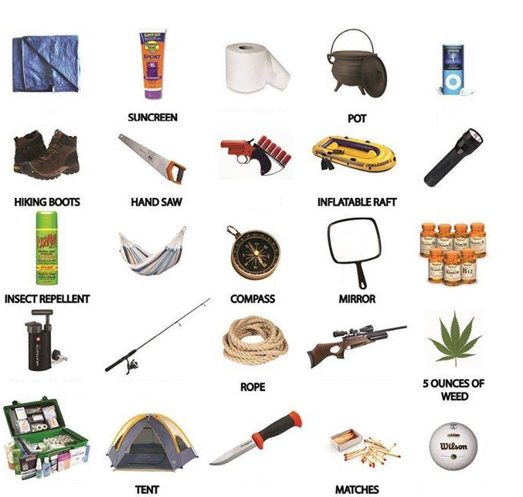

B Sheet

You are stranded on a deserted island
You need these items to survive
What are these called?
(Write the names of the items below the pictures)

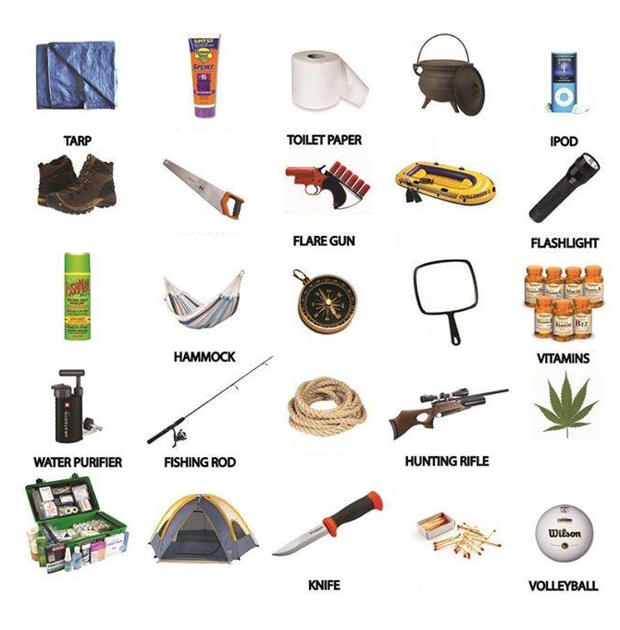

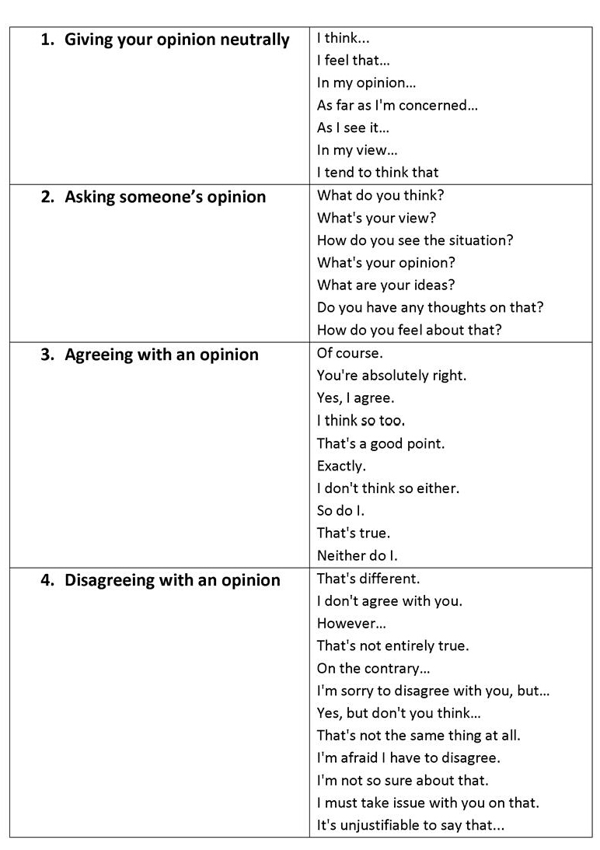
Debate expressions

Vocabulary cards

TARP
WATER PURIFIER
INSECT REPELLENT

Word
HAMMOCK
FLARE GUN
search
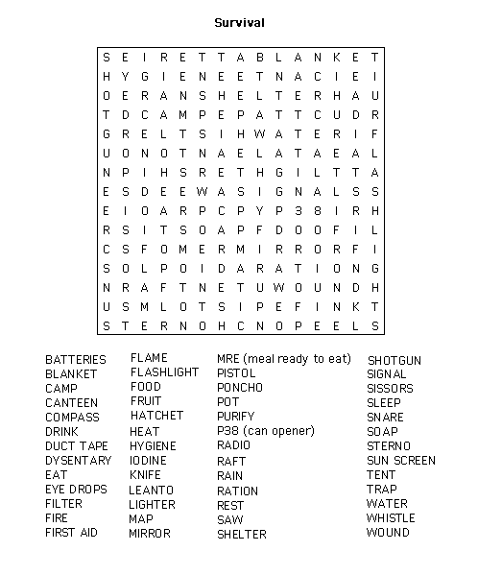

Word search answer

